Spline Tool for estimating soil attributes at standard depths

David Jacquier and Shane Seaton
CSIRO Land and Water, Australia

Background
The ability to produce continuous soil information to a given soil depth is a significant problem. Continuous soil attribute data to specified depths is required for environmental modelling. The ACLEP team has taken the research code developed at the Faculty of Agriculture, Food and Natural Resources at the University of Sydney and created a stand alone application (spline tool) that generates continuous depth functions for soil properties. The spline tool takes soil profile data (including instances where layers are not contiguous), fits it to a mass-preserving spline and outputs attribute means for standard depth intervals. If no surface layer is present the spline tool will use the uppermost layer’s attribute value as the surface value prior to fitting the spline. Read the following publication for more information.

B.P. Malone, A.B. McBratney, B. Minasny, G.M. Laslett (2009). Mapping continuous depth functions of soil carbon storage and available water capacity. Geoderma, 154, 138-152

T.F.A. Bishop, A.B. McBratney & G.M. Laslett (1999). Modelling soil attribute depth functions with equal-area quadratic smoothing splines. Geoderma, 91, 27-45.

Spline Tool Overview
To install the spline tool simply extract the contents of the zip file to a new folder. Double click on SplineTool.exe to run the application. It is a prerequisite that the Microsoft .NET framework 4 must be installed prior to using the tool (download standalone .NET framework 4).

The spline tool uses a comma delimited ASCII input file (see input.txt in the zip file) and generates up to 3 output files (cmsout.txt, stdout.txt and single.txt). The naming and output path of these files can be modified on the settings tab. The chart tab allows you to view the outputs of the splining process graphically.

Spline Tool Version 2.0
Please note that this is the second release of the spline tool. It has undergone limited testing prior to release. The tool will be updated and improved periodically. The spline tool can be downloaded from:
http://www.asris.csiro.au\downloads\GSM\SplineTool_v2.zip.

Generating Soil Attribute Outputs
The Spline Tool uses comma delimited input text files (see input.txt for formatting – depth must be in centimetres) and generates cmsout.txt, stdout.txt and single.txt. Check boxes on the settings tab allow the user to select which output files to export. The spline tool currently inputs and outputs one soil property (i.e. one of pH, clay content, etc) only. The cmsout.txt file contains soil attribute values for 1cm intervals to a depth of 200cm. The maximum depth of the output is limited by the maximum input depth.

The stdout.txt file contains soil attribute values for the standard depth specified by GlobalSoilMap.net as the default setting. The standard depths are: 0-5, 5-15, 15-30, 30-60, 60-100, 100-200 cm. Custom depths (entered in centimetres) can assigned from the settings tab. The single.txt file is created when only one layer exists for a given soil ID. In this instance the splining process is bypassed and the single soil layers are appended to single.txt and need to be dealt with separately. To generate the desired output file click the export button on the setting tab.

Note that the output files (stdout.txt and cmsout.txt) contain values for lambda (the smoothness of the spline function) and tmse (estimated mean squared error of the spline). In generating the outputs an equal-area spline is fitted to the soil property data for a lambda value of 0.1 as the default. Lambda is the spline smoothing parameter. The smaller the lambda the tighter the spline will be fitted to the input values. At the top right the lambda value can modified and its effect on the smoothness of the spline can be visualised when viewing the chart tab. The selected lambda value is used for generating the output files.

A default lambda value of 0.1 is used because this value has produced the ‘best’ fitting splines on tested datasets. User defined lambda values (e.g. 10, 1, 0.1, 0.01, 0.001, 0.0001 or 0.00001) can be specified from the spline tool interface or when running the tool via the command prompt. The names and locations of the input and output files can also be defined from the command prompt window. The measurement variance (s2) can also be input in the same manner to optimise the spline outputs.

To access the ProfileSplineGen.exe help use ‘ /?’ at the command prompt (e.g. E:\ACLEP3\ASRIS\Spline\Version2> SplineTool.exe /?) The optional arguments, comments and input file format for SplineTool.exe are displayed (see screenshot below)

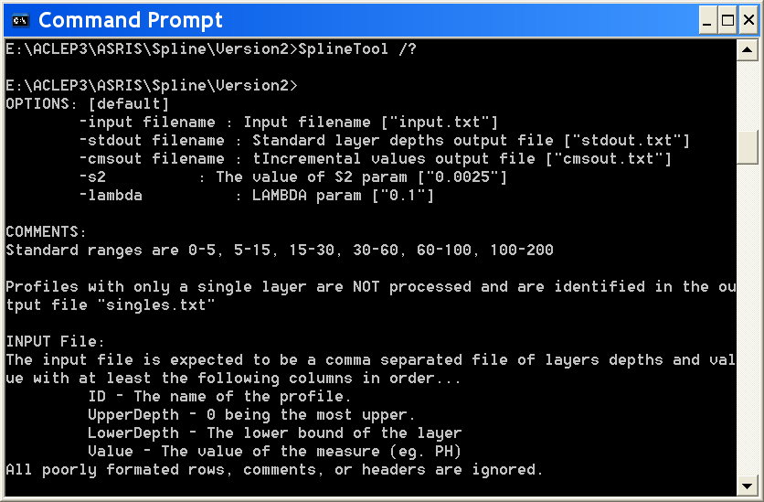

To input a user defined lambda value use the following syntax:
E:\ACLEP3\ASRIS\Spline\Version2> SplineTool.exe /lambda 0.01

Multiple arguments can also be parameterised. The following example inputs the lambda value and changes the path and filename for one of the outputs.
E:\ACLEP3\ASRIS\ Spline\Version2> SplineTool.exe /lambda 0.001 /stdout c:\test.txt /input c:\test_input.txt

Viewing Soil Attribute Outputs
The spline tool allows you to import an input file for visual inspection. Choose an input file and import it to view the data graphically. Layers can be turned on and off and reordered. The three layer options are: original (direct representation of the input data), Depth Layers (spline fitted and shown as the 6 standard depth means) and 1cm intervals. Click on the site ID to change sites. Select different values of lambda to view the effect of the smoothing parameter.

The following image is a screenshot of the spline tool graphical user interface.

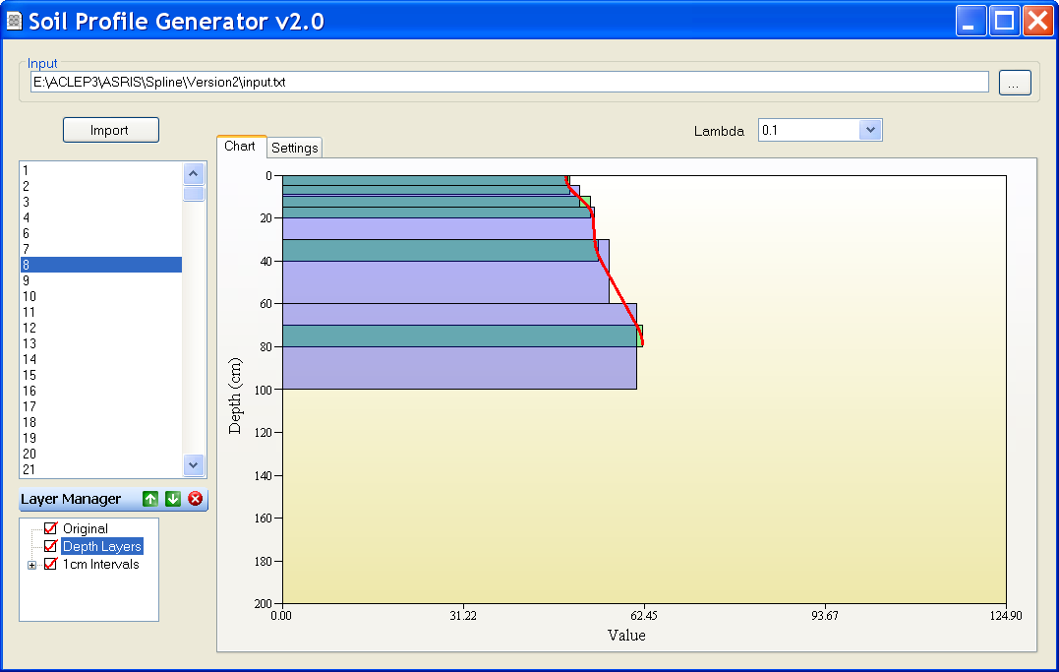

Advanced Spline Techniques
The equal-area spline that is fitted to the soil property may need to be refitted in some circumstances. When fitting splines to duplex soils additional data layers may need to be added above and below the point of texture contrast to force the spline to honour the soil morphology. The example below shows the standard spline fitting (left) and one where extra layers (1 cm thick) are added above and below a texture contrast at 45 cm (green bars are the input data and the red represents the fitted spline).
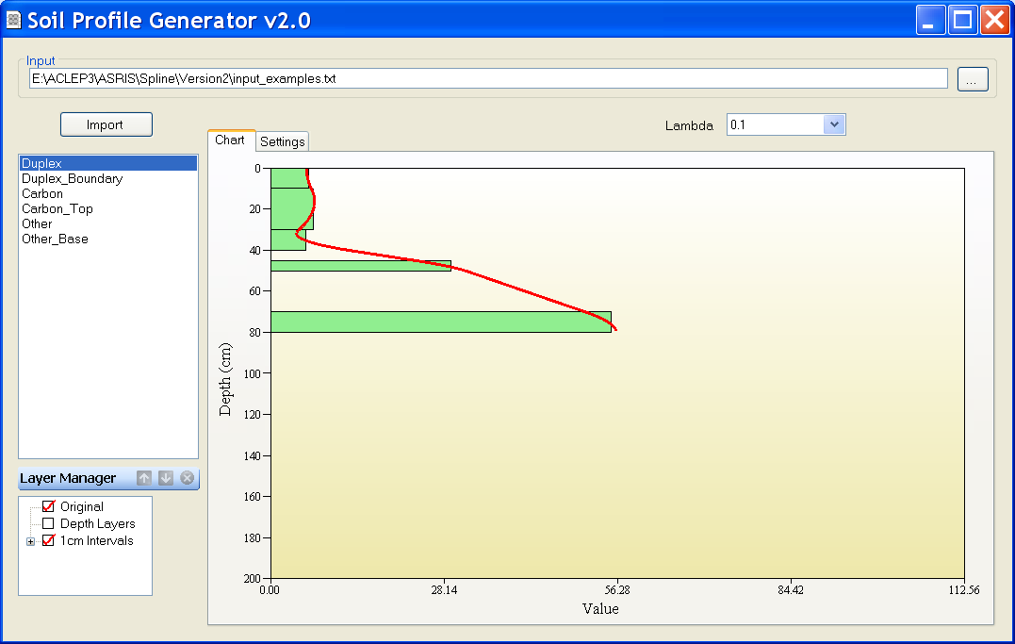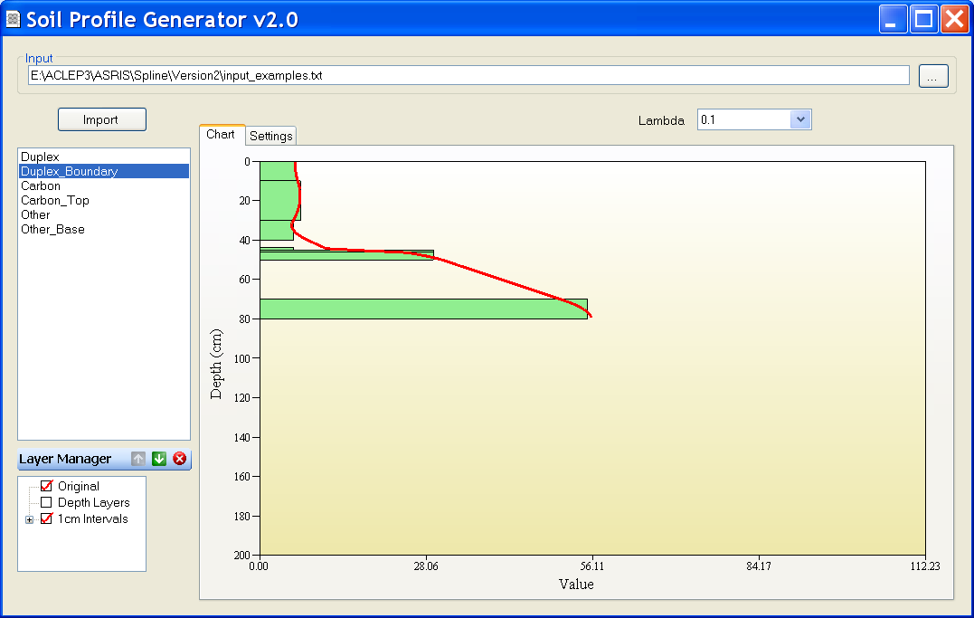
In cases where there are dramatic increases in soil property values at the top or bottom of a soil profile it may be wise to include additional data layers to ‘peg’ the spline at its extremities. The following example is of a soil with an organic carbon rich surface which decreases rapidly with depth. The left image depicts a standard spline and the right is for the same profile with a 0-1 cm data layer added. By adding the extra layer the spline doesn’t overestimate the near surface organic carbon.

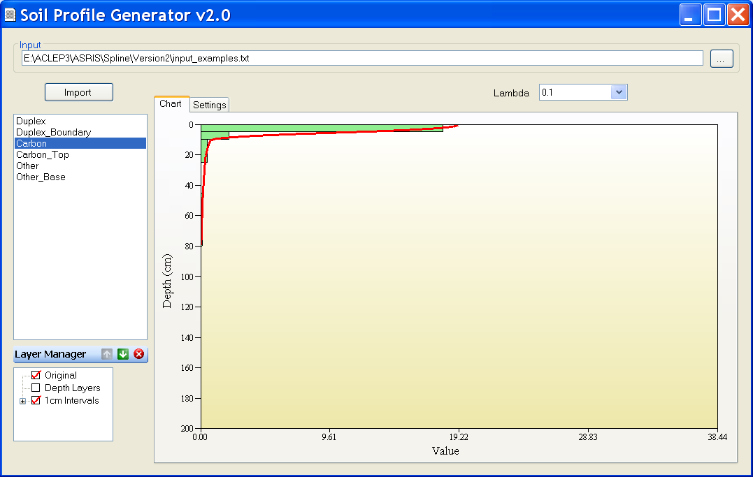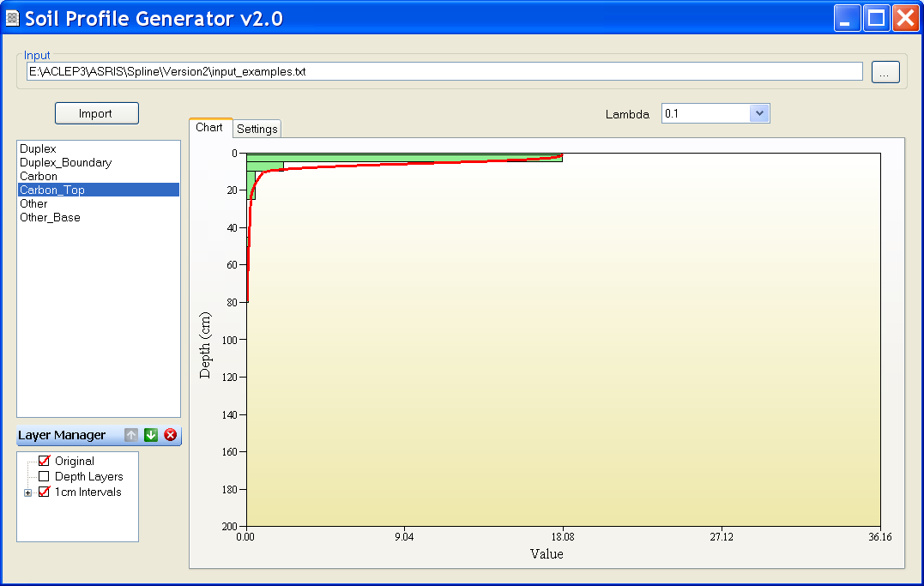

At the base of the profile an extra layer can be added for a similar effect.

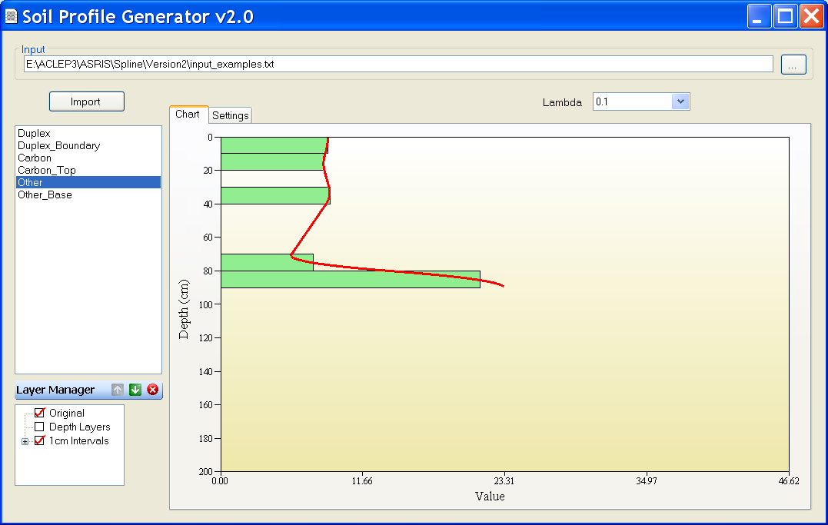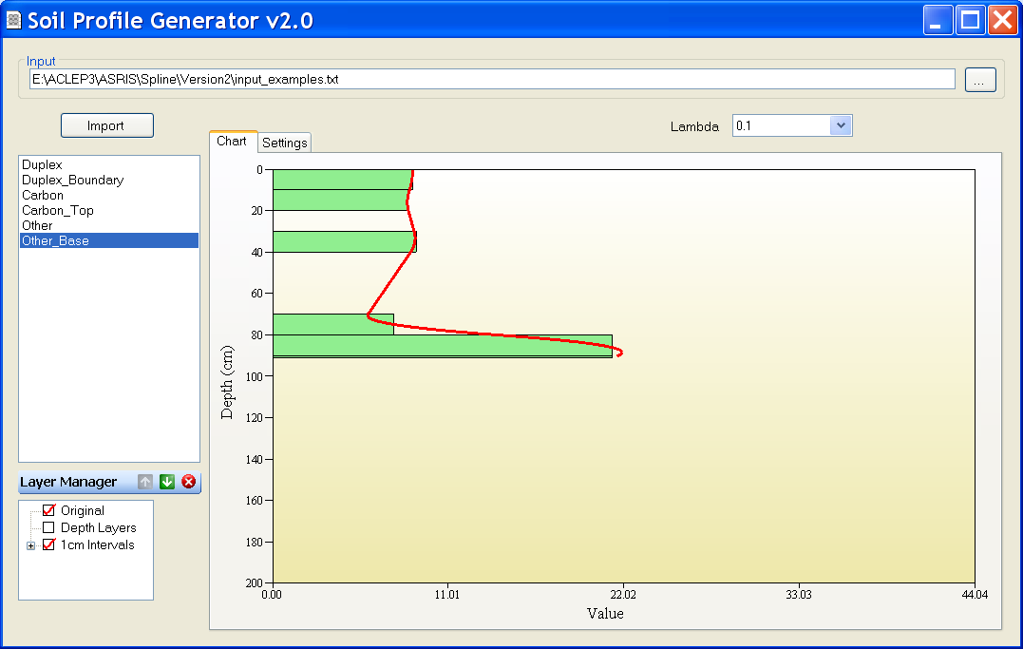

The data used to generate these examples can be found in input_examples.txt.

Uncertainties can also be fitted using the spline tool by adding lower and upper uncertainty values to the input file (see input_uncertainty.txt for formatting).

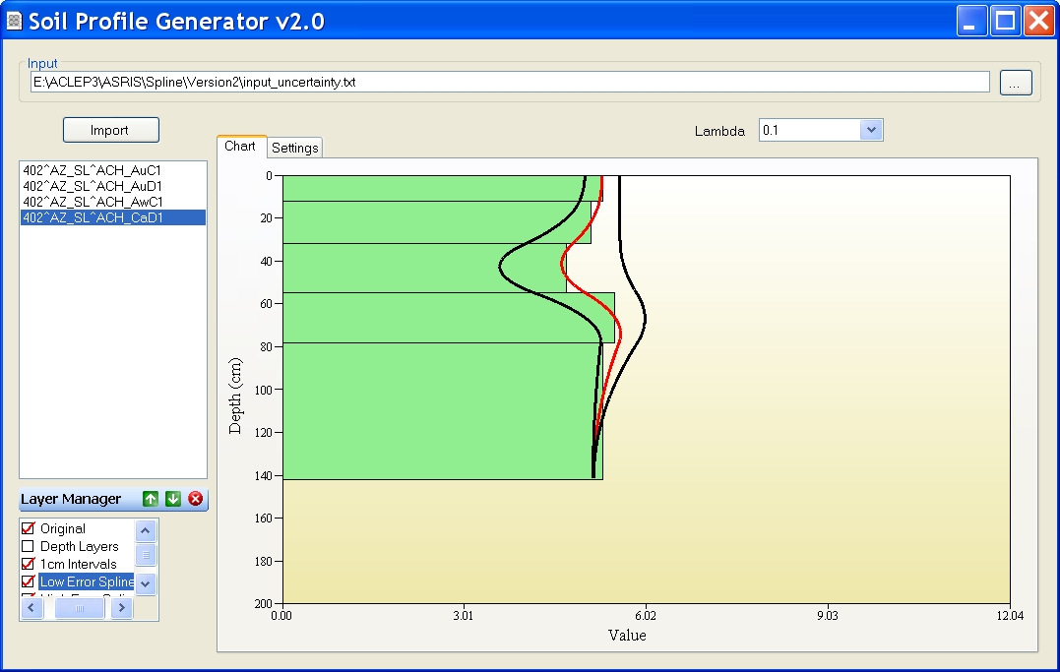

In the above example the black curves represent the fitted lower and upper uncertainty while the red is the fitted value for the soil attribute. The fitted uncertainties can currently only be visualised. The ability to export uncertainties is to be added shortly.

Contacts
If you are having problems with the spline tool or have any comments please contact David Jacquier (david.jacquier@csiro.au).

If you require assistance of a theoretical nature (i.e. science, mathematics and statistics) please contact Budiman Minasny (budiman.minasny@sydney.edu.au) at the University of Sydney.

