WRITE ALGORITHMS FOR THE BELOW PROBLEMS

1: Given a sentence S where the words are separated with '.'

Reverse the sentence without explicitly reversing each and every word of the sentence.

Input : this.is.a.sentence

Output: siht.si.a.ecnetnes

2:Given an input of n unsorted integers, find whether the elements of array form an arithmetic progression or not. Print true if possible, else print false.

Input: 8 , 4 , 2 , 6 , 10

Output: true

Explanation : Here the terms have a common difference 2.So it is an arithmetic progression.

3: Print the following pattern for given number of rows

Input : 5

Output:

1. 4 3 2 *

5 4 3 * 1

5 4 * 2 1

5 * 3 2 1

* 4 3 2 1

4:Given a stack with**push(), pop(), empty()**operations, delete **middle**of it .

Input:

|  |
| --- |
| 4 |
| 7 |
| 2 |
| 9 |
| 3 |

Output:

|  |
| --- |
| 4 |
| 7 |
| 9 |
| 3 |

5: Given a binary tree. Print the elements in level order

Input:

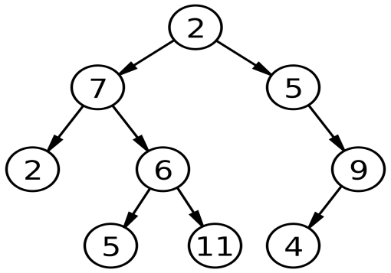

Output:

2 7 5 2 6 9 5 11 4