**ATAL BIHARI VAJPAYEE**

**Indian Institute of Information**

**Technology and Management, Gwalior**



**Report of proposed Minor Project (Internship) on**

**Face Mask Detection using**

**OpenCV and SVM**

*Submitted by: Rishu Kumar*

*Roll-NO- (2018IMG-048)*

**Abstract------**

People across the globe are suffering from the widespread COVID-19 pandemic and it is becoming crucial to develop and implement new technologies/software to analyse and fight against Covid and make people life peacefully as they were before. The most important guard against corona virus is Face Mask and Scientist and Doctors have recommended everybody to wear the mask for the safety of themselves and other people in public.Coronavirus spreads rapidly among individuals who are in close contact with each other ,So it is crucial to wear a mask In order to be safe from Corona virus. Therefore, to extricate the individuals wearing Face Mask, various identification actions are taken by the government. This project is more of a real-world application, the proposed face mask detection platform utilizes SVM to identify whether a person is wearing a mask or not. Experimental results show that this model performs well on the test data with 98% accuracy.

**Keywords---**

open cv, SVM, Image Processing, Numpy , Pandas, Classification, Covid, RGB, Jupyter Notebook, Cascading classifier, Haar feature selection, Object detection, Matplotlib, Face-marks-detection

**Introduction---------**

The mankind is facing COVID-19 pandemic that is the most life-changing event which has startled the world since the year 2020 begin. It is affecting the health and lives of masses, COVID-19 has called for harsh actions to be taken in order to prevent the spread of the disease. Face masks has become one of the most important personal protective equipment. people wear face masks once they step out of their homes , offices and government strictly ensure that everyone is wearing face masks while they are in public places.

A face mask detector system can be implemented to check if people are following the safety principle made by the government . The two steps that need to be implemented to spot the presence of a mask on the face is to first detect the face and detect masks on those faces. Face mask detection is one of the applications of object detection.

Here in this Project I am going implement face mask detection using OpenCV and Support Vector Machine (A Supervised machine learning algorithm) from scratch. This project can be helpful for the government to detect who all are not wearing marks in public areas. Also it help in pubic area to know if anyone who enters in that area is wearing a mask or not. If anyone is not wearing a mask then the person must not be permitted in that area. Thus to solve this problem of face mask detection we don’t require any security who keeps a watch on people but instead we can integrate a software that uses camera . With the help of this camera we continuously clicks pictures or take video of people and detect whether they are wearing a face mask or not.

**Background of this project—**

In March 2020, Covid pandemic hit India and was spreading at a very fast rate. To help limit the spread of this new virus, the WHO, doctors as well as government across the world advised people to wear facemasks to protect themselves and other people from this virus.

In reply to this growing Covid19 cases research in face-mask detection has fascinated the consideration of the computer vision and image processing community recently and they have taken various efforts towards developing automatic detection models which in a way can help society from COVID-19 pandemic . Face-mask detection project represents both a detection as well as classification problem because it first detects faces of people in digital images/videos and then recognise whether the are wearing a mask or not. If they are not wearing mask they will not be permitted in various public places.

**Objective-----**

It is tough time for people due to covid-19 outbreak ,thus keeping in mind the safety purpose of the people The objective of this project is to be able to detect whether a person is wearing a Face mask or not without having any human presence .The accuracy should be significantly accuracy. Thus this model can be implemented in offices , banks, and other public places so that we do not allow people who are not wearing mask in these areas. Thus in a way this project helps to increase the safety of people.

**Tools , Technology and algorithm requirements---------**

* Python
* OpenCV
* SVM machine learning algorithm
* A web camera

**Methodology of the project--------**

Before talking about the steps and process that we used to built this project I would talk about some of these topics/techniques that played a crucial role in building this project from scratch, that are—

* Image processing Technique
* OpenCV (a python library)
* Support Vector Machine Algorithm

**Image Processing---**

We would implement face mask detection but before implementing face mask detection, it is a prerequisite to know how to handle images. Images are group of RGB colour format that means red ,green and blue. A human see an image with some entity , shape or structure in it , but on the other hand a computer sees it an array with colour values ranging from 0 to 255.Thus it become easy for us to implement any algorithm on this array of RGB with the help of Numpy library of python.

**Steps to perform Image Processing----**

* **Step1**: Load images using python . In python we have OpenCV which will help us to do this it read the image and converts it into array and returns it.
* **Step2**:Convert the images into an array
* **Step3**: And Then we can apply any algorithm on that array to meet our requirement.

**Introduction to OpenCV(A python library)--------------**

* Open Source Computer Vision Library or OpenCV is an open source computer vision and a python library.
* OpenCV has Python, Java, C++ and MATLAB interfaces and supports most of the reputed OS like Windows, Linux, Mac etc.
* Its help to load images in Python and transforms them into an array.
* Every index of array represents RGB(Red, Green, Blue) colour pixel ranging from 0 to 255.

**Introduction to Support Vector Machine Algorithm----**

Support vector machines (SVMs) are linear classifiers which are based on the margin maximization principle. It perform organizational hazard minimization, which improves the complexity of the classifier with the aim of achieving excellent generality performance and accuracy . Support vector machine classifies the data in two categories by constructing the hyperplane.

Now we are in a position to discuss the steps that were used to built this project.

**Stepwise process to build this model from scratch----**

* We install OpenCV in our Jupyter Notebook using the pip command .
* Now we are ready to execute the basic image processing steps using OpenCV package. We we load the OpenCV package and read the image .

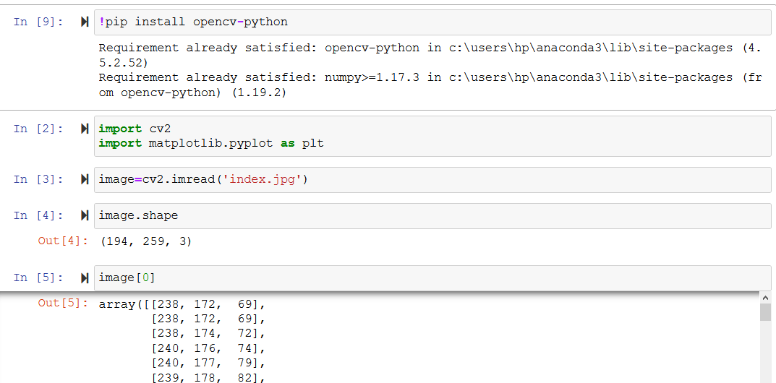

* We get the image in the array format and we can visualise the image using the matplotlib library of python.

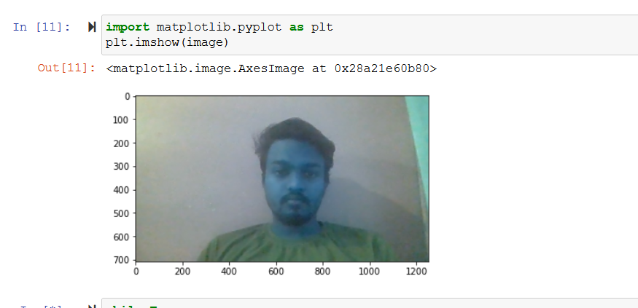To open an image in new window we can do this-

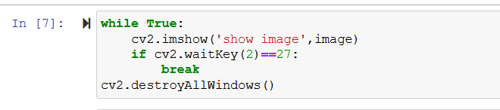

I going to detect face from an image using face detection algorithm.

* There are four stages of face detection of algorithm,they are---
* features selection
* Integral image
* AdaBoosts
* Cascading classifiers

We use a XML file which helps to detect face from any image or video.

This code returns a, b, width, height of the face detected in this image. And can draw a rectangle around the face present in the image.

* We will iterate over the array returned by detectMultiScale method and then put a, b, c, d in cv2.rectangle, the code is--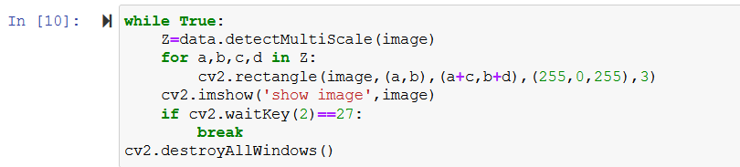

We can detect the face now as seen in the below image-

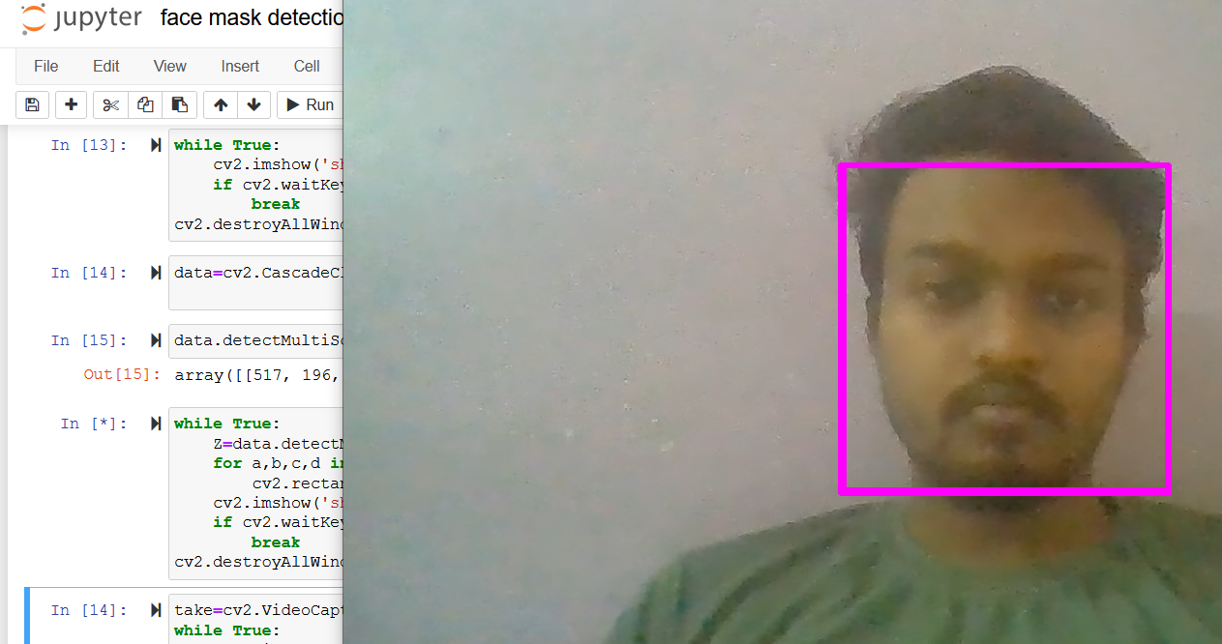

* Now we can start our start face mask detection process.

Steps of this are---

**Step1:**Collect face data with and without mask with the help of camera.

**Step2:**Train the data using SVM machine learning Algorithm.

**Step3:**we can do prediction on live data using our own Camera.

* We need a lot of data in the form images of a person wearing a mask and not wearing a mask to implement this detection.
* So we need to collect data and I am going to collect data using my own camera two time one without mask and the other one with mask. The complete code to perform face detection using camera and storing face data is below -----

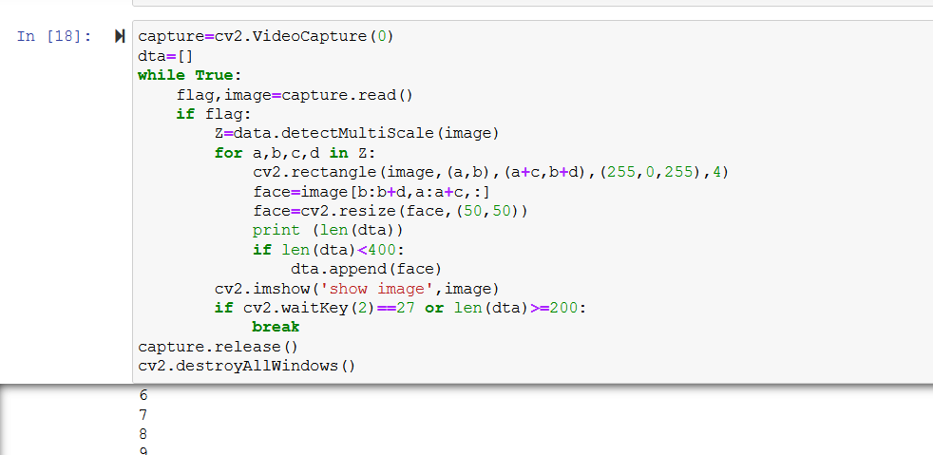

* Collecting data without mask –

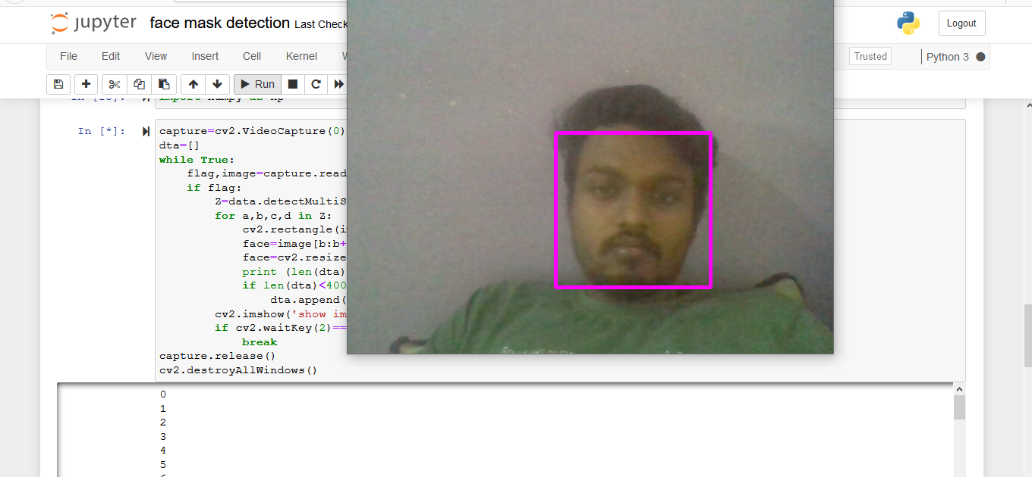

* Collecting data with mask—

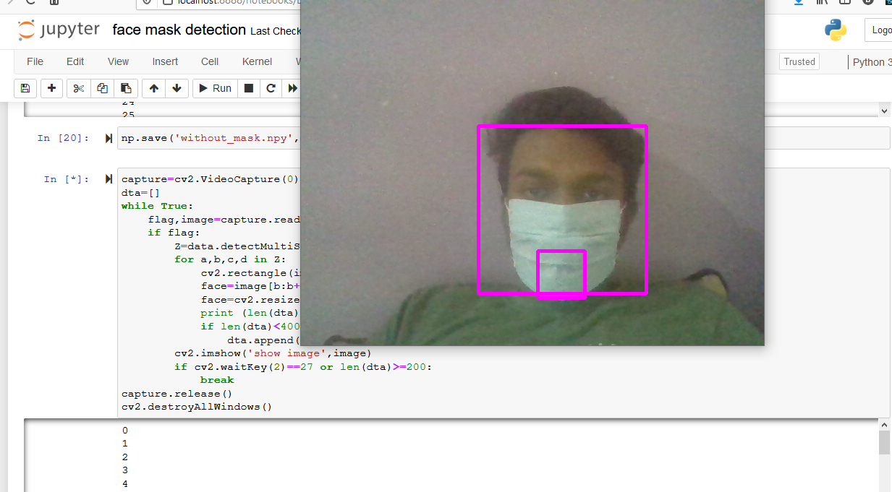

* And then we save the data in two files one with name without mask and one with name with mask so that we can perform our machine learning on it .
* We are ready with our data and now we will train our data by using SVM(Support Vector Machine Algorithm), we load the data and start to apply machine learning on it :

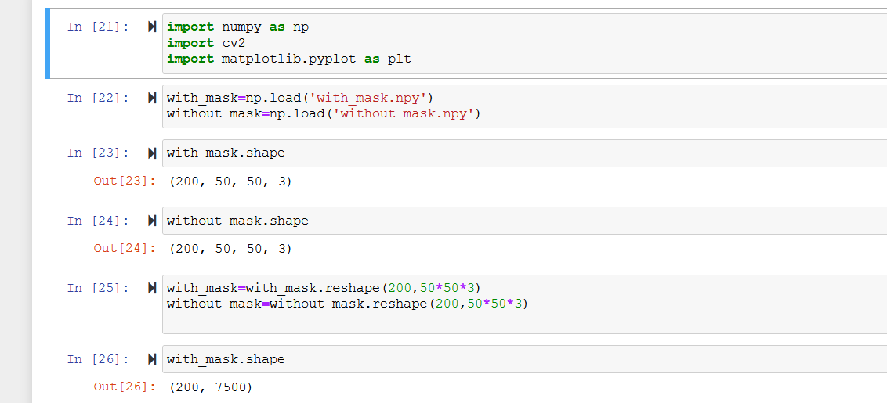

We split the our data into training set and test set with test size equal to 0.26.And apply SVM classifier to predict and detect mask on our face.

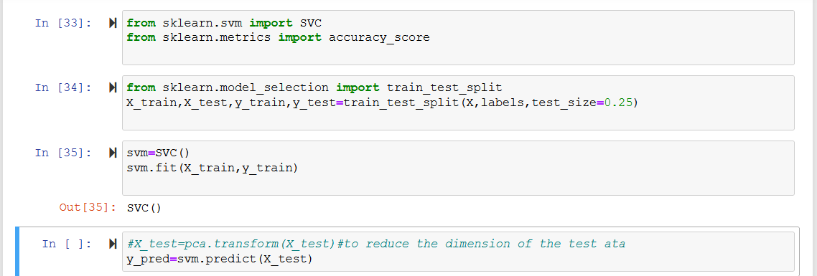

* We can test that whether this algorithm is able to detect a person is wearing a mask or not .

Face without Mask—

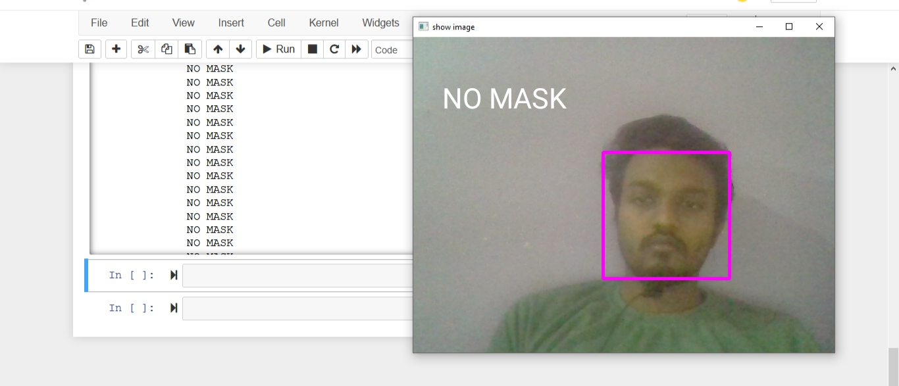

Face with Mask—

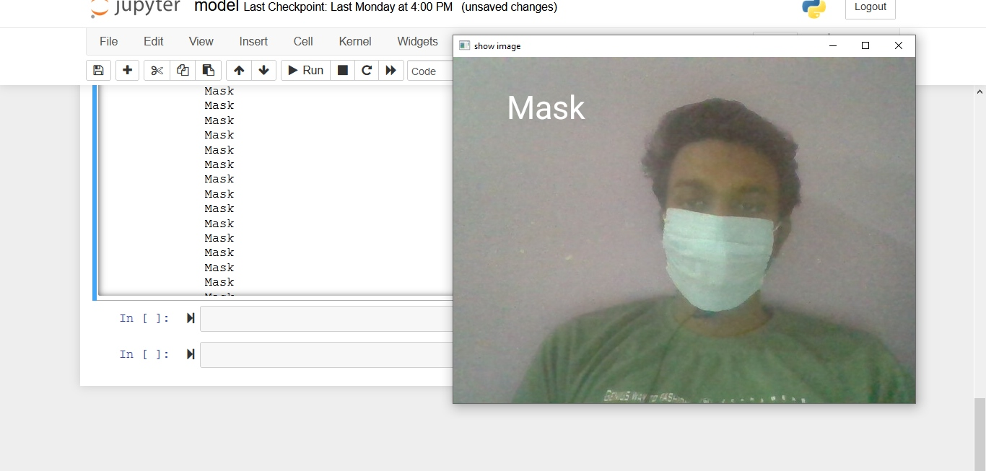

**Results and Discussion---------**

After providing the data to the machine learning model we are able to detect whether a person is wearing a Face mask or not with the help of OpenCV and SVM with an accuracy of 97-98%. When I was training the data on the training data set it was performing suitably well also it was performing quite well on the test data thus we can say that this model is neither overfitted nor underfitted. We can also increase the accuracy of this model further by hyperparameter tuning techniques. We can also use any other alternative approach to build this model like- least squares support vector machine(LS-SVM). This model can be used in various public places ,offices, banks etc for face mask detection at the entry.

**Conclusion--------**

To alleviate the spread of COVID-19 pandemic, strict measures must be taken. I have implemented a face mask detector using OpenCV and Support Vector Machine learning algorithm. I have collected two types of data/image first one was after wearing mask and other one was without wearing any mask .Then we performed our machine learning algorithm (SVM ) to detect face mask. This face mask detector can be installed in many public places like shopping malls, airports and other heavy traffic places to monitor the public and to avoid the spread of the Corona Virus .

**------------------------------ THE END ---------------------------**