DESKTOP OPERATIONS GUIDE
MUDPRO+ User Manual
Pad setup se daily report generation tak step-by-step guide
Version 1.0 | July 2026 | Windows Desktop
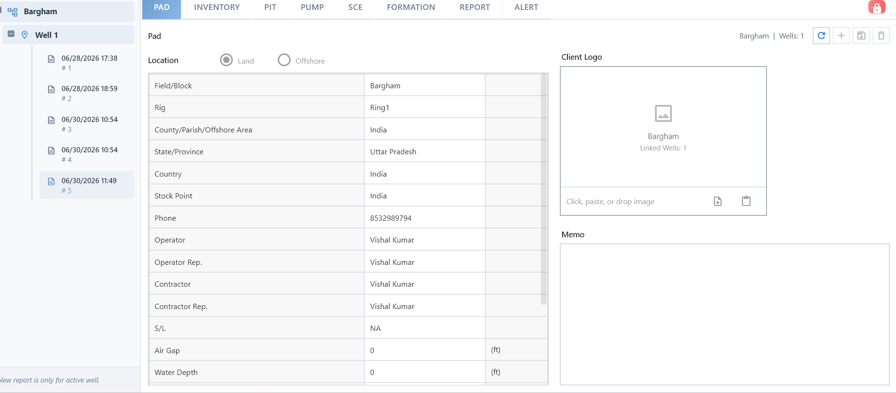
MUDPRO+ main workspace: Pad/Well/Report tree aur configuration tabs.
Manual language: Software labels English me hain; instructions simple Hinglish me diye gaye hain.

Contents
- 1. Manual ka purpose aur workflow
- 2. Interface aur common controls
- 3. First-time Company Setup
- 4. Pad, Well aur Report banana
- 5. Report - Well tab
- 6. Report - Mud tab
- 7. Report - Pump tab
- 8. Report - Operation tab
- 9. Report - Pit tab aur balancing
- 10. Report - Remarks tab
- 11. Save, Lock, Calculate aur Report Generation
- 12. Report Manager, Recap aur Utility
- 13. Common issues aur troubleshooting
- 14. Daily operator checklist
Screen colors: Blue section header hai, light-blue column header hai, pale-yellow editable/value area hai, aur gray/white read-only ya calculated area ho sakta hai. Lock state ke hisab se appearance change ho sakti hai.

1. Manual ka purpose aur workflow
Ye manual mud engineer, drilling engineer, operator aur reporting team ko MUDPRO+ me master data setup, daily data entry, calculations, pit reconciliation aur report tools use karne me help karta hai.

Recommended end-to-end sequence
- Mud Company Setup complete karein.
- Pad details enter karke save karein.
- Well banayein aur Well/Casing/Interval/Plan/Survey setup karein.
- New Report create karein.
- Report tabs ko sequence me complete karein: Well -> Mud -> Pump -> Operation -> Pit -> Remarks.
- Pit differences aur Storage measured values verify karein.
- Save, Calculate aur Lock karein; phir next report generate karein.
Important: Report aur operation calculations data-dependent hain. Empty mandatory setup, wrong units, ya unsaved edits calculation ko affect kar sakte hain.

2. Interface aur common controls

Figure 1. Home workspace me selected Pad, Well, reports aur configuration tabs.

Primary navigation
Tab | Use
Home | Pad, Well, Inventory, Pit, Pump, SCE, Formation, Report aur Alert configuration.
Report | Report Manager, Well Comparison, Recap aur Cost of Pad.
Utility | Engineering Tools aur Unit Conversion.
Help | User Manual, About, Disclaimer aur Abbreviation.

Top toolbar
Control | Purpose
New Well | Selected and completed Pad ke andar new Well banata hai.
Open Folder | Saved/exported files location open karta hai.
Save | Current active section ka latest data save karta hai.
Save As | Current data ki separate copy/export flow ke liye.
Carry-over Pad | Pad-level carry-over action.
New Report | Selected Well ke liye next report create karta hai.
Carry-over | Previous report data ko selected report me carry forward karta hai.
Lock / Unlock | Report editing enable/disable karta hai.
Calculate | Current tab ke calculation/save workflow ko execute karta hai.
Options | Units aur application options.
Mud Company | Company master-data setup open karta hai.
Upload / Batch Upload | Supported data upload workflows.

Selection rule: Report, Utility aur kuch toolbar actions tabhi active hote hain jab valid Pad, Well aur Report selected ho.

3. First-time Company Setup
Home toolbar me Mud Company icon se Company Setup open karein. Engineers, Product, Services, Operator aur Others sections master data define karte hain. Ye data baad me dropdowns aur operation screens me use hota hai.
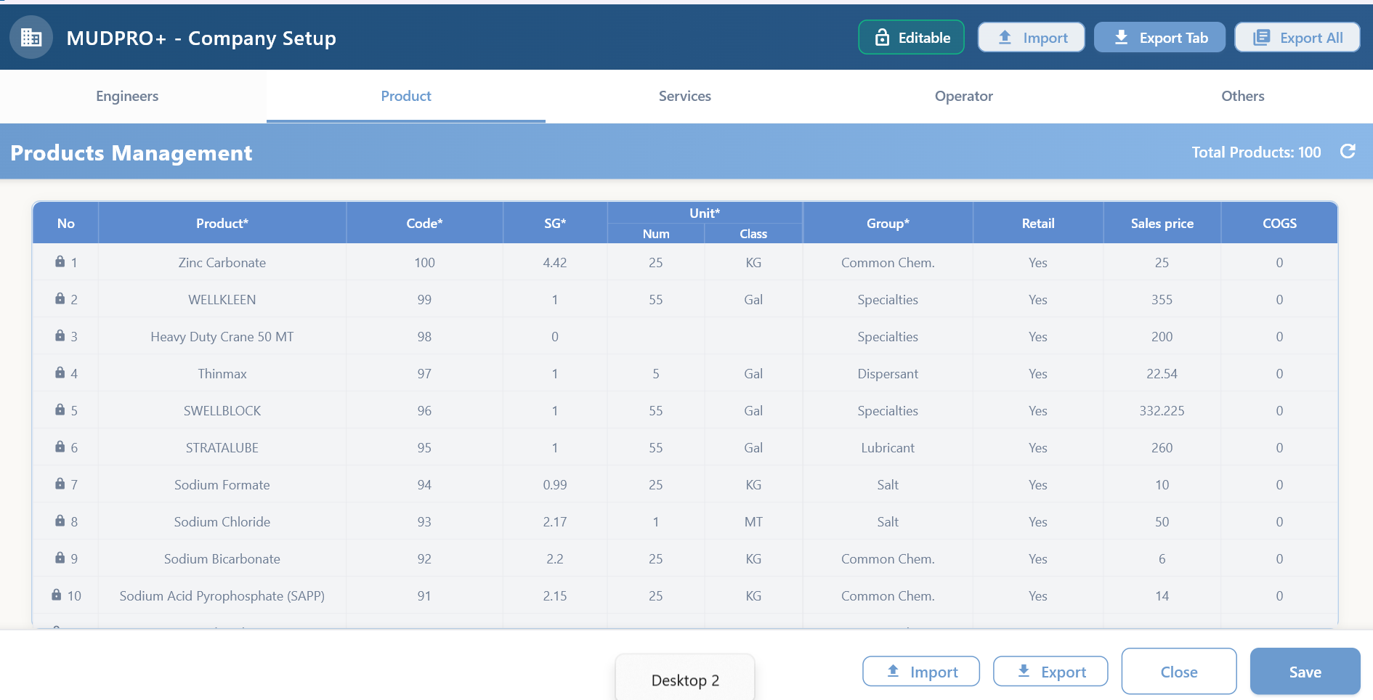
Figure 2. Product master: Product, Code, SG, Unit, Group aur pricing fields.

3.1 Products
Step 1: Editable mode open karein
Top-right Editable control use karein.
Step 2: Product data enter karein
Product name, unique Code, SG, unit quantity/class, Group aur price values fill karein.
Step 3: Save karein
Bottom Save button ya available global save flow use karein.
Step 4: Verify karein
Product list alphabetic order me visible honi chahiye aur report operations ke dropdown me available honi chahiye.
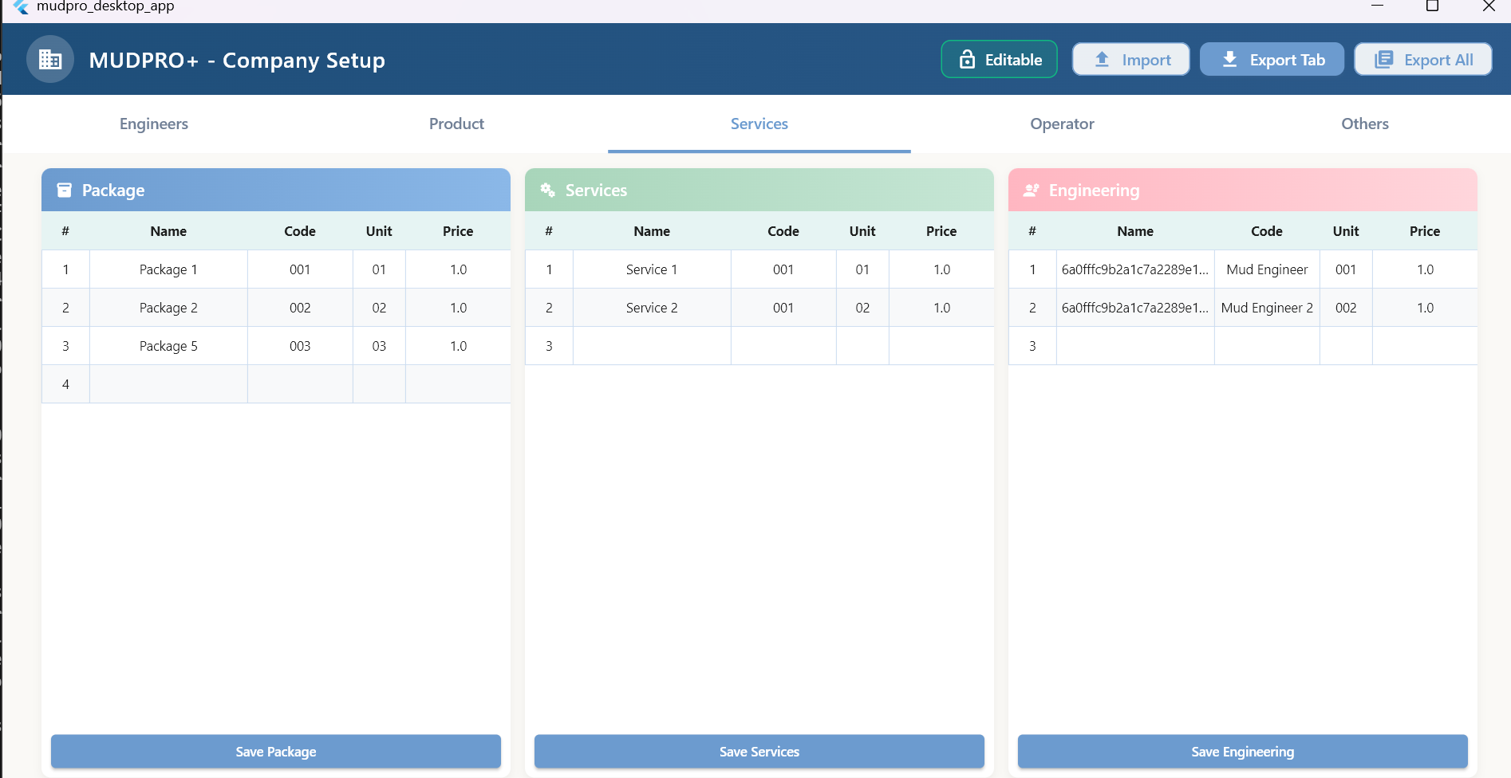
Figure 3. Package, Services aur Engineering master sections.

3.2 Services and Engineering
- Package me Name, Code, Unit aur Price define karein.
- Services aur Engineering items ko unke relevant section me enter karein.
- Existing row par right-click karke available edit/delete actions use karein.
- Delete action successful hone par item database aur UI dono se remove hona chahiye.

3.3 Engineers, Operators and Others
- Engineer/operator names aur contact details clean, unique format me rakhein.
- Units, activities, mud types aur supporting lookup values ko Others me maintain karein.
- Master data change ke baad affected report dropdown ko refresh/reopen karein.

4. Pad, Well aur Report banana

4.1 Pad setup

Figure 4. Pad tab, left report tree aur top-level setup tabs.
Step 1: Pad select/create karein
Left tree me Pad select karein. Required details complete kiye bina Well creation enabled nahi hoga.
Step 2: Location choose karein
Land ya Offshore select karein.
Step 3: Pad fields fill karein
Field/Block, Rig, location, stock point, phone, operator, contractor aur representative fields enter karein.
Step 4: Logo and Memo
Optional client logo aur memo add karein.
Step 5: Global Save
Top toolbar Save se Pad data save karein.
Pad tabs: PAD, INVENTORY, PIT, PUMP, SCE, FORMATION, REPORT aur ALERT configuration Pad/Well context ke liye use hote hain.

4.2 Well setup
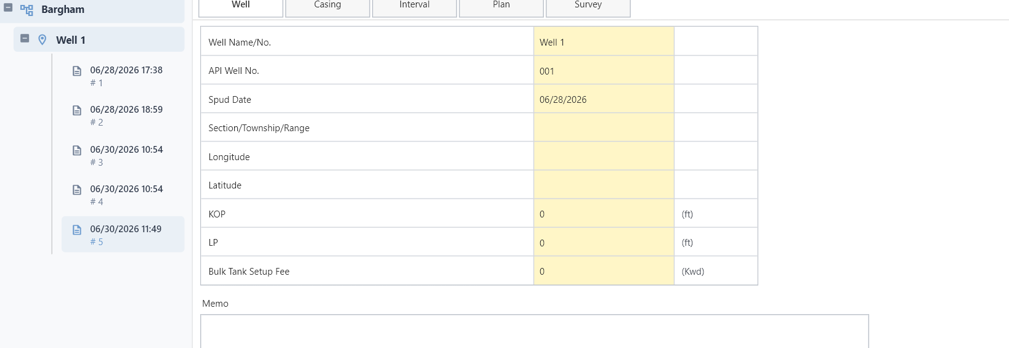
Figure 5. Well setup tabs: Well, Casing, Interval, Plan aur Survey.
Step 1: New Well click karein
Completed Pad selected hone par toolbar ka New Well button active hota hai.
Step 2: Basic fields enter karein
Well Name, API Well No. aur Spud Date fill karke Create karein.
Step 3: Well tab complete karein
Location/reference values aur units verify karein.
Step 4: Casing define karein
Description, Type, OD, Weight, ID, Top, Shoe aur Bit data enter karein.
Step 5: Interval/Plan/Survey complete karein
Hole interval, mud plan, depth plan aur survey stations maintain karein.
Persistent setup: Well/Casing/Pit configuration operational master setup hai. Data ko intentional delete action ke bina remove nahi karna chahiye.

4.3 New Report
Step 1: Well select karein
Left tree me active Well select karein.
Step 2: New Report click karein
Toolbar me document icon se next report create karein.
Step 3: Report select karein
Left tree me timestamp/report number wali new report row select karein.
Step 4: Carry-over decide karein
Previous report ka setup/data chahiye to Carry-over use karein; confirmation message dhyan se padhein.

5. Report - Well tab
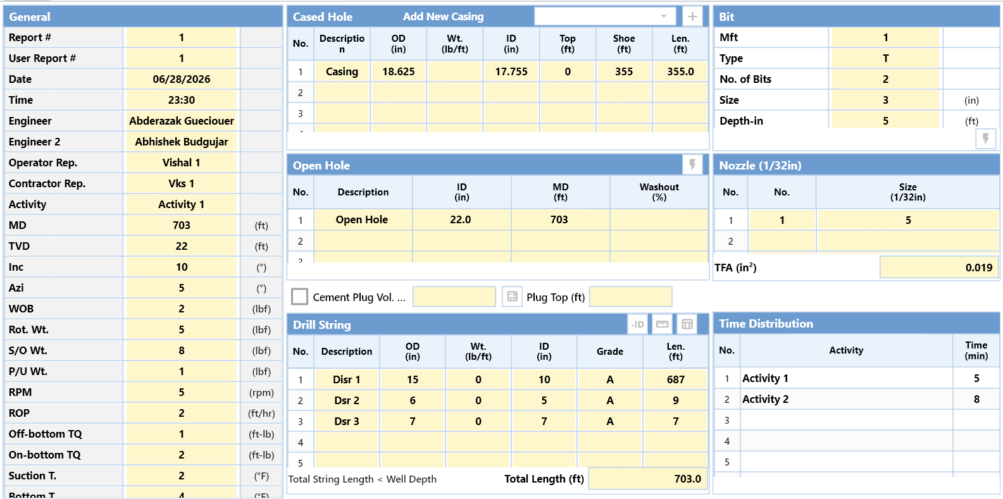
Figure 6. Report Well tab ke main sections.
Well tab daily drilling context define karta hai. Is tab ke values downstream hole volume, hydraulics, pit volume aur report summaries ko affect karte hain.
Section | What to enter / verify
General | Report no., date/time, engineers, representatives, activity, MD/TVD, inclination, drilling parameters aur temperatures.
Cased Hole | Current casing description, OD, ID, top, shoe aur length.
Open Hole | Hole description, ID, MD aur washout percentage.
Bit | Manufacturer/type, bit count, size aur depth-in.
Nozzle | Nozzle count aur size (1/32 in); TFA automatically calculate hota hai.
Drill String | Description, OD, weight, ID, grade aur length. Total Length verify karein.
Time Distribution | Daily activities aur minutes.

Calculation dependency: Hole volume ke liye casing/open-hole geometry, MD aur drill-string OD/ID/length complete hona zaroori hai.
Nozzle: Nozzle row update karne ke baad TFA change verify karein aur report generate karne se pehle Save karein.

6. Report - Mud tab
Mud tab me Mud Properties, Rheology Model, rheology readings, Specific Gravity aur Solids enter kiye jate hain.
Step 1: Mud Properties
Sample details, temperatures, depth, MW, funnel viscosity aur relevant chemical/physical properties enter karein.
Step 2: Rheology Model select karein
Available model, jaise Bingham, select karein.
Step 3: Rheology readings
600/300/200/100/6/3 RPM readings aur calculated PV/YP verify karein.
Step 4: Specific Gravity and Solids
Oil/HGS/LGS aur shale/bentonite CEC values enter karein.
Step 5: Save and review
Units aur decimal format verify karke Save karein.
Unit caution: Mud weight, viscosity aur concentration units Options me configured units se match hone chahiye.

7. Report - Pump tab
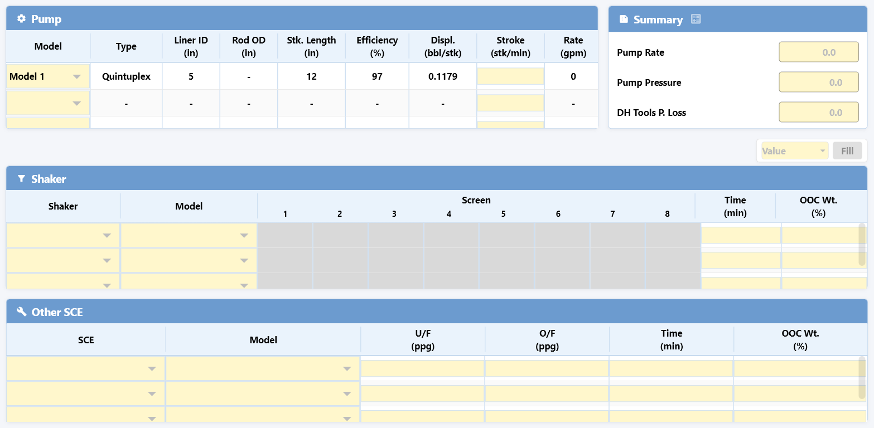
Figure 7. Pump, Summary, Shaker aur Other SCE sections.
Section | Use
Pump | Model/type, liner ID, rod OD, stroke length, efficiency, displacement, stroke rate aur flow rate.
Summary | Pump Rate, Pump Pressure aur Downhole Tools Pressure Loss.
Shaker | Shaker/model, screen values, operating time aur OOC weight.
Other SCE | Other solids-control equipment, model, U/F, O/F, time aur OOC weight.

Step 1: Configured equipment choose karein
Pad PUMP/SCE setup me available equipment dropdown se select karein.
Step 2: Operating inputs enter karein
Stroke, screen, flow aur time values fill karein.
Step 3: Calculated outputs verify karein
Displacement/rate/summary values expected range me hone chahiye.
Step 4: Save karein
Pump tab leave karne ya report generate karne se pehle save complete hone dein.

8. Report - Operation tab
Operation tab daily material aur mud movements record karta hai. Left operation menu me row select karke operation choose karein. Har operation apna independent data rakhta hai; unrelated operation values merge nahi honi chahiye.
Operation | Purpose
Consume Services | Package, service aur engineering usage record.
Consume Product | Inventory product usage, cost aur volume addition.
Receive Product | Product/package inventory receive karna.
Return Product | Product/package inventory return karna.
Transfer Mud | Pits/systems ke beech mud transfer.
Receive Mud | BOL ke against premixed mud receive karna.
Return / Lost Mud | Returned ya lost mud transaction.
Add Water | Selected system me water volume add karna.
Switch Pit | Active/storage pit status switch.
Switch Mud Type | Active pits/storage displacement workflow.
Empty Active System | Active system dump ya storage transfer.
Other Vol. Addition - Active System | Other volume addition to active system.
Mud Loss - Active System | Active system mud loss.
Mud Loss - Storage | Storage mud loss.

8.1 Consume Product
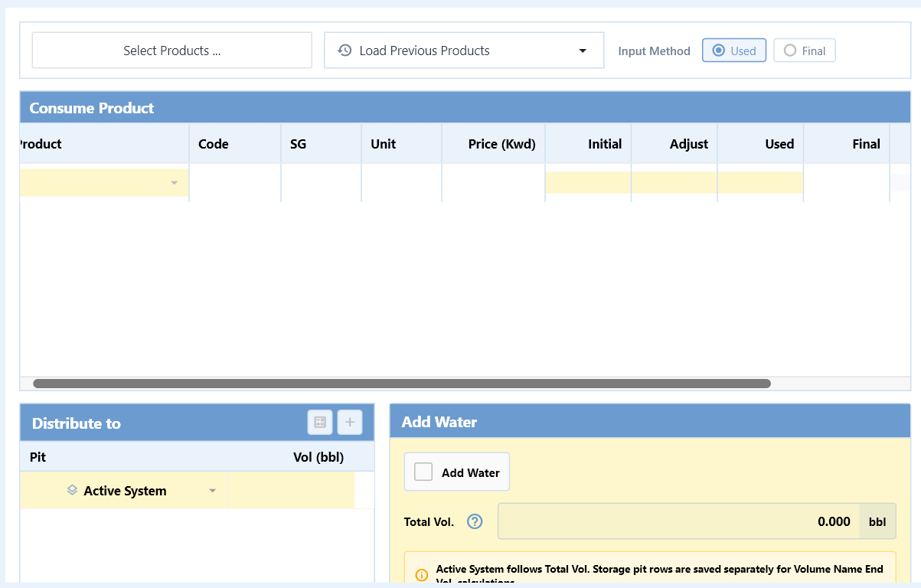
Figure 8. Consume Product table, distribution aur Add Water controls.
Step 1: Select Products
Inventory list se one or more products choose karein.
Step 2: Input Method
Used ya Final method select karein.
Step 3: Usage enter karein
Initial, Adjust aur Used/Final values fill karein; Cost aur Vol (bbl) verify karein.
Step 4: Distribution
Active System ya selected pit ko calculated volume distribute karein.
Step 5: Save
Operation tab ke save/calculate flow se product rows aur distribution save karein.
Carry forward: Previous report ka Final, same product select karne par next report ka Initial banta hai.

8.2 Receive and Return Product
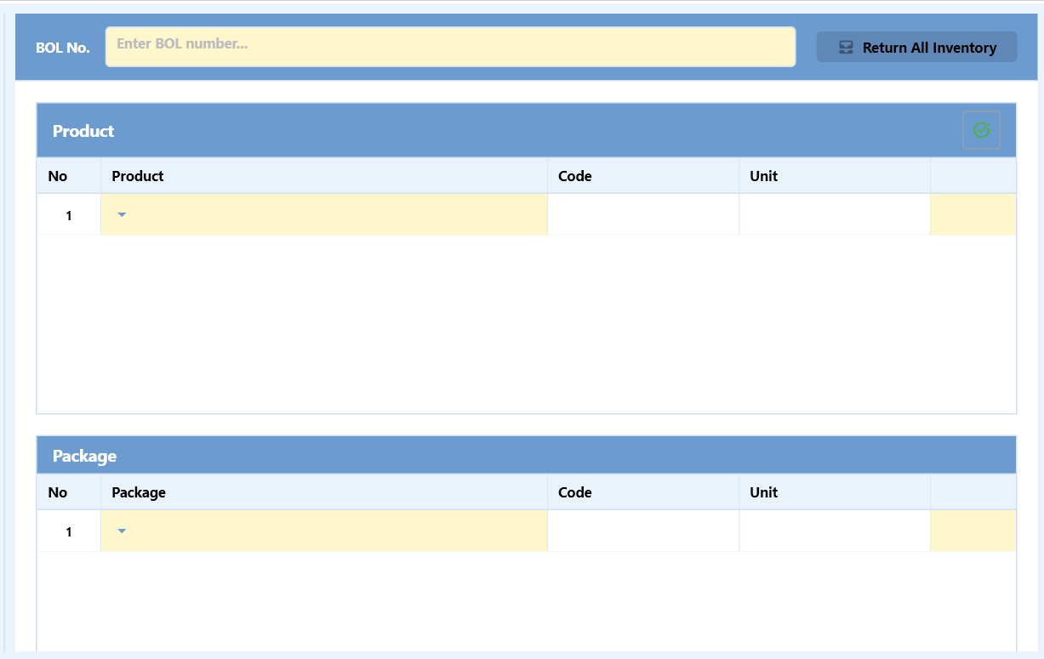
Figure 9. Return Product me BOL, Product aur Package sections.
- BOL number enter karein.
- Product/Package select karke quantity/unit details complete karein.
- Return All Inventory sirf intentional full-return case me use karein.
- Save ke baad inventory balance verify karein.

8.3 Return / Lost Mud
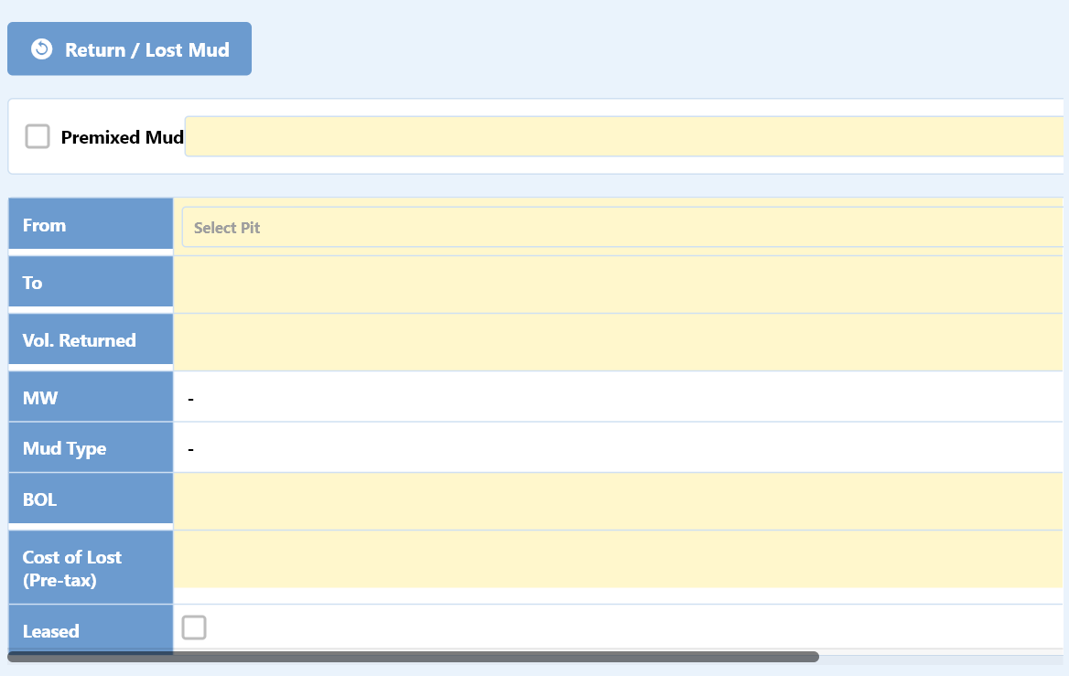
Figure 10. Return/Lost Mud fields.
- Premixed Mud applicable ho to checkbox aur source select karein.
- From, To, returned/lost volume, MW, Mud Type, BOL aur cost values enter karein.
- Leased status applicable ho to checkbox use karein.

9. Report - Pit tab aur balancing
Pit tab physical pit measurements ko calculated report volume se reconcile karta hai. Is tab ko report closeout se pehle zaroor verify karein.
Section | Use
Active Pits | Pit-wise measured volume, MW aur mud selection.
Storage | Calculated volume aur measured volume comparison.
Volume Name | Hole, Active Pits, Active System, End Vol. aur pending difference.
Haul Off | Loads, volume, weight, oil/water/solids aur OOC weight.
Pit Snapshot | Hole volume, pit distribution aur concentration snapshot.

9.1 Core relationships
Active System: Hole + Active Pits = Active System.
Pending difference: End Vol. - Active System batata hai ki pit adjustment abhi pending hai.
Target: Pit adjustment ke baad End Vol. aur Active System equal hone chahiye; pending difference 0 hona chahiye.

9.2 Positive and negative adjustment
- Positive pending: required amount kisi active pit me add karein.
- Negative pending: required amount kisi active pit se reduce karein.
- Pit capacity se zyada measured volume enter nahi karein.
- Adjustment current report me hona chahiye; previous report values ko unintentionally modify nahi karein.

9.3 Storage validation
Storage me Calculated Vol aur Measured Vol equal hone par report normal generate hoti hai. Missing/different value par confirmation popup aata hai. Yes se report continue hoti hai; No se generation cancel hoti hai.

9.4 Pit Snapshot
- Hole Volume (bbl) me String, Annulus, Below bit, Hole aur Displacement review karein.
- Displacement drill-string geometry ke OD volume aur ID/internal volume difference se calculate hota hai.
- Active Pits/Storage distribution aur product concentration values verify karein.

10. Report - Remarks tab
Field | Use
Recommended Tour Treatments | Next tour/team ke liye recommended treatment.
Operational Comments | Current operation ki important observations.
Remarks | Report recap/general remarks.
Internal Notes | Internal-only notes; external distribution se pehle review karein.

Step 1: Relevant text enter karein
Clear, factual aur time-specific statements use karein.
Step 2: Attachment
Supported attachment control available ho to evidence/document attach karein.
Step 3: Save
Tab leave karne ya report lock karne se pehle Save karein.

11. Save, Lock, Calculate aur Report Generation

11.1 Save
- Top global Save current active module ke latest edits persist karta hai.
- Cell edit ke turant baad tab switch/report generation na karein jab saving indicator active ho.
- Master setup aur report data alag scopes me save hote hain.

11.2 Lock / Unlock
- Unlock state me editable fields active hote hain.
- Lock state accidental edits prevent karta hai.
- Final review ke baad report lock karein.

11.3 Calculate
- Current tab calculations refresh karta hai.
- Calculated values ko source inputs aur units ke against verify karein.

11.4 New Report generation checklist
- Well geometry and MD/TVD complete.
- Mud and rheology values saved.
- Pump/SCE operating data saved.
- All selected operations saved.
- Pit pending difference zero or intentionally accepted.
- Storage calculated/measured volumes checked.
- Remarks completed.
- Current report saved and locked.
Do not proceed: Red error panel, overflow warning, missing mandatory selection ya failed save message visible ho to report generation se pehle issue resolve karein.

12. Report Manager, Recap aur Utility
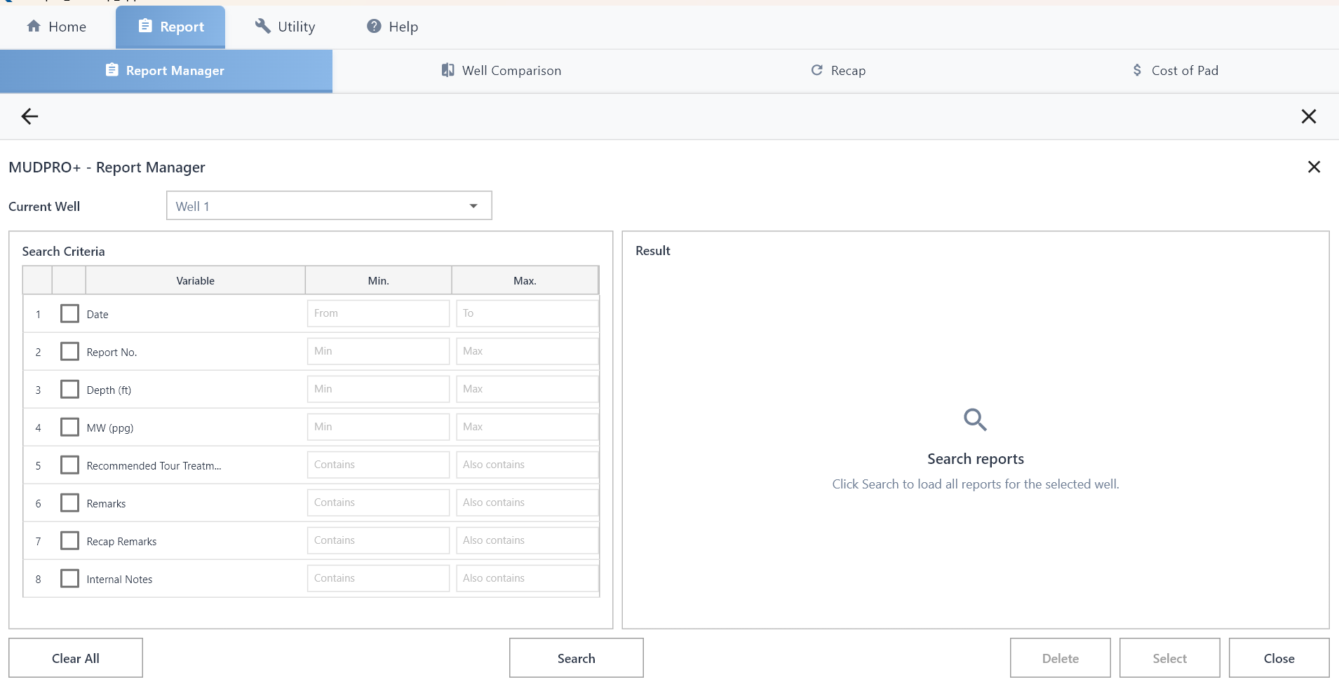
Figure 11. Report Manager search criteria aur result area.

12.1 Report Manager
Step 1: Current Well choose karein
Dropdown me required Well select karein.
Step 2: Criteria enable karein
Date, Report No., Depth, MW ya text filters ke checkbox select karein.
Step 3: Search karein
Search button se matching reports load karein.
Step 4: Result action
Required report select/open karein; delete sirf authorized case me.

12.2 Other Report tools
- Well Comparison: selected wells/reports ka comparison.
- Recap: report data ka summarized analytical view.
- Cost of Pad: Pad-level cost view.

12.3 Utility
- Engineering Tools: hydraulics/rheology related calculations.
- Unit Conversion: source value/unit se target unit conversion.
Engineering review: Software calculation engineering judgment ka replacement nahi hai. Input quality, selected model aur unit system verify karna user ki responsibility hai.

13. Common issues aur troubleshooting
Issue | Check / action
Report tabs disabled | Pad, Well aur Report selection complete karein.
Dropdown empty | Company Setup/Inventory master data save hua hai ya nahi check karein; refresh/reopen karein.
Old value reload ho rahi hai | Current report selected hai ya nahi verify karein; field edit ke baad Save complete hone dein.
Calculation zero | Required geometry, unit, depth, volume aur selection inputs missing ho sakte hain.
Pit difference non-zero | Active Pits ko positive/negative pending amount ke according adjust karein.
Measured Vol popup | Storage calculated vs measured volumes compare karein; intentional mismatch ho tabhi Yes choose karein.
Data load nahi ho raha | Network, backend/API availability aur selected Well/Report context check karein.
Red error screen | Current action stop karein, screenshot/error text capture karein aur support ko report karein.
Text/controls clipped | Window maximize karein; supported display scaling/resolution use karein.

Support ko kya dena hai
- Pad name, Well name aur Report number.
- Exact tab/section/operation name.
- Expected result aur actual result.
- Full screenshot including error message.
- Issue reproduce karne ke exact steps.
- Backend/server log ka relevant timestamp, agar available ho.

14. Daily operator checklist
Stage | Verification
Start of shift | Correct Pad, Well aur latest Report selected.
Well | MD/TVD, activity, hole/casing, bit/nozzle, drill string and time distribution updated.
Mud | Properties, rheology, SG and solids updated.
Pump | Pump, shaker and SCE inputs updated.
Operations | All inventory/mud movements recorded and saved.
Pit | Measured volumes updated; pending difference reconciled.
Storage | Calculated and measured volume reviewed.
Remarks | Operational comments, remarks and internal notes completed.
Closeout | Save -> Calculate -> Review -> Lock.
Next report | New Report/carry-over action only after current report closeout.

Final rule: Report generate karne se pehle data completeness, units, pit balance aur save status ko ek baar visually verify karein.

End of MUDPRO+ User Manual

