DESKTOP OPERATIONS GUIDE
MUDPRO+ User Manual
A step-by-step guide from pad setup to daily report generation
Version 1.0 | July 2026 | Windows Desktop
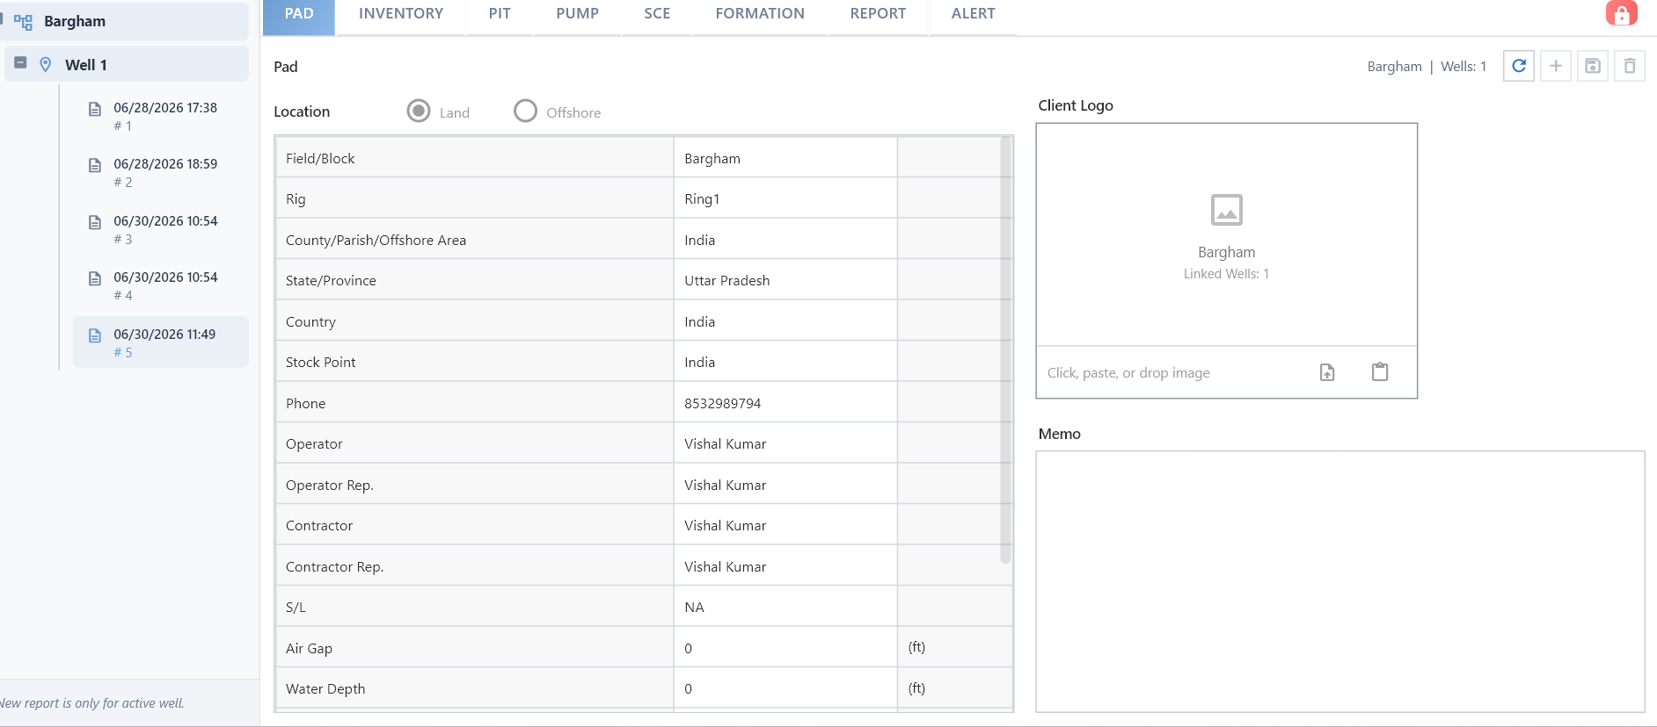
MUDPRO+ main workspace: Pad/Well/Report tree and configuration tabs.
Manual language: Software labels and all instructions in this manual are in English.

Contents
- 1. Purpose and workflow
- 2. Interface and common controls
- 3. First-time Company Setup
- 4. Create a Pad, Well, and Report
- 5. Report - Well tab
- 6. Report - Mud tab
- 7. Report - Pump tab
- 8. Report - Operation tab
- 9. Report - Pit tab and balancing
- 10. Report - Remarks tab
- 11. Save, Lock, Calculate, and Report Generation
- 12. Report Manager, Recap, and Utility
- 13. Common issues and troubleshooting
- 14. Daily operator checklist
Screen colors: Blue indicates a section header, light blue indicates a column header, pale yellow indicates an editable or value area, and gray or white may indicate a read-only or calculated area. The appearance may change according to the lock state.

1. Purpose and workflow
This manual helps mud engineers, drilling engineers, operators, and reporting teams use MUDPRO+ for master-data setup, daily data entry, calculations, pit reconciliation, and reporting tools.

Recommended end-to-end sequence
- Complete Mud Company Setup.
- Enter and save the Pad details.
- Create a Well and complete the Well, Casing, Interval, Plan, and Survey setup.
- Create a New Report.
- Complete the Report tabs in sequence: Well -> Mud -> Pump -> Operation -> Pit -> Remarks.
- Verify pit differences and Storage measured values.
- Save, Calculate, and Lock the report, then generate the next report.
Important: Report and operation calculations depend on the entered data. Missing mandatory setup, incorrect units, or unsaved edits may affect the calculations.

2. Interface and common controls

Figure 1. Home workspace showing the selected Pad, Well, reports, and configuration tabs.

Primary navigation
Tab | Use
Home | Configures Pad, Well, Inventory, Pit, Pump, SCE, Formation, Report, and Alert.
Report | Provides Report Manager, Well Comparison, Recap, and Cost of Pad.
Utility | Provides Engineering Tools and Unit Conversion.
Help | Provides User Manual, About, Disclaimer, and Abbreviation.

Top toolbar
Control | Purpose
New Well | Creates a new Well inside the selected, completed Pad.
Open Folder | Opens the saved/exported files location.
Save | Saves the latest data in the active section.
Save As | Creates a separate copy or starts an export workflow for the current data.
Carry-over Pad | Pad-level carry-over action.
New Report | Creates the next report for the selected Well.
Carry-over | Carries previous-report data into the selected report.
Lock / Unlock | Enables or disables report editing.
Calculate | Executes the calculation/save workflow for the current tab.
Options | Configures units and application options.
Mud Company | Opens Company master-data setup.
Upload / Batch Upload | Supported data upload workflows.

Selection rule: Report, Utility, and some toolbar actions are active only when a valid Pad, Well, and Report are selected.

3. First-time Company Setup
Open Company Setup from the Mud Company icon on the Home toolbar. The Engineers, Product, Services, Operator, and Others sections define master data that is later used in dropdowns and operation screens.
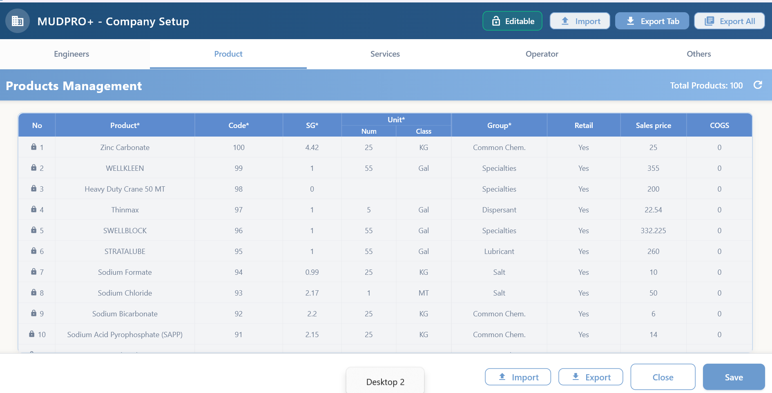
Figure 2. Product master: Product, Code, SG, Unit, Group, and pricing fields.

3.1 Products
Step 1: Enable Editable mode
Use the Editable control at the top right.
Step 2: Enter product data
Enter the product name, unique Code, SG, unit quantity/class, Group, and price values.
Step 3: Save
Use the bottom Save button or the available global save workflow.
Step 4: Verify
The product list should appear in alphabetical order and be available in the report operation dropdowns.
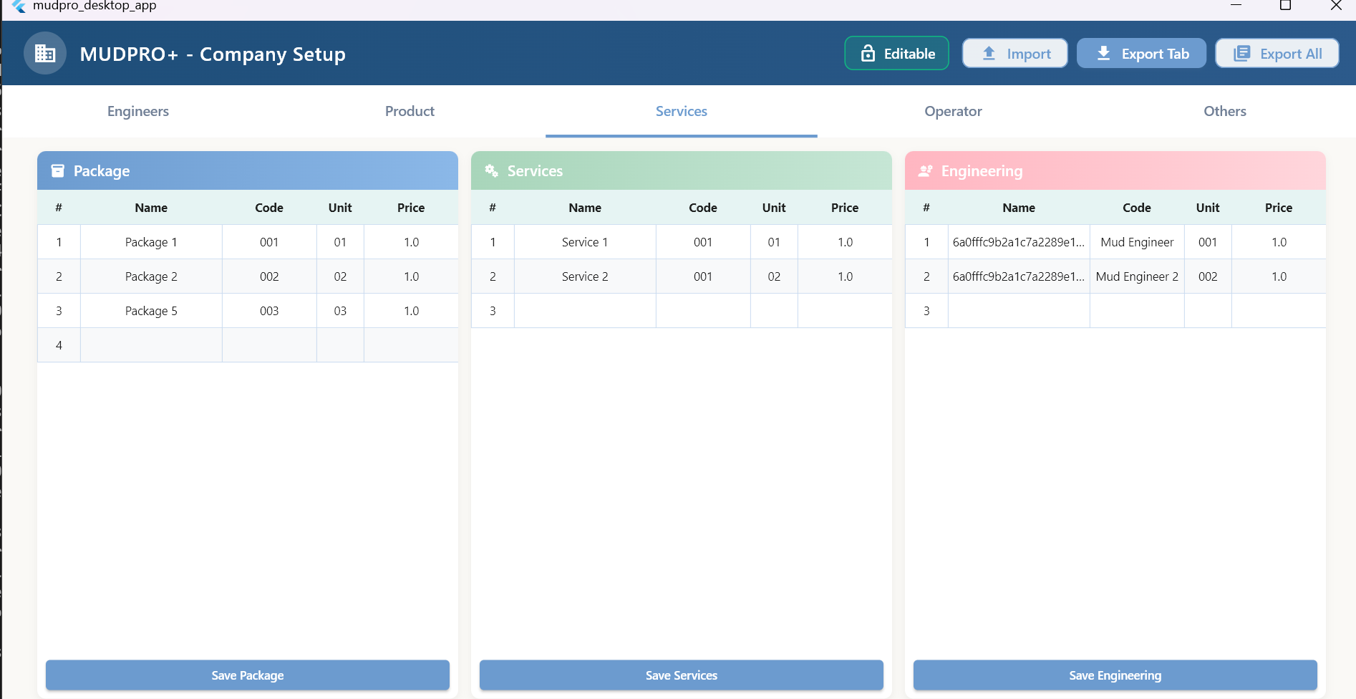
Figure 3. Package, Services, and Engineering master sections.

3.2 Services and Engineering
- Define the Name, Code, Unit, and Price in Package.
- Enter Services and Engineering items in their relevant sections.
- Right-click an existing row to use the available edit or delete actions.
- After a successful delete action, the item should be removed from both the database and the UI.

3.3 Engineers, Operators and Others
- Keep engineer/operator names and contact details in a clean, unique format.
- Maintain units, activities, mud types, and supporting lookup values in Others.
- Refresh or reopen the affected report dropdown after changing master data.

4. Create a Pad, Well, and Report

4.1 Pad setup

Figure 4. Pad tab, report tree on the left, and top-level setup tabs.
Step 1: Select or create a Pad
Select the Pad in the left tree. Well creation remains disabled until the required Pad details are complete.
Step 2: Choose the location
Select Land or Offshore.
Step 3: Complete the Pad fields
Enter the Field/Block, Rig, location, stock point, phone, operator, contractor, and representative fields.
Step 4: Logo and Memo
Optionally add a client logo and memo.
Step 5: Global Save
Save the Pad data using Save on the top toolbar.
Pad tabs: PAD, INVENTORY, PIT, PUMP, SCE, FORMATION, REPORT, and ALERT are used to configure the Pad/Well context.

4.2 Well setup
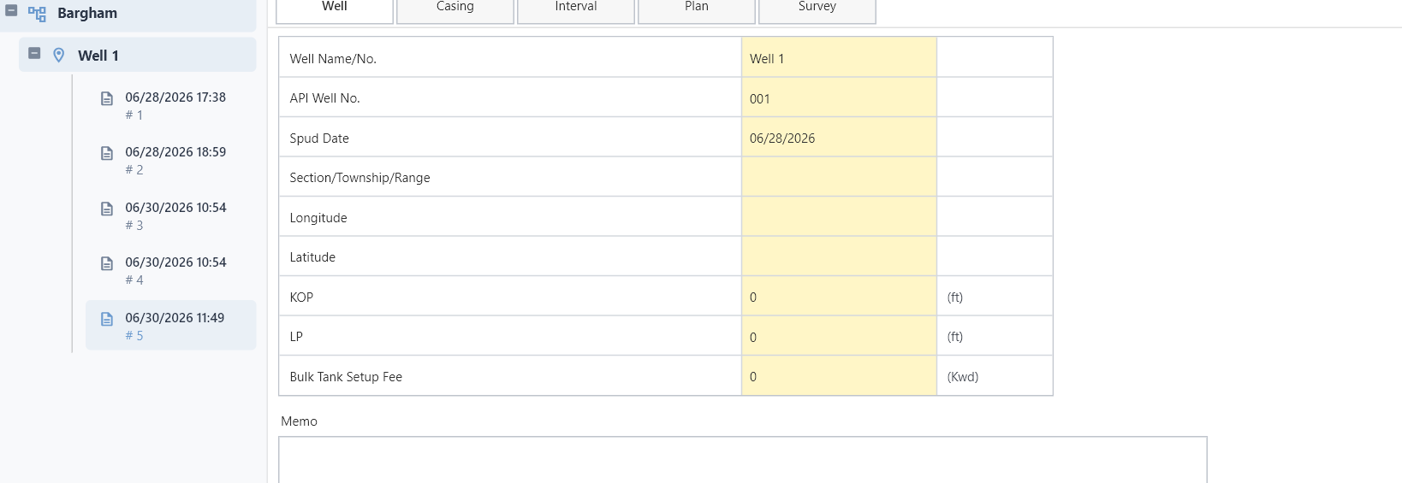
Figure 5. Well setup tabs: Well, Casing, Interval, Plan, and Survey.
Step 1: Click New Well
The New Well toolbar button becomes active when a completed Pad is selected.
Step 2: Enter the basic fields
Enter the Well Name, API Well No., and Spud Date, then click Create.
Step 3: Complete the Well tab
Verify the location/reference values and units.
Step 4: Define the Casing
Enter the Description, Type, OD, Weight, ID, Top, Shoe, and Bit data.
Step 5: Complete Interval, Plan, and Survey
Maintain the hole interval, mud plan, depth plan, and survey stations.
Persistent setup: Well, Casing, and Pit configuration is operational master setup. This data should remain saved until it is intentionally deleted.

4.3 New Report
Step 1: Select the Well
Select the active Well in the left tree.
Step 2: Click New Report
Create the next report using the document icon on the toolbar.
Step 3: Select the Report
Select the new report row with its timestamp/report number in the left tree.
Step 4: Choose whether to carry data over
Use Carry-over when setup or data from the previous report is required. Read the confirmation message carefully.

5. Report - Well tab
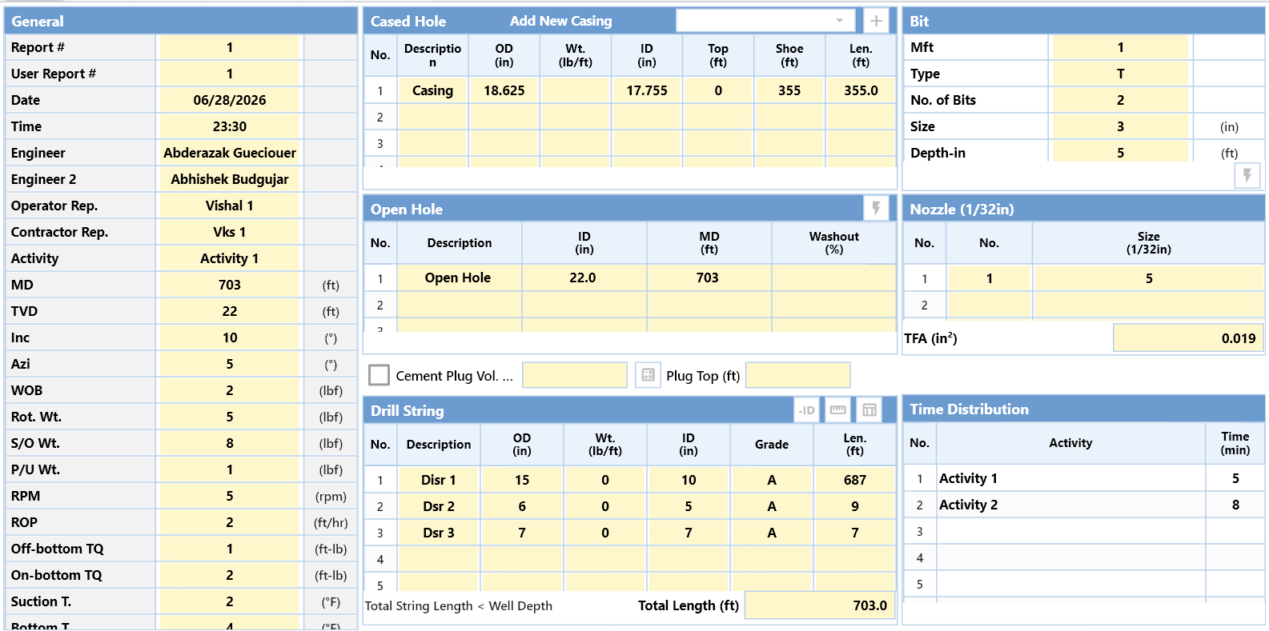
Figure 6. Main sections of the Report Well tab.
The Well tab defines the daily drilling context. Its values affect downstream hole-volume, hydraulics, pit-volume, and report-summary calculations.
Section | What to enter / verify
General | Report number, date/time, engineers, representatives, activity, MD/TVD, inclination, drilling parameters, and temperatures.
Cased Hole | Current casing description, OD, ID, top, shoe, and length.
Open Hole | Hole description, ID, MD, and washout percentage.
Bit | Manufacturer/type, bit count, size, and depth-in.
Nozzle | Nozzle count and size (1/32 in); TFA is calculated automatically.
Drill String | Description, OD, weight, ID, grade, and length. Verify Total Length.
Time Distribution | Daily activities and minutes.

Calculation dependency: Casing/open-hole geometry, MD, and drill-string OD, ID, and length must be complete for hole-volume calculations.
Nozzle: After updating a Nozzle row, verify the TFA change and save before generating the report.

6. Report - Mud tab
Use the Mud tab to enter Mud Properties, the Rheology Model, rheology readings, Specific Gravity, and Solids.
Step 1: Mud Properties
Enter sample details, temperatures, depth, MW, funnel viscosity, and the relevant chemical and physical properties.
Step 2: Select the Rheology Model
Select an available model, such as Bingham.
Step 3: Rheology readings
Enter the 600/300/200/100/6/3 RPM readings and verify the calculated PV/YP.
Step 4: Specific Gravity and Solids
Enter the Oil/HGS/LGS and shale/bentonite CEC values.
Step 5: Save and review
Verify the units and decimal format, then save.
Unit caution: Mud weight, viscosity, and concentration units must match the units configured in Options.

7. Report - Pump tab
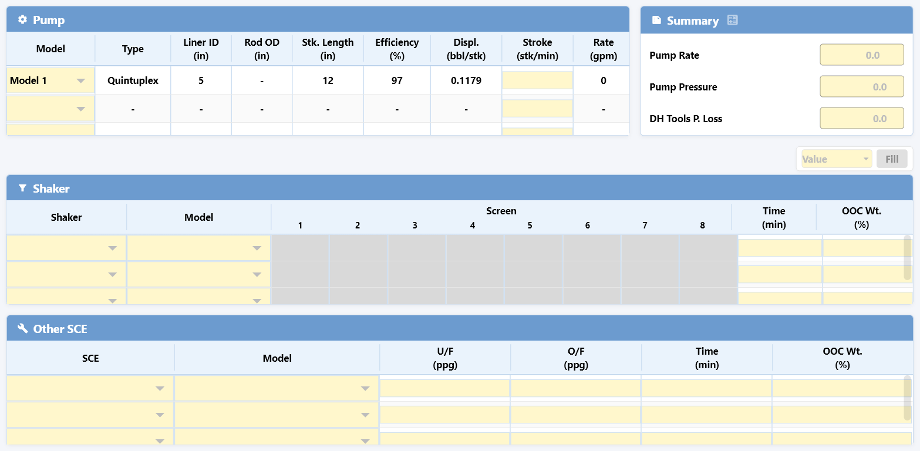
Figure 7. Pump, Summary, Shaker, and Other SCE sections.
Section | Use
Pump | Model/type, liner ID, rod OD, stroke length, efficiency, displacement, stroke rate, and flow rate.
Summary | Pump Rate, Pump Pressure, and Downhole Tools Pressure Loss.
Shaker | Shaker/model, screen values, operating time, and OOC weight.
Other SCE | Other solids-control equipment, model, U/F, O/F, time, and OOC weight.

Step 1: Choose configured equipment
Select the equipment from the dropdown populated by the Pad PUMP/SCE setup.
Step 2: Enter operating inputs
Enter the stroke, screen, flow, and time values.
Step 3: Verify calculated outputs
The displacement, rate, and summary values should be within the expected range.
Step 4: Save
Allow saving to finish before leaving the Pump tab or generating a report.

8. Report - Operation tab
The Operation tab records daily material and mud movements. Select a row in the left operation menu and choose an operation. Each operation stores independent data; values from unrelated operations must not be merged.
Operation | Purpose
Consume Services | Records Package, Service, and Engineering usage.
Consume Product | Records inventory product usage, cost, and volume addition.
Receive Product | Receives Product or Package inventory.
Return Product | Returns Product or Package inventory.
Transfer Mud | Transfers mud between pits or systems.
Receive Mud | Receives premixed mud against a BOL.
Return / Lost Mud | Records a returned or lost mud transaction.
Add Water | Adds water volume to the selected system.
Switch Pit | Active/storage pit status switch.
Switch Mud Type | Active pits/storage displacement workflow.
Empty Active System | Dumps the Active System or transfers it to Storage.
Other Vol. Addition - Active System | Other volume addition to active system.
Mud Loss - Active System | Active system mud loss.
Mud Loss - Storage | Storage mud loss.

8.1 Consume Product
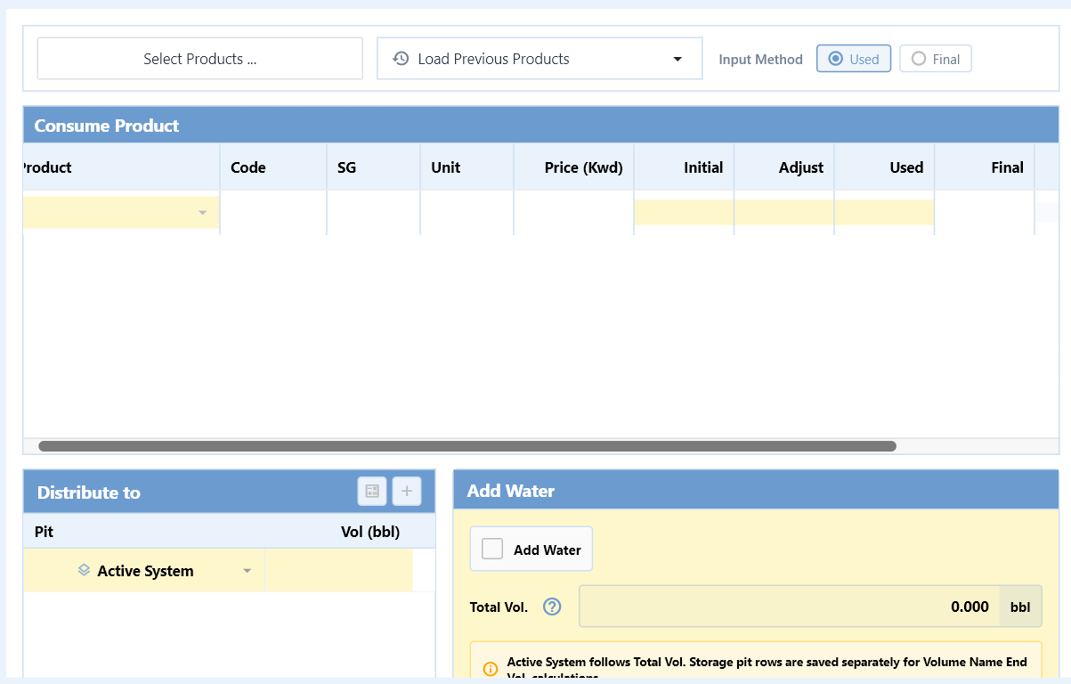
Figure 8. Consume Product table, distribution, and Add Water controls.
Step 1: Select Products
Choose one or more products from the inventory list.
Step 2: Input Method
Select the Used or Final input method.
Step 3: Enter usage
Enter the Initial, Adjust, and Used/Final values, then verify Cost and Vol (bbl).
Step 4: Distribution
Distribute the calculated volume to Active System or the selected pit.
Step 5: Save
Save the product rows and distribution using the Operation tab save/calculate workflow.
Carry forward: For the same selected product, the previous report's Final value becomes the next report's Initial value.

8.2 Receive and Return Product
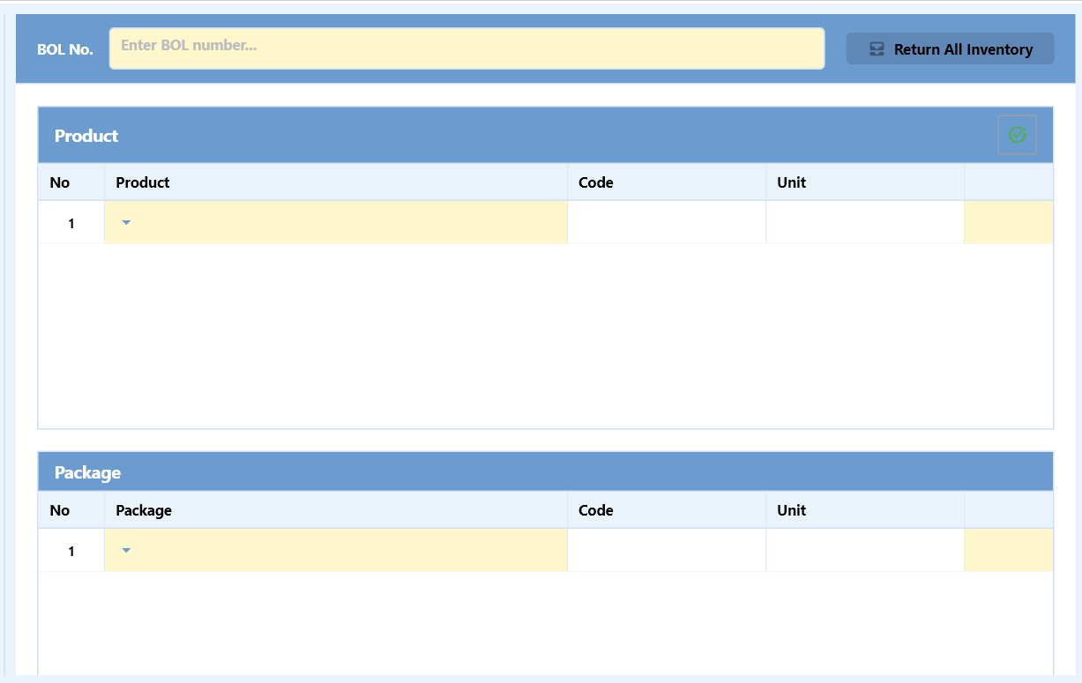
Figure 9. BOL, Product, and Package sections in Return Product.
- Enter the BOL number.
- Select a Product or Package and complete the quantity and unit details.
- Use Return All Inventory only for an intentional full return.
- Verify the inventory balance after saving.

8.3 Return / Lost Mud
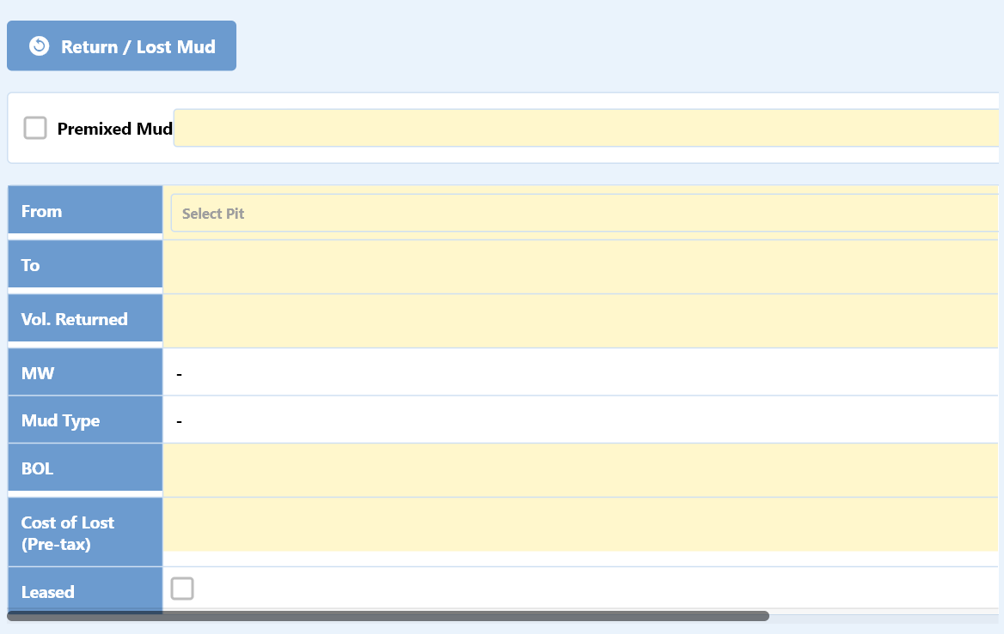
Figure 10. Return/Lost Mud fields.
- If Premixed Mud applies, select the checkbox and source.
- Enter From, To, returned/lost volume, MW, Mud Type, BOL, and cost values.
- Select the checkbox if the Leased status applies.

9. Report - Pit tab and balancing
The Pit tab reconciles physical pit measurements with the calculated report volume. Always verify this tab before report closeout.
Section | Use
Active Pits | Pit-wise measured volume, MW, and mud selection.
Storage | Compares calculated volume and measured volume.
Volume Name | Shows Hole, Active Pits, Active System, End Vol., and pending difference.
Haul Off | Shows loads, volume, weight, oil/water/solids, and OOC weight.
Pit Snapshot | Shows hole volume, pit distribution, and concentration snapshot.

9.1 Core relationships
Active System: Hole + Active Pits = Active System.
Pending difference: End Vol. - Active System shows the pit adjustment that is still pending.
Target: After the pit adjustment, End Vol. and Active System should be equal, and the pending difference should be 0.

9.2 Positive and negative adjustment
- Positive pending amount: add the required amount to an active pit.
- Negative pending amount: reduce an active pit by the required amount.
- Do not enter a measured volume greater than the pit capacity.
- Make the adjustment in the current report; do not unintentionally modify previous-report values.

9.3 Storage validation
When Calculated Vol and Measured Vol are equal in Storage, the report is generated normally. If a value is missing or different, a confirmation dialog appears. Select Yes to continue or No to cancel report generation.

9.4 Pit Snapshot
- In Hole Volume (bbl), review String, Annulus, Below bit, Hole, and Displacement.
- Displacement is calculated from the difference between the drill-string OD volume and ID/internal volume.
- Verify Active Pits/Storage distribution and product concentration values.

10. Report - Remarks tab
Field | Use
Recommended Tour Treatments | Recommended treatment for the next tour or team.
Operational Comments | Important observations for the current operation.
Remarks | Report recap and general remarks.
Internal Notes | Internal-only notes; review them before external distribution.

Step 1: Enter relevant text
Use clear, factual, and time-specific statements.
Step 2: Attachment
Attach evidence or a document when a supported attachment control is available.
Step 3: Save
Save before leaving the tab or locking the report.

11. Save, Lock, Calculate, and Report Generation

11.1 Save
- The top global Save control persists the latest edits in the active module.
- Do not switch tabs or generate a report immediately after editing a cell while the saving indicator is active.
- Master setup and report data are saved in separate scopes.

11.2 Lock / Unlock
- Editable fields are active in the unlocked state.
- The locked state prevents accidental edits.
- Lock the report after the final review.

11.3 Calculate
- Refreshes calculations for the current tab.
- Verify calculated values against the source inputs and units.

11.4 New Report generation checklist
- Well geometry and MD/TVD complete.
- Mud and rheology values saved.
- Pump/SCE operating data saved.
- All selected operations saved.
- Pit pending difference zero or intentionally accepted.
- Storage calculated/measured volumes checked.
- Remarks completed.
- Current report saved and locked.
Do not proceed: If a red error panel, overflow warning, missing mandatory selection, or failed-save message is visible, resolve the issue before generating the report.

12. Report Manager, Recap, and Utility
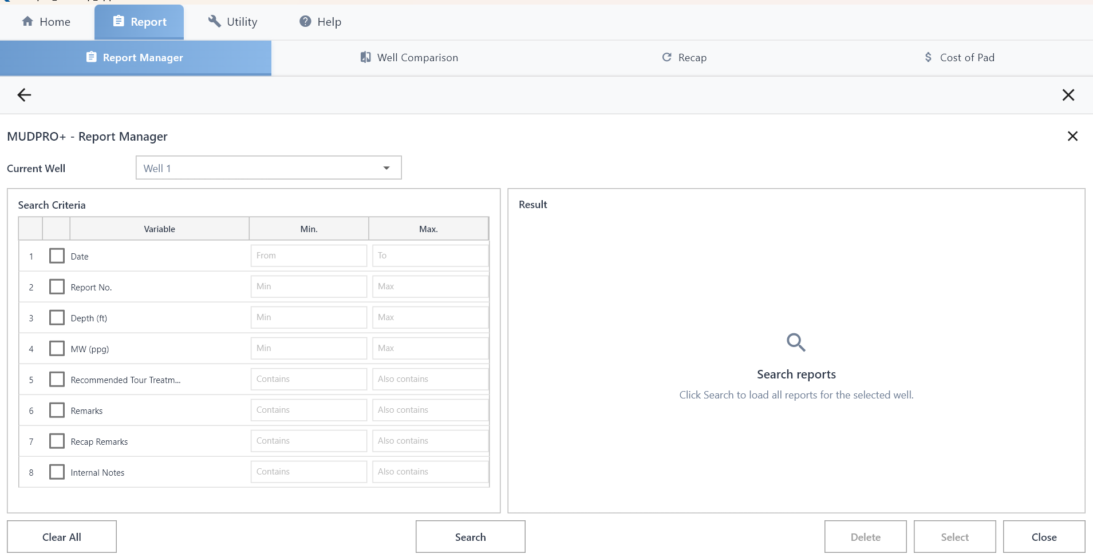
Figure 11. Report Manager search criteria and result area.

12.1 Report Manager
Step 1: Choose the Current Well
Select the required Well from the dropdown.
Step 2: Enable criteria
Select the checkboxes for Date, Report No., Depth, MW, or text filters.
Step 3: Search
Use Search to load matching reports.
Step 4: Result action
Select or open the required report. Delete a report only when authorized.

12.2 Other Report tools
- Well Comparison: compares selected wells and reports.
- Recap: provides a summarized analytical view of report data.
- Cost of Pad: provides a Pad-level cost view.

12.3 Utility
- Engineering Tools: provides hydraulics- and rheology-related calculations.
- Unit Conversion: converts a source value and unit to a target unit.
Engineering review: Software calculations do not replace engineering judgment. The user is responsible for verifying input quality, the selected model, and the unit system.

13. Common issues and troubleshooting
Issue | Check / action
Report tabs disabled | Complete the Pad, Well, and Report selection.
Dropdown empty | Confirm that Company Setup/Inventory master data has been saved, then refresh or reopen the screen.
The old value is being reloaded. | Verify that the current report is selected and allow Save to finish after editing a field.
Calculation zero | Required geometry, unit, depth, volume, or selection inputs may be missing.
Pit difference non-zero | Adjust Active Pits according to the positive or negative pending amount.
Measured Vol popup | Compare Storage calculated and measured volumes. Choose Yes only when the mismatch is intentional.
The data is not loading. | Check the network, backend/API availability, and selected Well/Report context.
Red error screen | Stop the current action, capture the screenshot or error text, and report it to Support.
Text/controls clipped | Maximize the window and use a supported display scaling and resolution.

Information to provide to Support
- Pad name, Well name, and Report number.
- Exact tab, section, or operation name.
- Expected result and actual result.
- Full screenshot including error message.
- Exact steps required to reproduce the issue.
- Relevant backend/server log timestamp, if available.

14. Daily operator checklist
Stage | Verification
Start of shift | Correct Pad, Well, and latest Report selected.
Well | MD/TVD, activity, hole/casing, bit/nozzle, drill string and time distribution updated.
Mud | Properties, rheology, SG and solids updated.
Pump | Pump, shaker and SCE inputs updated.
Operations | All inventory/mud movements recorded and saved.
Pit | Measured volumes updated; pending difference reconciled.
Storage | Calculated and measured volume reviewed.
Remarks | Operational comments, remarks and internal notes completed.
Closeout | Save -> Calculate -> Review -> Lock.
Next report | New Report/carry-over action only after current report closeout.

Final rule: Before generating a report, visually verify data completeness, units, pit balance, and save status.

End of MUDPRO+ User Manual

