**Read Me: Data Download**

artstation.com is a dynamic website which means the content of the web page that is displayed in our web browser is not available in the original HTML. So we need reverse engineering the web page first.

1. Go to <https://www.artstation.com/>
2. Use Option+Command+I to active console
3. Click on Network

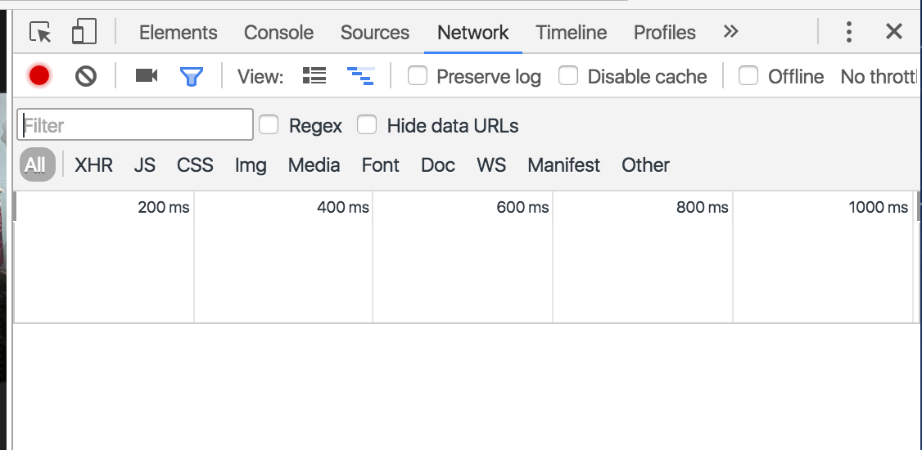

1. Reload the web page, and all requests should appear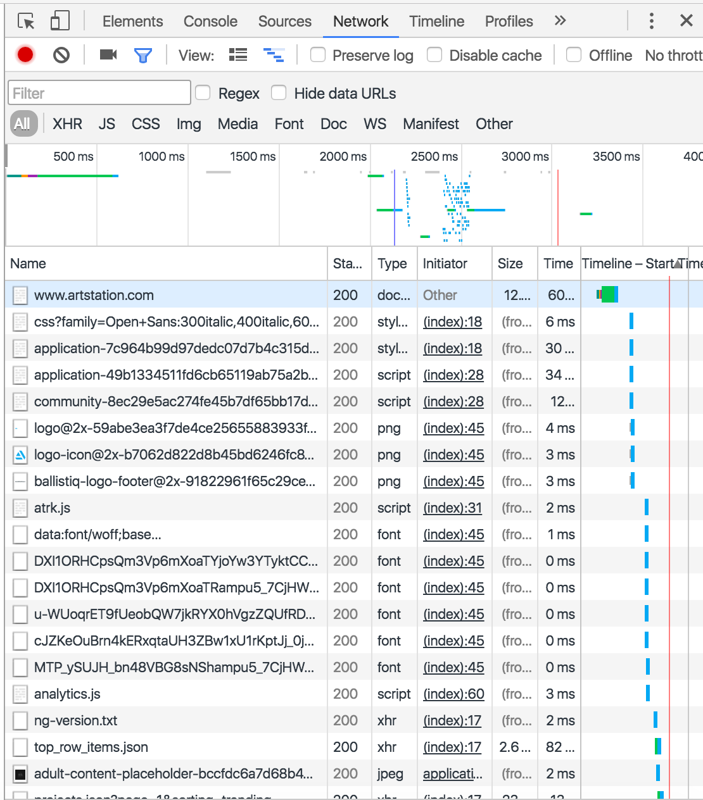
2. Go through the requests and select the one we need for data scripting

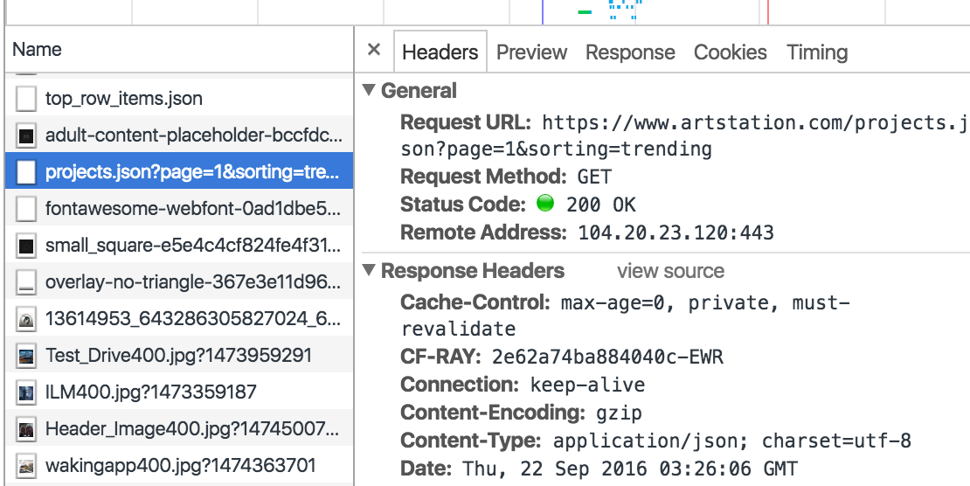

1. Copy the Request URL

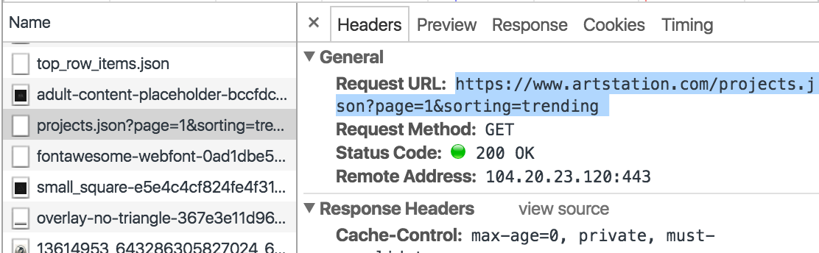

1. The URL can be downloaded directly and returns data in JSON format. The data includes basic information for each artwork on the loaded homepage. Here page=1 means we are going to download data for the first page. We can switch to page=2/3/4…for other pages. And sorting=trending means the artworks are sorted by trending. We can also pick other sorting methods: latest, picks, streams and community
2. We can do the same thing to scrap the data for each artist/artwork:

For artists, for example:

https://www.artstation.com/users/peleng/projects.json?page=1

“peleng” is the artist’s username. It’s tag in the JSON file is “username”

For artwork:

https://www.artstation.com/projects/3mOXE/comments.json

“3mOXE” is the artwork’s name. It’s tag in the JSON file is "hash_id"