Readings from different papers and key points

28.09.2020
Main Paper from TUHH

Main benefits from the modem
- small enough to be carried by micro AUVs
- low energy consumption
- cost below $600
- reliable communication at distances 150m and more
- supports ranging without additional hardware
- “We conducted extensive real-world studies and present results of communication range, packet reception rate, ranging accuracy, and efficient and reliable self-localization.”
- shallow-water sceneries such as coastal and in-shore environmental monitoring and disaster management at depths of normally double digits or at most a few hundred meters.

Acoustic underwater communication and signal propagation
- hydrophone or piezo-electric transducer is used to convert electric signal to acoustic and vice versa
- In contrast to radio communication, propagation delay of acoustic communication is high due to a low speed c of sound (in water) around 1400 m/s to 1550 m/s.
- the actual value of c mainly depends on water temperature, salinity, and pressure
- This also influences -directionality of the transducer (e.g., hydrophone), air
bubbles, different water layers, turbulence, obstacles, and reflections (primarily at the water surface for shallow water communication)
- frequency-shift keying (FSK) and phase-shift keying (PSK).

Underwater Localization
- “Localization can be achieved through multi-lateration of several
ranging measurements between a mobile node and anchors with known position”
- Other methods are not considered much

System Overview
- All coding- and modulation-related functionality is realized in software, leaving a light burden of analog filtering and signal amplification as hardware realizations
- It is even possible to omit the μC and connect the analog part of the modem to an oscilloscope or function generator; e.g., to carry out studies of the acoustic channel
- The presented hardware and software are tailored for the AS-1 hydrophone
- The default frequency band of 50 kHz to 75 kHz (with potential extension to 87.5 kHz) is a compromise of meeting contradicting demands, such as satisfying the Nyquist criterion and real-time signal processing at the same time.
- Early experiments revealed that a combination of different techniques is required to counter the challenges of the shallow-water acoustic channel, as discussed in Section 2.3. In shallow water, multi-path propagation is a severe problem due to heavy reflections at the surface. Particularly at short distances of a few meters, (surface) echos lead to inter-symbol and even intra-symbol
interference, so countermeasures are needed. Remedies are discussed and evaluated subsequently.
- Implemented - orthogonal binary frequency shift keying (BFSK)
- Frequency spacing is 781.25 Hz with a symbol duration T s of a multiple of 1.28 ms to achieve orthogonality, modulation index of 2 to improve separation of adjacent frequencies at the cost of a lower data rate

mainboard (blue), receive filter and amplifier (green), high-power transmit
amplifier (red)

Acoustic Communication Stack
- Not understanding properly ( :( ) Some shifting and modulation

Hardware Implementation
- Receiver Analysis
- Transmitter Analysis
- Power Consumption
- Processing Delays

Real-World communication experiments
- Metrics are measures of quantitative assessment commonly used for comparing, and tracking performance or production.
- evaluation is packet reception rate (PRR), which indicates the percentile of received vs. sent packets
- automatic gain control (AGC)
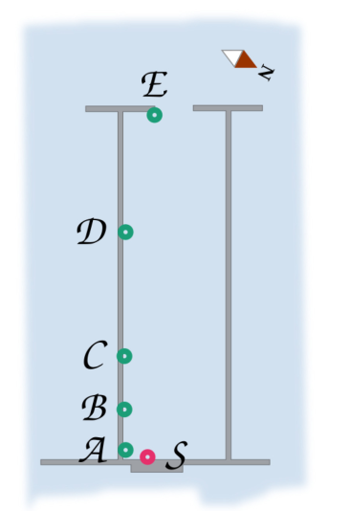

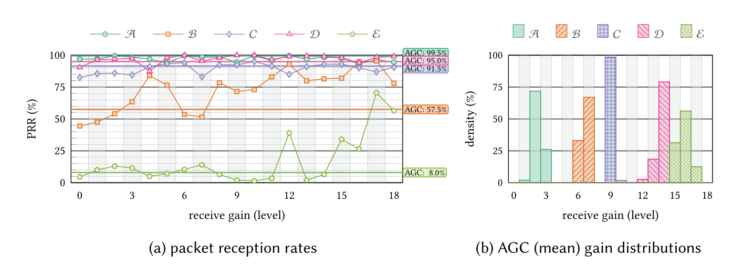

Distance, Position, and Receive Gain
- As a thumb of rule the more distance more packets are lost
- to a boat, potentially causing more reflections and scattering of the signal
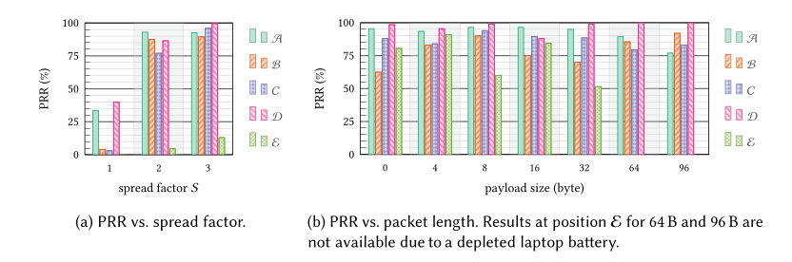
- 96 B payload leads to a packet duration of 3.3 s. Even at a moderate μAUV speed of 0.5 m/s, this may cause a 50% symbol shift (or synchronization error, respectively) towards the end of the packet

Preamble based synchronization
- As precise and correct synchronization—i.e., preamble detection—plays a paramount role for successful packet reception, we investigated the process of synchronization in more detail.
Low-power Transmitter
- haven’t went through completely
EU Export-regulations-compliant Frequency Band
- didn’t go through
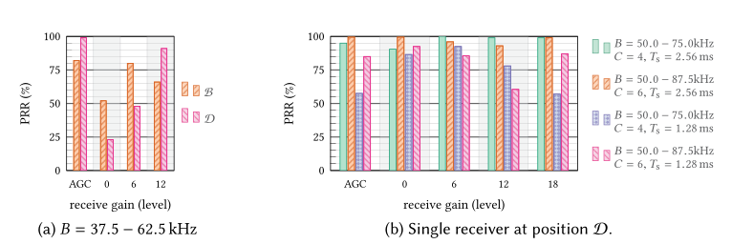
Larger Frequency Band and Shorter Symbol Duration
- left unread for now

REAL-WORLD RANGING AND MOBILE LOCALIZATION EXPERIMENTS
- keep the robot at a constant depth initially
- add a GNSS module at the surface to obtain reference position data (ground truth)
- Latency - The delay before a transfer of data begins following an instruction for its transfer
- At the beginning of each round, the μAUV sent an empty 4 ranging request as broadcast. Upon reception of a request, the anchors replied with a ranging response consecutively: Anchor A replied immediately, anchors B through D replied with a single, double, and triple delay, respectively. Delays and round length were chosen as follows to prevent collisions and allow for a bit of extra time to let echos on the channel fade
- In our setup, packet duration for request and response (4 B payload) is 292 ms and 476 ms respectively.
- At distances of at most 75 m between anchors and μAUV, propagation delay is below 55 ms.
- To avoid collisions, the delay between anchor responses needs to encompass
(at least) response duration plus double propagation delay
