Basics

Multimeter
- COM -Common socket (Ground)
- Current chooses the path with least resistancs
- Continuity – when almost zero resistance
- Differentiate between AC / DC
- Voltage measurement in parallel
- Always start with the high current socket if you are not sure
- Current measurement in series
- Know how to replace the fuse

Leds
- PWM LED dimming can be achieved easily using PWM signals
- Forward voltage
- lower voltages – dimmed led
- Don’t forget to add resistor before
- Longer leg is positive and is called anode
- shorter leg is negative and cathode
- Current can only flow from anode to cathode (+ve to -ve)
- duty cycle tells you how long the signal has been on or off 50% duty cycle of 5v means it outputs 2.5 v
- can be seen in a cool way with an oscilloscope
- You can use a potentiometer and dim
- Always use mosfet when you need more power or higher voltage
- PWM – goes to gates, output at drain and ground is connected to source

ATTINY 85 (1€ 5 Ios)
- import attiny board to arduino ide
- 3 analog input is there coool
- Bitbanging to emulate protocol (he used for spi)

Bluetooth + arduino + android
- Arduino nano (good for small projects)
- voltage divider so that less voltage input is soming to arduino
- S2 terminal for android can be used to send trings

How to multiplex
- How to control many leds with less Ios
- in a matrix all the anodes in one were connected to each other and all the cathodes were connected to each column
- Used TLC and MOSFET (row of arduino requires a lot of power)
  - Code + Schematic

Standalone arduino circuit
- using atmega 328
- Always test your circuit in a breadboard
- 16 mHZ -clock 2 22pic f to generate external clock signal
- reset and 5v has to be connected over a resistance to avoid micro controller resetting itself
- Can be programmed using FTDI

Segment display
- Always check data sheet to find out Pinouts
- display numbers without a microcontroller?
  - BCD to seven segment display driver
  - SN74LS247N
    - has an active low level
    - capable of controlling each cathodes
    - 220 oh resistors were used to resist current
    - used a counter SN74LS290N – has a BCD count sequence
    - SAA1064 is just made to control 4 digit segment display uses i2c
      - connected to arduino
      - Code for i2c is a bit more advanced

Diodes and Bridge Rectifiers
- Look for polarities while connecting power plugs if it’s DC
- Diode can limit the flow of current to only one direction
- it also eats current .. keep it in mind
- and if it draws a lot of current it can get screwed up
- Transformer
- RMS values (Root means square values)
- You can convert AC to DC remember from electronics??
- Remember Bridge rectifiers?

Digital to Analog
- You can create ramp function and other kind of functions cool shit
- Resistor ladder thing was used here
- DAC0800 – DAC
- LC low pass filter – makes things cooler
- or use some device from market

Sending sms with arduino
- just use a shield

Coils / Inductors
- why are they so iportant?
  - Found in relays ...tranformers ..motors everywhere
- We are also antennas
- just wrap the copper wire around a nail(or something ferromagnetic) and then you know ..it acts as a magnet
- Inductance can be measured using RLC meter
- LENZ law
- Can be used to get 5v from 3.3v batteries
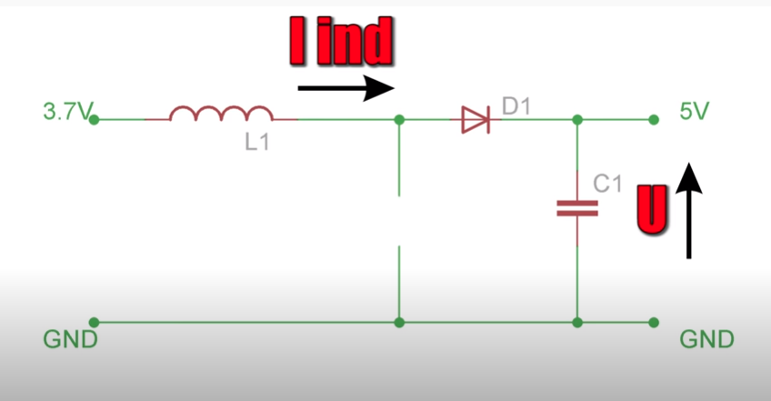
- Inductance itself gets converted to resistance can be called as reactance
- Reactive power
- Ohms low still active
- Xl = 2pifL
- Use LTSpice
- phase shift 90° with ideal inductive load
- transstor testor with lcd. It gain measure resistance capacitance and even the gain of transistors
- from a project microcontroller.net (it has got to be good)

Capacitors
- Almost every circuit has it inside
- more capacitance and maximum voltage rating it got more power it can deliver
- There is always a voltage limit
- You can avoid instant jump in Voltages
- In combination with a resistance you can use it to build current slowly
- remember equation !!!!
- Filter

Temperature measurement
- PT100 (RTDs)
- Resistance increases with higher temperature
- Voltage divider
- map function in arduino???
- He used some transmitter with it
- There also ICs which does this
- like DS18B20 has only a tolerance of 0.5 °C
- Due to thermal inertia the temperatures change only slowly

Resistors
- Resistor resists currents flow
- You have to think about power of the resistors
- You need a good resistor in case of a big power change
- Pull down resistors

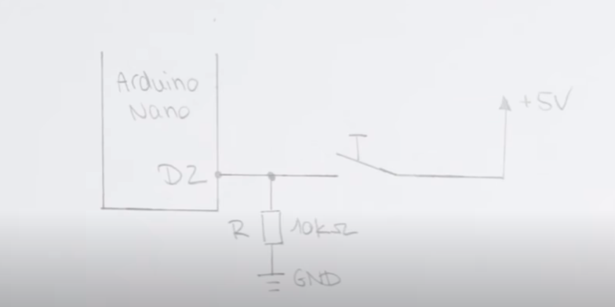
- Pullup

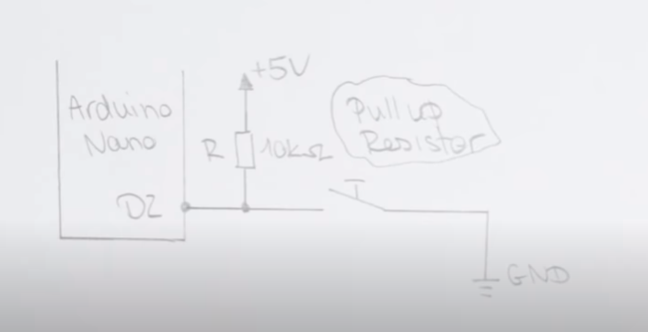
- Voltage drop per amp can be calculated which is useful to output a constant current source
- Can also be used as fuse or for temperature measurement or for light measurement or to measure weights
- They behave the same as dc but it has mostly a capacitance and a impedance due to it’s structure

Oscillator
- Periodic Ac’s(basically from oscillators) are the sources for clocks
- LC resonators can be used to very high frequency
- always consider parasitic power and capacitance
- Don’t build any oscillators in breadboard
- Oscillators can be made by piezo-electric vibrations. Which can be bought with the clock name

DC & Brushless DC Motor
- Stator and rotor
- RPM
- Overall current draw is determined by the weights attached to the shaft, voltage applied to the esc and is regulated by the pulse width modulation
- Brushless motors are slower
- Brushless motors can bring more torsion
- KV – stands for RPM per volts applied
- RPM can be measured using the rotating tool
- Higher KV you get more RPM

I2C and how to use it
- 2 Wire Interface
- Allows one master to talk to up to 112 slaves
- what to do can be said by the master
- You must read the datasheet to understand how it works
- Pll to choose the frequency to tune in
- Use an oscilloscope to measure everything properly
- Study datasheet properly

Thyristor
- Has 4 layers
- only way to block current flow is by using a mosfet or some other transistor as a switch
- He uses oscilloscope with everything
- Triac
- Optocoupler
- With all these you can create a phase angle control system

Operational Amplifiers
- LM358 Dual Opamp – Famous shit
- #1 Output always tries to keep the inputs at zero volt

