Neural Networks and deep learning notes

Week 1 Introduction

- function which goes to zero sometimes and then it'll takes of as a straight line.
This function is called a ReLU function which stands for rectified linear units. So R-E-L-U. And rectify just means taking a max of 0
- Supervised learning, Structured and unstructured data
- Did the questions part and Rest skipped

Week 2 Neural Networks and deep learning

- Binary classification
  - Avoid using for loops to loop over entire training set
  - Pauses – Forward pauses / propogation and backward pauses / propogation
  - Logistic regression is an algorithm for binary classification
  - Image is a set of 3 matrices corresponding to their RGB Values
    - Every pixel get an RGB value
    - Suppose if the image has 64 * 64 pixels then (3 (for rgb) * 64 * 64 (for pixels) * 8 (space per pixel)) bit space is required in memory
    - and 3*64*64 would be called as gravity or dimension of the input vector represented with “n” or “n_x”
    - Notation
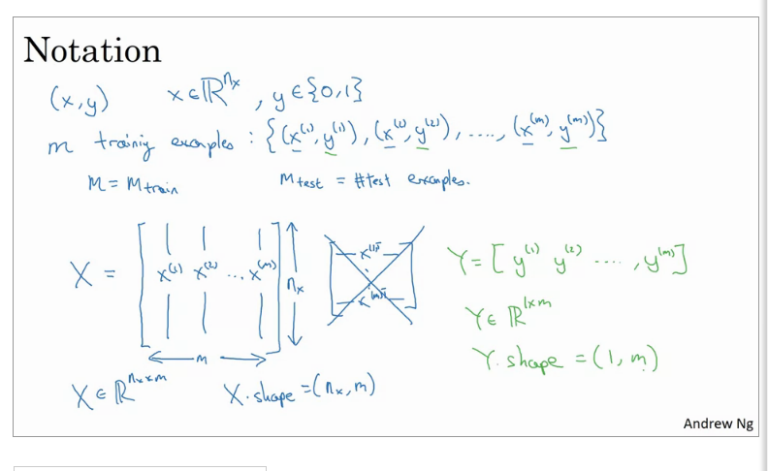
- Logistic regression
  - parameters w and b?
    - Y^ = w^T*x + b linear regression equation doesn’t work here
    - Keep w and b separate

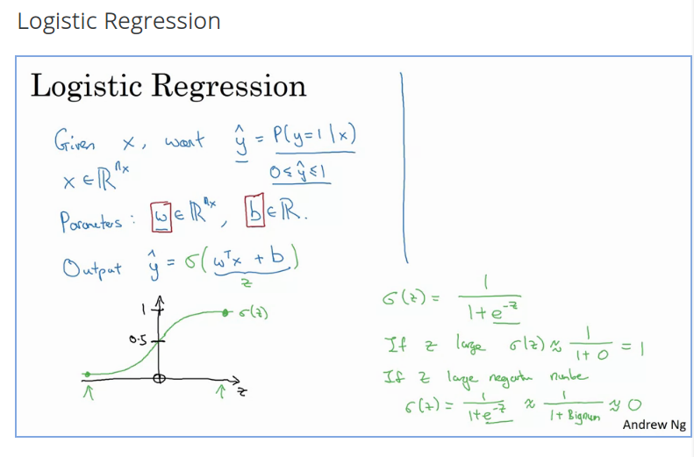
Logistic regression cost function
- “I” in parenthesis means ith data example
- loss (error) function : this function L called the loss function is a function you'll need to define to measure how good our output y-hat is when the true label is y
- loss function defines how well you did in one training example
- Cost function is for entire training set

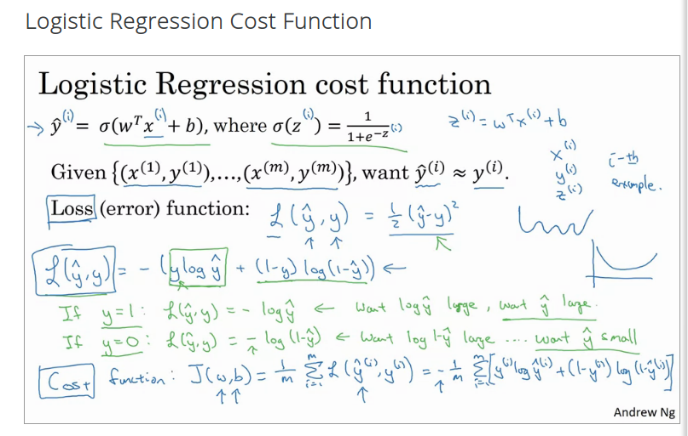
- Logistic regression is a very small neural network

Gradient Descent algorithm
- J(w,b)=m1​∑i=1m​L(yhat(i),y(i))=−m1​∑i=1m​(y(i)logyhat(i)+(1−y(i))log(1−yhat(i)))
- Cost function – for what value of w and b will j be minimum (check pic below)
- And what gradient descent does is it starts at that initial point and then takes a step in the steepest downhill direction until it converges to global optimum.

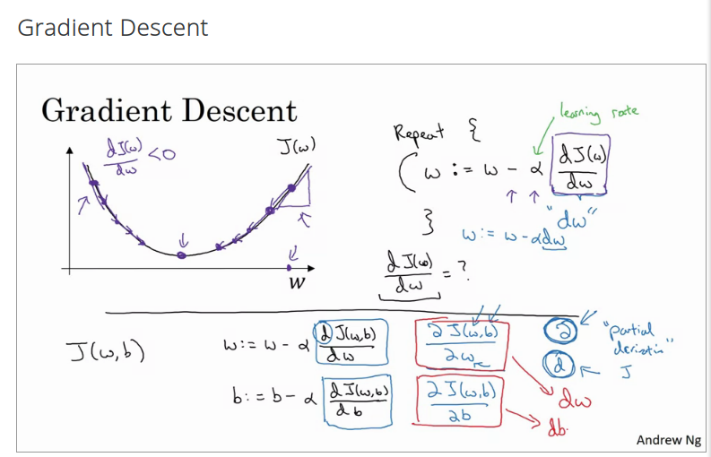
Derivatives
- Nothing new here but a good review
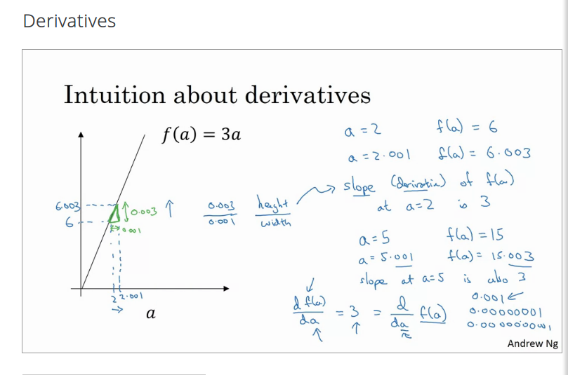
- More derivative examples does almost same for polynomial functions and

Computation graph
- Relations can be mapped as graphs. Look image below:
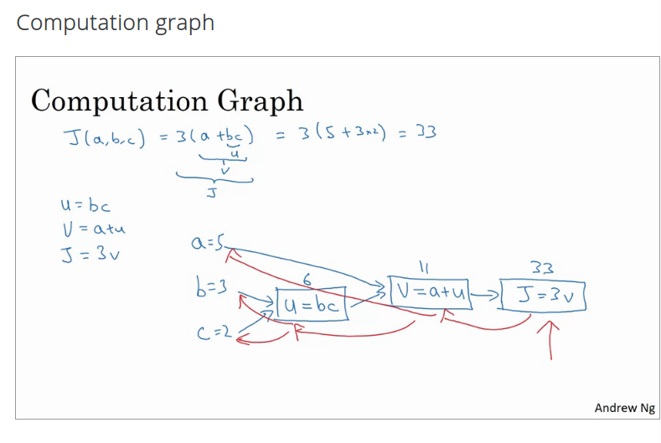
- Computation graph organizes a computation with this blue arrow, left-to-right computation. Backward also possible of derivatives
- One step of backward propagation yields derivative output

Derivatives with a computation graph
- chain rule of derivatives
- dj/da is represented as “da” for representation

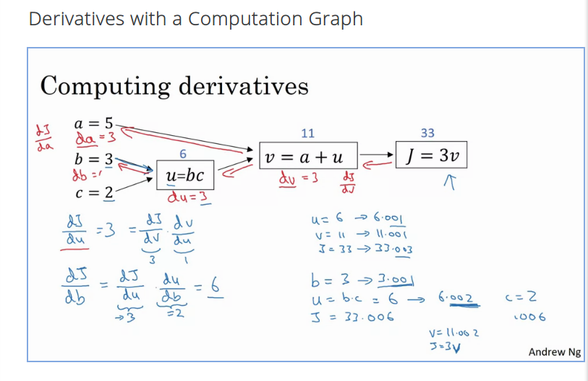
- Right to left computation is easier to find derivatives

Implementing gradient descent for logistic regression
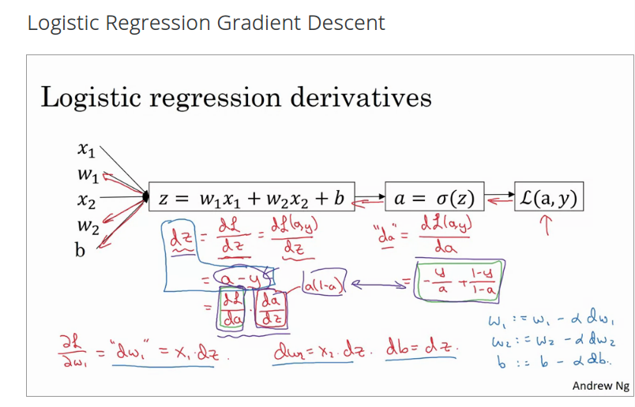
Gradient descent for logistic regression on m examples
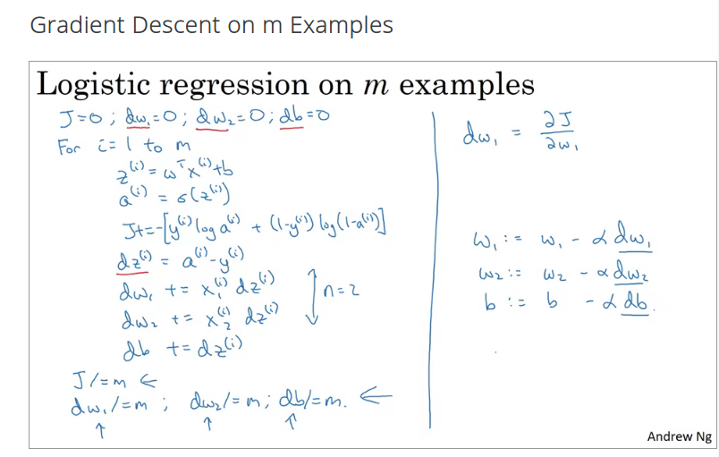
- Use vectorization to avoid loops 4:15 as small as possible

Vectorization
- Avoid for loops and code runs 300x faster :D
- np.dot(w, x) + b as a vetorized alternative for for I in range (n – x) z += w[i]*x[i]
  - z += b
- SIMD – Single instruction multiple data
- Whenever possible, avoid explicit for loops
- V vector and u has to be calculated where u exponential function of v for every element. Use u = np.exp(v)
- Logistic regression vectorized (head burned)
  - broadcasting (a real number added gets added to every element of a vector)
