

**ACCOUNT CONFIRMATION DOCUMENT**

We hereby confirm that the below account is held on our books:

Account Number: **007**

IBAN: **123**

Account Name**: Jithu R Jacob**

Account Currency: **INR**

Swift Code: **ABC**

Branch Address:

**Citibank International PLC, Luxembourg**

**31 Z.A. Bourmicht L 8070,**

**Bertrange,**

**Luxembourg**

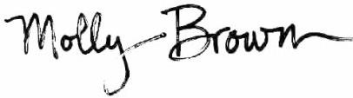

Signed by on behalf of

Citi:



# Citibank Europe plc

Directors: Aidan M Brady, Breffni Byrne, Jim Farrell, Bo J. Hammerich (Sweeden), Mary Lambkin, Marc Luet (France), Rajesh Mehta (India)

Cecilia Ronan, Patrick Scully, Christopher Teano (U.S.A), Zdenek Turek (Czech Republic), Francesco Vanni d’Archirafi (Italy), Tony Woods

Registered in Ireland, Registration Number 132781, Registered Office: 1 North Wall Quay, Dublin 1

Ultimately owned by Citigroup Inc, New York, U.S.A. Citibank Europe plc is regulated by the Central Bank of Ireland