Worksheet-1

Q1: Use VLOOKUP to find the product names for each product id

Ans: Step1:In worksheet tool create a new column next to product id called product Name.

Step2: In the first row in the new column E4 Use the following Formula

Formula: **=VLOOKUP(D4,Sheet2!$B$3:$D$8,2,0)**

D4 is the product id in the order worksheet

Is the range of the table when in the product if or table located

2 indicates the column index number and o is for exact match

|  |  |  |  |  |
| --- | --- | --- | --- | --- |
| **OrderID** | **Product-ID** | **Product Name** | **Quantity** | **Total Price** |
| 1 | 101 | Product A | 2 |  |
| 2 | 103 | Product C | 1 |  |
| 3 | 105 | Product E | 4 |  |
| 4 | 106 | Product F | 3 |  |
| 5 | 102 | Product B | 5 |  |
| 6 | 104 | Product D | 6 |  |

Q2: Use VLOOKUP to find the price For ProductID in the Orders worksheet then calculate the Total Price Multiplying by the product Price.

Answer: Step 1: In order’s Worksheet 2 create a new column called Price.

Step2: In the 1st row in the new column F4 write the following Formula.

Formula : **=VLOOKUP(D5,Sheet3!D5:F10,3,0)**

D4 is the product Id in the order Worksheet 3 refer’s to the 3rd column (Price) in product worksheet 1

Step3: In the total price column calculate the total price by multiplying the price and qualtity.

Formula: **=F4*G4**

|  |  |  |  |  |  |
| --- | --- | --- | --- | --- | --- |
| **Order ID** | **ProductID** | **Product Name** | **Quantity** | **TotalPrice** | **Product Price** |
| 1 | 101 | product A | 2 | 120 | 240 |
| 2 | 103 | Product C | 1 | 200 | 200 |
| 3 | 105 | Product E | 4 | 220 | 880 |
| 4 | 106 | Product F | 3 | 130 | 390 |
| 5 | 102 | Product B | 5 | 150 | 750 |
| 6 | 104 | Product D | 6 | 90 | 540 |

Q3: 3. Use VLOOKUP to check if there are any Product IDs in the Orders worksheet that do not exist in the Products worksheet

Answer: Step1: In worksheet 2 create a new column product id in oroder table add a new record with a product id that is not present in the product table.

Step3: In the first row in the new column I4 write the following formula

# Formula: =IF(ISNA(VLOOKUP(D17,Sheet10!$B$3:$D$8,1,0)),”NOT FOUND”,”FOUND”)

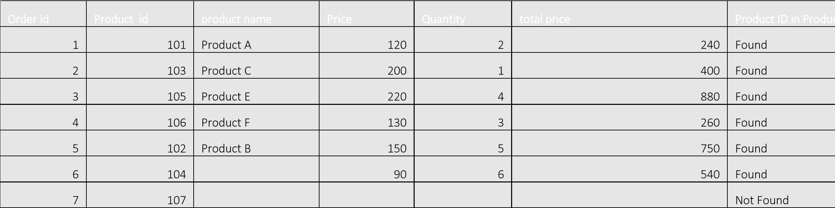

Q4: Assume a discount of 10% is given on all products. Use VLOOKUP to find the original price and then calculate the discounted price.

Answer:

Step1: In worksheet 2 create a new column called discounted price .

Step2: in the 1st row of the new column [j4] use the following formula.

Formula: -f4*(1-0.1)

|  |  |  |  |  |  |  |  |
| --- | --- | --- | --- | --- | --- | --- | --- |
| **Order id** | **Product**  **id** | **product name** | **Price** | **Quantity** | **total price** | **Product**  **ID in**  **Product table** | **Discounted price** |
| 1 | 101 | Product A | 120 | 2 | 240 | Found | 108 |
| 2 | 103 | Product C | 200 | 1 | 400 | Found | 180 |
| 3 | 105 | Product E | 220 | 4 | 880 | Found | 198 |
| 4 | 106 | Product F | 130 | 3 | 260 | Found | 117 |
| 5 | 102 | Product B | 150 | 5 | 750 | Found | 135 |
| 6 | 104 |  | 90 | 6 | 540 | Found | 81 |
| 7 | 107 |  |  |  |  | Not  Found | 0 |

Q5: Use VLOOKUP to find the price for each Product ID and then calculate the order value. Find the maximum order value from the list.

Answer:

Step1: In worksheet 2 create a new column called maximum value and called maximum cells

Step2: In worksheet 2 Create a new column Called maximum value and merge the cell

Step3: To find the formula

# =MAX(H4:H9)



Q6:

Q6: Answer:

Step1: Add a record in product table that is not in order table.

Step2: Create a new column called product order or not in product table Add one record over there

Step3: In the first row of the new column that is E3 write down the formula

## Formula: =IF(ISNA(B3,VLOOKUP2!$D$4:$J$10,1,0)),”Not ordered”,”Ordered”)

|  |  |  |  |
| --- | --- | --- | --- |
| **Order id** | **product** | **price** | **Product ordered or not** |
| 101 | product A | 120 | Ordered |
| 102 | product B | 150 | Ordered |
| 103 | product C | 200 | Ordered |
| 104 | product D | 90 | Ordered |
| 105 | product E | 220 | Ordered |
| 106 | product F | 130 | Ordered |
| 108 | Product G | 150 | Not Ordered |

Q7: Use VLOOKUP to find the Product name and summarize the total quantity sold for each product.

Answer:

Formula Step2: Formula =IF(VLOOKUP(B2, $J$2:$K$7, 2, FALSE), "")

Step 3: Summarize the Total Quantity Sold for Each Product

|  |
| --- |
| **Product Name** |
| Product A |
| Product B |
| Product C |
| Product D |
| Product E |
| Product F |

|  |
| --- |
| **Total Quantity Sold** |
| 2 |
| 5 |
| 1 |
| 6 |
| 4 |
| 3 |

Q7:

Answer:

Step1: Use the same Vlookup formula to face the product name(refer to question number 1).

Step2: Summarise