<^> TRIFORCE <^>

By: Brandon Hinesley
Other Team member: Gabe Pike
Table of Contents
Section 1: Requirements workflow 3
1.1 Requirements workflow 3
1.1.1 Initial understanding of the project 3
1.1.2 Initial business model 8
1.1.3 Initial requirements 11
1.1.4 Detailed requirements 12
1.1.5 Iterated use-case diagrams and updated descriptions 13
1.2 Walkthrough 14
1.3 Revised Requirements after walkthrough 15

Section 1: Requirements workflow

1.1 Requirements workflow

1.1.1 Initial understanding of the project
Triforce is a clone of the original Tetris Attack (a Super Nintendo game), with modern graphics and features.
Tetris Attack in 2-player mode
There are single and 2-player modes. The object of the 2-player game is to cause your human opponent's blocks to reach the top of the grid, at which point they lose. The object of the single player game is to prevent your blocks from reaching the top of the grid while the game speeds up. In all game modes, the normal blocks rise from the bottom, and the garbage blocks fall from the top. There are two principal operations in the game: raising the stack of blocks manually (more quickly), and swapping the two blocks under the cursor. By swapping blocks, they can be rearranged to form combinations, which cause the blocks to clear. Combinations consist of 3 or more blocks of the same type directly adjacent to each other in a row or column.
Chains are the most critical (and difficult) aspect of the game. Garbage blocks can be dropped on your opponent by forming chains, which are multiple combinations occuring in a related sequence. The greater the chain multiplier, the larger the garbage block.
An interesting aspect of the game, is that the rising of blocks from below pauses under certain conditions. This allows players to respond to difficult situations (or be rewarded for clearing blocks), making the game less frustrating than it might otherwise be. It also allows for comebacks from seemingly impossible situations.
Glossary
- Clearing blocks (aka breaking) – Blocks are cleared whenever a combo occurs. They dissapear, and any blocks above them fall.
- Clearing garbage blocks - Breaking garbage blocks (see Garbage blocks) is somewhat different. They are indirectly cleared by a combination of normal blocks occuring directly adjacent to them. When a garbage block is cleared, the first (and possibly only) row of the garbage block changes into normal blocks. Any combinations made as these normal blocks fall count towards the chain multiplier (see Chains). If any garbage blocks of the same color are adjacent to a cleared garbage block, they are also cleared in the same fashion.
- Combination (aka combo) – Combinations are one of the most basic elements in the game. They occur when 3 or more blocks are in a row, at which point all blocks used to create the combination are cleared. The greater then number of blocks in the chain, the greater the score for clearing them. Note that in some cases, blocks of different types can be used to create a single large combination.
  - 3x Combo
    - smallest possible combo
    - 3 of a given block type A in one of two possible ways
  - 4x Combo
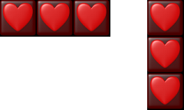Every possible 3x combo
    - 4 of a given block type A in one of two possible ways
  - 5x Combo
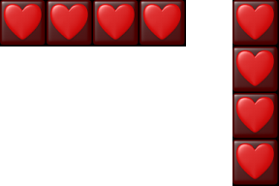Every possible 4x combo
    - 5 of a given block type A in one of 10 possible ways
  - 6x Combo
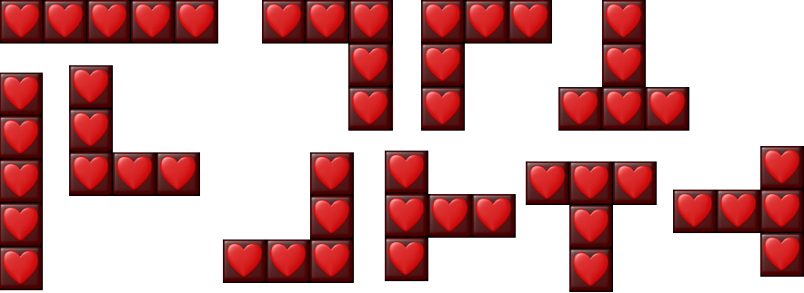Every possible 5x combo
    - 3 of a given block type A and 3 of a given block type B (or A) in one of many possible ways
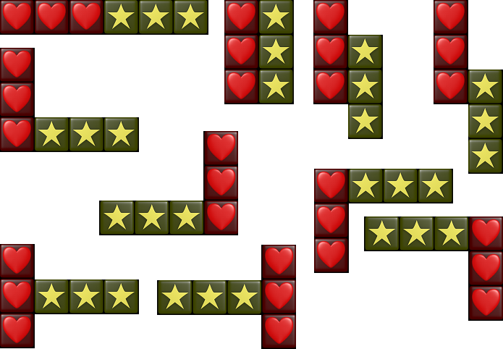Every possible 6x combo
  - 7x Combo
    - 4 of a block type A and 3 of a block type B (or A) in one of many possible ways
  - 8x Combo
    - 5 of a block type A and 3 of a block type B (or A) or
    - 4 of a block type A and 4 of a block type B (or A)
  - 9x Combo
    - 5 of a block type A and 4 of a block type B (or A)
  - 10x Combo
    - largest possible combo
    - 5 of a block type A and 5 of a block type B (or A)
- Chains – Chains of combinations occur when more than one combination occurs as a direct result of blocks falling due to a prior combination. A (theoretically) unlimited length of chains are possible. Chains act as multipliers to the score that would normally be calculated for a combination. Chaining together N amount of combinations result in a score multiple for that run of xN. From the original Tetris Attack, here are the 5 different ways that chains can occur, in order of increasing difficulty:
  - Basic Chain
Basic chain
  - Raised Chain
    - the first combination is not adjacent to the chained combination
Raised chain
  - Skill Chain
    - a chain quickly made by the player by moving a block into the space left from the first combination, creating a new combination once the blocks fall
Skill chain
  - Advanced Chain
    - these chains take advantage of the fact that there is a split second before a combination is cleared, where the blocks directly above it have not yet fallen, but it is possible for the player to drop another block
Advanced chain
  - Time-Lag Chain
    - involve 2 or more combinations being cleared as a direct result of the first combination being cleared
Time-lag chain
- Garbage blocks – Special blocks of varying width, which turn into normal blocks when cleared (see Clearing garbage blocks). The sole purpose of garbage blocks is to block players from making combinations, while simultaneously increasing the height of their stack. Garbage blocks fall at random in single player mode. In 2-player mode, garbage blocks fall as a result of chains made by opposing players.
Garbage blocks from Panel De Pon and Tetris Attack
- Raise blocks – The blocks naturally rise as time progresses. The player can manually speed up this process if they want more blocks on the screen. It is possible to raise them past the top of the grid, and lose the game.
- Stack (aka Grid – The stack consists of the play area, which holds blocks and the cursor.
- Swapping blocks – The only operation that can be directly performed on blocks. The swap in the left part of the cursor swaps places with the block in the right part of the cursor. Other than moving the cursor and raising the stack (see Raising the stack), there is no other input action that can be performed in-game.

1.1.2 Initial business model
Initial processes:
- Play game
  - Swap blocks
  - Speed up game
- Options
- Help
- About
- Quit

Brief Description: When the Player activates the Play Game menu item, the game state changes to Play, and the game starts.
Play Game
Player

Brief Description: When the Player activates the Options menu item, the options configuration dialog opens. The player is presented with a set of graphical controls for configuring the game.
Options
Player

Brief Description: When the Player activates the Help menu item, the game displays instructions of the various actions that are possible in the game, and graphics of how different combinations/chains are made.
Player
Help

Brief Description: When the Player activates the About menu item, the game displays a brief description of Gabe and Brandon, and possibly pictures.
Player
About
Player
Quit
Brief Description: When the Player activates the Quit menu item, the game asks the user if they are sure, and then quits upon 'yes', or goes back to the menu upon 'no'.

Player
Swap
Blocks
Cursor
Brief Description: In the Play state, when the Player activates the Swap Blocks function, the special in-game cursor swaps the two blocks that are underneath it.
Brief Description: In the Play state, when the Player activates the Speed Up Blocks function, the Grid will speed up it's normal action of moving the blocks up.
Player
Grid
Speed
Up Blocks

1.1.3 Initial requirements

1.1.4 Detailed requirements

1.1.5 Iterated use-case diagrams and updated descriptions

1.2 Walkthrough

1.3 Revised Requirements after walkthrough

