<^> TRIFORCE <^>
Analysis Workflow

by Gabe Pike
CMPS 335
Spring 2012
Team 10
Other Team Member: Brandon Hinesley

Section 2: Analysis Workflow
2.1 Analysis Workflow 3
2.1.1 Functional Modeling 3
2.1.2 Entity Class Modeling 6
2.1.3 Boundary Class Extraction 8
2.1.4 Control Class Modeling 9
2.1.5 Dynamic Modeling 10
2.1.6 Communication Modeling 11
2.2. Walkthrough 12
2.3. Revised Analysis after Walkthrough 13

2.1 Analysis Workflow
2.1.1 Functional Modeling
Normal scenarios
1. Game starts and shows the main menu
2. Player selects the Play button
2.1. Game is loaded and customized based on selected settings
2.2. Timer counts down from 3 then starts the game
2.3. Player moves with cursor
2.4. Player swaps blocks
2.5. Execute the combo detection subroutine
2.6. If a combo is detected:
a. Grid changes state to COMBO
b. Blocks in the combo are changed to state COMBO
c. After S seconds the blocks break
d. Execute the fall detection subroutine (goto 2.7a)
2.7. If no combo is detected:
a. Execute the fall detection subroutine
b. If a fall is detected:
1. Set the blocks that need to fall to the FALL state
2. Make the blocks fall by Y pixels every S milliseconds until they land on
a non-disabled block.
3. Execute the combo detection subroutine on each FALL block
4. Increment the chain counter for each combo detected and goto 2.6
5. Set the chain counter to 0 if no combo detected
6. Set Grid's state to PLAY
2.8. Player selects the Pause button
a. The game's state changes to PAUSE
b. The blocks are not displayed to prevent cheating
c. The player selects the Pause button again
d. The game's state changes to PLAY
e. Normal gameplay resumes
2.9. Player selects the Menu button
a. Game objects are deleted
b. The player is returned to the main menu
2.10. Player selects the Quit button
a. The game immediately exits
3. Player selects the Settings button
3.1. The settings menu is loaded
3.2. Player toggles sound on/off
3.3. Player toggles mouse on/off
3.4. Player changes key bindings
3.5. Player clicks the Save button
a. Settings are saved
b. Main menu is loaded
4. Player selects the Help button
4.1. Some text and graphics are displayed that explain how to play the game
4.2. Player selects the Back button
4.3. Main menu is loaded
5. Player selects the About button
5.1. A short description of the game, credits, and licensing information is displayed on the screen.
5.2. Player selects the Back button
5.3. Main menu is loaded
6. Player selects the Exit button
6.1. Game immediately exits.

Exception scenarios
Early Quit:
1. Player starts playing the game
2. Player clicks Quit
3. Game immediately exits

Player intentionally loses
1. Player holds the push-row button
2. The blocks hit the top very quickly
3. Player loses
4. Game over screen is displayed
5. Player returns to main menu

Player gets very large chains
1. The player is skilled enough to chain many combos together
2. The game is able to handle it because combos are detected after every combo occurs.

2.1.2 Entity Class Modeling
Noun extraction
When the game is loaded, the configuration file is read and saved into settings. Then the player is presented with the main menu. The player can click buttons to take them to other menus or to play the game. The settings menu lets the user configure options. Options are saved to a configuration file. The help menu displays explains how to play the game. The About menu displays gives some background information about the game. The player clicks the play button and to start the game.
The game play area consists of the of a grid of blocks. The player controls a cursor and can use it to swap blocks. If at least 3 blocks are lined up, a combo event occurs. If there are disabled blocks under an enabled block, then a fall event occurs. A fall event can only occur after the player swaps or a combo event. A combo event can only occur after the player swaps or a fall event. The grid controller is responsible for detecting combo events and fall events. A heads-up display (HUD) keeps track of the time and displays a timer and the score.
Input devices all go through a single input controller that controls the flow of execution based on the current state of the game and the action bound to the input event.

Identification of nouns: game, player, main menu, settings menu, help menu, about menu, button, settings, options, game play area, grid, blocks, combo event, fall event, grid controller, HUD, timer, score, input device, input controller, state, action, input event

Entity classes:
Game
HUD
Block
Cursor
Menu

Game
currentState (enum)
gamePlay (GamePlay class)
menus (list of Menus)

Cursor
row, column (int)

Block
currentState (enum)
fallOffset (int)
HUD
x, y (int)
startTime (int)
currentTime (int)
currentSeconds, currentMinues (int)
Menu
buttons (list of Buttons)
text

2.1.3 Boundary Class Exaction
Boundary classes:
Input
Button
GamePlay

Input Controller
Action (class)
Player (class)

Menu
buttons (list of Buttons)
text
Game
currentState (enum)
gamePlay (GamePlay class)
menus (list of Menus)

Cursor
row, column (int)

Block
currentState (enum)
fallOffset (int)
HUD
x, y (int)
startTime (int)
currentTime (int)
currentSeconds, currentMinues (int)
Button
hovering (bool)
pressing (bool)
enabled (bool)
GamePlay
grids (list of Grids)
currentState

2.1.4 Control Class Modeling
Control classes: Grid, ComboEvent, FallEvent

Grid
Blocks (stored as deque of Block vectors)
x, y (int)
yOffset (int, used for calculating block y positions)
currentState (enum)
comboEvents (list of ComboEvents)
fallEvents (list of FallEvents)
chainCount (int, # of current chains)
ComboEvent
comboState (enum)
left, right, up, down, mid (class of x and y pos)
cells (list of coordinates in the combo)
startTime (time that the combo began)
enabled (bool)

FallEvent
row, col (int)
numBlocks (int)
lastFall (int)
enabled (bool)
currentState (enum)

Input Controller
Action (class)
Player (class)

Menu
buttons (list of Buttons)
text
Game
currentState (enum)
gamePlay (GamePlay class)
menus (list of Menus)

Cursor
row, column (int)

Block
currentState (enum)
fallOffset (int)
HUD
x, y (int)
startTime (int)
currentTime (int)
currentSeconds, currentMinues (int)
Button
hovering (bool)
pressing (bool)
enabled (bool)
GamePlay
grids (list of Grids)
currentState

2.1.5 Dynamic Modeling
Main Loop
Input Event occurs
Input Controller calls registered
callback based on the current state
state == PLAY
state == MENU
display/run menu
display/run game
display/update Grid
Display/update Blocks
display/update cursor
input to move cursor or swap blocks
state == PLAY
Handled by Input Controller
state == FALL
fall down
state == combo
look like a combo
detect combos/falls

2.1.6 Communication Modeling

2.2 Walkthrough
It seems like some attributes are missing. Re-evaluate your classes and consider what else should be added.
Make sure to include all the states in your dynamic model.
Break functional model up into different scenarios
Use UML conventions
- Walkthrough by Brandon Hinesley

2.3 Revised Analysis after Walkthrough
2.3.1 Functional Modeling
Normal Scenarios
Scenario 1:
1. Player selects Play
2. Change game's stay to PLAY
3. Initialize the Grid with randomized blocks, and initialize the timer and score.

Scenario 2:
1. Player selects Help
2. Display a helpful guide for how to play
3. Display a button to go back

Scenario 3:
1. Player selects Quit
2. Immediately exit the game

Scenario 4:
1. Player moves cursor
2. Cursor's position is recalculated based on the direction it is moved
3. Cursor is redrawn

Scenario 5:
1. Player swap blocks
2. The selected blocks are swapped with each other
3. Detect combos for each block
4. If combo is detected, goto combo detected scenario
5. Detect fall for each block
6. If fall is detected, goto fall detected scenario
Scenario 6:
1. A combo is detected
2. Increment the chain count for the combo
3. If combo has 4 or more blocks, display an animated bonus with the number of blocks in it
4. Set state of Grid and Blocks in the combo to COMBO
5. Remain in the COMBO state for (N number of blocks * T milliseconds)
6. Set the state of the COMBO blocks to DISABLED when the timer elapses, and set Grid's state to PLAY
7. Detect falling blocks
8. Group all falling blocks in the same fall event, and goto scenario for detecting a fall event

Scenario 7:
1. A fall event is detected
2. Set all the blocks in the fall event to the FALL state
3. For each block, fall Y pixels every T milliseconds while in the FALL state
4. Set block's state to ENABLED when it lands in a cell above another enabled block.
5. Detect combo for each falling block
6. If combo is detected, goto combo detected scenario

Scenario 8:
1. Player input requests to push blocks up faster
2. Grid set to PUSH state
3. Automatic block rising is temporarily disabled
4. Blocks are pushed up every T milliseconds, an interval less than the automatic interval
5. Grid restored to PLAY state when input binding is no longer active

Scenario 9:
1. A block comes into contact with the top of the Grid
2. Game set to GAMEOVER state for T milliseconds
3. Game over graphic displayed on screen while in GAMEOVER state, and player controls are disabled
4. Go back to main menu when timer elapses

Exception Scenarios

Scenario 1:
1. Player sends input that is not a registered binding
2. Nothing happens

Identification of Nouns
When the game loads, the player is presented with the main menu. The player can select buttons that take actions when selected. The buttons on the main menu are Play, Help, and Quit. The Help menu displays explains how to play the game. The Quit button closes the game. The player clicks the Play button and to start the game.
The game play consists of a grid for each player. A grid contains blocks and a cursor. The player controls the cursor and can use it to swap blocks. If at least 3 blocks are lined up, a combo event occurs. If there are disabled blocks under an enabled block, then a fall event occurs. A fall event can only occur after the player swaps blocks or after a combo event. A combo event can only occur after the player swaps or after a fall event. The grid is responsible for detecting combo events and fall events. An animated bonus is displayed when the player gets a big combo or a chain. A heads-up display (HUD) displays a timer and the score.
Input devices all go through a single input controller that controls the flow of execution based on the current state of the game and the action bound to the input event.

Noun Extraction
player, menu, button, actions, grid, block, cursor, combo event, fall event, bonus, HUD, timer, score, input device, input controller, state

2.3.2 Entity Class Modeling
Noun Extraction
button, block, cursor, combo event, fall event, bonus, HUD, timer, score
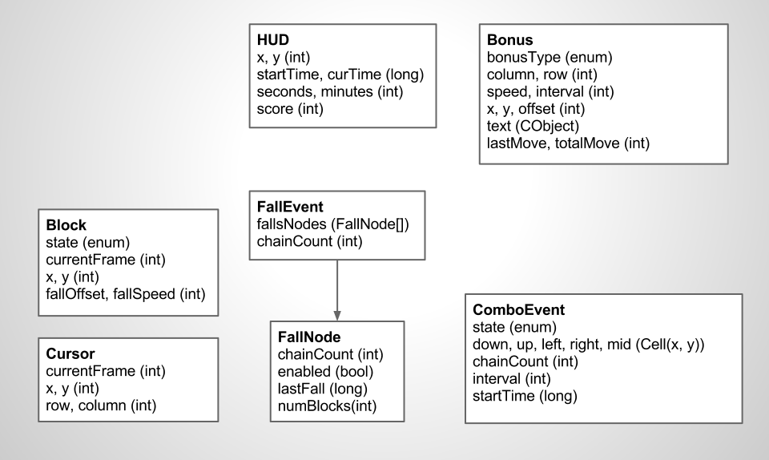Attribute Box Diagram
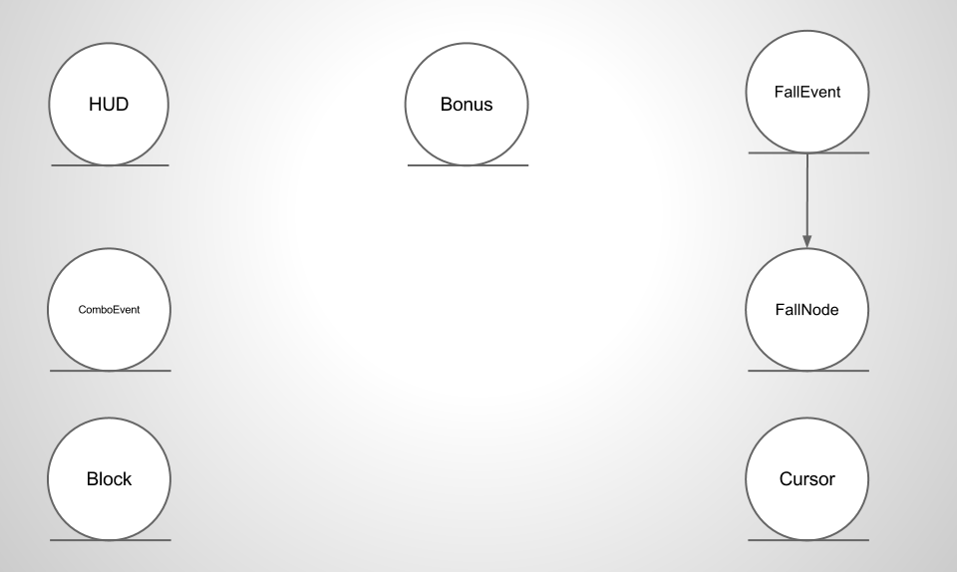UML Class Diagram
2.3.3 Boundary Class Modeling

Noun Extraction:
button, player, input, input device, action
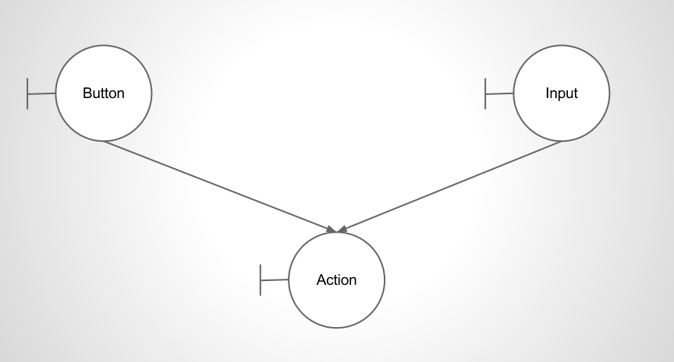UML Class Diagram
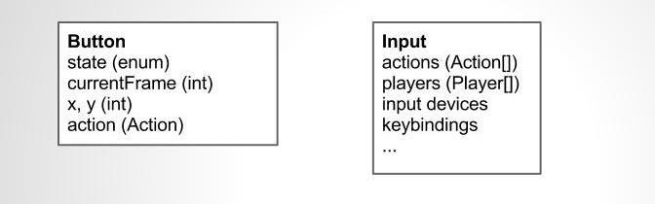Attribute Box Diagram
2.3.4 Control Class Modeling

Noun Extraction:
game, game play, grid

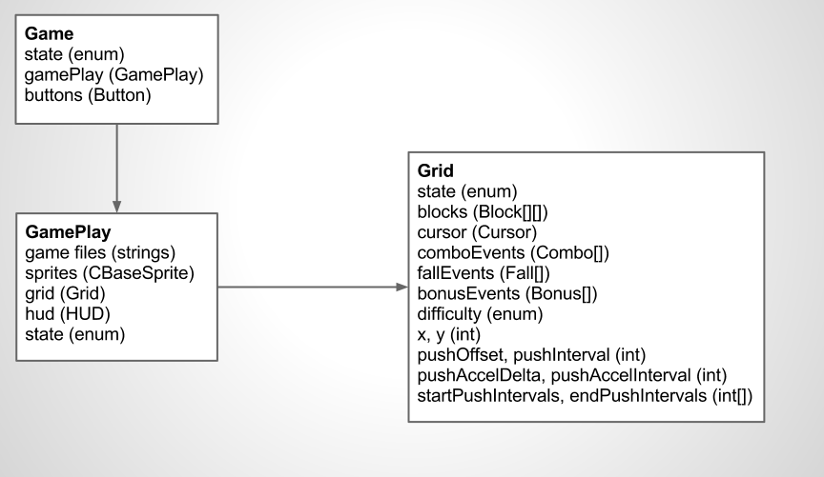Attribute Box Diagram
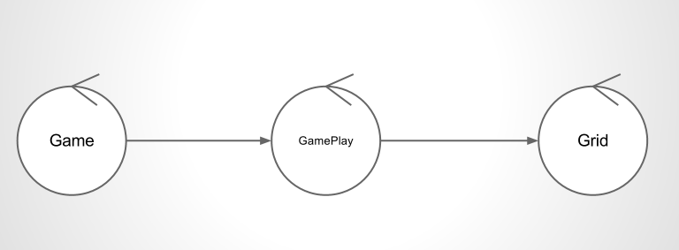UML Class Diagram
2.3.5 Dynamic Modeling
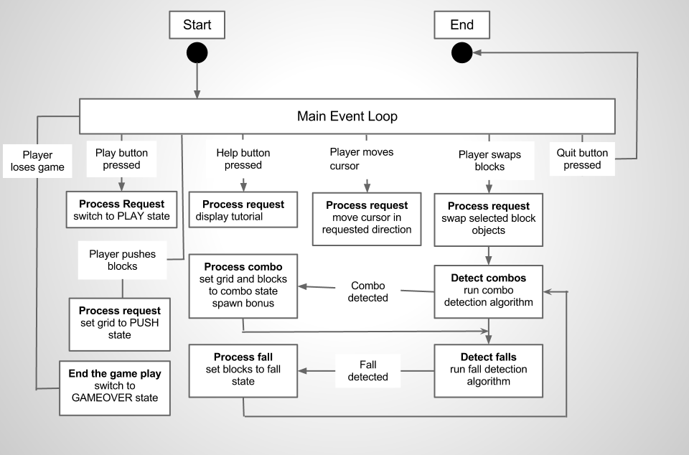Dynamic Model Diagram
2.3.6 Communication Modeling
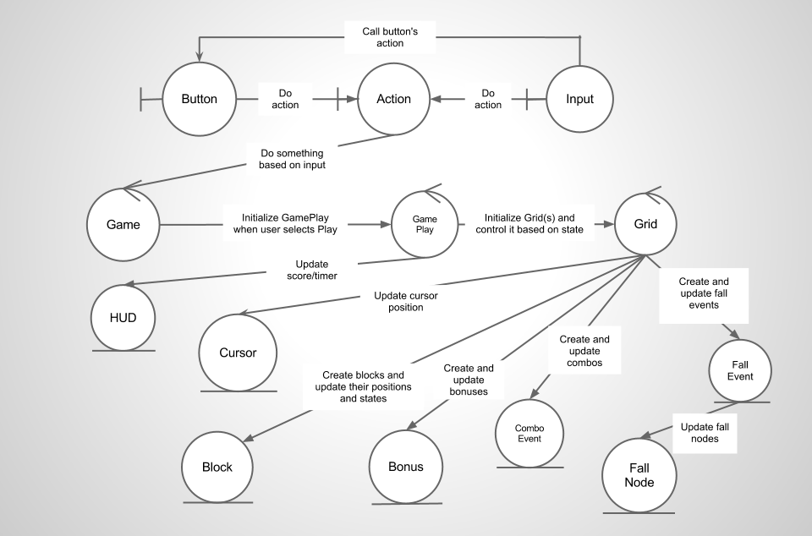Communication Model Diagram

