<^> TRIFORCE <^>

A Tetris Attack Clone
by Gabe Pike
Team Members: Gabe Pike and Brandon Hinesley

Table of Contents

Section 1: Requirements workflow
  - Requirements workflow
    - Initial Understanding and Glossary
    - Initial Business Model
    - Initial Requirements
    - Detailed Requirements
    - Iterated Use-Case Diagrams and Descriptions
  - Walkthrough
  - Revised Requirements After Walkthrough

Section 1.1: Requirements Workflow

1.1.1 Initial understanding of the project
General
Triforce is a remake of the classic SNES game, Tetris Attack. It is called Triforce in part because of the core game mechanic where one must align at least three matching blocks. In the game, a player controls a cursor that lets him swap two adjacent blocks horizontally. Combinations of 3 or more blocks in a row will break the blocks, causing the blocks above them to fall. The game mechanics allow the player to use their skills and reaction time to gain great rewards. The game mechanics are flexible and allow for several fun modes of play. Figure 1 shows a screenshot of gameplay in Tetris Attack.
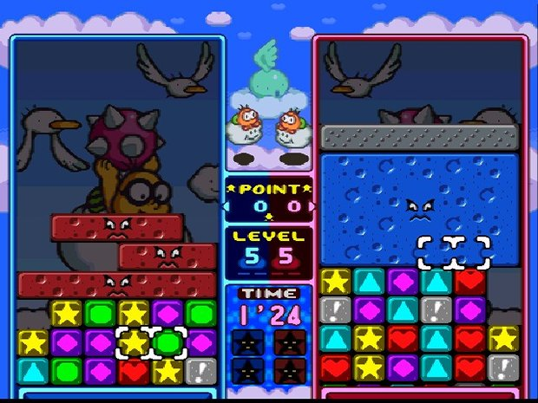Figure 1: This screenshot shows a game with two players. Each player controls the white cursor on their grid of blocks. A player presses a button two swap the blocks inside the cursor.

Menu
The user experience should begin with opening the game to the main menu. The menu will contain buttons for Play, Settings, Help, Credits/About, and Quit. The Settings button will open a new menu to configure settings such as themes, sounds, and difficulty. Help will tell the user how to play. When the user selects Play, they will be taken to another menu to select what mode they want to play. When they select the mode, they will be taken to the actual game. It will start after a timer of three seconds. The gameplay area will consist of a grid of blocks and a cursor for the player to control, as seen in Figure 1. The player uses the keyboard or mouse to move the cursor to an adjacent block horizontally or vertically. The player must break blocks by aligning three or more of the same color vertically or horizontally.

Controls/Input
The controls to Triforce are rather simple. The user only needs to concern himself with the following input (input that will use the same binding is put in the same bullet point):
- Navigate the menus; Move the cursor in four directions
- Select a menu item; Swap blocks
- Boost the speed of play
- Pause/Unpause; Exit
We want to support multiple methods of input. It will be possible to use a keyboard, mouse, or Xbox 360 controller to control everything in the game. This will be done by making generic bindings that are not specific to any kind of input device. Then, we will map each input method from each input device to the generic bindings.

Gameplay and Mechanics
Triforce has potential for several modes of play. Due to time constraints, we will not likely be able to implement them all. At a minimum, we want to implement Endurance Mode, where a player must survive as long as he can while blocks are pushed onto the play area at accelerating speeds. If time permits, we will also implement Versus Mode. In Versus Mode, two players build up large combos and chains, and drop them on each other. It could be played on the input device or over a network connection. Due to time constraints and experience, it is unlikely we will implement any sort of artifical intelligence.

The game play of Triforce looks rather simple to a player, but its inner workings are actually rather complex. The main game mechanics are combos and chains. The mechanics of combos are the easiest to explain. A combo is achieved by aligning at least three matching blocks together. However, you can combine sets of blocks by positioning things right before moving them. Below are some examples of possible combos.

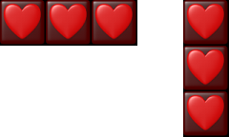Figure 2: 3x Combo
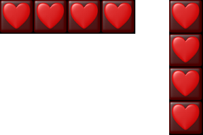Figure 3: 4x Combo

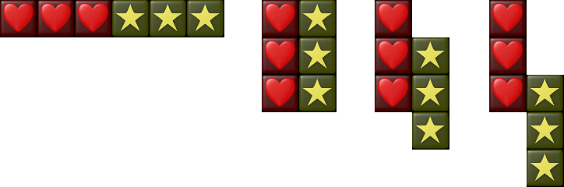Figure 4: 6x Combo (2 sets of blocks)

Chains are more difficult to pull off. Simple chains require a bit of planning, but it is possible to pull off some very complex, well-thought-out chains. A chain is when at least one combo causes blocks to fall directly into another combo. The figures below feature some examples of chains in ascending difficulty.
Figure 5: Basic Chain
Figure 6: Raised Skill Chain
Figure 7: Advanced Chain
Figure 8: Time-Lag Skill Chain

Tools, Libraries, and Version Control:
We will be using Visual Studio 2010 as our development environment during the production Triforce. The game will require the GLUT library for graphics and sounds, and the 2DGraphics library. Due to some limitations of the 2DGraphics library, we will be adding several features to the header file. It will run in a Windows environment and compiled an x86 architecture. We are going to manage our source code and resources with Git and use Github to host our Git repository. We chose Git because both of us know the benefits of version control, and I have experience with Git. Github was chosen because of its many rich features for developers, such its bug/enhancement ticket system, commit tracking tools, wiki, and online code viewing.

Glossary
Combo: A game mechanic where a player aligns at least three matching blocks
Chain: A game mechanic that requires a player to use smart timing and positining to cause combos to generate more combos from falling blocks.
OpenGL: An open-source, cross-platform API for creating 2D and 3D computer graphics.
GLUT (OpenGL Utility Toolkit): A closed-source procedural library written in C that contains utilities for OpenGL programs and input devices.
2DGraphics Library: A closed-source interface to GLUT that contains library functions useful for games, created by Dr. Arif Wani.
Version Control: Management of changes to documents, computer programs, or other collections of information.
Repository: A data structure, usually stored on a server, that contains a set of files and directories, historical record of changes in the repository, set of commit objects, and a set of references to commit objects, called heads.
Git: A version control system that is fast, local, and distributed.
Github: A popular website for hosting Git repositories that is free to use.
Commit: A single revision in a revision control system.
Visual Studio 2010: An integrated development environment for Windows.

1.1.2 Initial Business Model
When a user runs the game, the first thing that happens is that the configuration file is loaded from disk. The configuration file contains key bindings for input, the preferred default theme, and theme directory location. After loading the configuration file, the initial menu is displayed to the user. The initial menu will display a background image and the buttons used to transition to other states of the game. The menu contains the following buttons: Play, Settings, Help, About, and Quit.

Use-Cases
Use-Case 1: User runs the executable

Play
Settings
Help
About
Quit
Main Menu
User



Brief Description: When the user runs the programs, a configuration file is loaded and the main menu is displayed.

Use-Case 2: User activates an input event


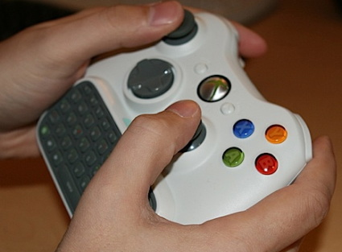
User
Input

Brief Description: When a user activates a binding on an input device, it is handed by a generic interface via mappings and callback routines.

Use-Case 3: User selects Play
User
Play
Settings
Help
About
Quit
Main Menu

Brief Description:
The user selects play on the main menu and the game begins.

Use-case 4: User selects Settings
User
Play
Settings
Help
About
Quit
Main Menu

Brief Description: The user selects Settings and the settings menu is displayed. On the settings menu, the user can change controls, audio, theme, and game play settings.

Use-case 5: User selects Help
User
Play
Settings
Help
About
Quit
Main Menu

Brief Description: The Help button will display a small tutorial about how to play.

Use-case 6: User selects About
User
Play
Settings
Help
About
Quit
Main Menu

Brief Description: The About button will display information about the authors, licensing information, and a brief description of the game.

Use-Case 7: Use selects Quit
User
Play
Settings
Help
About
Quit
Main Menu

Brief Description: The game will exit when the user selects Quit.

User-Case 8: User moves the cursor
User
Game State
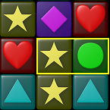
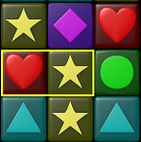

Move Cursor

Brief Description: A user moves the cursor and its position is updated to a new cell.

User-Case 9: User activates a combo
User
Game State

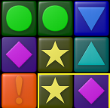
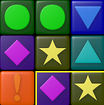

Swap blocks

Brief Description: When the user swaps blocks, their positions in the grid are swapped and combo and fall detection must occur.

User-Case 10: User activates a combo
User
Game State

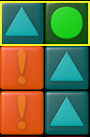
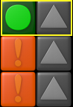

Initiate combo

Brief Description: If a user activates a combo, the blocks will momentarily pause, then break, then cause all blocks above them (if any) to fall.

1.1.3 Initial Requirements
Use-Case 1: User runs the executable

Play
Settings
Help
About
Quit
Main Menu
User

Step-by-step description The first thing that occurs when a user runs the executable is that the configuration file is loaded. If there is no configuration file, some sane defaults are assumed. After loading the configuration file, the main menu objects are loaded and the game transitions into a Menu state. The user is presented with a main menu containing five buttons: Play, Settings, Help, About, and Quit. He will have the ability to select any of these buttons with an input device.

Use-Case 2: User activates an input event
User
Input

Step-by-step description When a user activates an input event, such as from a keyboard, mouse, or Xbox 360 controller, it is handled by a single interface. This interface is a pseudo-device that maintains keybindings for the actual device. For instance, the 'A' key, 'A' button, and left-click can all map to a binding that handles selecting menu items and swapping blocks. In essence, the user activates a registered key binding and passes it to the Input interface. The Input interface will convert it to a generic key binding, and then the action is handled by a callback function.

Use-Case 3: User selects Play
User
Play
Settings
Help
About
Quit
Main Menu

Step-by-step description
The business model begins with the player opening the game. From the main menu, he will most often choose Play. This will start initialize a change in state from Menu to Play. The game's resources will be loaded and the objects will be initiated. Then the game begins and the player can interact.

Use-case 4: User selects Settings
User
Play
Settings
Help
About
Quit
Main Menu

Step-by-step description When the user selects Settings, the menu displayed will be switched to the settings menu. The objects in this menu must be initialized and set in the correct position. The user will be able to configure controls, sound, video, and gameplay options from this menu. Users can save their changes to the configuration file by hitting a Save button. They can return to the main menu by selecting the Back button.

Use-case 5: User selects Help
User
Play
Settings
Help
About
Quit
Main Menu

Step-by-step description When the user selects Help, a change of state will occur and the help screen will be loaded. The user will be given a small tutorial aided by pictures and captions. They can return to the main menu in the same way mentioned before.

Use-case 6: User selects About
User
Play
Settings
Help
About
Quit
Main Menu

Step-by-step description When the user selects About, a change of state will occur and a new screen will be loaded. The About screen will display a short description of the game, credits, and copywrite/licensing information.

Use-Case 7: Use selects Quit
User
Play
Settings
Help
About
Quit
Main Menu

Step-by-step description When the user selects Quit, the game will immediately exit. If time permits, we will add a prompt to ask if they are sure.

User-Case 8: User moves the cursor
User
Game State

Move Cursor

Step-by-step description When a user moves the cursor, its new position is calculated as an offset from the grid's position, given the row and column that the user requests to move to and the length of a single block. The keyboard and Xbox controller can move the cursor one block at a time, but the mouse can select any blocks at any time.

User-Case 9: User activates a combo
User
Game State

Swap blocks

Step-by-step description When the user swaps blocks, the positions of the blocks in the Grid must be swapped. The positions are recalculated using the Grid's x and y position as a reference, and the column, row, and block length to calculate the offset. Combo detection must occur after every swap on the blocks that were swapped.

User-Case 10: User activates a combo
User
Game State

Initiate combo

Step-by-step description When a user swaps two blocks and initiates a combo, the blocks that make up the combo are put into a combo state. The blocks in the combo state have their sprites swapped out with combo sprites. The play area (Grid) is temporarily frozen, and then the combo breaks. Then the blocks above it (if any) fall down until they hit unbroken blocks. Upon landing, combos must be detected again from every block that fell, and the whole process is repeated if a combo is detected.

