<^> TRIFORCE <^>

By: Brandon Hinesley
Other Team member: Gabe Pike
Table of Contents
Section 3: Design Workflow 3
3.1 Design Workflow 3
3.1.1 Component design 3
3.1.2 Interface design 4
3.1.3 Architectural design 5
3.1.4 Detailed Class Design 6

Section 3: Design Workflow

3.1 Design Workflow

3.1.1 Component design
CLASS
Triforce (loader)
RESPONSIBILITY
- Display startup screen
- Control state of game
COLLABORATION
- Buttons
- Input
- GamePlay
MODULE
Input
RESPONSIBILITY
- Accept input from multiple devices
- Register input actions for different parts of game
- Bind actions to specific input buttons
- Queue up input commands and call actions.
COLLABORATION
- Action (subclass)
- Player (subclass)

MODULE
Action
RESPONSIBILITY
- Compare actions
- Call action callback
COLLABORATION
- Input module

MODULE
Player
RESPONSIBILITY
- Store control bindings for each player
COLLABORATION
- Input module

CLASS
Grid
RESPONSIBILITY
- Swap blocks
- Detect chains and combos
- Move blocks up
COLLABORATION
- Blocks
MODULE
GamePlay
RESPONSIBILITY
- Load grid
- Pause game
- Quit game
COLLABORATION
- Grid
CLASS
Blocks
RESPONSIBILITY
- Detect adjacent blocks
- Set state of block
COLLABORATION
- Grid

3.1.2 Interface design

Actions | Objects | Events
Play() | Loads Grid and starts game. | User clicks the play button.
Quit() | Unloads everything and quits the game. | User clicks the quit button.
Pause() | Pauses pushing up of grid. | User clicks the pause button.
Regenerate() | Pushes another row of blocks. | User presses space bar.
Cyclone() | Mixes up blocks. | User activates block matrix.
MoveCursor() | Moves cursor to position of mouse. | Mouse moves.
Swap() | Swaps blocks. | Swap button is pressed.
Push() | Pushes blocks up from below. | Push button is pressed.
Pull() | Pulls blocks from above
composeSchedule() | Composes a schedule of when to push blocks. | Called when user generates blocks via the callback.
siphon() | Destroys blocks by sucking them through a tube. | Called when blocks reach the top and haven't been cleared.

3.1.3 Architectural design

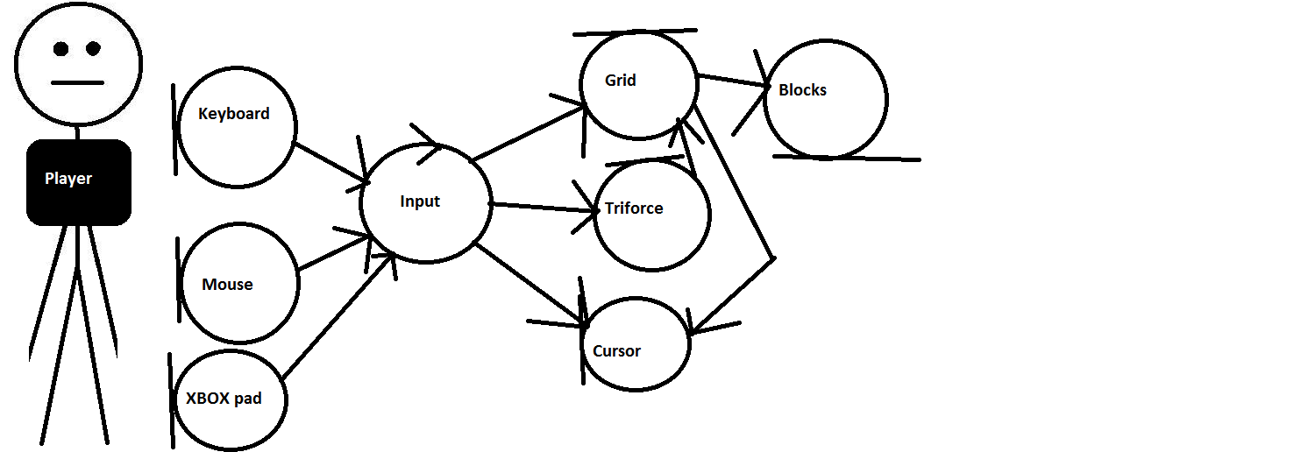

3.1.4 Detailed Class Design

