Section 2: Analysis workflow

2.1 Analysis workflow

2.1.1 Functional Modeling
- Normal scenario
  - A player awakens, drenched in sweat. He knows that his addiction to Triforce is more severe than he would ever admit to his psychiatrist, but he doesn't care. After releasing an ominous battle moan, he throws on a robe, shuffles into his slippers, and makes his way towards the computer. As the program loads, the neon glow of the play button flashes across his face, like the reflection of the sun upon the moon.
  - The player clicks play.
  - A player presses the Play button, to start a single-player game.
  - The menu unloads.
  - The game loads.
  - A timer counts down from 3 to 1, then says GO.
  - The game begins.
  - Blocks begin rising from the bottom. The elapsed game play timer starts.
  - The player moves the block cursor around with the keyboard, and activates the swap block action.
  - Blocks swap.
  - Combo detection is activated, and a combo is detected.
  - The rising of the blocks stops, and the time at which it stopped is recorded.
  - Blocks involved in the combo dissapear.
  - Fall detection is activated, and the blocks above the combo fall.
  - The blocks hit the bottom.
  - Combo detection is activated, and another combo is detected.
  - The chaining of the two combos is detected.
  - Steps 10-13 repeat.
  - The chain ends, and the blocks start rising again.
  - The score is added, with a multiplier based on the number of chains (2).
  - The player presses the button bound to Speed Up Blocks for too long, and the stack reaches the top.
  - The player loses.
  - The score is displayed, and the user clicks OK
  - The main menu loads and the game objects are deallocated.
  - The user clicks quit.
  - The game exits.
- Normal scenario – informational
  - A player presses the Help button.
  - Images and text explaining how to play the game are loaded.
  - After reviewing the information, the user clicks quit
  - The game exits.
- Exception scenario
  - A player presses the Play button, to start a single-player game.
  - The menu unloads.
  - The game loads.
  - A timer counts down from 3 to 1, then says GO.
  - The game begins.
  - Blocks begin rising from the bottom. The elapsed game play timer starts.
  - The user has to leave the computer, and clicks the Pause button.
  - A menu loads.
  - The user returns to the computer, but decides not to resume the game and clicks Quit.
  - The game exits.

2.1.2 Entity Class Modeling
The Triforce main menu loads and several buttons are displayed. The player selects an button which performs an action, using an input device such as the keyboard, mouse, or an xbox controller. The user also has option of selecting help from the menu, which loads a help screen. The user can click the quit button, and the game will exit. If the user selects the play button, the gameplay begins. Then a grid displays, filled with blocks, and a HUD is displayed. The user moves the special in-game cursor around, and swaps blocks. The user creates combinations with the blocks, and a fall event occurs. More than one combination after another creates chains.
Nouns
Triforce
main menu
buttons player
button
action
input device
keyboard
mouse
xbox controller
user
button
game
gameplay
grid
blocks
cursor
combinations
chains
fall event
HUD

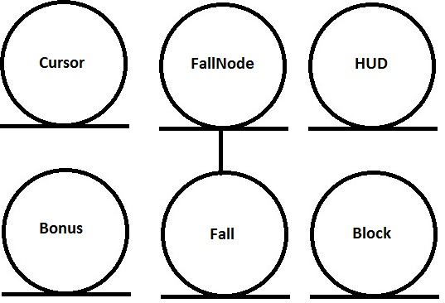
Cursor
pos : Point
row : int
col : int
Bonus
col : int
row : int
bonusType : BonusType
FallNode
chainCount : int
enabled : bool
numFalls : int
Fall
chainCount : int
fallInterval : int
HUD
currentSeconds : int
score : int
x : float
y: float
Block
fallFactor : int
fallOffset : int

2.1.3 Boundary Class Modeling
Boundary classes:
Input
Buttons
Action

Buttons
button[] : Button
currentBtn : Button *
Input
bindings : KeyBinding

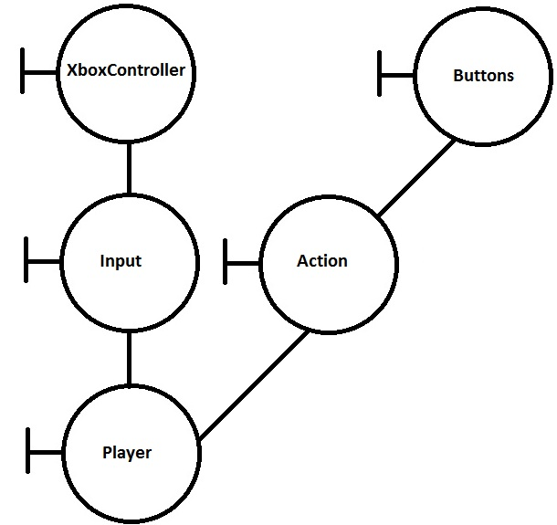

2.1.4 Control Class Modeling

Control classes:
Triforce
GamePlay
Grid
GamePlay
gameState : state

Triforce
gamePlay : GamePlay
buttons : Button []

Grid
blocks : Block []
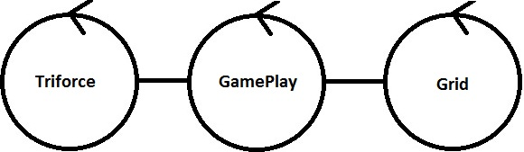

2.1.5 Dynamic Modeling
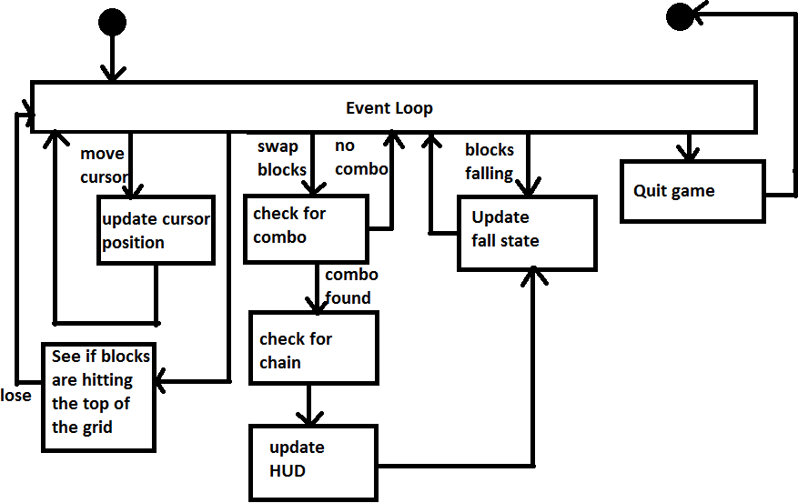

2.1.6 Communication Modeling
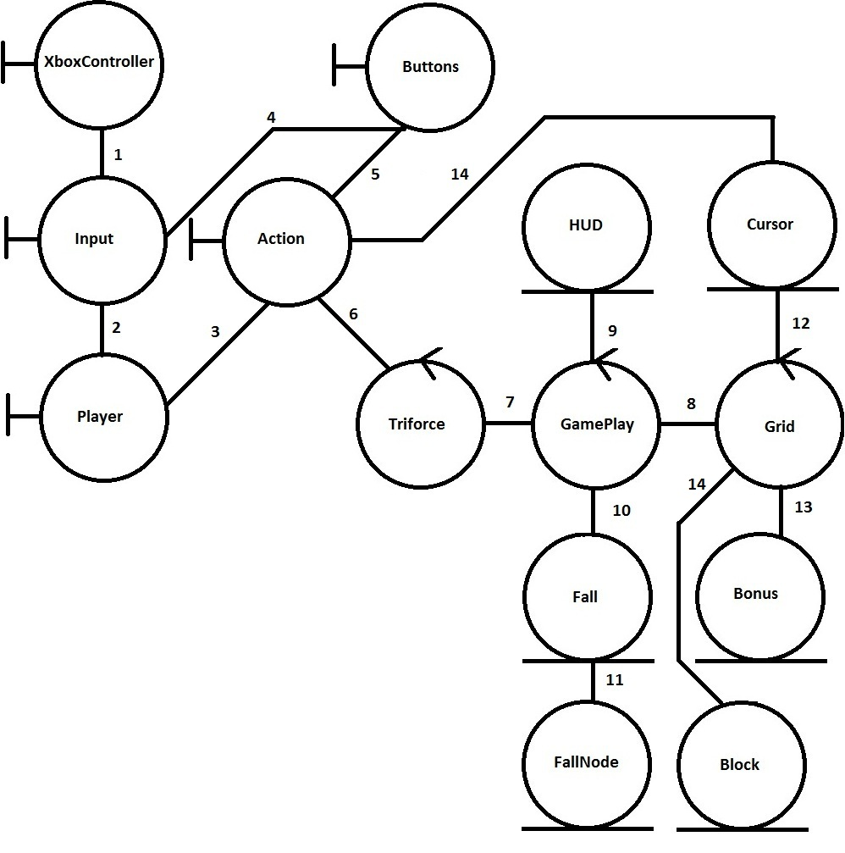
- Input polls state of xbox controller periodically
- Sends signals to a player that has input bindings that correspond to actual input
- Tells action to activate itself
- Input triggers button event
- Button even triggers the action it is bound to
- Action triggers whatever menu event it was registered to
- Loads actual game
- Manipulates grid to account for falls
- Updates score and time
- Look for fall events and handle them
- Update fall nodes
- Cursor manipulates grid speed and tells grid to swap blocks
- Update bonuses
- Update block positions

2.3 Walkthrough
Not all data members are shown.
Some things seem to be incomplete.
- Walkthrough by Gabe Pike

2.3 Revised Analysis workflow

2.1.1 Functional Modeling
- Normal scenario
  - A player awakens, drenched in sweat. He knows that his addiction to Triforce is more severe than he would ever admit to his psychiatrist, but he doesn't care. After releasing an ominous battle moan, he throws on a robe, shuffles into his slippers, and makes his way towards the computer. As the program loads, the neon glow of the play button flashes across his face, like the reflection of the sun upon the moon.
  - The player clicks play.
  - A player presses the Play button, to start a single-player game.
  - The menu unloads.
  - The game loads.
  - A timer counts down from 3 to 1, then says GO.
  - The game begins.
  - Blocks begin rising from the bottom. The elapsed game play timer starts.
  - The player moves the block cursor around with the keyboard, and activates the swap block action.
  - Blocks swap.
  - Combo detection is activated, and a combo is detected.
  - The rising of the blocks stops, and the time at which it stopped is recorded.
  - Blocks involved in the combo dissapear.
  - Fall detection is activated, and the blocks above the combo fall.
  - The blocks hit the bottom.
  - Combo detection is activated, and another combo is detected.
  - The chaining of the two combos is detected.
  - Steps 10-13 repeat.
  - The chain ends, and the blocks start rising again.
  - The score is added, with a multiplier based on the number of chains (2).
  - The player presses the button bound to Speed Up Blocks for too long, and the stack reaches the top.
  - The player loses.
  - The score is displayed, and the user clicks OK
  - The main menu loads and the game objects are deallocated.
  - The user clicks quit.
  - The game exits.
- Normal scenario – informational
  - A player presses the Help button.
  - Images and text explaining how to play the game are loaded.
  - After reviewing the information, the user clicks quit
  - The game exits.
- Exception scenario
  - A player presses the Play button, to start a single-player game.
  - The menu unloads.
  - The game loads.
  - A timer counts down from 3 to 1, then says GO.
  - The game begins.
  - Blocks begin rising from the bottom. The elapsed game play timer starts.
  - The user has to leave the computer, and clicks the Pause button.
  - A menu loads.
  - The user returns to the computer, but decides not to resume the game and clicks Quit.
  - The game exits.

2.1.2 Entity Class Modeling
The Triforce main menu loads and several buttons are displayed. The player selects an button which performs an action, using an input device such as the keyboard, mouse, or an xbox controller. The user also has option of selecting help from the menu, which loads a help screen. The user can click the quit button, and the game will exit. If the user selects the play button, the gameplay begins. Then a grid displays, filled with blocks, and a HUD is displayed. The user moves the special in-game cursor around, and swaps blocks. The user creates combinations with the blocks, and a fall event occurs. More than one combination after another creates chains.
Nouns
Triforce
main menu
buttons player
button
action
input device
keyboard
mouse
xbox controller
user
button
game
gameplay
grid
blocks
cursor
combinations
chains
fall event
HUD

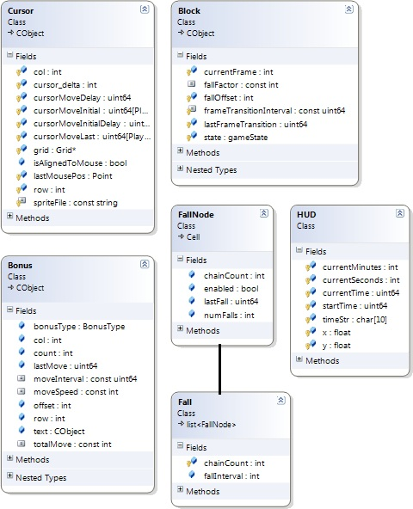

2.1.3 Boundary Class Modeling

Boundary classes:
Input
Buttons
Action

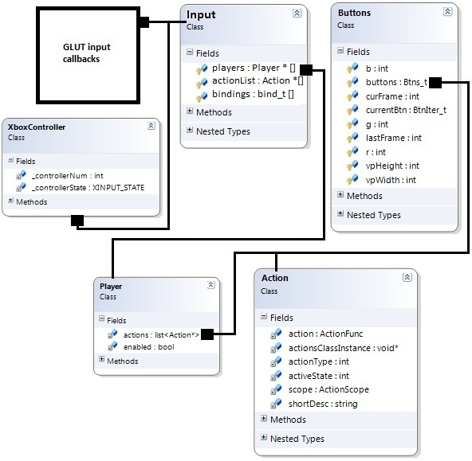

2.1.4 Control Class Modeling

Control classes:
Triforce
GamePlay
Grid
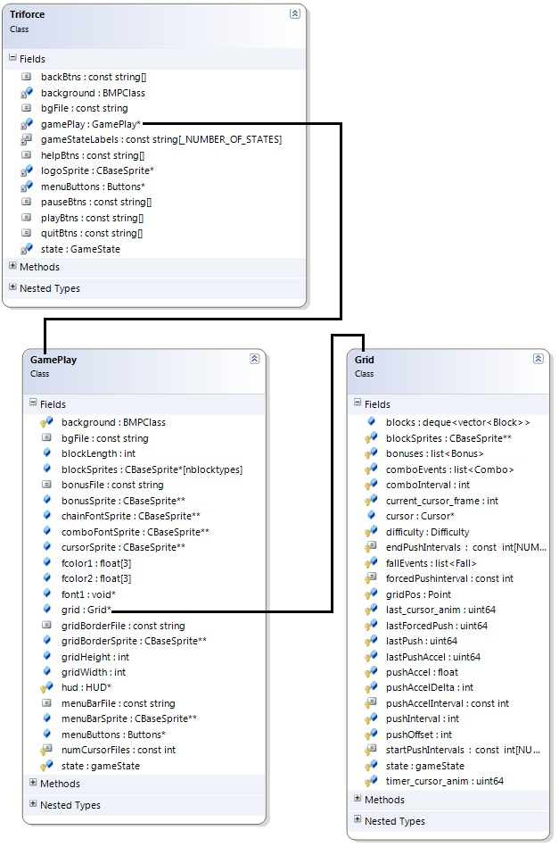

2.1.5 Dynamic Modeling

2.1.6 Communication Modeling
- Input polls state of xbox controller periodically
- Sends signals to a player that has input bindings that correspond to actual input
- Tells action to activate itself
- Input triggers button event
- Button even triggers the action it is bound to
- Action triggers whatever menu event it was registered to
- Loads actual game
- Manipulates grid to account for falls
- Updates score and time
- Look for fall events and handle them
- Update fall nodes
- Cursor manipulates grid speed and tells grid to swap blocks
- Update bonuses
- Update block positions

