DATA4400 – Forecasting Boating Activity Trends
Individual Report
Introduction
This report conducts a monthly time analyses for a boating activity to support a local government feasibility study on whether an existing sinlge-lane boat ramp should be upgraded or not. This kind of activity is seasonal during specific weathers and period of holidays Different kind of forecasting techniques were used to evaluate the most suitable model for medium-to-long term planning.
Data Preparation and Imputation
The dataset was in excel format and there were approximately 84 monthly observations of boating activity and missing observations were labbeled as “N/A”. These were later converted to missing values and visualized properly using time-series plot. I have used linear Interpolation to impute the missing values because the missing values were small. The final 12 months data was reserved for a test of model validation
Holt-Winters Forecasting
A Holt-Winters (triple exponential smoothing) model with additive trend and additive seasonality (period = 12) was fitted to the training data. The model was used to generate a one-year forecast, which was compared visually against the test data.
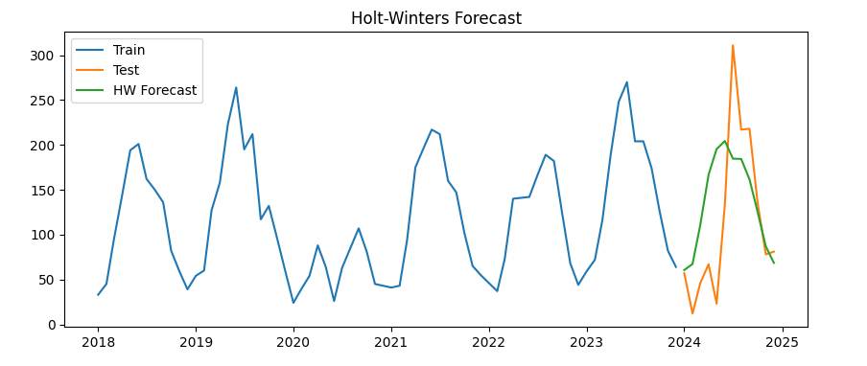
It successfully captured the strong annual seasonality in boating activity Model performance was evaluated using Mean Absolute Scaled Error (MASE), benchmarked against a seasonal naïve forecast. While Holt-Winters give stable forecasts, its limited responsiveness to spikes of sharp demand suggest potential understimation during peak periods.
Prophet Modeling and Diagnostics
The Prophet model was fitted to the training data using both additive and multiplicative specifciations.. Root Mean Squared Error (RMSE) was applied for test accuracy with the add seasonal model producing the lower RMSE and therefore selected for further analysis. Residual diagnostics were conducted by examining the remainder series, Autocorrelation (ACF) and Partial Autocorrelation (PACF).
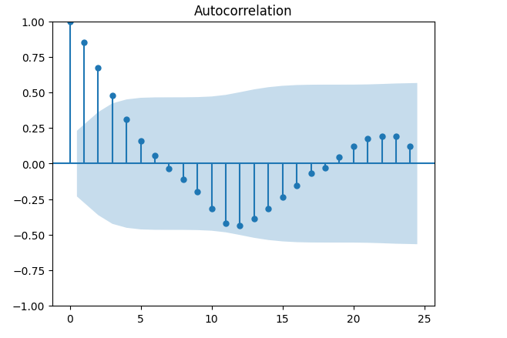
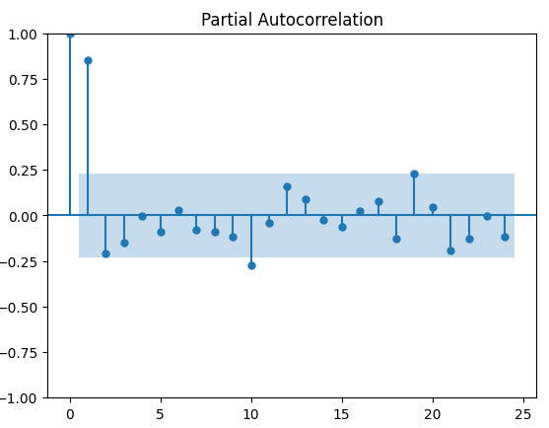

The above pictures validate that Prophet actually demonstrated higher flexibility than Holt-Winters and improved performance in period of high activity.
Seasonal ARIMA Modeling
Based on Information Criteria, Seasonal ARIMA models were implemented. The selected SARIMA model incorporated month seasonlity and with 95% prediction intervals, produced forecasts. RMSE was used here too, to evaluate performance. Although SARIMA performed reasonably well, its RMSE was higher than that of the selected Prophet model. In addition, SARIMA forecasts were less intuitive to interpret for long-term planning purposes. Consequently, Prophet was preferred in this context.
Business Recommendation
The maximum observered monthly boating activity in the historical dataset was found and used to define an operatoinal capacity threshold of 1.3 times the historical peak. Based on the observed peak, the resulting threshold was approximately 404 monthly boat movements. Prophet Forecasting model with additive seasonality was used for predicting 5 years into the future. These mean value which are forecasted remain below the defined threshold all through the period. This suggests that, the current ram configuration is likely to remain adequate over the medium term.
The 68% prediction interval was also checked to account for forecast uncertainity. These do not indicate a sustained or highly probable exceedance. So, the risk of congestion is moderate rather than critical. If it takes 4 month to construct the upgraded ramp, the absence of forecasted threshold shows that immediate construction is not needed. I would advice annual reassessment of boating activity trends, focusing on several new changes and parameters.
In conclusion, based on current forecast and associated uncertainty, upgrading the boat ramp is not necessary within the coming five years. The cost-effective and data-driven task would be to maintain the already-existing facility.

