CODEVENGERS

**A PROJECT REPORT**

**SUBMITTED IN THE PARTIAL FULFILLMENT FOR THE AWARD OF THE DEGREE OF**

**BACHELOR’S OF COMPUETER APPLICATIONS**

**BY**

**GAURAV MISHRA (7001) & ROHAN (7071)**

**UNDER THE ESTEEMED GUIDANCE OF**

**POST GRADUATE GOVERNMENT COLLEGE, SECTOR-11,**

**CHANDIGARH (2021-24)**



**Under The Esteemed Guidance Of**

**MRS. SHAVETA GUPTA**

**ASSISTANT PROFESSOR**

**Department Of Professional Studies**

**AFFILIATED TO**



**PANJAB UNIVERSITY, CHANDIGARH**

**HARDWARE AND SOFTWARE REQUIREMENT**

**HARDWARE REQUIRMENTS**

* RAM : 2GB (MIN)

**SOFTWARES REQUIRMENTS**

* VSCode
* Live server (for local server)
* Browser
* Node & Npm

**INTRODUCTION TO THE PROJECT**

This website is a fantastic place for students to expand their knowledge and learn new skills and languages without any cost. It's a great opportunity for anyone looking to enhance their abilities and broaden their horizons. Students can take advantage of the diverse range of courses and resources available on the website to develop their skills and language proficiency. This kind of platform can be super beneficial for personal growth and academic success. From mastering new languages to acquiring valuable skills, the possibilities are endless.

**FLOWCHART**



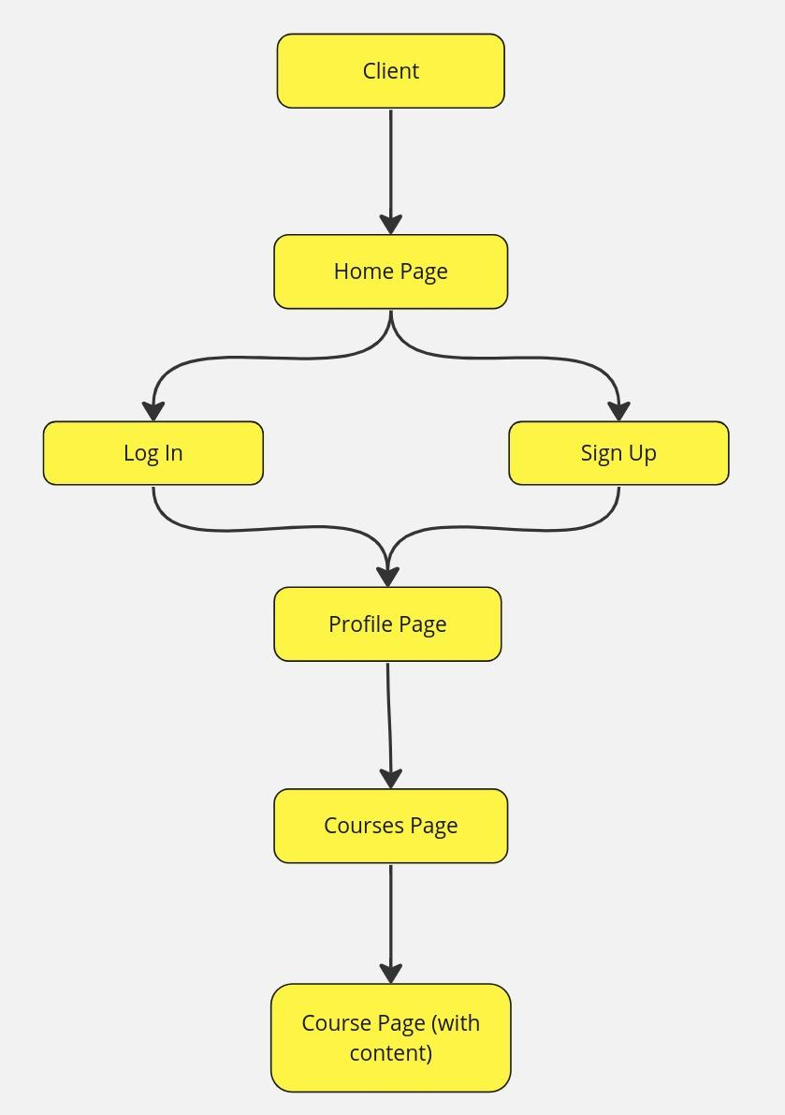

**FUTURE SCOPE OF THE PROJECT**

The future scope of this project entails expanding its capabilities to offer a comprehensive learning platform. This includes enhancing user authentication and authorization mechanisms for secure access. Building upon user profiles, the platform will incorporate social features to foster community engagement and collaboration. Advanced course management functionalities will enable users to create, manage, and share content seamlessly. Interactive learning tools and gamification elements will enrich the learning experience. Integration with third-party services will extend the platform's functionality, while analytics and reporting features will provide valuable insights..

**Some of the features are :**

* Enhanced User Profile
* Social Features
* Advanced Course Management
* Content Creation & Sharing
* Interactive Learning Tools
* Community Engagement
* Integration with Third-Party Services
* Accessibility & Localization
* Analytics & Reporting
* Mobile App Development
* Monetization Strategies

**REFERENCES**

**WEBSITES:**

* [Tutorialspoint](http://www.tutorialspoint.com)
* [GeeksforGeeks](http://www.geeksforgeeks.org)
* [freecodecamp](http://www.freecodecamp.org)
* [w3schools](http://www.w3schools.com)
* [MDN Docs](http://www.developer.mozilla.org)

**YOUTUBE CHANNELS:**

* [CodeWithHarry](https://www.youtube.com/@CodeWithHarry)
* [Chai Aur Code](https://www.youtube.com/@ChaiAurCode)
* [Hitesh Choudhary](https://www.youtube.com/@HiteshChoudharydotcom)
* [freecodecamp](https://www.youtube.com/@freecodecamp)
* [CodeHelp](https://www.youtube.com/@CodeHelp)
* [WebDevSimplified](https://www.youtube.com/@WebDevSimplified)