PROBLEM 1:
Assessment Goal: Validate understanding of basic navigation between pages and form creation using HTML5 elements.
Explanation: The idea is to create two pages and connect them with navigation links. I also designed a registration form with inputs like name, email, password, gender, and course selection. By using attributes such as required and placeholder, the browser ensures correct data entry. This shows we can build a simple multi-page site and collect user information properly.
OUTPUT1:
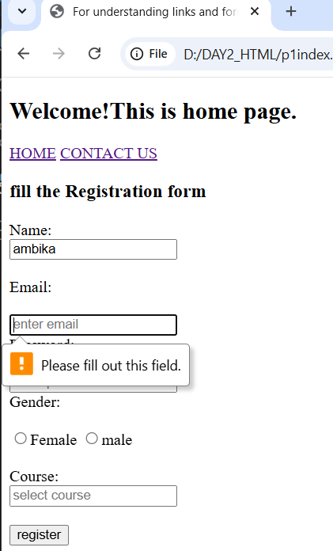

PROBLEM 2:
Assessment Goal: Validate understanding of semantic navigation and relative linking in a multi-page static website.
Explanation: Here I created three pages--Home, Courses, and Contact--and link them using a <nav> menu with anchor tags. Relative paths connect the pages correctly, while internal and external links demonstrate flexibility. This proves we can structure a navigation system that works smoothly across multiple pages.
OUTPUT 2:
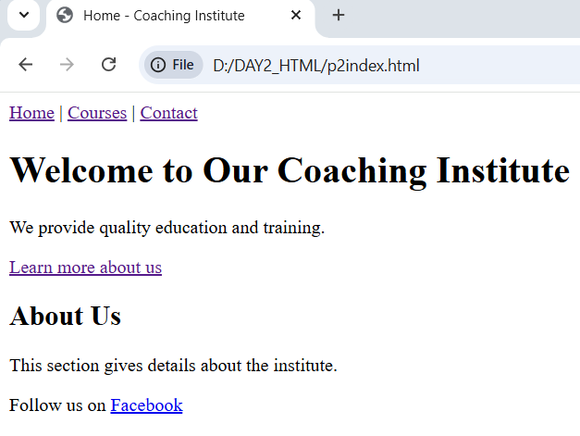
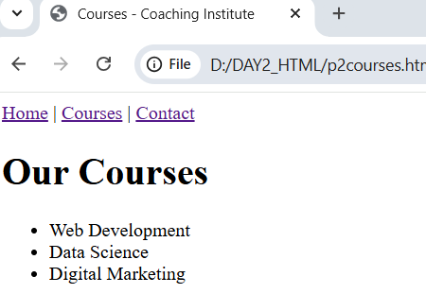
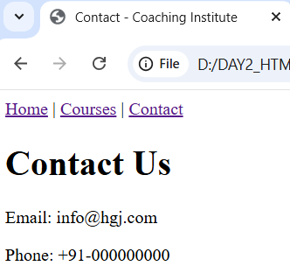

PROBLEM 3:
Assessment Goal: Validate understanding of HTML5 input types and built-in validation features.
Explanation: I built a form with inputs for name, email, phone, age, and date. Each input type enforces rules automatically: email checks format, number uses min/max, and phone uses a pattern. Adding required ensures no field is left empty. This demonstrates how HTML5 can handle validation without JavaScript, making forms more user-friendly.
OUTPUT 3:
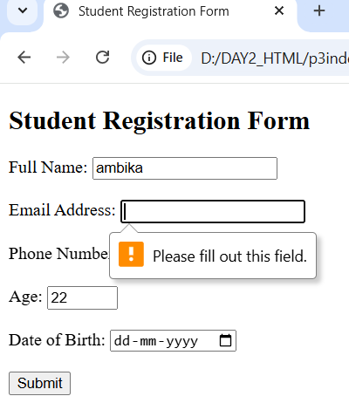

PROBLEM 4:
Assessment Goal: Validate understanding of hierarchical navigation using breadcrumbs.
Explanation: I designed a training portal with multiple levels: Home -> Courses -> Web Development → HTML Course. Breadcrumbs show the user’s exact location and allow easy backtracking. Using anchor tags and relative paths ensures correct linking. This demonstrates how to organize pages in a hierarchy and guide users clearly through a site.
OUTPUT 4:
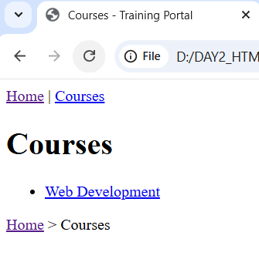

PROBLEM 5:
Assessment Goal: Validate understanding of advanced HTML5 elements that improve user experience in forms.
Explanation: I created an enrolment form using <datalist> for course suggestions, <progress> to show completion, and <meter> to display skill level. Inputs like email, range, and number add modern usability. Built-in validation ensures correctness without extra code. This demonstrates how advanced HTML5 elements can make forms interactive and visually informative.
OUTPUT 5:
