PROBLEM 1:
Assessment Goal: Ensure learners understand responsiveness and screen adaptability using viewport meta tag and media queries.
Explanation: The logic is to use the viewport meta tag so the browser scales content correctly on mobile. Media queries detect screen size and apply different styles (like smaller fonts or vertical navigation). This demonstrates how CSS enables responsive design without extra frameworks.
OUTPUT:
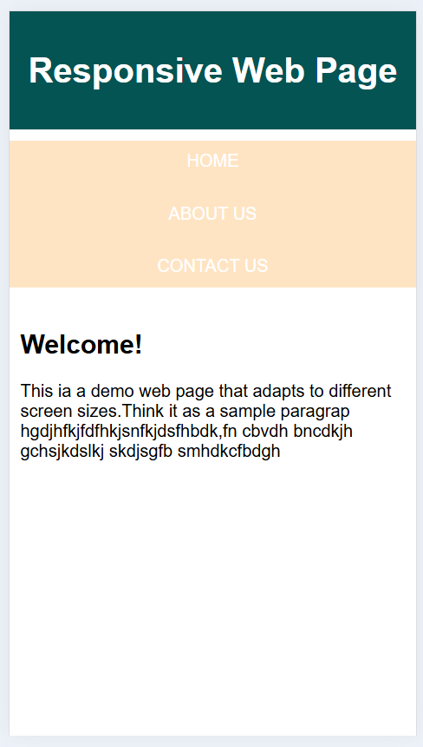
PROBLEM 2:
Assessment Goal: Practice conditional logic in JavaScript by assigning grades based on marks.
Explanation: The logic is to declare a variable for marks, then use comparison operators with if–else to check ranges. Each condition outputs a grade. This shows how JavaScript makes decisions based on numeric values.
OUTPUT 2:
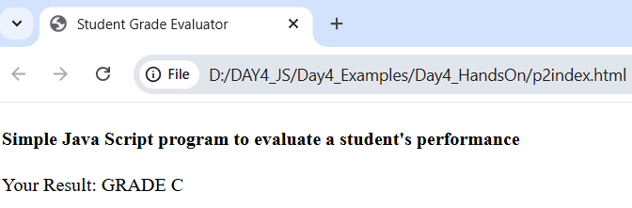
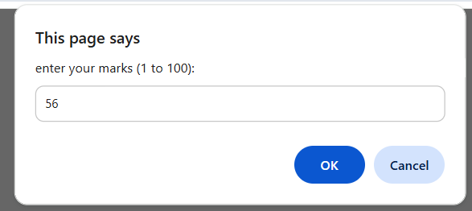
PROBLEM 3:
Assessment Goal: Apply arithmetic and conditional statements to calculate discounts.
Explanation: The logic is to store the purchase amount in a variable, use if–else to check thresholds, apply arithmetic operators to calculate discount, and then subtract it from the total. This demonstrates real-world use of operators and conditions.
OUTPUT 3:
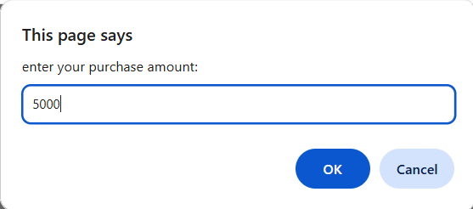
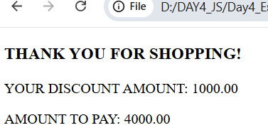

PROBLEM 4:
Assessment Goal: Use switch–case statements to handle multiple conditions based on traffic signal colour.
Explanation: The logic is to store the signal colour in a variable and use switch–case to compare string values. Each case outputs the correct instruction. This shows how switch provides cleaner control flow than multiple if–else statements.
OUTPUT 4:
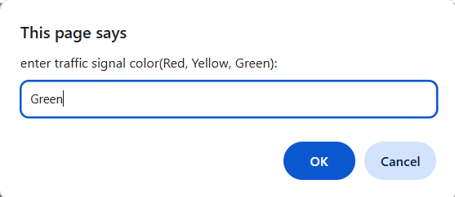
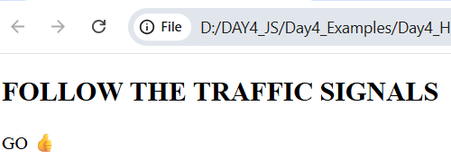

PROBLEM 5:
Assessment Goal: Combine multiple control flow techniques to analyse numbers.
Explanation: The logic is to store a number in a variable, use the ternary operator for quick positivity check, if–else for parity, and a loop to iterate from 1 to the given number. This demonstrates combining operators, conditions, and loops in one program.
OUTPUT 5.1:

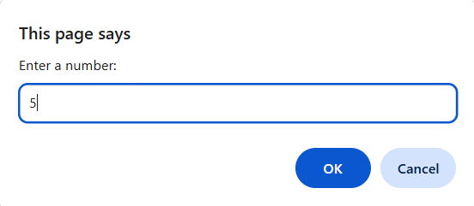

OUTPUT 5.2:
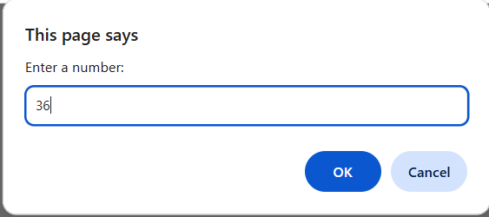
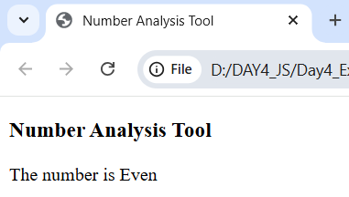
OUTPUT 5.3:
