PROBLEM 1:
Assessment Goal: Check ability to apply styling using external CSS, selectors, and the box model.
Explanation: The logic is to separate design from structure by using an external CSS file. Selectors target specific elements (like headings, paragraphs, and forms) to apply styles consistently. Background colours and borders visually group sections, while margin and padding demonstrate the box model by controlling spacing outside and inside elements. This problem shows how CSS enhances presentation without altering HTML content.
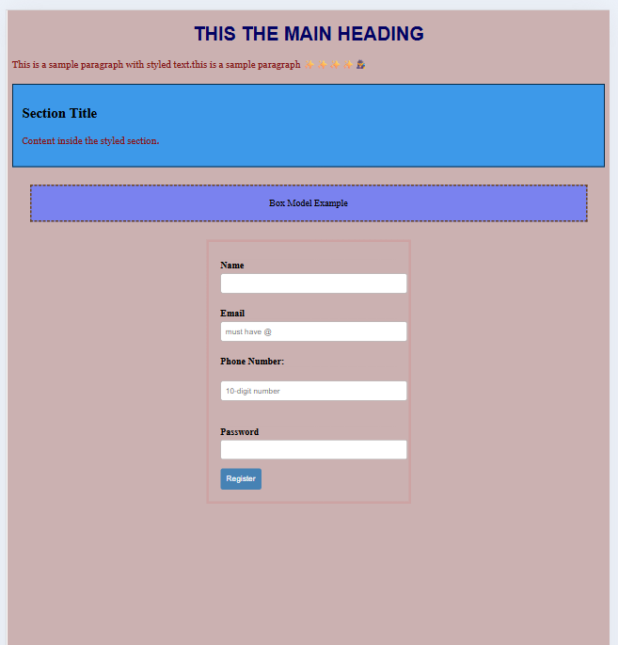

PROBLEM 2:
Assessment Goal: Build a simple personal profile card styled with CSS to demonstrate text formatting, typography, and box model concepts.
Explanation: Here the logic is to create a visually distinct card using CSS properties. Typography (fonts, sizes, spacing) improves readability and hierarchy, while the box model (padding, borders, margins) defines the card’s structure and spacing. Background colour and border radius make the card visually appealing, and hover effects add interactivity to the button. This demonstrates how CSS can transform plain HTML into a styled component suitable for portfolios.
OUTPUT 2:
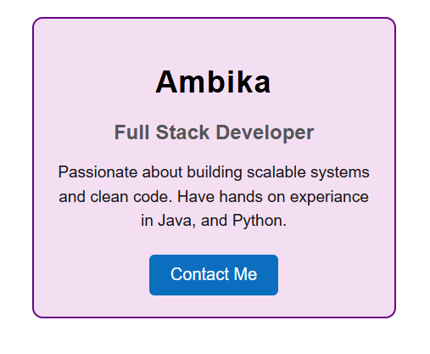

PROBLEM 3:
Assessment Goal: Design a product feature highlight section using lists and CSS selectors to improve presentation.
Explanation: The logic is to style a list of product features using CSS selectors. Element, class, and descendant selectors allow precise control over text and layout. Borders and padding give each feature item definition and spacing, while hover effects add interactivity. Custom fonts and colours improve readability and branding. This problem emphasizes how CSS selectors and box model properties can make lists professional and engaging.
OUTPUT 3:
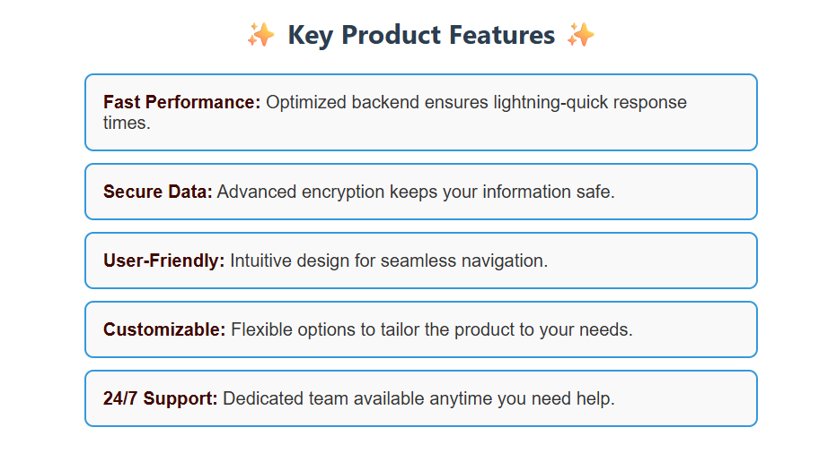
PROBLEM 4:
Assessment Goal: Create a responsive blog homepage layout using Flexbox or Grid, applying box model spacing and media queries.
Explanation: The logic here is to use Flexbox or Grid to create a responsive layout that adapts to different screen sizes. The box model ensures proper spacing between blog cards, while background colours, borders, and typography enhance readability. Media queries adjust the layout: multiple columns for desktops and single column for mobile. This problem demonstrates how CSS enables responsive design without fixed widths, ensuring usability across devices.

OUTPUT 4:
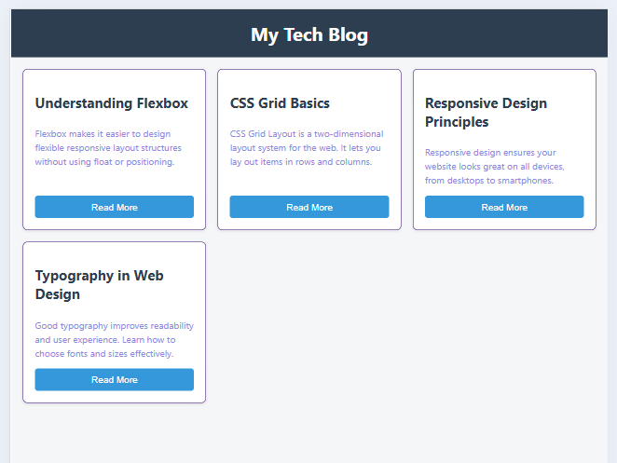

PROBLEM 5:
Assessment Goal: Design a simple admin dashboard layout using Flexbox or Grid with responsive adjustments.
Explanation: The logic is to design a dashboard layout with a sidebar and main content using Flexbox or Grid. Display properties organize the structure, while background colors, borders, padding, and margins style the sidebar and info cards. Media queries adapt the layout: the sidebar becomes top navigation on mobile, and cards stack vertically for smaller screens. This problem shows how CSS can build industry-relevant, responsive UI structures without external frameworks.
OUTPUT 5:
