PROBLEM 1:
Assessment Goal: Demonstrate understanding of basic HTML structure and content creation.
Outcome: Built a static HTML page with proper structure (DOCTYPE, head, body), a heading and paragraph introducing myself, an unordered list of hobbies, an ordered list of daily routine steps, and a simple table showing student details.
CODE 1:
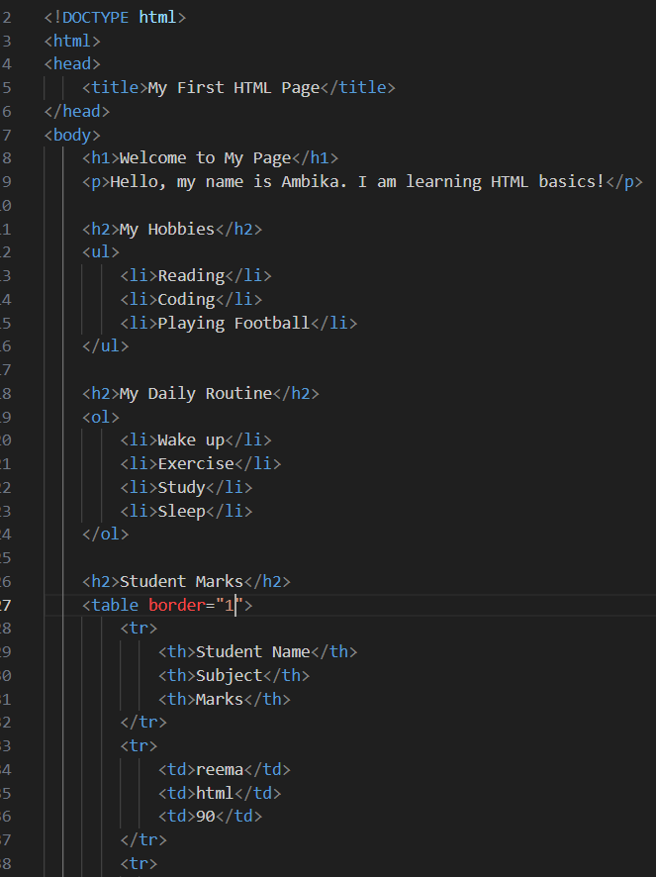
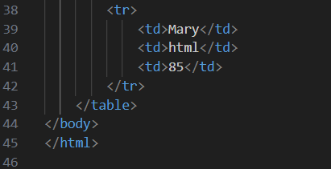
OUTPUT 1:
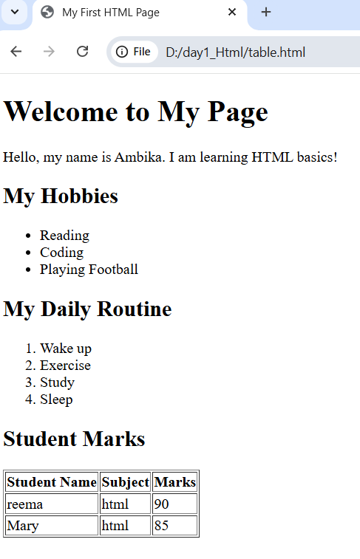

PROBLEM 2:
Assessment Goal: Apply HTML lists and tables to create a simple restaurant menu page.
Outcome: Designed a webpage with the restaurant name and description, menu categories displayed as an unordered list, and a price list shown in a table with item, category, and price columns.
OUTPUT 2:
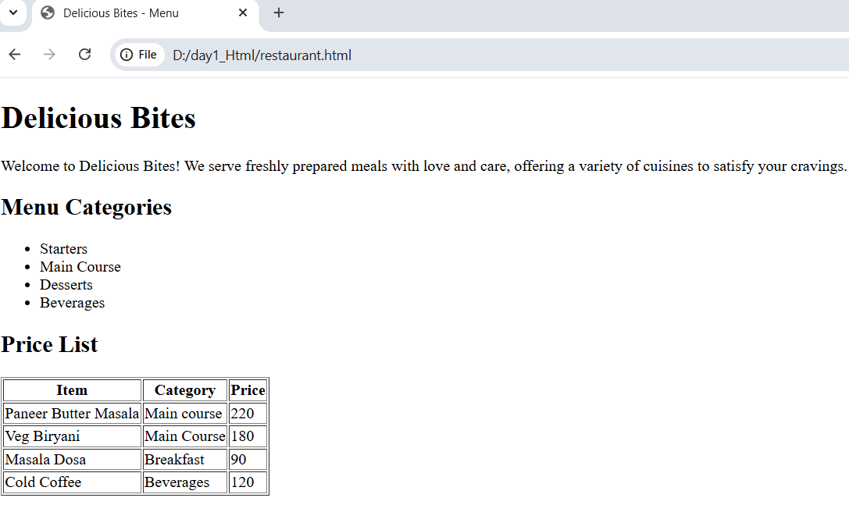
CODE 2:
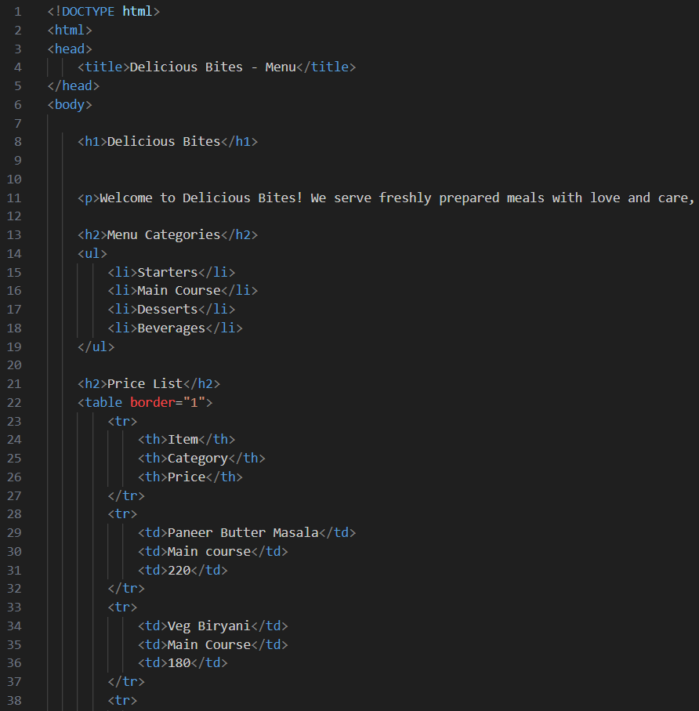
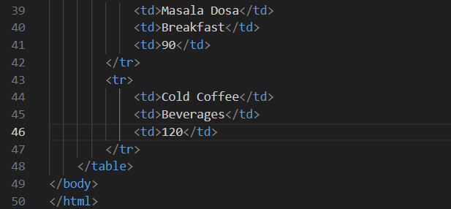

PROBLEM 3:
Assessment Goal: Practice using ordered and unordered lists to organize information.
Outcome: Created a webpage titled Weekly Grocery Checklist with a main heading, an ordered list for high-priority grocery items (Rice, Milk, Vegetables, Cooking Oil), and an unordered list for optional items (Snacks, Ice cream, Soft Drinks).
CODE 3:
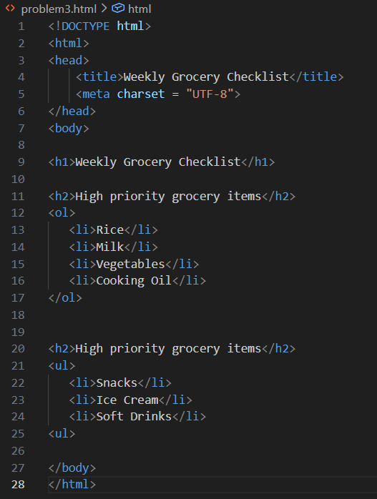

OUTPUT 3:
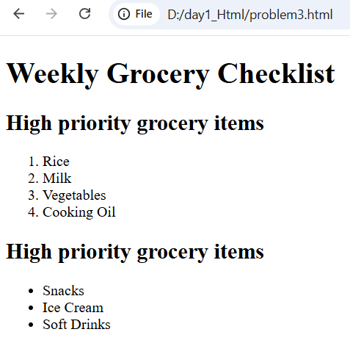
PROBLEM 4:
Assessment Goal: Use semantic HTML tags to structure onboarding information for new employees.
Outcome: Built a webpage with:
- for company name and welcome message
- containing employee details in a table (Employee ID, Name, Department, Joining Date)
- listing company policies in an ordered list
- for facilities provided in an unordered list
- with HR contact information
CODE 4:
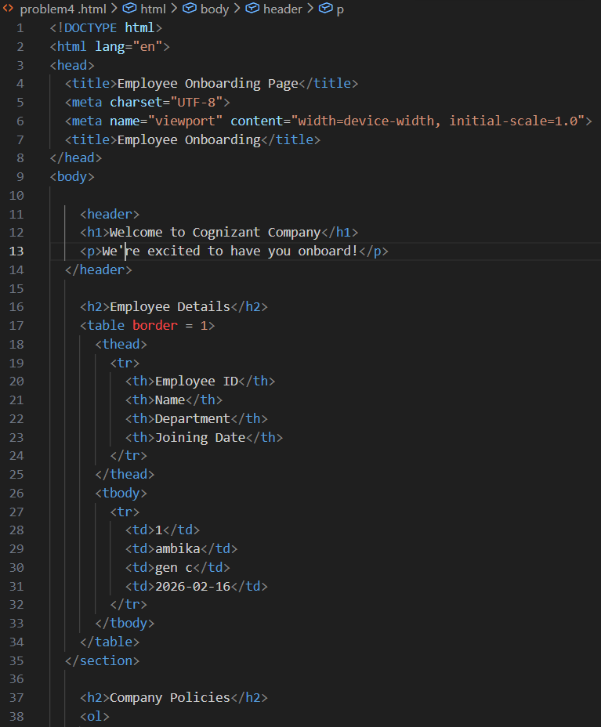
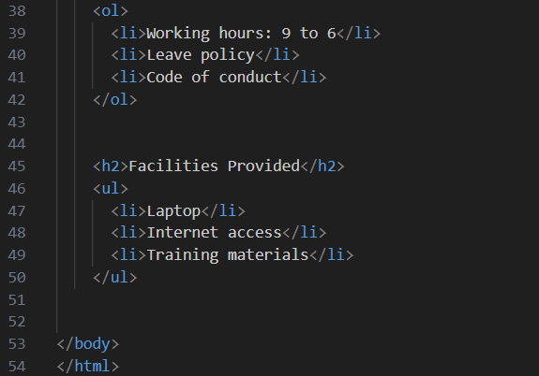

OUTPUT 4:
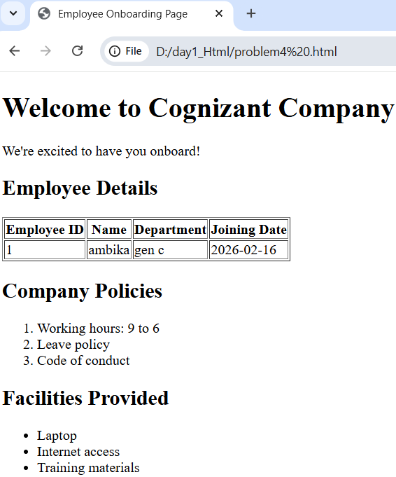

PROBLEM 5:
Assessment Goal: Organize academic information using semantic HTML with tables and lists.
Outcome: Developed a webpage with:
- showing department and college name
- Faculty details in a table (Faculty Name, Designation, Subject Handled)
- Subjects offered in an unordered list
- Weekly timetable in a table (Day, Subject, Time Slot)
- with college address and contact details
CODE 5:
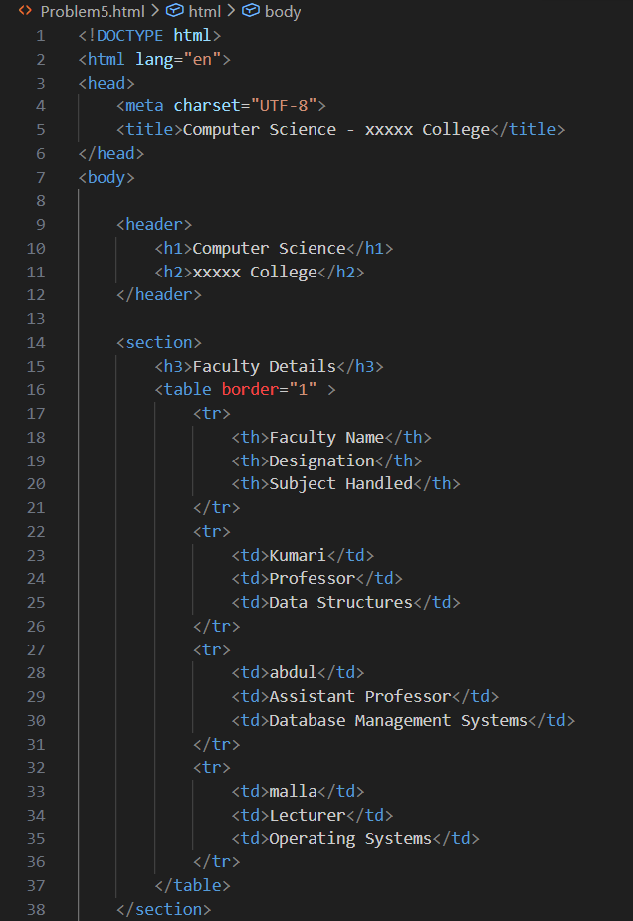
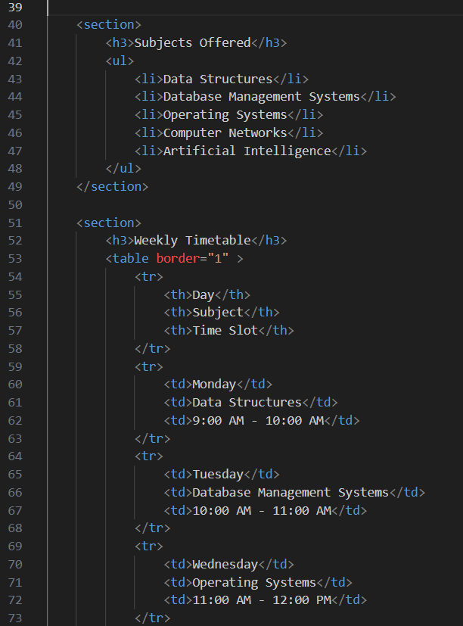
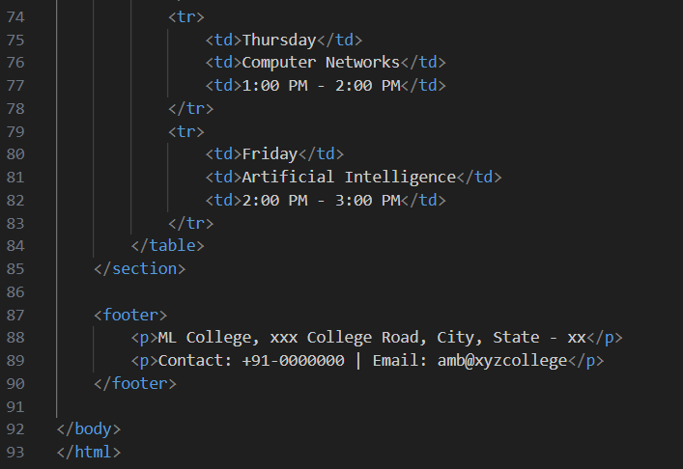

OUTPUT 5:
