**Numerical Analysis – Winter 2021**

Assignment #2

Issued: Nov. 18, 2021 Due: Dec.02, 2021

Please hand in the C or Matlab code (.m files) or others, graphics, and a brief description of your reasoning as well as comments if any. You should pack all of your files into a .rar or .zip file, titled as “xxxxxxx(your student ID)_Homework_2”, and then submit it by uploading to web server or sending to TA before 11:59pm of the due day.

**Please upload to the ‘hw2’ directory if you submit your homework in time.**

**Problem 1：**



**Problem 2：**

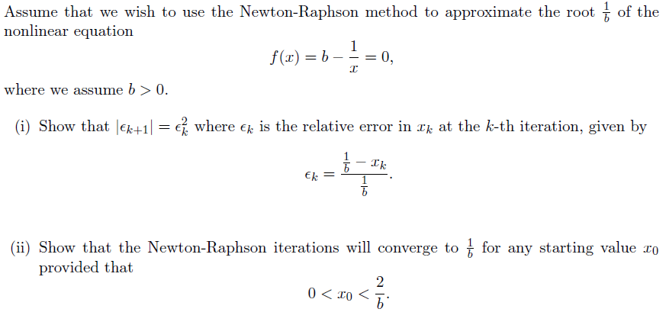

**Problem 3：**

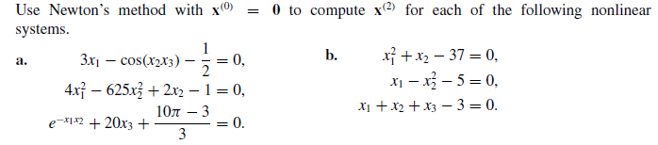

**Problem 4：**

