**Numerical Analysis – Winter 2021**

Assignment #4

Issued: Dec. 06, 2021 Due: Dec.20, 2021

Please hand in the C or Matlab code (.m files), graphics, and a brief description of your reasoning as well as comments if any. You should pack all of your files into a .rar or .zip file, titled as “xxxxxxx(your student ID)_Homework_4”, and then submit it by uploading to web server or sending to TA before 11:59pm of the due day.

**Please upload to the ‘hw4’ directory if you submit your homework in time.**

**Problem 1:**

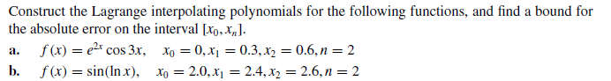

**Problem 2:**



**Problem 3:**

**a.**

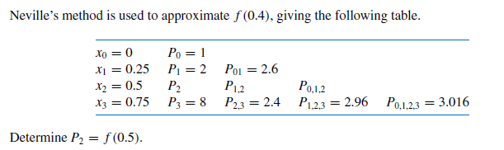

**b.**

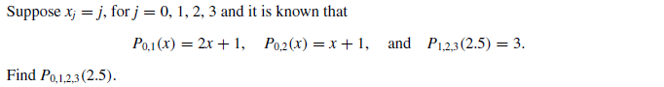

**Problem 4:**

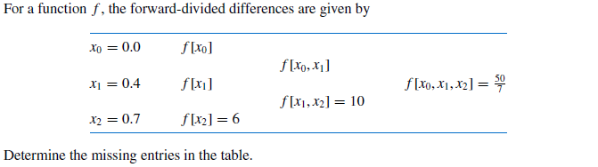

**Problem 5:**



**Problem 6:**

Proof that a strictly diagonally dominant matrix is invertible