For discussion:
- SQLi
  - SQL injection(SQLi) is a web security vulnerability that is utilized by the attacker to view some data that is not authorized by modifying the normal users’ SQL queries, for example, adding some characters to comment out some ‘AND’ constraints for retrieving the hidden information. It usually is related with SQL language and in the SQL database-driven platforms. Also, attacks by concatenating with some ‘TRUE’ or ‘FALSE’ logics injected into the filtering clause like ‘WHERE’ are pretty common as well.
- Brute-Force-Attack
  - Brute force attacks are actually trying all possibilities to find the target information like the login passwords, encryption keys, or finding a URL, etc. It’s old trick and relies on some luck but still popular among the hackers. Also, according to the nature of brute force, which means a large amount of requests in a short time, this can cause some other problems like overloading the servers and resulting in failed common visits, in this case, it works like DDoS.

- SQLi (SQL injection)
For SQL injection(SQLi) detection, we should first focus on the SQL language, and try to find the clause where the injection codes are probably in. the most common locations where SQL injection arises are the WHERE statements, SELECT statements to bypass some constraints to retrieve more data or information. Also, UNION statements can be a sign of some evil attempts for snipping to other tables in the database.
So, after filtering and confirming the SQL injection attacks, we have the attacks’ request URLs at hand. There are attacks using the logics to bypass some constrains
We made analysis on these records and get some interesting pattern.
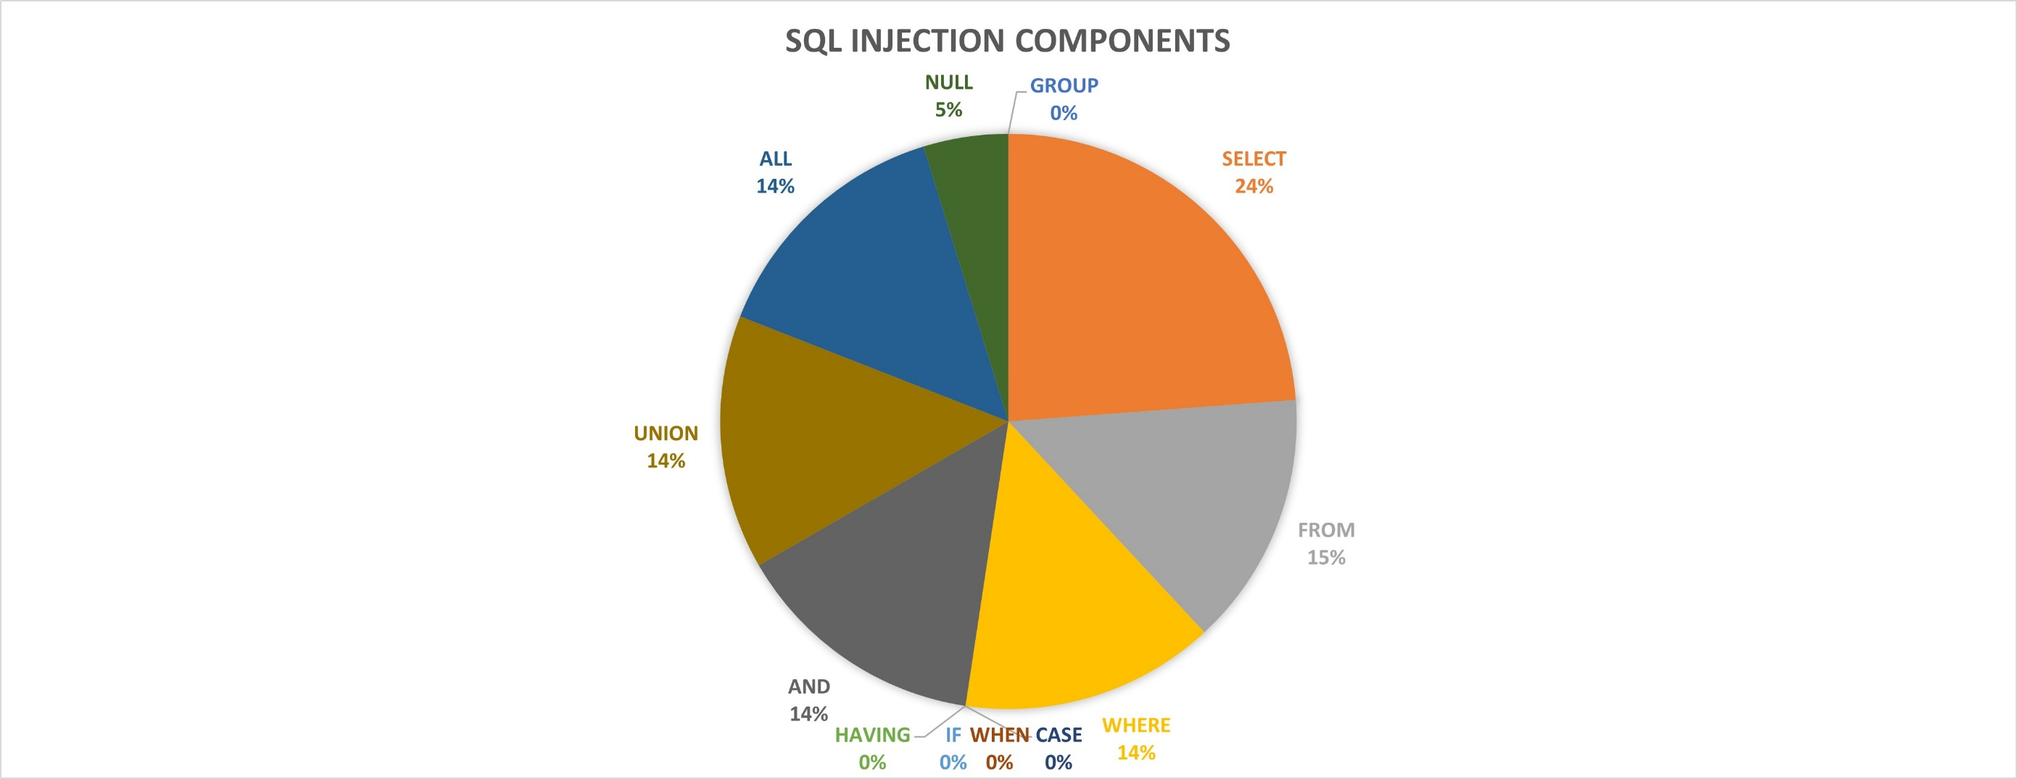
Figure 1.

From the pie chart(Figure 1.), we can find that 14% of the injections have ‘UNION’ or ‘ALL’ or ‘AND’ or ‘WHERE’, 24% have ‘SELECT’, 15% have ‘FROM’ and 5% have ‘NULL’. This can be difficult to analyze and detect whether a request is SQLi just according to the SQL queries’ components. It can be very easy to mix the abnormal requests with the normal ones as the key words like ‘SELECT’, ‘FROM’ can be very common. However, still there’s a clue here, we can find that the percentage of ‘UNION’ as well as ‘ALL’ and ‘AND’ are the same, so we tried filtering all the requests that have the ‘UNION ALL’. Theses request URLs look as Figure 2 shows:
Figure 2.

Also as Figure 3 shows, we get 100% accuracy for identifying as SQLi:
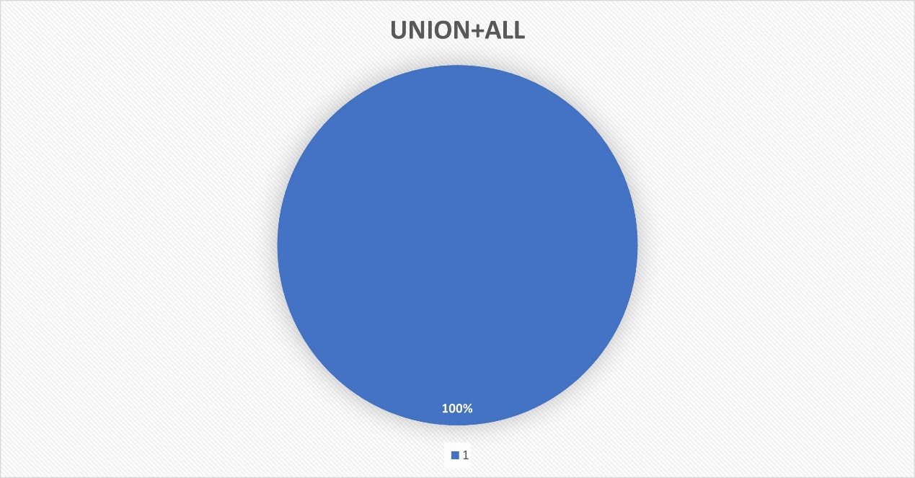
Figure 3

This is rational as most of the requests only need to be remain in several tables or just a single table for the ‘UNION ALL’ can be very expensive within a huge database, it can be suspicious if this case happens in some large company database.
This can be one rule for preliminary detection of attacks, however, the number of results after filtering can still be huge in real life since many users still operate queries in the whole database.

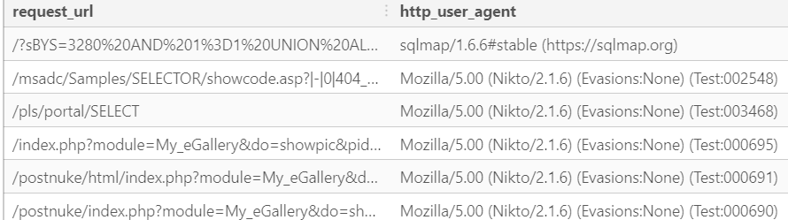
Figure 4.

Injection tool like sqlmap has 6 SQL injection techniques: boolean-based blind, time-based blind, error-based, UNION query-based, stacked queries and out-of-band.
Nikto is an open source (GPL) web server scanner, it can find SQLi, cross-site scripting and other vulnerabilities.

- Brute force attack
Brute force attacks applies the method: trial-and-error to guess, so brute force attacks always take place when large amount of visits requests appear within a short range of time, and usually along with many error messages.

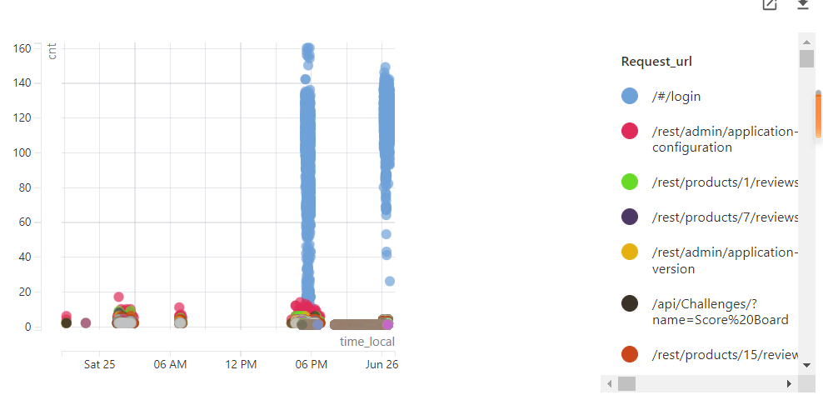
Figure 5.

In order to find any abnormal flaw, for those with unknow normal flaw as reference, we may want to group by requests and time_local to see the pattern to find anything unusual. In our experiment, we have noticed the unusual number of requests: ” /#/login” as figure shows. It has been confirmed that they are attacks and the chart shows that the attacks may come at around 6 p.m. on Saturday, June 25th and some time on June 26th.

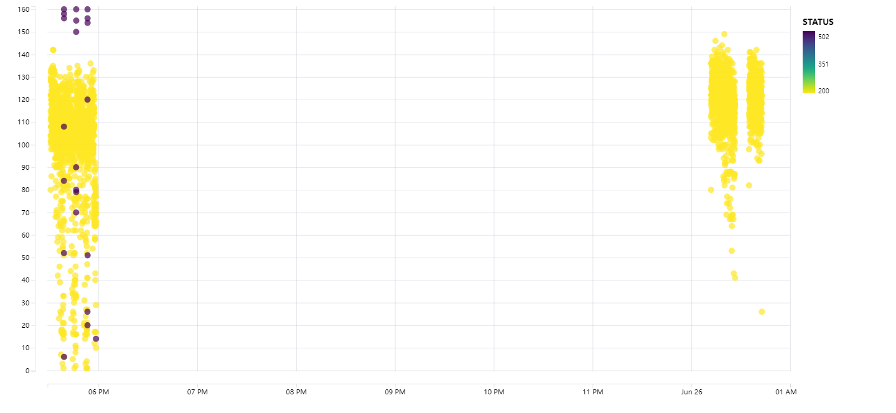
Figure 6.

When checking the state number of this request, we find several state codes are in 500 range(Figure 6.), which indicates failed responses due to problems on the server, this can be seen as DDoS attack in some cases as well.
One famous parallelized login cracker is hydra. It guesses the right combination of right password and uer_id which is known as dictionary attack as well. This can lead to seconds and sometimes years to crack the information.

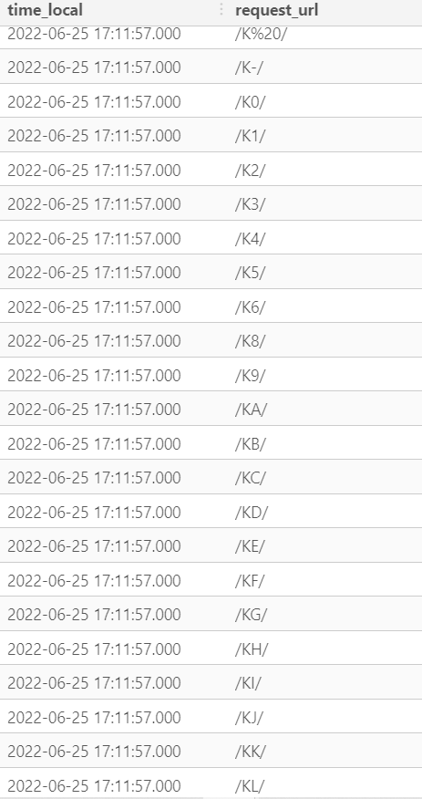
Figure 7.
Another similar attack observed is brute force URL, which is to try every possible URL given some hints. For this kind of attack, a large amount of similar URLs requests appear within a small period of time can be suspicious as Figure 7 shows.

During the analysis on the SQL injection attacks, we first try to filter out all the requests that have ‘UNION ALL’ and all the results turn to be attacks, however, this kind of method needs data analysts to be quite familiar with the database. UNION ALL is irregular when it takes place in a large database with numerous tables because there are few requests that need all the information from all tables. In this case, false positive can occur as there is still possibility. For some injections like adding some characters to comment out constraints for hidden information, submitting Boolean conditions like ‘1=2’ as well as some other methods can also cause false positive. They look abnormal but can still be possible to be normal. Such kind injection vulnerabilities occur in WHERE clause to destroy original constraints logics can be easy to detect but still need further investigation.

When we work on the brute force attacks, our method is to group by requests and time and look at the number of each group according to time series and observe any sudden increase of each request. This operation can be rather expensive. Also, a sudden increase of the request number can be related with some social activities. For example, when people forget their passwords and keep trying can be detected as a brute-force attack if following our principle in this experiment, and cause some false positive errors. For large amount of similar URLs within short time can be normal as well for the same reason.

Filter out SQLi : 5h
Analysis on the SQLi:5h
Filter out brute-force login: 6h
Analysis on it:4h
Filter out brute-force urls:4h
Analysis on it: 4h
Report(part): 10h
Presentation(slide,speech draft): 6h

​

