Test Cases

Note: The test cases covered here are explained in much more depth in our report. Please visit our report to gain a better understanding of these test cases.

# Simple Test Cases (without blaze meter)

These are the test cases that were done initially but were quickly proven to be not useful as they did not show a real-world representation stress test.

Home Page

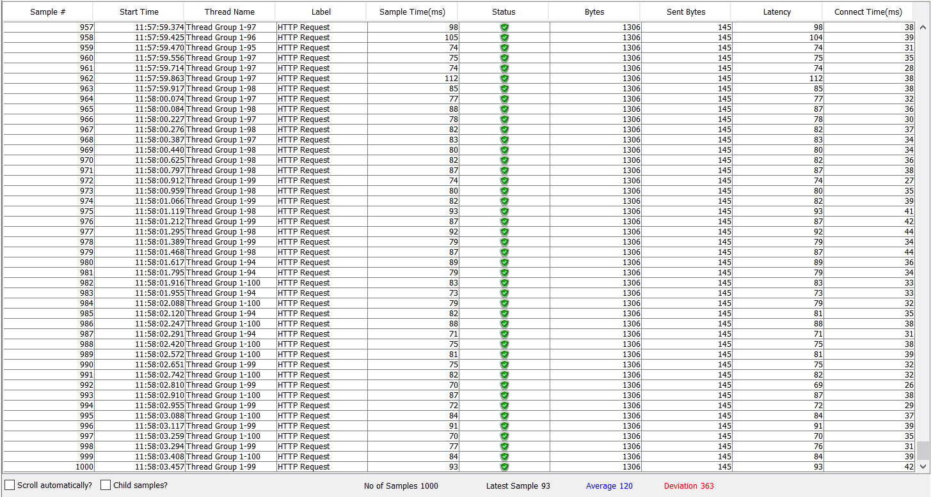

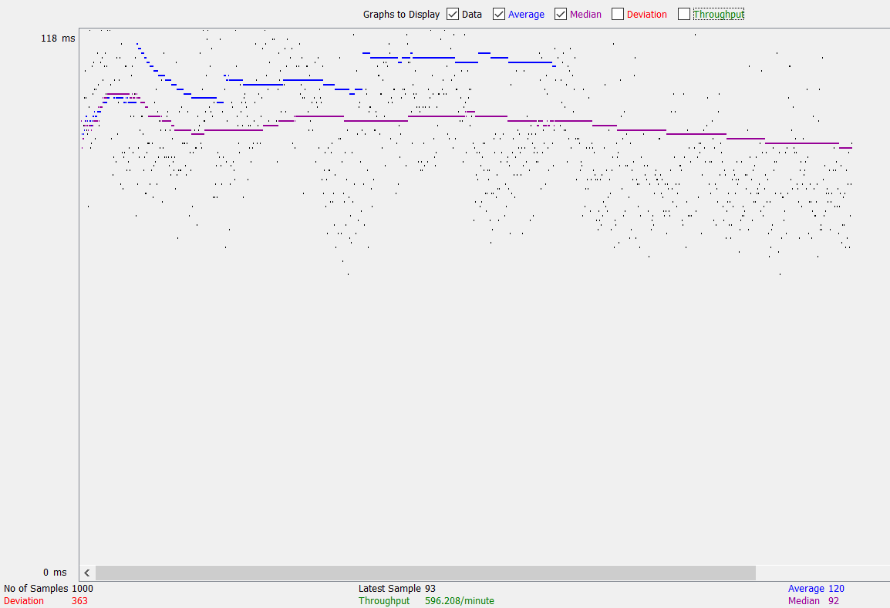

Login Authentication

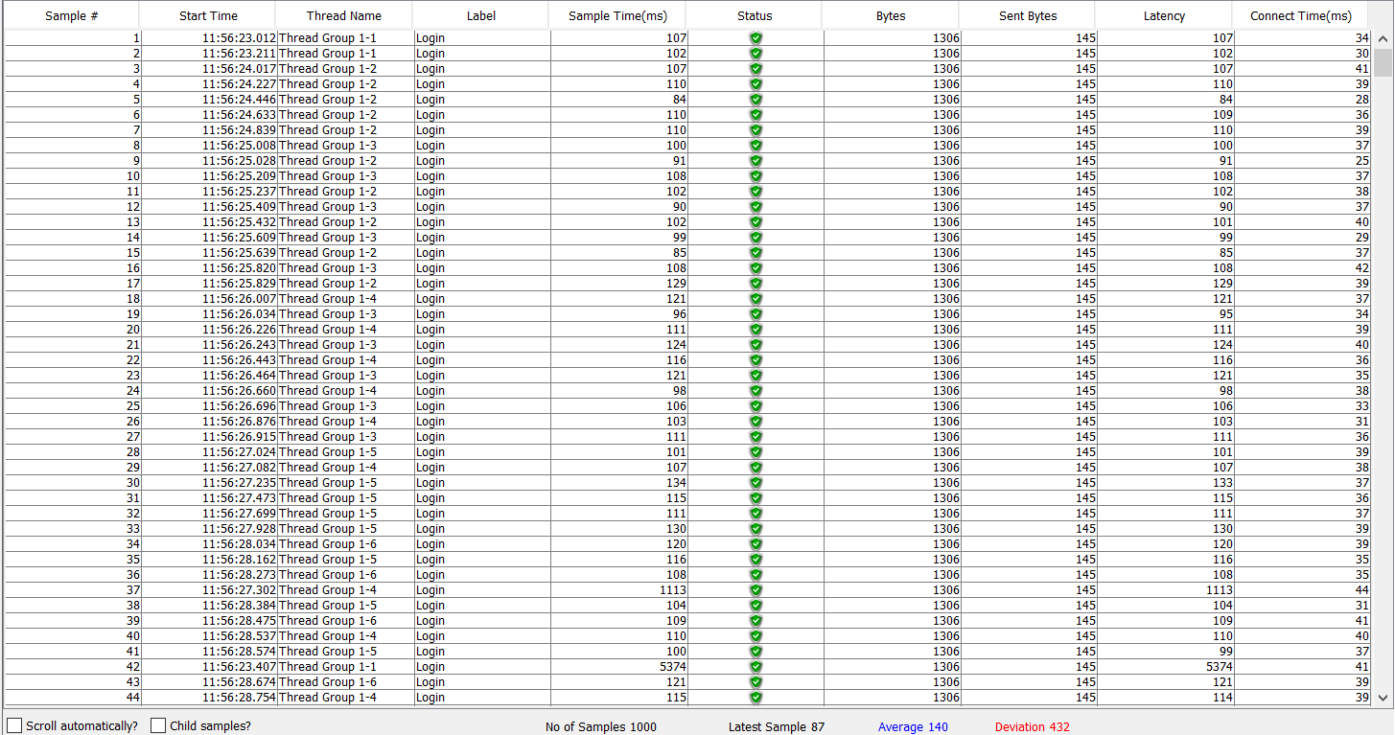

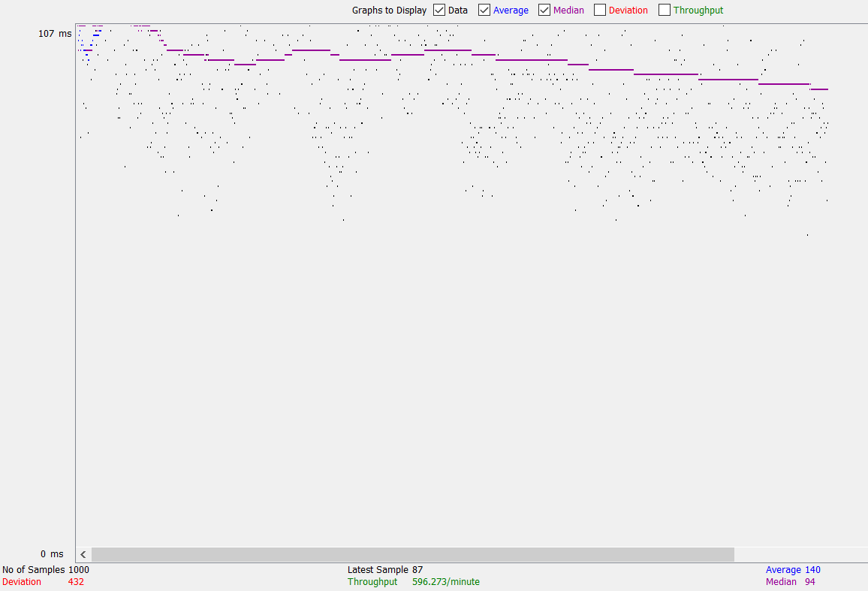

# Complex Test Cases (without blaze meter)

These tests cases represent real world usage as they actually represent real users using the application, this can be actions such as viewing the logging in, viewing the program map, adding/dropping courses, etc..

50 Users

* This scenario is where we have tested 50 Users attempting to use our system

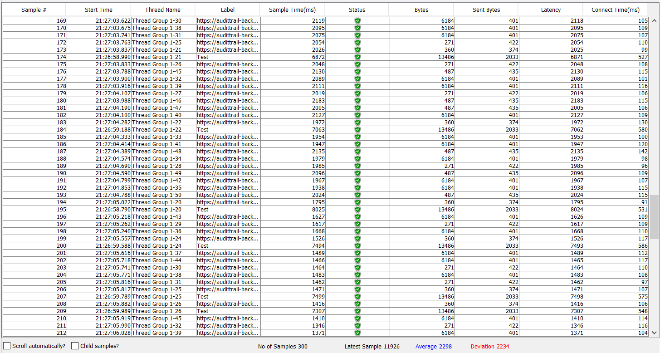

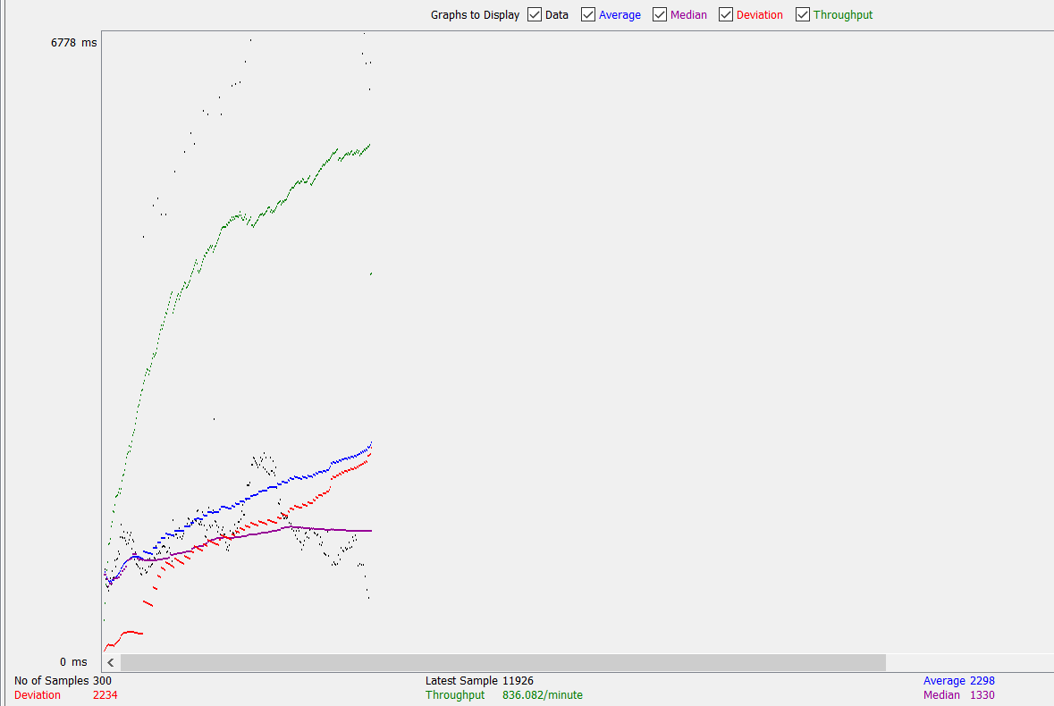

500 Users

* This scenario is where we have 500 Users attempting to use our system

