**TERADATA MTP**

**QUESTION-1**

**PART-1**

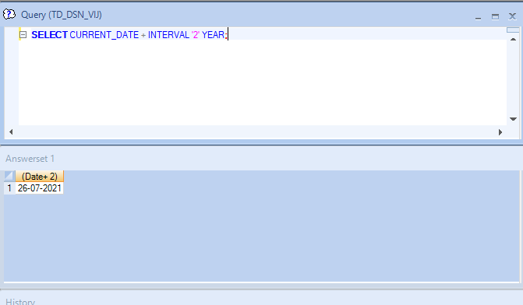

**PART-2**

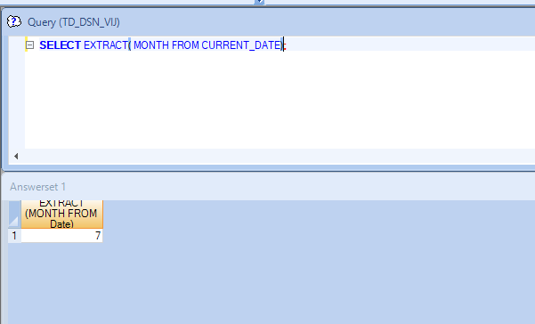

**QUESTION-2**

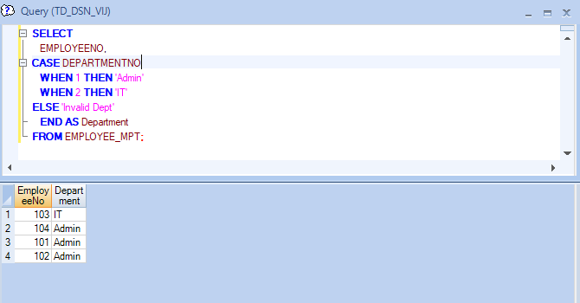

**QUESTION-3**

**DISCLAMAIR:**

We were told not to make tables ,just to write the querie for macro .Take it into consideration.

**FOREIGN_KEY ADDITION**



**CREATION OF MACRO**

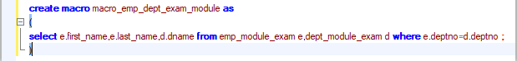

**EXECUTION OF MACRO**



**QUESTION-4**

**EXPORT.BTQ**

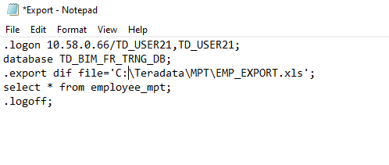

**DELETE.BTQ**

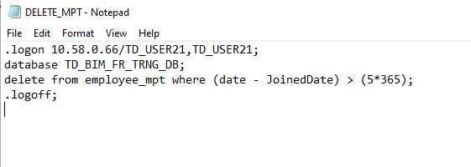

**CMD OUTPUT**

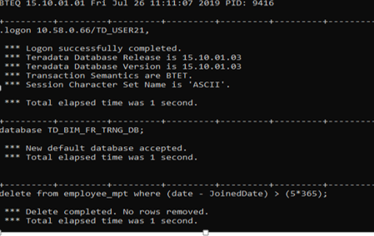

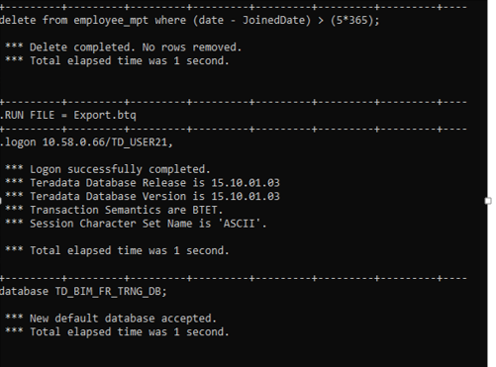

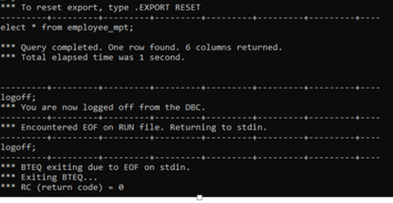

**OUTPUT EXCEL FILE**

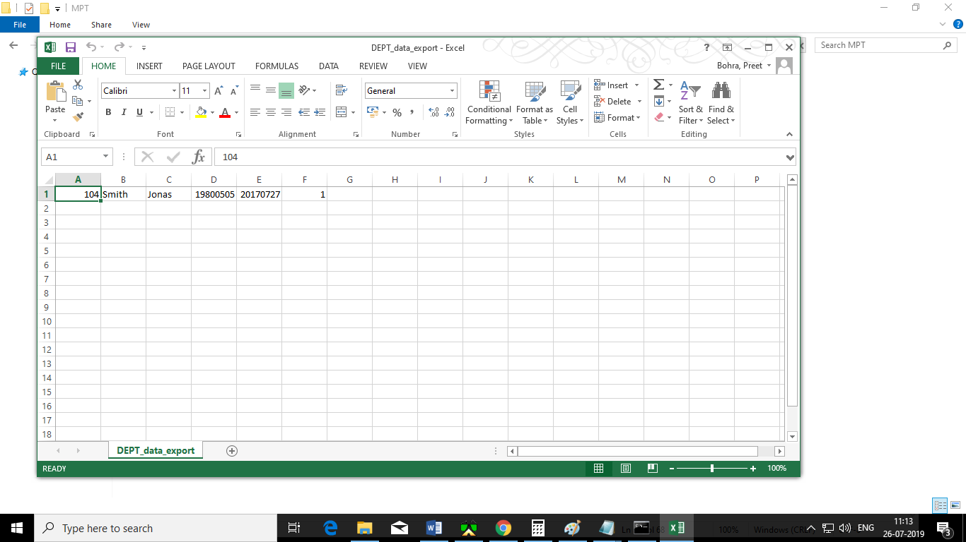

**QUESTION-5**

**MPT_04.BTQ**

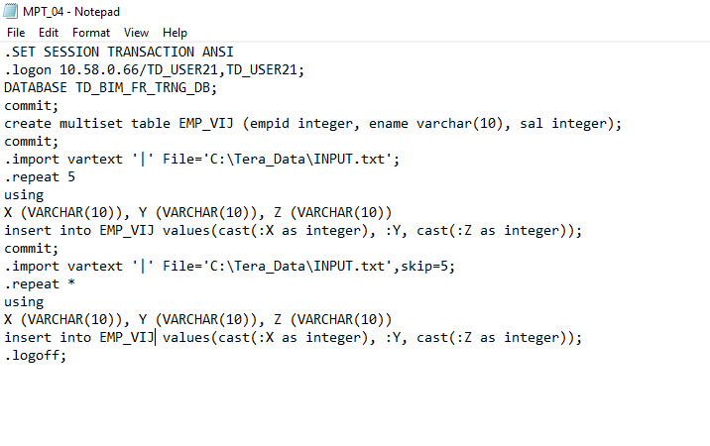

**CMD OUTPUT**

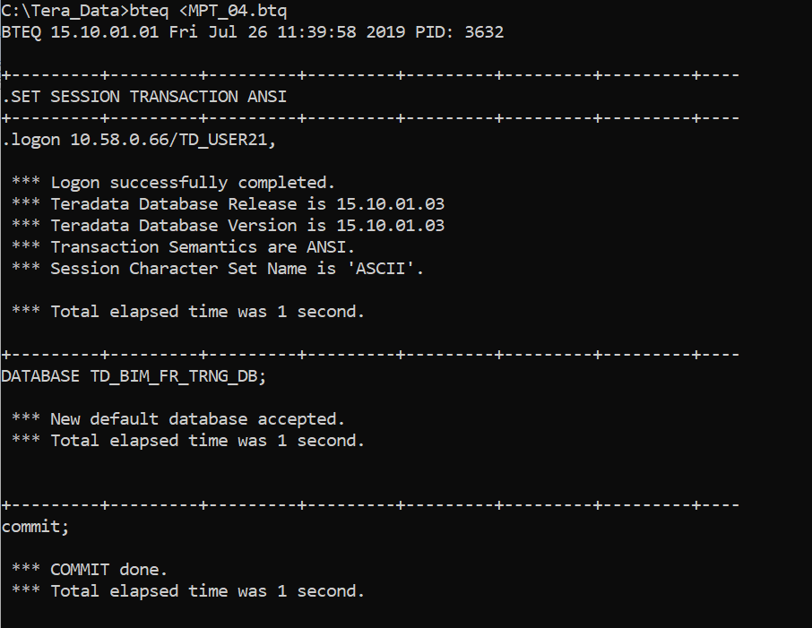

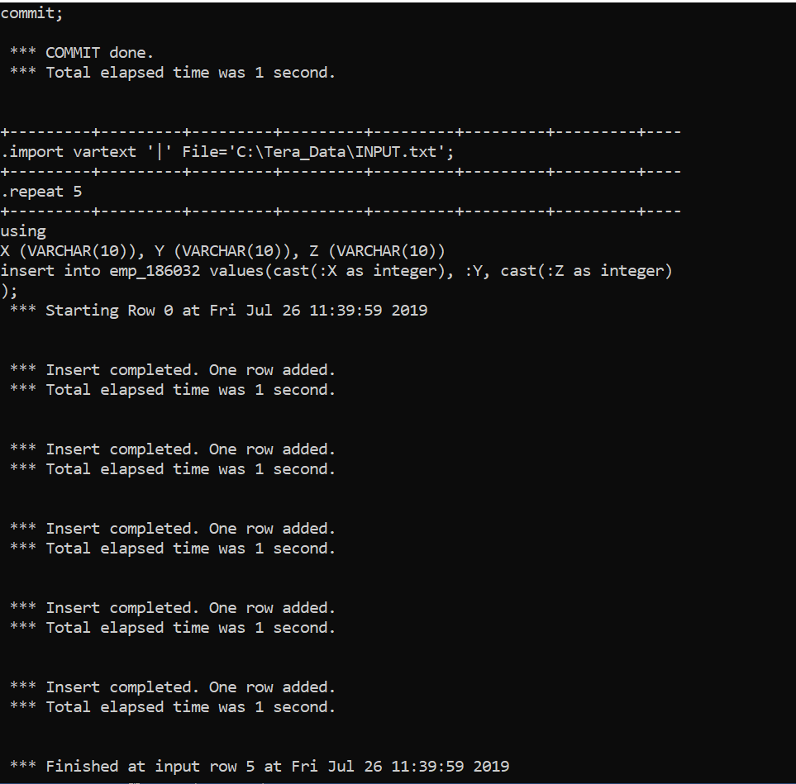

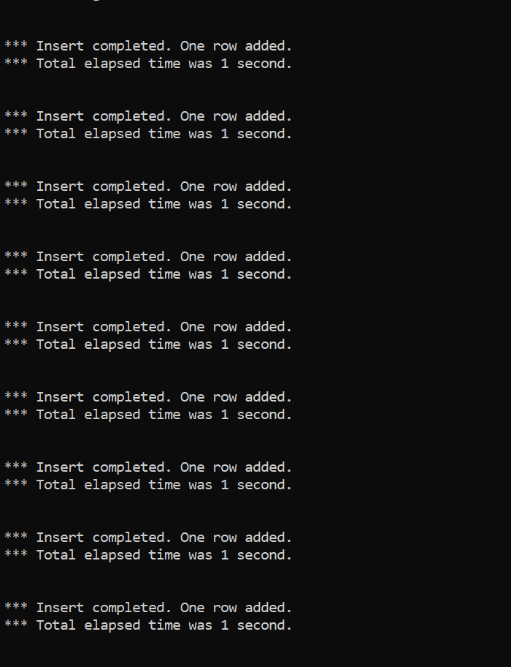

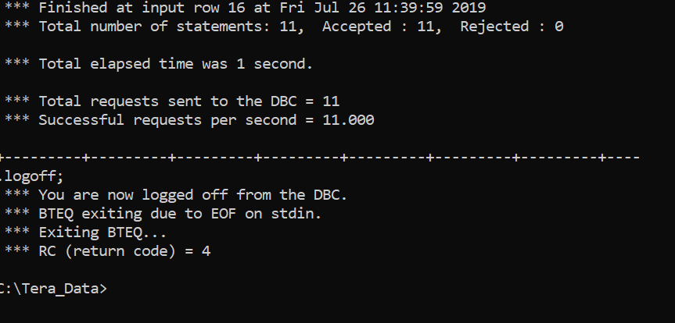

**OUTPUT:**

