KiGN Servo Tester Rev. 0.2

Connection Diagram
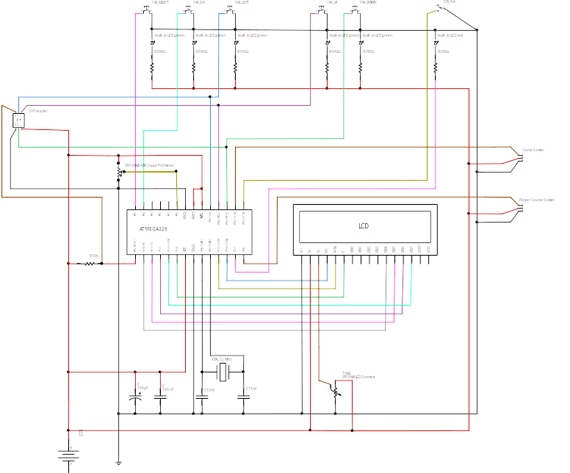

Parts List

schematics ID | description | part.no | count
SW_OK | OK button LED backlit green | HIGHLY PB61302BL-3-103 | 1
SW_LEFT/RIGHT/UP/DOWN | arrow button LED backlit green | HIGHLY PB61302BL-3-104 | 4
SW_NA | switch (reserved for later use), red backlight as error indicator | HIGHLY PB61304AL-13 | 1
ATMEGA328 | microcontroller | ATMEGA328-PU | 1
 | plastic case 125 x 72 x 25 mm |  | 1
xtal 12Mhz | quartz 12 Mhz crystal | Fox Electronics FOXSLF/120-20 | 1
 | single sided prototyping board, 2.54x2.54mm |  | 1
LCD | LCM1602 2x16 character display | EL 1602A – F L – Y B W | 1
R390 | 390 Ohm resistor for LED backlit button |  | 6
R10k | 10kOhm resistor for reset pin |  | 1
C100nF | 100nF ceramic capacitor - power supply filter |  | 1
C15nF | 15nF ceramic capacitor - crystal oscillator |  | 2
C100uF | 100uF electrolytic capacitor - power supply buffer |  | 1
Servo / Power Source Socket | Futaba / JR servo female connector |  | 2
ISP Header | 2x3 pin header |  | 1
VR100kB | ADC input potmeter linear (type B) 100k Ohm |  | 1
VR10kB | LCD contrast trimmer potmeter linear (type B) 10k Ohm |  | 1

