KiGN Servo Tester
Hardware Revision 0.2
Firmware Version 0.2.x

Safety Instructions
Always ensure correct voltage rating and polarity before connecting power source and servo! If your servo behaves unexpectedly - moves unintentionally, audibly strains or moves erratically etc, immediately disconnect it from tester to prevent damage! The tester can be set up to generate non-standard PWM signals that can force a servo beyond its mechanical limits which may cause permanent damage! Please carefully read your servo's datasheet to find correct PWM range, and set up PWM parameters to match your servo's specications before connecting. If you suspect that your servo could be damaged or malfunctioning, do not use it on RC models until fixed or replaced! If the servo is built in to a model, and linkage is still connected to servo arm, make sure you do not move the servo beyond the model's physical limits!

Never leave your servo, tester and battery unattended when turned on! Practice extreme caution when using Servo Excercise function. Lengthy continuous testing, especially when using short/frequent periods can damage your servo, cause it to heat up and may cause fire.

The built-in voltmeter is for rough check only. Use a precise instrument to determine input voltage when it is critical for your application. The tester includes a buffer condenser which smoothens sudden changes in input voltage, and voltage is measured every few ms only, so there may be very short voltage changes not noticed by the tester. To correctly determine voltage drops/surges, use a proper instrument like an oscilloscope. Check voltmeter calibration often.

KiGN takes no responsibility from any damage / harm caused by neglecting these safety measures. Although we tested this appliance as thoroughfully as we can, there are servos, power sources, circumstances or unknown bugs which may cause malfunction.

Technical Specifications

- Operating Voltage*: 4.2 to 5.5 V DC
- Operating Temperature: 0 to 40ºC
- Humidity: 5% to 85% non-condensing
- Current Drawn: 0.4 A @ 4.5 V
- Dimensions: 125 x 72 x 49 mm
- Display: LCM1602 2x16 character LCD display
- Microcontroller Unit: Atmel ATMEGA328
- Internal Clock Speed 3 MHz
- Servo Signal mode: PWM
- PWM Frequency Range: 50 to 300 Hz
- Minimum Pulse Width: 50 μs
- Servo Memory: 20 slots
- PWM Resolution: 0.33 μs
- Potmeter Resolution: 10 bit (0 – 1024)
- Voltmeter Resolution: 0.03 V

* The tester and most analog servos will work from around 3.8 V – for example a single cell LiPo battery charged to at 2/3 of its capacity – but LCD screen will be barely readable even with highest contrast setting

Features

- Precise PWM pulse based on quartz crystal clock source, PWM resolution: 0.33 us
- 2x16 character text and data display, flat menu structure
- Servo PWM frequency, center PWM and PWM range can be set
- Up to 16 character long servo names, a-z A-Z 0-9 characters are available
- Up to 20 servos can be stored in internal EEPROM
- Manual Mode: min / center / max muttons and potmeter with resolution of 1024 steps
- Excercise Mode: adjustable servo travel and delay between 25-5000 ms in 25 ms increments
- Voltmeter: current (averaged) in Manual Mode, min/max when in Excercise Mode, voltmeter calibration menu

Front Panel
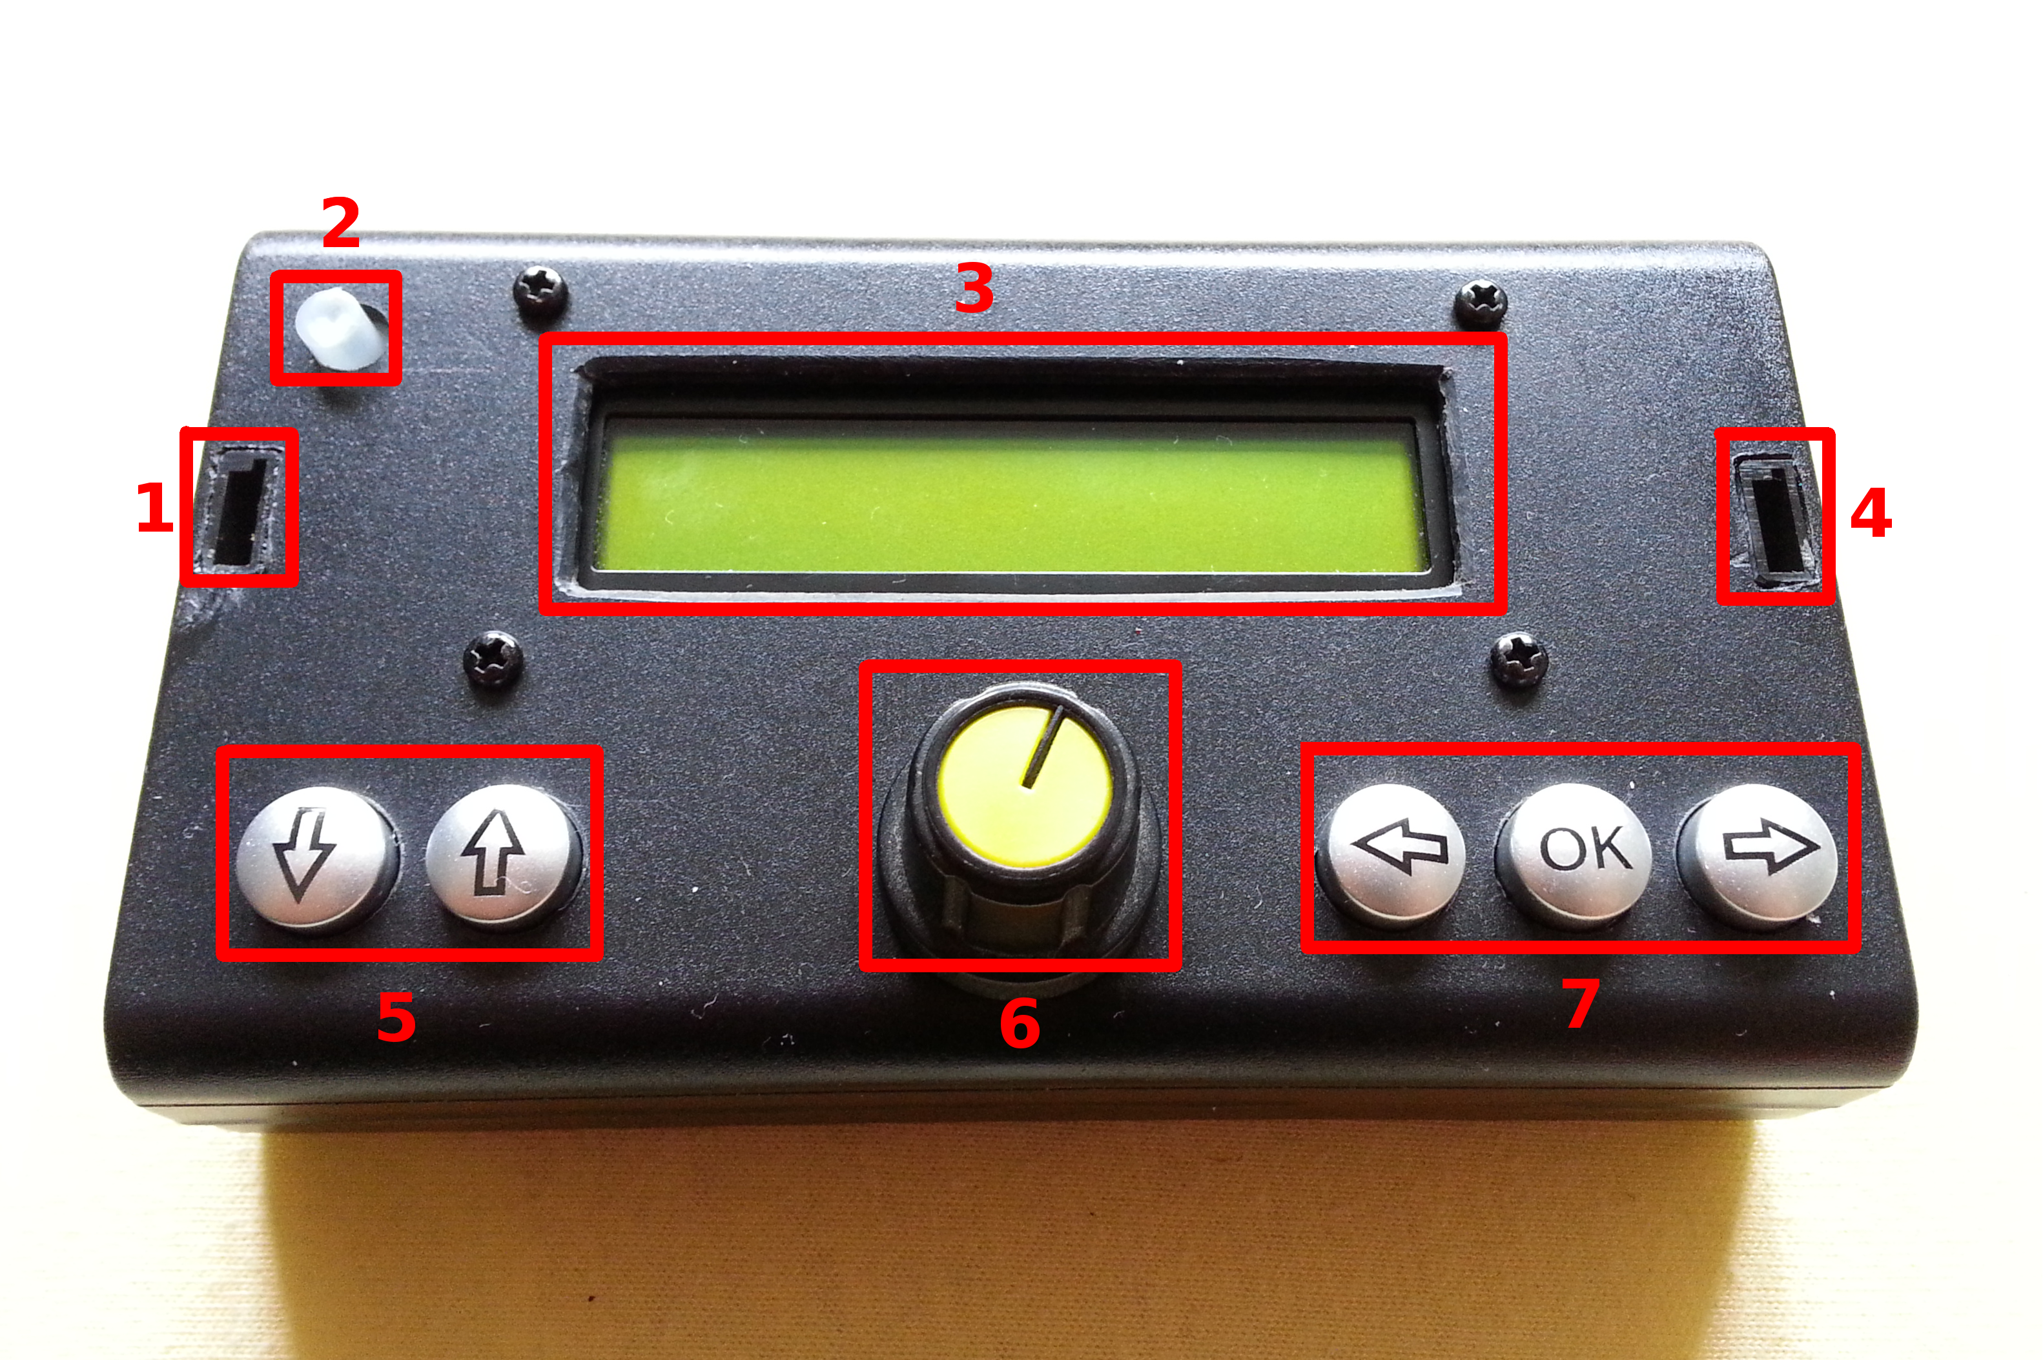

- Power Input Socket: pin 1: GND, 2: +5V, 3: Not Used
- Error LED / BiStable Switch: error LED indicates an impossible / not supported PWM range setting. Switch is reserved for future functions and is currently ignored.
- LCD Display
- Servo Socket, pin 1: GND, 2: +5V, 3: signal
- Menu / Screen Select:
Power / Servo Socket
  - ↓: previous, ↑: next
- Potmeter: pulse width / character select
- Multi-Function Buttons:
  - ← left / decrease / previous item
  - OK center / quit / apply
  - → right / increase / next item

Back Panel
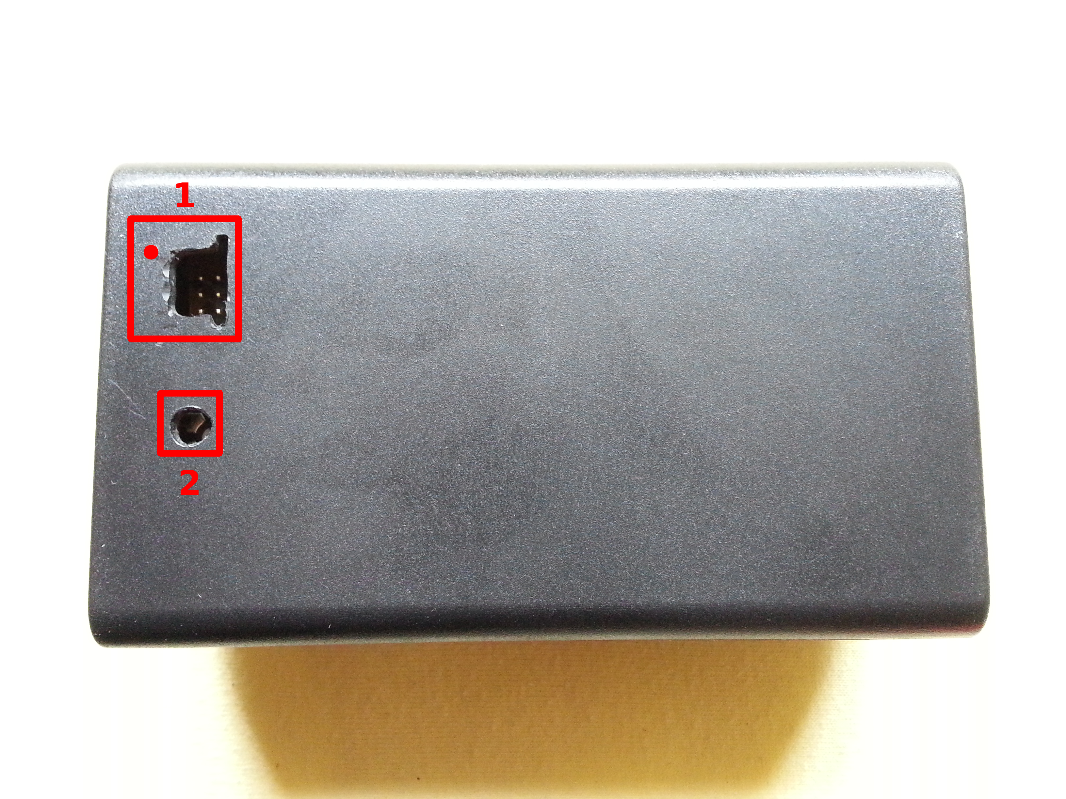
- ISP port: 6-pin Atmel In-System Programming interface for firmware upgrade
- LCD display contrast: use a small + or – head narrow screwdriver to adjust. Display contrast also depends on power source voltage.
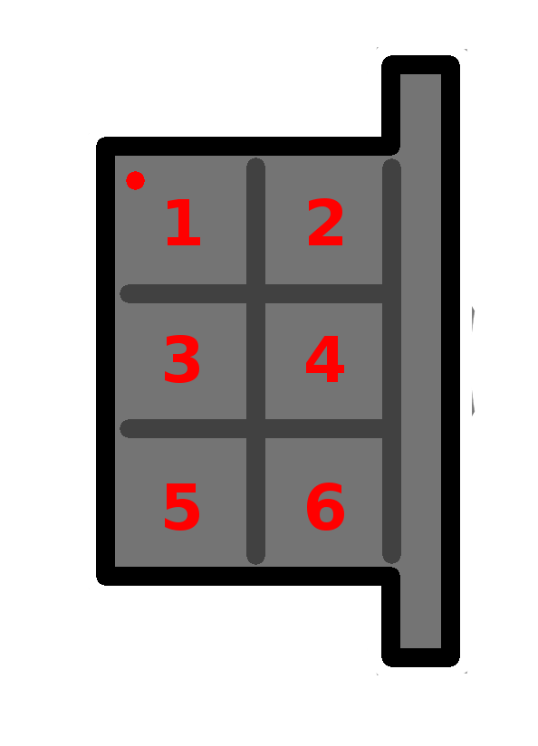ISP port

Menus and functions

1. Manual Mode (default view)

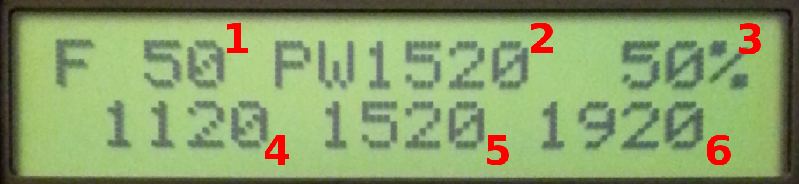
- Input Voltage (V), averaged
- Current Pulse Width (μs)
- Duty Cycle (%)
- Minimum Pulse Width (0%, μs)
- Center Pulse Width (50%, μs)
- Maximum Pulse Width (100%, μs)
Button functions:
  - ← decrease delay by 25 ms
  - OK start / stop excercise
  - → increase delay by 25 ms

2. Servo Excercise (P.E., Physical Education) Mode

- Minimum Voltage (V)
- Maximum Voltage (V)
- Delay between alternating servo movements (ms)
- Minimum Pulse Width (0%, μs)
- Maximum Pulse Width (100%, μs)
Button functions:
  - ← generate minimum PW
  - OK generate center PW
  - → generate maximum PW
Servo travel (minimum and maximum PWM) can be adjusted with potmeter. If the delay is shorter than the time needed for the servo to travel between endpoints, the servo may not reach either endpoint. Minimum and maximum voltage readings are reset when excercise is started.
Do not excercise your servo for extended period of time, as it may be permanently damaged. Never leave your battery and servo unattended. If the servo being tested is built in a model and linkage is attached to it, make sure you do not overstress moving parts or fuselage with too short delays or too long travel.

3. Center Pulse Width Adjustment

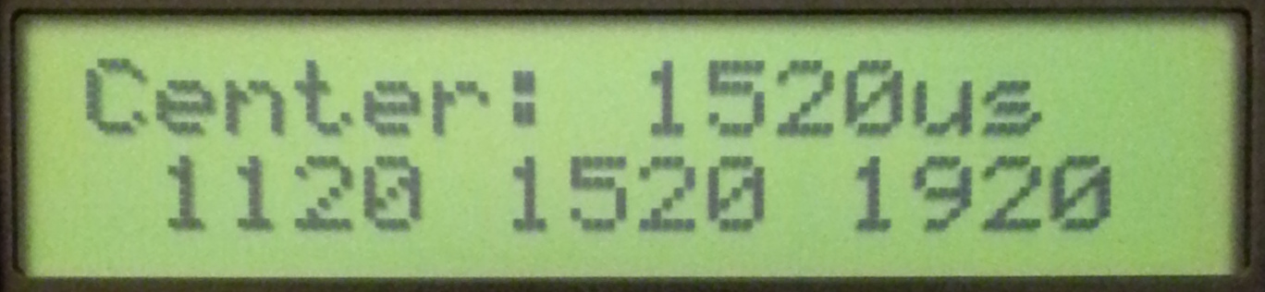
Button functions:
  - ← decrease center PW by 10 μs
  - OK return to live data
  - → increase center PW by 10 μs
Servo parameters are not stored automatically, and may be lost if power is removed before manually saving.

4. Pulse Width Range

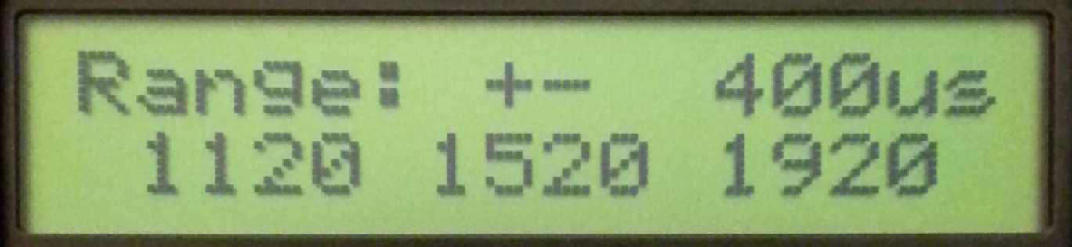
For example ±400 μs means a total range of 1920 – 1120 = 800 μs, symmetrical around center pulse width.
Button functions:
  - ← decrease range by ±10 μs
  - OK return to live data
  - → increase range by ±10 μs

5. PWM Frequency

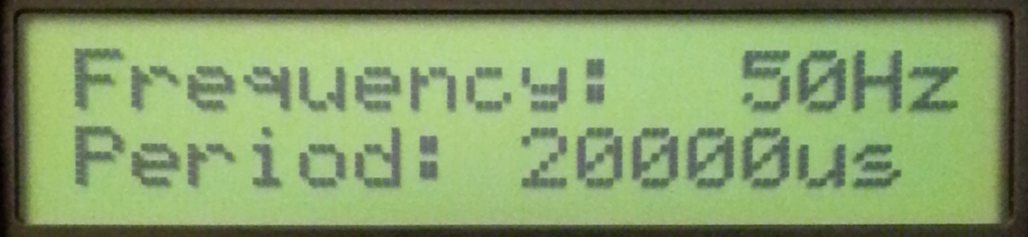
PWM Frequency setting in Hz. PWM Period is 1 / PWM Frequency.
Button functions:
  - ← decrease frequency by 10 Hz
  - OK return to live data
  - → increase frequency by 10 Hz

6. Servo Name
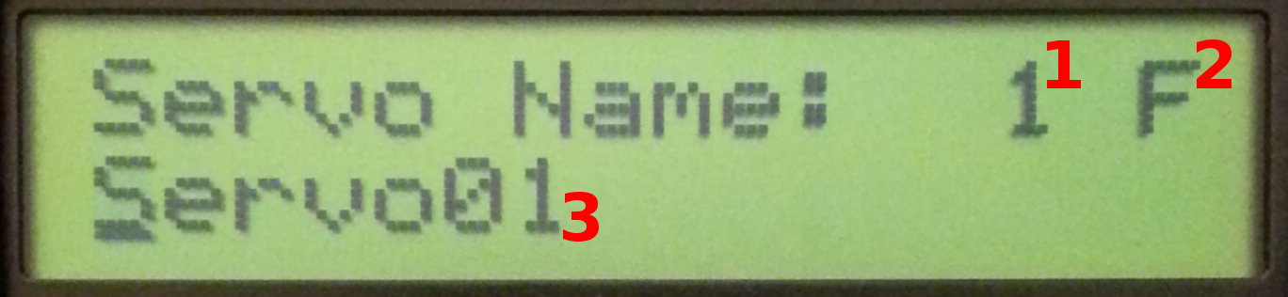

- Memory Slot (1-20): slot number where the current servo settings are loaded from
- Selected Character: use potmeter to select a-z A-Z 0-9 and space characters
- Servo Name: maximum 16 characters
Please note that the potmeter is disconnected from PWM signal generator while in Servo Name menu, and is reconnected when exiting. Make sure that potmeter is in a position that is within the mechanical limits of the servo when exiting.
Button functions:
  - ← move cursor one step left
  - OK Insert selected character at current position and advance cursor
  - → move cursor one step right

7. Save Servo Settings

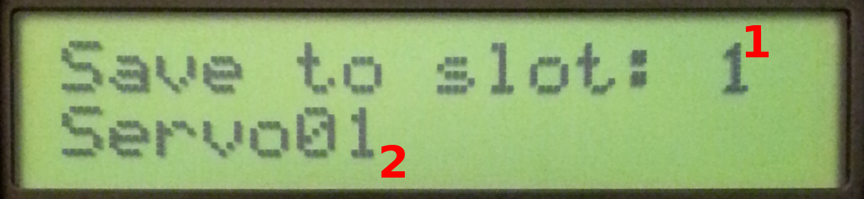
- Memory Slot: slot number to save servo settings to
- Name of Servo To Be Overwritten
Please note that servo settings are not stored automatically to conserve EEPROM life.
Button functions:
  - ← select previous slot
  - OK Save servo data to currently selected slot and return to live data
  - → select next slot

8. Calibrate Voltmeter

- Current voltage
Button functions:
  - ← decrease voltage
  - OK Save calibration and return to default view
  - → increase voltage
To properly calibrate voltage, use quality voltmeter attached to the terminals of your power source to determine the actual voltage, then adjust Servo Tester calibration until the voltage readout is correct.

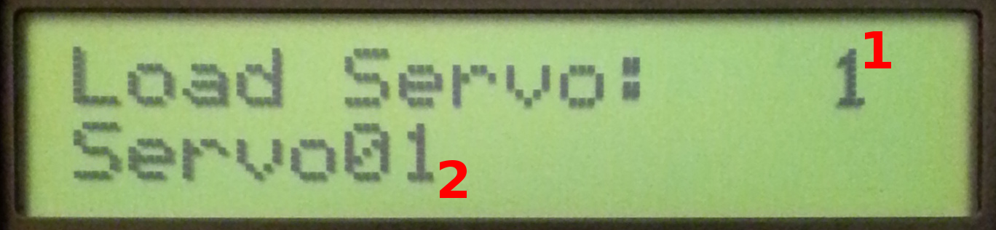
9. Load Servo Settings

Button functions:
  - ← select previous slot
  - OK Load servo data from currently selected slot and return to live data
  - → select next slot

Firmware Upgrade

Programmer Hardware
Firmware upgrade can be carried out with any Atmel 6-pin ISP or compatible programmer. The best is of course Atmel original ISP programmer, but it comes with a price tag. Most programmers will work on Windows, Linux, MacOS. A slight modification to the instrument case may be needed to accomodate different cable heads and plugs. Most cheap USB programmers are only available with 10-pin cable, so make sure the programmer comes with 6-pin interface or converter before checking out at your favourite webshop.
Example 3rd party programmers*:
URL Price Remark>
https://www.pololu.com/product/1300 $19.95 seems like a decent programmer with extra features
http://www.ebay.com/itm/10-Pin-Convert-to-Standard-6-Pin-Adapter-Board-USBASP-USBISP-AVR-Programmer-USB-/310730828729 $5.18 El Cheapo 10-pin programmer that comes with a 6-pin converter

Example DIY 10-pin to 6-pin converter
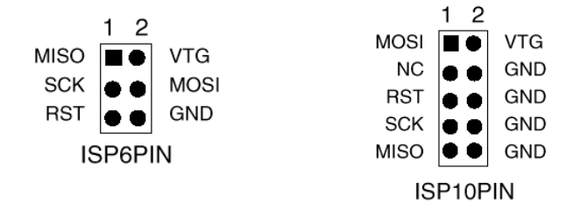
You may build your own converter plug yourself as 10-pin headers only utilize 6 pins – actually the same pins as 6-pin header but in different order (NC: Not Connected)

* These programmers have not been tested, just serve as an example where to look for. Please do not buy the cheap-est-est out there.

Software

Open Source: avrdude
Will work with most programmers.
Linux: http://www.nongnu.org/avrdude/
Windows: http://sourceforge.net/projects/winavr/

Original Atmel Software: Atmel Studio
http://www.atmel.com/tools/atmelstudio.aspx

Before Programming
Firmware is stored in so-called flash memory, while servo settings are stored in EEPROM in the microcontroller unit. Writing the flash memory requires an erase cycle that will destroy the contents of both flash and EEPROM, so please make sure that you backup the EEPROM in advance (may not be necessary with Atmel Studio, please check the manual), and restored afterwards.
Servo tester has to be powered to perform firmware upgrade. The programmer hardware does not provide power to the microcontroller unit.

Atmel Studio
To program firmware image with Atmel Studio, please refer to the documentation available at Atmel's.

Programming (AVRDude)
It is important not to press any button while programming, as the programmer share some pins with buttons.
These are the exact command lines your very servo tester has been programmed using an Atmel original JTAG3ISP programmer*:
- Make a backup of EEPROM memory to eeprom_save_file.bin
avrdude -c jtag3isp -p m328 -U eeprom:r:eeprom_save_file.hex:i
- Flash new firmware
avrdude -c jtag3isp -p m328 -U flash:w:firmware_filename.hex
- Restore EEPROM from eeprom_save_file.bin
avrdude -c jtag3isp -p m328 -U eeprom:w:eeprom_save_file.hex:i

* avrdude parameter -c specifies programmer hardware, please replace it with what is appropriate for your programmer.
You are strongly encouraged to make a backup of your EEPROM regularly. Should your EEPROM become corrupt or need to replace the microcontroller unit, you can always restore it from backup.

Recovering From Failed Upgrade
It is almost impossible to brick the microcontroller, as there is no internal bootloader whatsoever, and you are basically upgrading firmware with factory programmer. It is important not to press any button while programming, as the programmer shares some pins with buttons. There is no other known issue that can cause a firmware upgrade to fail. In the very unlikely event of firmware upgrade failing, please refer to the troubleshooting guide of the programmer and programming software.

Customer Replaceable Parts
Actually, you may replace any parts of the tester you feel the need to, or customize it to your needs. You may even replace the microcontroller itself to another ATMega328 or 328p microcontroller itself as it is seated in a socket – should that become necessary, for instance, after applying reverse polarity voltage. You only need a good soldering iron, desoldering pump, spare parts, some basic soldering skills and a little patience. The schematics will be available on the homepage later this year.

Contact
Please feel free to contact us should you have any feedback to give – feature requests, problems, know-to-work power sources and servos etc.

Product page with latest documentation and firmware:
http://www.kign.org/servo_tester

E-mail: lengyakb@kign.org

