**Organ Donation and Procurement Management System**

**Relevance:**

The "Organ Donation and Procurement Network Management System" is crucial for optimizing organ donation processes. It connects donors with recipients, streamlining organ transplant waiting lists and facilitating real-time communication among healthcare professionals. By centralizing information, it enhances organ allocation speed and accuracy, improving transplant success rates. This system promotes transparency, ethical practices, and equitable organ distribution, addressing critical challenges in the organ donation ecosystem.

**ER Diagram:**

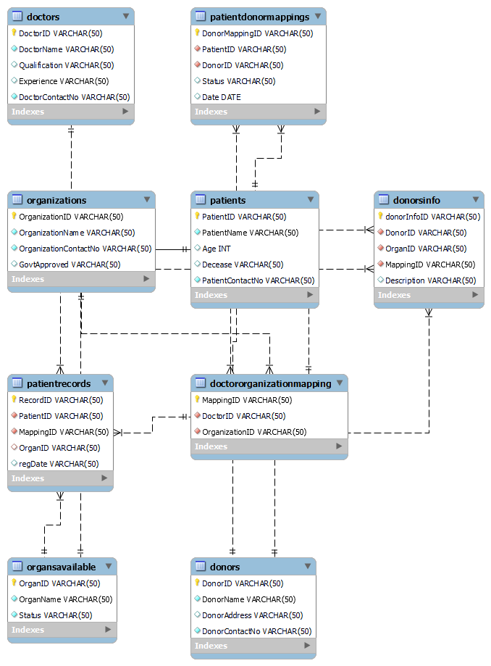

**Tables Used:**

**Patients Table:**

|  |  |  |
| --- | --- | --- |
| **Attributes** | **Datatype** | **Constraints** |
| PatientID | Varchar | Primary Key |
| PatientName | Varchar | Not Null |
| Age | Number |  |
| Decease | Varchar |  |
| PatientContactNo | Varchar | Not Null |

**Doctors Table:**

|  |  |  |
| --- | --- | --- |
| **Attributes** | **Datatype** | **Constraints** |
| DoctorID | Varchar | Primary Key |
| DoctorName | Varchar | Not Null |
| Qualification | Varchar |  |
| Experience | Varchar |  |
| DoctorContactNo | Varchar | Not Null |

**Organizations Table:**

|  |  |  |
| --- | --- | --- |
| **Attributes** | **Datatype** | **Constraints** |
| OrganizationID | Varchar | Primary Key |
| OrganizationName | Varchar | Not Null |
| OrganizationContactNo | varchar | Not Null |
| GovtApproved | varchar |  |

**DoctorOrganizationMapping Table:**

|  |  |  |
| --- | --- | --- |
| **Attributes** | **Datatype** | **Constraints** |
| MappingID | Varchar | Primary key |
| DoctorID | Varchar | Not Null |
| OrganizationID | Varchar | Not Null |

**Donors Table:**

|  |  |  |
| --- | --- | --- |
| **Attributes** | **Datatype** | **Constraints** |
| DonorID | Varchar | Primary Key |
| DonorName | varchar | Not Null |
| DonorAddress | Varchar |  |
| DonorContactNo | Varchar | Not Null |

**OrgansAvailable Table:**

|  |  |  |
| --- | --- | --- |
| **Attributes** | **Datatype** | **Constraints** |
| OrganID | Varchar | Primary Key |
| OrganName | Varchar | Not Null |
| Status | Varchar | Not Null |

**DonorsInfo Table:**

|  |  |  |
| --- | --- | --- |
| **Attributes** | **Datatype** | **Constraints** |
| donorInfoID | Varchar | Primary Key |
| DonorID | Varchar | Not Null |
| OrganID | Varchar | Not Null |
| MappingID | Varchar | Not Null |
| Description | Varchar |  |

**PatientRecords Table:**

|  |  |  |
| --- | --- | --- |
| **Attributes** | **Datatype** | **Constraints** |
| RecordID | Varchar | Primary Key |
| PatientID | Varchar | Not Null |
| MappingID | Varchar | Not Null |
| OrganID | Varchar |  |
| regDate | Varchar |  |

**PatientDonorMappings Table:**

|  |  |  |
| --- | --- | --- |
| **Attributes** | **Datatype** | **Constraints** |
| DonorMappingID | Varchar | Primary Key |
| PatientID | Varchar | Not Null |
| DonorID | Varchar | Not Null |
| Status | Varchar |  |
| Date | Date |  |

**Normalization:**

In this project we need to store the data of the donor, the organization, doctor, patient, organs available and so on.

The initial design of the database is,

**PatientRecords** Table

|  |  |  |  |  |  |  |  |  |
| --- | --- | --- | --- | --- | --- | --- | --- | --- |
| **Patient Name** | **Age** | **Decease** | **Organ** | **Doctor Name** | **Organization** | **Date** | **Donor Name** | **Donor**  **Phone** |

There exists a partial dependency between DonorName and DonorPhone. To eliminate the partial dependency, we create another table called **Donors.**

|  |  |  |  |  |
| --- | --- | --- | --- | --- |
| **DonorID** | **DonorName** | **DonorAddress** | **DonorContactNo** | **OrganDonating** |

When we delete the data of donor there can be chance for missing the data of organ. We can divide it into two tables,

**Donors**

|  |  |  |  |
| --- | --- | --- | --- |
| **DonorID** | **DonorName** | **DonorAddress** | **DonorContactNo** |

**OrganAvailable**

|  |  |  |
| --- | --- | --- |
| **OrganID** | **OrganName** | **Status** |

We have patientRecord table as,

|  |  |  |  |  |  |  |  |
| --- | --- | --- | --- | --- | --- | --- | --- |
| **PatientName** | **age** | **decease** | **Patient Address** | **contactNo** | **organization** | **DoctorName** | **donorID** |

Eliminating partial dependency,

**Patients**

|  |  |  |  |  |
| --- | --- | --- | --- | --- |
| **PatientID** | **PatientName** | **Age** | **Decease** | **PatientContactNo** |

**Doctors**

|  |  |  |  |  |
| --- | --- | --- | --- | --- |
| **DoctorID** | **DoctorName** | **Qualification** | **Experience** | **DoctorContactNo** |

**Organizations**

|  |  |  |  |
| --- | --- | --- | --- |
| **OrganizationID** | **OrganizationName** | **OrganizationContactNo** | **GovtApproved** |

**DoctorOrganizationMapping**

|  |  |  |
| --- | --- | --- |
| **MappingID** | **OrganizationID** | **DoctorID** |

**PatientRecord**

|  |  |  |  |  |
| --- | --- | --- | --- | --- |
| **RecordID** | **PatientID** | **MappingID** | **OrganID** | **RegDate** |

**PatientDonorMapping:**

|  |  |  |  |  |
| --- | --- | --- | --- | --- |
| **DonorMappingID** | **PatientID** | **DonorID** | **Description** | **Date** |

**DonorInfo:**

|  |  |  |  |  |
| --- | --- | --- | --- | --- |
| **DonorInfoID** | **DonorID** | **OrganID** | **MappingID** | **Description** |