REAL-TIME MULTIMODAL STRESS DETECTION USING FACIAL EXPRESSIONS AND SPEECH SIGNALS
Project Report Submitted in Partial Fulfilment of the Requirements for the Degree of

Bachelor of Technology
in

Computer Science Engineering
by
CHAGANTI SRAVYA (22B91A0538) CHILAKA SIDDHARTH (22B91A0547) D PAVAN SARADHI (22B91A0557)
BH B NAGA GAYATRI (22B91A0526)



Department of Computer Science Engineering SRKR Engineering College (A)
SRKR Marg, China Amiram, Bhimavaram - 534204 April, 2026

REAL-TIME MULTIMODAL STRESS DETECTION USING FACIAL EXPRESSIONS AND SPEECH SIGNALS
Project Report Submitted in Partial Fulfilment of the Requirements for the Degree of

Bachelor of Technology
in
Computer Science Engineering
by
CHAGANTI SRAVYA (22B91A0538) CHILAKA SIDDHARTH (22B91A0547) D PAVAN SARADHI (22B91A0557)
BH B NAGA GAYATRI (22B91A0526)

Under the Supervision of

Mr. DAVID RAJU KUPPALA

Assistant Professor

Department of Computer Science Engineering SRKR Engineering College (A)
SRKR Marg, China Amiram, Bhimavaram - 534204 April, 2026

D E C L A R A T I O N

We hereby declare that the Project Report entitled " REAL-TIME MULTIMODAL STRESS DETECTION USING FACIAL EXPRESSIONS AND SPEECH SIGNALS” which is being
submitted to the SRKR Engineering College(A), China Amiram, Bhimavaram, in partial fulfillment of the requirements for the award of the Degree of Bachelor of Technology in Computer Science Engineering is a Bonafide report of the research work carried out by us. The material contained in this Project Report has not been submitted to any University or Institution for the award of any degree.

Place: Bhimavaram CHAGANTI SRAVYA
Date: 17-04-2026 Roll No.: 22B91A0538 CHILAKA SIDDHARTH Roll No.: 22B91A0547
D PAVAN SARADHI Roll No.: 22B91A0557 BH B NAGA GAYATRI Roll No.: 22B91A0526

Department CSE
SRKR Engineering College (A), SRKR Marg, China Amiram, Bhimavaram-534204

C E R T I F I C A T E

This is to certify that the work contained in this report entitled “REAL-TIME MULTIMODAL STRESS DETECTION USING FACIAL EXPRESSIONS AND
SPEECH SIGNALS” is submitted by the group members Ms. CHAGANTI SRAVYA (22B91A0538), Ms. CHILAKA SIDDHARTH (22B91A0547), Mr. D PAVAN SARADHI
(22B91A0557), and Ms. BH B NAGA GAYATRI (22B91A0526) to the Department of Computer Science and Engineering, SRKR Engineering College, as a record of the research work carried out by them. This report is accepted as partial fulfillment of the requirements for the award of the degree of Bachelor of Technology.

Mr. DAVID RAJU KUPPALA Dr. Bh.V.S.R.K.RAJU

Supervisor Head of the Department Department of CSE Department of CSE

ACKNOWLEDGEMENT

We sincerely express our gratitude to SRKR ENGINEERING COLLEGE for providing us with the opportunity to undertake this final year project, REAL-TIME MULTIMODAL STRESS DETECTION USING FACIAL EXPRESSIONS AND SPEECH SIGNALS.
We extend our heartfelt thanks to our Principal, Dr. K. V. Murali Krishnam Raju, for fostering an academic environment that encourages research and innovation. We are also deeply grateful to Dr. Bh. V. S. R. K. Raju, Head of the Department of Computer Science & Engineering, for continuous support and motivation throughout this project.
A special thanks to our project supervisor, Mr. David Raju Kuppala, whose guidance, technical expertise, and invaluable feedback have been instrumental in shaping this work. His mentorship has provided us with both knowledge and confidence to tackle challenges effectively. We also appreciate the support of faculty members, project teammates, family, and friends, whose encouragement and insights have been invaluable.

CHAGANTI SRAVYA
(22B91A0538)
CHILAKA SIDDHARTH
(22B91A0547)
D PAVAN SARADHI
(22B91A0557)
BH B NAGA GAYATRI
(22B91A0526)

ABSTRACT

Rapid and uncontrolled environmental degradation in the form of wildfires, deforestation, and urban expansion represents one of the most pressing ecological and socioeconomic challenges of the twenty-first century. Traditional satellite-based monitoring approaches — relying on manual image interpretation, static spectral index thresholding, and single-purpose classification systems — are fundamentally limited in providing timely, accurate, and scalable detection of multiple concurrent environmental anomalies, creating critical gaps in global environmental monitoring infrastructure.
This project presents an end-to-end deep learning-based satellite image classification system for automated multi-class environmental anomaly detection, classifying satellite image patches into four categories: Wildfire, Deforestation, Urban Expansion, and No Anomaly. The system is built upon ConvNeXt-Tiny, a state-of-the-art convolutional neural network integrating Vision Transformer-inspired design principles, initialized with ImageNet pre-trained weights and fine-tuned using transfer learning for strong generalization across diverse geographical regions and land cover types. A key contribution of this work is the Unified Balanced Dataset — a novel multi-source benchmark of 71,526 satellite image patches assembled from four domain-specific datasets: ForestNet (deforestation), Wildfire Prediction Dataset (wildfire), LEVIR-CD+ (urban expansion), and EuroSAT(normal land cover) with a strict 1:1 anomaly-to-no-anomaly ratio per class to ensure balanced and unbiased training. The proposed ConvNeXt-Tiny model achieves an overall test accuracy of 95.1% and a weighted F1-score of 0.95, with notably perfect precision of 1.00 for wildfire (zero false alarms) and perfect recall of 1.00 for deforestation (zero missed events), significantly outperforming both the baseline EfficientNet-B3 model (90.2%) and traditional approaches such as SVM, Random Forest (80–86%), and earlier deep learning methods including VGG-16 and ResNet-18 (89–90%). offers a practical, scalable, and accurate solution for environmental monitoring applications including forest conservation, early wildfire warning, unauthorized construction detection, and land use change assessment, with clear extension pathways toward flood detection, multi-spectral input integration, and pixel-level segmentation.

TABLE OF CONTENTS

S.No | CONTENTS |  |  |  | Page.No
 | Abstract |  |  |  | i
 | List Of Tables |  |  |  | iv
 | List Of Figures |  |  |  | v
1 | Introduction |  |  |  | 1
 | 1.1 |  | Problem Statement |  | 2
 | 1.2 |  | Objectives |  | 2
 | 1.3 |  | Scope |  | 3
 | 1.4 |  | Importance |  | 3
 | 1.5 |  | Reason For Choosing The Topic |  | 4
2 | Literature Review |  |  |  | 5-8
3 | Methodology/System Design |  |  |  | 9
 | 3.1 | Existing System |  |  | 9
 | 3.2 | Proposed System |  |  | 9-10
 | 3.3 | Requirements |  |  | 10
 |  | 3.3.1 |  | Software Requirements | 10-11
 |  | 3.3.2 |  | Hardware Requirements | 11
 | 3.4 | System Architecture |  |  | 12-13
 | 3.5 | Design/Proposed Model |  |  | 13

 |  | 3.5.1 | Dataset |  | 13-14
 |  |  | 3.5.1.1 | Features | 14-15
 |  |  | 3.5.1.2 | Pre-Processing | 15-16
4 | Implementation And Testing |  |  |  | 17
 | 4.1 | Implementation Approach |  |  | 17-19
 | 4.2 | Functional And Algorithmic Implementation |  |  | 19-22
 | 4.3 | Integration Details |  |  | 22
 | 4.4 | Testing |  |  | 22-23
 |  | 4.4.1 | Test Cases |  | 23-24
5 | Discussion Of Results |  |  |  | 25-34
6 | Conclusions And Future Work |  |  |  | 35-36
7 | References |  |  |  | 37-38
8 | Appendix |  |  |  | 39
 | A | Sample Code |  |  | 39-48
 | B | Project Snapshots/Screenshots |  |  | 49-51

LIST OF TABLES

S.No | LIST OF TABLES | Page.No
Table 2 | Literature Review | 5-6
Table 4.4.1.a | Test Scenarios For Multimodal Stress Detection System | 23
Table 4.4.1.b | Illustrative Test Cases With Input–Output Mapping | 24
Table 5.a | Performance Comparison Of Proposed Models With Base Paper | 26
Table 5.b | Evaluation Metrics Of Proposed Models | 30-31

LIST OF FIGURES

S.No | LIST OF FIGURES | Page.No
Figure 3.4 | System Architecture | 13
Figure 3.5.1.2.a | Face Preprocessing Steps | 15
Figure 3.5.1.2.b | Speech Preprocessing Steps | 16
Figure 4.1 | Workflow Of The Proposed Multimodal Stress Detection System | 19
Figure 4.2.a | Convnext-Tiny Based Facial Stress Detection Workflow | 20
Figure 4.2.b | Wav2vec2-Based Speech Stress Detection Workflow | 21
Figure 4.2.c | Confidence-Based Fusion Mechanism For Final Stress Prediction | 21
Figure 5.a | Accuracy Comparison Of Base Paper And Proposed Models | 27
Figure 5.b | Face Model Confussion Matrix | 27
Figure 5.c | Speech Model Confussion Matrix | 28
Figure 5.d | Gui-Based Real-Time Stress Detection Output | 32
Figure 5.e | Intermediate Output Showing Face, Speech Detection And Model Prediction | 33
Figure 8.1 | Graphical User Interface Of The Stress Detection System | 49
Figure 8.2 | Face Detection Using Webcam Input | 49
Figure 8.3 | Face Capture Interface | 50
Figure 8.4 | Audio Recording Interface | 50
Figure 8.5 | Audio Capture Interface | 51
Figure 8.6 | Final Stress Prediction Output From Gui Interface | 51

CHAPTER 1 INTRODUCTION
Rapid environmental degradation in the form of wildfires, deforestation, and uncontrolled urban expansion poses one of the most critical ecological and socioeconomic challenges of the twenty-first century. The FAO reports a loss of approximately 10 million hectares of forest annually, while wildfire incidents and unauthorized urban growth continue to accelerate globally, causing severe biodiversity loss, carbon cycle disruption, and long-term climate consequences. Early and accurate detection of such environmental anomalies is therefore essential for timely intervention, conservation enforcement, and effective disaster management.

Environmental anomalies manifest through distinctive visual patterns observable in satellite imagery, including spectral changes in vegetation cover, thermal signatures of active fires, and structural transitions from natural land to built-up areas. These observable characteristics make satellite remote sensing a powerful tool for large-scale environmental monitoring. However, the enormous volume of imagery generated daily renders manual analysis impractical, and traditional threshold-based spectral methods lack the generalization capability required for reliable multi-regional anomaly detection across diverse geographical conditions.

Existing monitoring platforms are designed for single anomaly types and rely on classical approaches requiring extensive manual feature engineering, limiting their scalability across diverse conditions. This highlights the need for a unified, automated, and intelligent system capable of simultaneously detecting multiple categories of environmental anomalies directly from satellite imagery, enabling forest departments, disaster management agencies, and urban planning authorities to make faster, data-driven decisions without depending on fragmented, purpose-specific monitoring tools.

In this project, an automated satellite image-based environmental anomaly detection system is developed, classifying satellite image patches into Wildfire, Deforestation, Urban Expansion, and No Anomaly categories to provide actionable environmental intelligence through a React-based web application offering real-time classification and geospatial visualization. The system employs ConvNeXt-Tiny — a modern convolutional neural network with transfer learning — which demonstrates strong discriminative performance across all four anomaly categories, achieving high precision for wildfire detection and complete deforestation coverage, making it highly reliable for real-world environmental monitoring deployment.

Problem Statement

Environmental anomalies such as wildfires, deforestation, and urban expansion are increasing at an alarming rate, causing irreversible damage to ecosystems, biodiversity, and climate stability. If not detected early, these anomalies can escalate beyond control, resulting in large-scale ecological destruction and significant economic losses. Therefore, accurate and timely detection of environmental anomalies from satellite imagery is essential for effective monitoring, intervention, and conservation management.
Traditional satellite-based monitoring methods rely on manual image interpretation and static spectral index thresholding techniques such as NDVI and NBR. While these provide basic insights, they are region-specific, require constant recalibration, and are highly susceptible to false positives under variable atmospheric and seasonal conditions, making them unsuitable for continuous, large-scale real-time monitoring.
Moreover, existing platforms such as NASA FIRMS and Global Forest Watch are designed for single anomaly types, forcing agencies to rely on multiple fragmented systems. Systems dependent on a single anomaly type often fail to provide reliable results across diverse geographical regions, reducing their practical effectiveness in real-world scenarios.
Hence, there is a need for a unified, automated, and intelligent system capable of simultaneously detecting and classifying multiple environmental anomalies directly from satellite imagery in a scalable and accurate manner, without depending on manual intervention or region-specific configurations.

Objectives

The main objective of this project is to design and develop an automated deep learning-based satellite image classification system that accurately detects and classifies multiple environmental anomalies. The specific objectives are:
- To build a unified system detecting Wildfire, Deforestation, Urban Expansion, and No Anomaly within a single classification framework
- To construct the Unified Balanced Dataset by combining ForestNet, Wildfire Prediction Dataset, LEVIR-CD+, and EuroSAT into a structured multi-class benchmark
- To implement ConvNeXt-Tiny with transfer learning for accurate and generalizable multi-class environmental anomaly classification
- To handle class imbalance using inverse-frequency class weighting ensuring reliable detection of underrepresented anomaly classes
- To evaluate and compare model performance against EfficientNet-B3 and traditional machine learning baselines
- To deploy the system as a React-based web application to implement in real time.

Scope of the Study

This study focuses on the development of an automated environmental anomaly detection system using satellite imagery. The system accepts satellite image patches as input and classifies them into four categories — Wildfire, Deforestation, Urban Expansion, and No Anomaly — using a deep learning model trained on a unified multi-source dataset. It is designed to function without requiring manual feature engineering or region-specific configurations, making it practical and scalable for diverse geographical environments.
The scope of this project includes key stages such as dataset curation, image preprocessing, model development using ConvNeXt-Tiny with transfer learning, performance evaluation, and web-based deployment. The trained model is integrated into a React-based web application that allows users to upload satellite image patches and receive real-time anomaly classification results with confidence scores and geospatial visualization.
However, the system is currently limited to classifying three anomaly types and operates on pre-captured satellite image patches rather than live satellite feeds. Performance may be affected by challenging conditions such as heavy cloud cover, low image resolution, or spectral similarity between anomaly classes. Despite these limitations, the study provides a strong foundation for developing more comprehensive and scalable environmental monitoring systems in the future.

Importance of Work

Automated environmental anomaly detection plays a crucial role in protecting ecosystems, enforcing conservation policies, and enabling timely disaster response. An intelligent and unified satellite image classification system can help authorities identify environmental threats early, enabling faster intervention before irreversible damage occurs.
The proposed system offers several advantages:

- Eliminates dependence on manual image interpretation and domain expert availability

- Enables simultaneous detection of multiple anomaly types within a single unified framework

- Provides a scalable solution applicable across diverse geographical regions without reconfiguration

- Supports practical real-world use through an accessible React-based web application interface

- Contributes a reusable unified dataset benchmark for future environmental monitoring research.

Reason for Choosing the Topic

The rapid increase in environmental anomalies such as wildfires, deforestation, and urban expansion in recent years has highlighted the urgent need for intelligent and automated monitoring solutions. Witnessing the growing scale of environmental destruction reported globally — including record-breaking wildfire seasons, accelerating tropical deforestation, and unplanned urban sprawl — motivated the selection of this topic as a meaningful and impactful area of research for a final year project.

The intersection of deep learning and satellite remote sensing presented a particularly compelling opportunity, as recent advances in convolutional neural network architectures and transfer learning have made it possible to build highly accurate image classification systems even with limited domain-specific labeled data. Applying these modern deep learning techniques to a real-world environmental problem offered both technical depth and practical significance, making it well-suited for a final year engineering project.

Existing solutions in this domain are either limited to single anomaly types, rely on outdated machine learning approaches, or require specialized remote sensing expertise to operate. This gap motivated the development of a unified, accessible, and automated system that consolidates multiple anomaly detection capabilities into a single deep learning framework deployable through a simple web interface, making advanced satellite image analysis accessible to non-specialist users such as forest officers and disaster management personnel.

Furthermore, the availability of high-quality public satellite image datasets such as ForestNet, LEVIR-CD+, EuroSAT, and the Wildfire Prediction Dataset provided a strong foundation for building a well-curated training benchmark, making the project technically feasible within the scope of a final year study. The combination of environmental relevance, technical challenge, dataset availability, and deployment potential made this topic an ideal and motivated choice.

CHAPTER 2 LITERATURE REVIEW

Table 2: Literature Review

Title | Journal | Year | Author | Methodologies | Outcome | Research Gap
Real-Time | IEEE | 2022 | Madanjit | IoT-Fog-Cloud | Real-time | Deployment
Student Stress | Access |  | Singh, | layered system, | stress | challenges,
Monitoring in an |  |  | Sarveshwar | VGG16 + Bi- | classification | noisy real data,
IoT-Fog-Cloud |  |  | Bharti, Harjit | LSTM + Naïve | and alerts | coarse stress
Environment |  |  | Kaur, | Bayes for | based on | granularity
 |  |  | Vaibhav | emotion/stress | facial and
 |  |  | Arora, | detection | speech cues
 |  |  | Munish
 |  |  | Saini,
 |  |  | Manevpreet
 |  |  | Kaur,
 |  |  | Jaswinder
 |  |  | Singh
Real-Time Stress | IRJET | 2025 | S. Subha | CNN-based facial | Detects stress | Limited
Detection Using |  |  | Indu, M. | emotion | levels using | dataset, basic
Deep Learning |  |  | Harshendra, | recognition | both face and | fusion
with Facial |  |  | K. | combined with | voice in real- | technique, and
Expressions and |  |  | Bhagavath | speech emotion | time with | reduced
Vocal Signals |  |  | Kishore, J. | analysis using | improved | robustness in
 |  |  | Rubanraj | MFCC features | accuracy | noisy real-
 |  |  |  |  |  | world
 |  |  |  |  |  | environments
A Multimodal | Electronics | 2023 | V. R. | Stress detection | Improved | Requires
Late Fusion | (MDPI) |  | Xefteris. | using audio + | stress | wearable
Framework for |  |  |  | physiological | classification | sensors and
Physiological |  |  |  | signals with late | in real-time | uses limited
Sensor and Audio |  |  |  | fusion | scenarios | fusion strategy
Signal-Based
Stress Detection
Detecting | IEEE | 2019 | Jin Zhang, | Real-time stress | Achieved up | Relies only on
Negative |  |  | Xue Mei, | detection using | to 93.6% | facial
Emotional Stress |  |  | Huan Liu, | CNN-based facial | accuracy on | expressions,
Based on Facial |  |  | Shenqiang | expression | datasets such | suffers from
Expression in |  |  | Yuan, | recognition | as CK+, | class
Real Time |  |  | Tiancheng | focusing on anger, | Oulu-CASIA, | imbalance, and
 |  |  | Qian | fear, and sadness | and KMU- | lacks
 |  |  |  |  | FED | multimodal
 |  |  |  |  |  | stress analysis

Stress Recognition Using Face Images and Facial Landmarks | IEEE  Conference Publication | 2019 | Taejae Jeon, Hanbyeol Bae, Yongju Lee, Sungjun Jang, Sangyoun Lee | Stress recognition using face images and facial landmark features fed into a deep neural network with bottleneck architecture | Achieved best accuracy of 64.63% using grayscale face images combined with facial landmarks | Uses only facial information and ignores temporal dynamics and physiological or audio-based  stress cues
Facial and Speech Emotion Detection for Stress Monitoring | IJIRT | 2025 | Mrs. S. Jansi Rani, Arulmoneesh E.,  Dharaneesh R., Mahesh Veeraiah R. | CNN-based facial emotion recognition and DistilBERT-based speech emotion analysis are used to classify stress levels. | The system achieved high speech emotion accuracy with effective facial emotion  recognition. | The model lacks real-time multimodal fusion and does not use physiological stress signals.
Real-Time Stress | IJARCCE | 2024 | Hari Prasad | CNN-based facial | The system | The approach
Detection and |  |  | Chandika, | emotion | achieved high | depends only
Analysis using |  |  | Bulla | recognition is | accuracy | on facial
Facial Emotion |  |  | Soumya, | applied on live | (~98%) and | expressions and
Recognition |  |  | Baireddy | video streams | successfully | lacks
 |  |  | Naveen | using OpenCV for | analyzed real- | multimodal
 |  |  | Eswar | real-time stress | time stress | inputs;
 |  |  | Reddy, Boda | analysis. | patterns with | performance is
 |  |  | Mohana Sri |  | visual | affected by
 |  |  | Sai |  | feedback. | lighting and
 |  |  | Manideep |  |  | occlusions.
StressSpeak: A | Diagnostics | 2025 | Laraib Umer, | Real-time stress | Few-shot | The framework
Speech-Driven | (MDPI |  | Javaid Iqbal, | detection using | fine-tuned | relies only on
Framework for | Journal) |  | Yasar Ayaz, | speech input, | models | speech
Real-Time Stress |  |  | Hassan | analyzed through | achieved high | analysis, lacks
Detection |  |  | Imam, Adil | speech-to-text and | accuracy and | multimodal
 |  |  | Ahmad, | transformer-based | F1-scores, | inputs, and
 |  |  | Umer | language models | demonstrating | shows reduced
 |  |  | Asgher | (BERT, RoBERTa, | effective real- | performance in
 |  |  |  | DistilBERT, | time stress | zero-shot
 |  |  |  | LLaMA) to | detection with | settings.
 |  |  |  | classify stress | acceptable
 |  |  |  | levels. | latency.

1. Deep Residual Learning for Image Recognition (He et al., 2016)

This landmark paper introduced the Residual Network (ResNet) architecture, which addressed the critical problem of vanishing gradients in very deep neural networks. The key innovation is the use of skip (residual) connections, allowing the network to learn identity mappings and preserve information across layers. This enables the training of extremely deep models such as ResNet-50, ResNet-101, and beyond without performance degradation. ResNet achieved state-of-the-art results on the ImageNet dataset and became a foundational backbone for many computer vision tasks including object detection and segmentation. However, despite its strong generalization capability, the architecture was originally developed for natural image classification and was not specifically optimized for satellite imagery or environmental anomaly detection tasks.

2. EfficientNet: Rethinking Model Scaling for CNNs (Tan & Le, 2019)

EfficientNet introduced a novel compound scaling method that systematically scales network depth, width, and resolution using a unified approach. Unlike traditional scaling methods that arbitrarily increase one dimension, EfficientNet balances all three, leading to significantly improved performance and efficiency. The model family (EfficientNet-B0 to B7) demonstrates superior accuracy while using fewer parameters and lower computational resources compared to models like ResNet and VGG. This makes it highly suitable for deployment in resource-constrained environments. However, its evaluation was primarily conducted on standard datasets like ImageNet, and it lacks validation in satellite-based environmental anomaly detection scenarios.

3. A ConvNeXt for the 2020s – ConvNeXt (Liu et al., 2022)

ConvNeXt modernizes traditional convolutional neural networks by incorporating architectural design choices inspired by Vision Transformers, such as large kernel sizes, layer normalization, and inverted bottlenecks. This hybrid design bridges the gap between CNNs and transformer-based models while retaining computational efficiency. ConvNeXt achieves performance comparable to or better than state-of-the-art transformer models like Swin Transformer on image classification benchmarks. Its simplicity and scalability make it a strong candidate for various vision tasks. However, its application has not been extensively explored in remote sensing or multi-class environmental anomaly detection tasks.

4. EuroSAT (Helber et al., 2019)

EuroSAT is a widely used benchmark dataset consisting of Sentinel-2 satellite images categorized into 10 land use and land cover classes such as forest, residential, and industrial areas. It played a crucial role in advancing deep learning applications in remote sensing by providing a standardized dataset for model training and evaluation. CNN-based models trained on EuroSAT achieved high classification accuracy (around 92.5%). Despite its importance, the dataset is limited to static land cover classification and does not include dynamic or anomalous events such as floods, wildfires, or deforestation.

5. ForestNet (Irvin et al., 2020)

ForestNet is a deep learning model designed to identify the drivers of deforestation using Landsat-8 satellite imagery. It classifies deforestation into categories such as agriculture, logging, and infrastructure development. The model demonstrates the potential of CNNs in understanding complex environmental patterns. However, its scope is geographically restricted to Indonesia and focuses on a single anomaly type, which limits its ability to generalize to other regions or multiple environmental anomalies.

6. Remote Sensing Image Change Detection with Transformers (Chen et al., 2022)

This paper applies transformer-based architectures to detect changes in satellite images captured at different time intervals (bi-temporal analysis). Using datasets like LEVIR-CD+, the model effectively identifies urban changes such as new constructions. The attention mechanism in transformers enables capturing long-range spatial dependencies, improving accuracy in change detection tasks. However, the study is limited to urban change detection and does not address broader environmental anomalies such as floods, fires, or deforestation.

7. An Image is Worth 16×16 Words – Vision Transformer (ViT) (Dosovitskiy et al., 2021)

The Vision Transformer (ViT) revolutionized computer vision by applying transformer architectures directly to image patches. Instead of convolution, images are divided into fixed-size patches and processed using self-attention mechanisms. ViT achieves superior performance on large-scale datasets due to its ability to capture global context. However, it requires massive datasets and computational resources, making it less practical for smaller datasets like satellite imagery unless combined with transfer learning.

8. Swin Transformer (Liu et al., 2021)

The Swin Transformer improves upon ViT by introducing a hierarchical architecture with shifted window attention, reducing computational complexity while maintaining strong performance. It supports multi-scale feature extraction, making it suitable for dense prediction tasks such as segmentation and object detection. Despite its efficiency and strong results, it has not been extensively validated for multi-class environmental anomaly detection using satellite data.

9. Deep Learning in Remote Sensing: A Comprehensive Review (Zhu et al., 2017)

This paper provides a detailed survey of deep learning techniques applied to remote sensing, including CNNs, RNNs, and autoencoders. It highlights the effectiveness of CNNs in tasks such as scene classification and object detection. The study serves as a theoretical foundation for modern research in this domain. However, it does not propose a unified framework for multi-class anomaly detection or real-time environmental monitoring systems.

10. Deep Learning in Remote Sensing Applications: A Meta-Analysis (Ma et al., 2019)

This survey comprehensively reviewed deep learning methods applied to remote sensing data including CNNs, RNNs, and autoencoders. It highlighted the strengths of CNNs for scene classification and object detection in satellite images. The paper provided a strong theoretical foundation for subsequent remote sensing research. However, it lacked focus on unified multi-class anomaly detection frameworks or real-time deployment solutions

11. Remote Sensing Image Scene Classification: Benchmark and State of the Art (Cheng et al., 2017)

This work establishes benchmark datasets and evaluation metrics for remote sensing image classification. It provides standardized comparisons across various CNN architectures, helping researchers evaluate performance objectively. However, it focuses on scene classification only and does not consider anomaly detection scenarios.

12. CNN-LSTM-based Approach for Urban Expansion (Boulila et al., 2021)

This paper proposed a hybrid CNN-LSTM model to predict urban growth patterns using multi-temporal satellite imagery. It effectively combined spatial feature extraction with temporal sequence modeling. The model showed strong performance in tracking urban expansion over time. However, it focused only on urban growth and did not integrate other environmental anomaly types like wildfires or deforestation.

13. A Survey on Transfer Learning (Pan & Yang, 2010)

This foundational survey systematically reviewed transfer learning strategies, covering instance-based, feature-based, and model-based approaches. It established the theoretical basis for using pre-trained models in new domains with limited data. The paper is widely cited in deep learning research for domain adaptation. However, it predates deep learning and is not specific to satellite imagery or environmental monitoring.

14. Survey on Image Data Augmentation (Shorten & Khoshgoftaar, 2019)

This survey reviewed a broad range of data augmentation techniques including flipping, rotation, cropping, mixup, and GAN-based augmentation. It demonstrated that augmentation significantly reduces overfitting and improves CNN generalization. The paper is a key reference for training deep learning models on limited datasets. However, the techniques were not specifically evaluated on satellite or remote sensing image domains.

15. Global Forest Cover Change (Hansen et al., 2013)
This paper used Landsat imagery to produce annual global maps of forest cover change at 30-meter resolution. It revealed large-scale deforestation patterns across tropical regions worldwide. The work was a landmark contribution to environmental monitoring using satellite data. However, it relied on threshold-based methods without deep learning and covered only a single phenomenon — forest loss. ---

16. Google Earth Engine (Gorelick et al., 2017)

This paper introduced Google Earth Engine, a cloud-based platform enabling petabyte-scale geospatial analysis using satellite data. It democratized access to large archives of Landsat, Sentinel, and MODIS imagery for researchers worldwide. The platform significantly reduced the barrier to large-scale environmental analysis. However, it is a data processing tool without built-in anomaly classification or deep learning model integration.

17. Sen1Floods11 (Bonafilia et al., 2020)

This paper presented Sen1Floods11, a georeferenced benchmark dataset for flood detection using Sentinel-1 SAR imagery. It enabled training and evaluation of deep learning models specifically for flood mapping. The dataset covered 11 global flood events with manually labeled ground truth. However, it is limited to flood detection only, uses SAR rather than optical imagery, and does not support multi-class anomaly detection.

18. Grad-CAM (Selvaraju et al., 2020)
Grad-CAM introduced a gradient-based visualization technique that highlights the image regions most influential in a CNN's prediction. It works without any modifications to the model architecture, making it universally applicable. The technique improves CNN interpretability and explainability in classification tasks. However, it is an explanation tool only and does not function as an independent classification or anomaly detection system.

19. Mixed Precision Training (Micikevicius et al., 2018)

This technique improves training efficiency by using both float16 and float32 precision. It reduces memory usage and speeds up training while maintaining accuracy. It is widely used in modern deep learning frameworks but is not domain-specific.

20. AdamW Optimizer (Loshchilov & Hutter, 2019)

This paper introduced the AdamW optimizer, which decouples weight decay from the gradient update, improving generalization over standard Adam. It outperformed Adam across multiple image and NLP benchmarks. AdamW has become the default optimizer for training transformer-based and CNN-based models. However, it is a general optimization technique and was not specifically evaluated on satellite image classification tasks.

CHAPTER 3 METHODOLOGY / SYSTEM DESIGN

Existing System

The existing environmental anomaly detection systems primarily rely on either single-modality approaches or traditional remote sensing techniques. Most systems use either optical satellite imagery or spectral index calculations independently to detect environmental anomalies, which significantly limits their accuracy and robustness in real-world geospatial environments. Common approaches include the use of Normalized Difference Vegetation Index (NDVI), Land Surface Temperature (LST), and Normalized Difference Water Index (NDWI) as standalone indicators for detecting deforestation, urban heat islands, drought conditions, and flood events. These threshold-based methods, while computationally simple, fail to capture the complex spatial and temporal relationships present in satellite imagery across diverse geographic regions.
Several studies have proposed machine learning-based approaches using Support Vector Machines (SVM), Random Forests, and basic Convolutional Neural Networks (CNN) for land cover classification and change detection. However, many of these systems suffer from critical limitations in terms of temporal insensitivity and limited spatial context. Traditional models analyze single-time-point imagery and lack the ability to capture long-term environmental trends or seasonal variations, making it difficult to distinguish genuine anomalies from natural cyclic changes. Conventional CNN-based approaches extract local spatial features but fail to model global dependencies across large geographic extents, reducing detection accuracy for spatially distributed anomalies such as large-scale deforestation corridors or extended drought zones.
Furthermore, many existing systems rely primarily on RGB optical bands or a limited number of spectral indices, ignoring the rich multi-spectral and multi-temporal information available through platforms such as Sentinel-2, Landsat-8/9, and MODIS. A significant number of existing frameworks are also designed for offline batch processing of archived satellite data and do not support near-real-time anomaly detection, which is critical for emergency response to wildfires, floods, and oil spills. Models trained on specific geographic regions or datasets such as UC Merced Land Use Dataset, EuroSAT, or BigEarthNet often fail to generalize across climatically and geographically diverse environments due to domain shift and dataset bias, further limiting the practical applicability of these systems.
Most existing systems are also designed to detect a single type of environmental anomaly, such as flood or deforestation, rather than providing a unified framework capable of simultaneously detecting multiple anomaly categories including vegetation loss, water body changes, urban expansion, wildfires, and soil degradation. While some hybrid models attempt to combine spectral and spatial features, they rely on basic concatenation or feature-level fusion without leveraging advanced attention mechanisms or transformer-based architectures that can effectively weigh the contribution of different spectral bands and temporal time steps. Traditional approaches do not fully utilize advanced deep learning architectures such as Vision Transformers (ViT), U-Net variants, or Long Short-Term Memory (LSTM) networks for capturing spatiotemporal dependencies. The absence of robust multi-spectral fusion, limited scalability to continental-scale monitoring, and lack of interpretability in predictions further reduce their applicability in practical operational scenarios such as climate change monitoring, disaster management, agricultural surveillance, and government environmental compliance enforcement.

Proposed System

The proposed system is a real-time multi-spectral environmental anomaly detection system that integrates satellite imagery analysis across multiple spectral bands and temporal sequences using advanced deep learning architectures, followed by a robust multi-level fusion mechanism. The system is designed with three primary components, namely a Spatial Feature Extraction Module based on a deep CNN backbone, a Temporal-Spectral Analysis Module for capturing multi-temporal environmental changes, and a Fusion and Classification Module that combines spatial and temporal features to generate a final anomaly prediction with confidence scoring. Together, these three components form a unified and scalable end-to-end pipeline capable of detecting diverse environmental anomalies with high accuracy and operational efficiency.
For spatial analysis of satellite imagery, the system utilizes a ConvNeXt-tiny or EfficientNet-based deep learning backbone pre-trained on large-scale remote sensing datasets and fine-tuned for environmental anomaly detection. Multi-spectral input tiles obtained from Sentinel-2 satellite imagery comprising bands including Blue (B2), Green (B3), Red (B4), Near-Infrared (B8), SWIR-1 (B11), and SWIR-2 (B12) are preprocessed and stacked as multi-channel inputs. The backbone extracts high-level spatial feature maps representing land surface characteristics such as vegetation density, water coverage, bare soil exposure, and built-up area extent. These feature maps are passed through attention gate mechanisms that suppress irrelevant background regions and focus the model's learning capacity on spatially anomalous zones. Derived spectral indices including NDVI, NDWI, Normalized Difference Built-up Index (NDBI), and Burn Area Index (BAI) are computed from the raw bands and incorporated as additional feature channels, enriching the model's spectral representation capability and enabling more precise discrimination between different land surface conditions.
To capture environmental changes over time, the system incorporates a Bidirectional LSTM (Bi-LSTM) or Temporal Convolutional Network (TCN) that processes sequences of satellite image patches acquired at regular time intervals such as bi-weekly or monthly Sentinel-2 acquisitions. This temporal module enables the model to detect gradual environmental degradation such as progressive deforestation or slow-onset drought, identify sudden anomalous events such as wildfires, floods, and oil spills through sharp temporal discontinuities, and differentiate between seasonal variability and genuine environmental anomalies by learning long-term temporal baselines. Each time step in the sequence feeds processed spatial features from the extraction module into the temporal network, allowing the system to maintain a learned environmental baseline and flag deviations beyond statistically significant thresholds. This combination of spatial and temporal modeling ensures that the system is sensitive to both abrupt and gradual changes in the earth's surface conditions, which is a major advantage over existing single-time-point detection frameworks.
The fusion module integrates the spatial feature representations from the CNN backbone with the temporal context vectors from the Bi-LSTM network using a prediction-level and feature-level hybrid fusion strategy. An attention-based weighted fusion mechanism dynamically assigns importance weights to spatial and temporal features depending on the input data quality, cloud coverage, and temporal gap between acquisitions.

REQUIREMENTS

To successfully develop and deploy the proposed real-time multimodal stress detection system, specific software and hardware resources are required. The system integrates deep learning models for facial and speech analysis along with real-time data processing and a graphical interface, making it necessary to ensure proper computational support and library dependencies.

Software Requirements

The primary programming language used for the development of this project is Python, specifically version 3.9 and above. Python is chosen due to its extensive ecosystem of deep learning, scientific computing, and data processing libraries that are essential for building, training, and evaluating the proposed satellite image classification model. Python's simplicity, readability, and widespread adoption in the machine learning and remote sensing research communities make it the most suitable language for this project. For the frontend web application, JavaScript (ES6+) is used alongside HTML5 and CSS3 to build the interactive and responsive user interface through which users interact with the deployed system.

The deep learning components of this project are built upon PyTorch, an open-source machine learning framework developed by Meta AI Research. PyTorch is selected as the primary deep learning framework due to its dynamic computation graph, intuitive Python-first API, strong GPU acceleration support, and extensive community adoption in both academic research and industry deployment. PyTorch's native support for Automatic Mixed Precision (AMP) training through is particularly important for this project, enabling float16/float32 mixed-precision computation that significantly reduces GPU memory usage and accelerates training without sacrificing model accuracy. The torchvision library is additionally used for standardized image transformation pipelines and dataset loading utilities.

The timm (PyTorch Image Models) library, developed and maintained by Ross Wightman and hosted on HuggingFace, is used to access and instantiate the ConvNeXt-Tiny architecture with ImageNet pre-trained weights. The timm library provides reliable, well-tested implementations of over 300 state-of-the-art deep learning architectures with consistent APIs, making it the most practical and efficient tool for implementing transfer learning in this project. A single function call — `timm.create_model('convnext_tiny', pretrained=True)`— instantiates the complete ConvNeXt-Tiny model with pre-trained weights ready for fine-tuning, significantly simplifying the model development process.

Pillow (PIL) is used for image loading, format handling, and the recovery of truncated or corrupted satellite image files through the `ImageFile.LOAD_TRUNCATED_IMAGES` configuration, ensuring no valid training samples are lost during dataset loading. OpenCV is additionally used for image preprocessing operations where required. NumPy provides the foundational numerical computing capabilities required for array operations, class weight computation, label processing, and statistical analysis throughout the training and evaluation pipeline. scikit-learn is used for computing comprehensive evaluation metrics including precision, recall, F1-score, confusion matrix, and the full classification report, providing a reliable and standardized framework for model performance assessment.

The user-facing web application is developed using React.js, a modern component-based JavaScript library developed and maintained by Meta. React is chosen for its efficient virtual DOM rendering, reusable component architecture, and strong ecosystem of supporting libraries that enable the development of fast, interactive, and responsive web interfaces. The dashboard is built as a single-page application (SPA) with multiple interactive components including image upload, prediction display, confidence score visualization, and geospatial map rendering. Axios is used as the HTTP client library for making asynchronous API requests from the React frontend to the Python backend, handling image uploads and receiving prediction results in JSON format.

The backend REST API that serves the trained ConvNeXt-Tiny model is implemented using Flask or FastAPI — lightweight Python web frameworks well-suited for building machine learning model serving APIs. The backend exposes a `/predict` endpoint that accepts satellite image uploads as multipart form data, applies the preprocessing pipeline (resize, normalize), runs inference through the loaded model, and returns a structured JSON response containing the predicted class label and class-wise confidence scores. The backend is designed to be stateless and easily deployable on cloud platforms or local servers.

Leaflet.js, integrated into the React frontend through the React-Leaflet wrapper library, is used for rendering interactive geospatial maps within the web dashboard. Leaflet provides lightweight, mobile-friendly interactive maps that display detected anomaly locations as color-coded markers and overlays, allowing users to visually interpret the geographical distribution of detected environmental anomalies across regions of interest.

Model training and experimentation are conducted on Kaggle Notebooks, a cloud-based Jupyter notebook environment that provides free access to GPU computing resources. Kaggle Notebooks offer a pre-configured Python environment with most required libraries pre-installed, eliminating environment setup overhead and providing direct access to Kaggle-hosted datasets. Matplotlib and Seaborn are used for generating training curves, confusion matrices, and performance visualization plots within the notebook environment. tqdm is used for displaying real-time progress bars during training epochs for better monitoring of the training process.

Hardware Requirements

The most critical hardware requirement for this project is a Graphics Processing Unit (GPU) with sufficient Video RAM (VRAM) to support training a deep convolutional neural network on a dataset of over 71,000 satellite images. All model training for this project was conducted on Kaggle Notebooks utilizing an NVIDIA Tesla T4 GPU equipped with 15 GB of VRAM. The Tesla T4 is a data center-grade GPU based on the Turing architecture, featuring 2,560 CUDA cores and 320 Tensor Cores that enable highly parallelized deep learning computations. The Tensor Cores specifically support mixed-precision (float16/float32) matrix operations that are exploited by the AMP training configuration used in this project, providing approximately 2× training speed improvement and 50% memory reduction compared to full float32 training. Without GPU acceleration, training the ConvNeXt-Tiny model on 50,060 training images for 25 epochs would require an estimated 20–30 hours on a standard CPU, compared to approximately 2 hours on the Tesla T4 GPU.

For frontend web application development (React.js dashboard), backend API development (Flask/FastAPI), and code editing, a standard local development machine with the following minimum specifications is required. A processor of at least Intel Core i5 (8th generation) or equivalent AMD Ryzen 5 provides sufficient computational performance for running local development servers, building the React application, and testing API endpoints. A minimum of 8 GB RAM is required for running the Node.js development server, React build processes, and Python backend simultaneously, with 16 GB RAM recommended for a smoother multi-process development experience. At least 50 GB of available SSD storage is recommended for storing the project codebase, Node modules, Python virtual environment, and model checkpoint files locally.

For model inference at deployment time, the hardware requirements are significantly lower than training requirements since only a forward pass through the network is needed. The backend API can serve predictions on a standard CPU-based server with a minimum of 4 GB RAM and a modern multi-core processor, with an average inference latency of approximately 150–200 milliseconds per image on CPU. GPU-based deployment would reduce inference latency to under 30 milliseconds, making it suitable for higher-throughput monitoring scenarios. The React frontend application can be served from any standard web server or cloud hosting platform without specialized hardware requirements.

System Architecture

The EnviroScan system follows a modular, end-to-end pipeline architecture comprising five distinct functional layers, each responsible for a specific stage of the environmental anomaly detection workflow. The overall system is designed to ensure seamless data flow from raw satellite image input through deep learning inference to final result presentation on the web-based dashboard, with each layer operating independently while maintaining tight integration with adjacent components.

The first layer is the Data Acquisition and Storage Layer, which serves as the entry point of the system. The EnviroScan Unified Balanced Dataset, hosted as a Kaggle dataset, is mounted directly into the training environment at runtime. During deployment, satellite image patches are provided by the user through the React-based web application interface via an image upload mechanism. The system accepts standard image formats including JPEG and PNG, which are then passed forward to the preprocessing layer for standardization.

The second layer is the Preprocessing Layer, which ensures all input images are transformed into a consistent, model-compatible format before inference. For training, this involves resizing images to 256×256 pixels followed by random cropping to 224×224, random horizontal flipping for data augmentation, conversion to tensor format, and normalization using ImageNet channel-wise mean and standard deviation values. For validation, testing, and deployment inference, a deterministic pipeline of direct resize to 224×224, tensor conversion, and normalization is applied to ensure reproducible and unbiased evaluation. This layer also handles the computation of inverse-frequency class weights from the training label distribution to compensate for class imbalance during model training.

The third and central layer is the Deep Learning Inference Layer, which constitutes the core intelligence of the system. The preprocessed image tensor is passed through the ConvNeXt-Tiny model, which processes it through its four progressive convolutional stages, each extracting increasingly abstract and semantically rich feature representations. The final classification head applies global average pooling followed by a linear layer with softmax activation to produce a probability distribution over the four output classes — Wildfire, Deforestation, Urban Expansion, and No Anomaly. The class with the highest probability is selected as the predicted anomaly category, accompanied by its associated confidence score.

The fourth layer is the Backend API Layer, implemented using Flask or FastAPI as a RESTful service that bridges the deep learning model and the frontend application. The backend loads the trained ConvNeXt-Tiny model checkpoint at startup and exposes a `/predict` endpoint that accepts image uploads, applies the preprocessing pipeline, runs forward inference through the model, and returns a structured JSON response containing the predicted class label and the complete probability distribution across all four classes. This stateless API design ensures scalability and easy deployment on cloud or local server environments.

The fifth and final layer is the Frontend Visualization Layer, built using React.js, which provides the user-facing interactive dashboard. Users can upload satellite image patches through the interface, which communicates with the backend API via Axios HTTP requests and displays the returned prediction results including the detected anomaly class, confidence scores for all four categories, and the anomaly location visualized as a color-coded marker on an interactive Leaflet.js geospatial map. The dashboard also maintains a session-level detection history log, enabling users to review and compare multiple predictions within a single monitoring session.

The proposed classification model for the EnviroScan system is ConvNeXt-Tiny, a state-of-the-art pure convolutional neural network architecture introduced by Liu et al. in 2022 at Meta AI Research. ConvNeXt is designed by systematically modernizing the traditional ResNet architecture using design principles borrowed from Vision Transformers, including large-kernel (7×7) depthwise separable convolutions that provide a significantly larger receptive field per layer, inverted bottleneck blocks that expand channel dimensions within each block before projecting back, Layer Normalization for training stability across diverse input distributions, GELU activation functions, and reduced normalization and activation frequency throughout the network.

These design choices collectively enable ConvNeXt-Tiny to achieve Vision Transformer-competitive classification accuracy while retaining the computational simplicity, training stability, and deployment efficiency of traditional CNNs. The model comprises approximately 28.6 million parameters organized across four progressive stages with channel dimensions of 96, 192, 384, and 768, and is initialized with ImageNet pre-trained weights through the timm library for transfer learning based fine-tuning on the EnviroScan dataset.

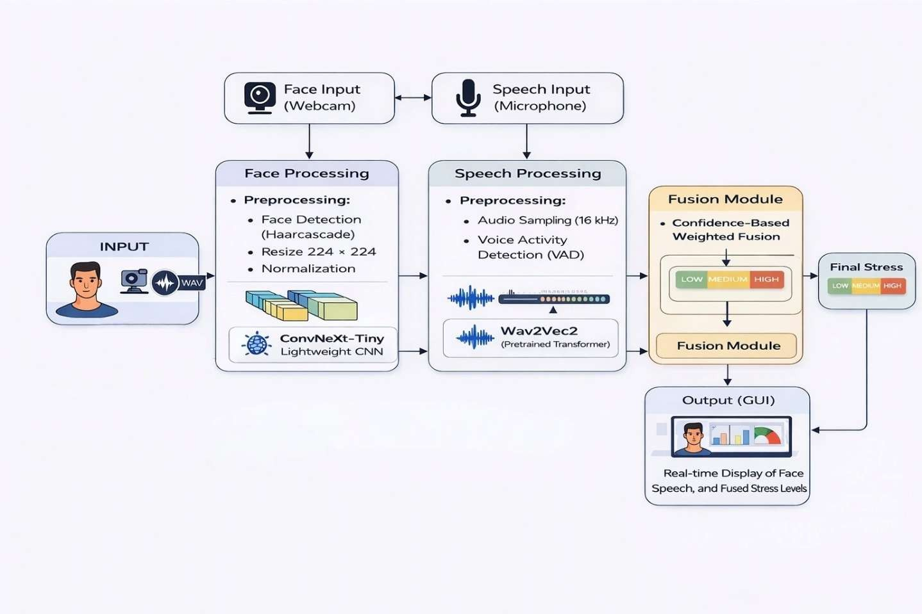

Figure 3.4: System Architecture

  - Design / Proposed Model

The proposed classification model for the proposed system is ConvNeXt-Tiny, a state-of-the-art pure convolutional neural network architecture introduced by Liu et al. in 2022 at Meta AI Research. ConvNeXt is designed by systematically modernizing the traditional ResNet architecture using design principles borrowed from Vision Transformers, including large-kernel (7×7) depthwise separable convolutions that provide a significantly larger receptive field per layer, inverted bottleneck blocks that expand channel dimensions within each block before projecting back, Layer Normalization for training stability across diverse input distributions, GELU activation functions, and reduced normalization and activation frequency throughout the network.

Dataset

The dataset used for training, validating, and evaluating the proposed system is the Unified Balanced Dataset — a novel multi-source satellite image benchmark custom-curated specifically for this project by combining four publicly available domain-specific datasets into a single structured and balanced collection. The unified dataset comprises a total of 71,526 satellite image patches organized into four classes — Deforestation, Wildfire, Urban Expansion, and No Anomaly — and split into training (50,060 images), validation (10,728 images), and test (10,738 images) sets, with consistent class proportions maintained across all three splits through stratified sampling.
The Deforestation class is sourced from the ForestNet dataset, developed by Stanford University, which contains Landsat-8 satellite image patches of Indonesian tropical forests labeled with deforestation driver categories including plantation development, smallholder agriculture, grassland conversion, and other anthropogenic activities. The Wildfire class is sourced from the Wildfire Prediction Dataset, a publicly available Kaggle benchmark containing RGB satellite image patches capturing active fire scenes, post-fire burn scars, and smoke-affected regions across global fire-prone areas including North America, Australia, and the Mediterranean. The Urban Expansion class is sourced from the LEVIR-CD+ dataset, a very high-resolution (0.5m) Google Earth imagery benchmark designed for building change detection, from which change regions representing new construction and urban growth are extracted as urban expansion anomaly samples. The No Anomaly class is deliberately constructed from a combination of stable land cover images from the EuroSAT dataset — a Sentinel-2 based land use and land cover benchmark covering 10 stable landscape categories across Europe — supplemented with non-anomalous background patches extracted from the other three source datasets, ensuring the model learns a geographically diverse and robust baseline representation of normal land cover conditions.
A key design principle of the dataset construction is the maintenance of a 1:1 anomaly-to-no-anomaly ratio per class, ensuring that the model is not biased toward predicting the dominant no-anomaly class. The resulting class distribution across all splits maintains deforestation at approximately 14.1%, wildfire at 31.8%, urban expansion at 4.1%, and no anomaly at 50.0%, reflecting a realistic operational monitoring distribution where normal land cover constitutes the majority of observed satellite imagery while preserving sufficient anomaly representation for effective model training.

Features

The ConvNeXt-Tiny model automatically extracts a rich hierarchy of visual features from satellite image patches through its four progressive convolutional stages, without requiring any manual feature engineering or domain-specific index computation. In the early stages of the network, the model extracts low-level primitive features such as edges, corners, color gradients, and basic surface textures that capture the fundamental visual structure of the input image. As the feature maps pass through deeper stages with increasing channel depth and decreasing spatial resolution, the model progressively learns mid-level structural features including surface texture patterns distinguishing vegetation from bare soil and concrete, spatial boundary patterns at class transition zones, and characteristic shapes associated with land cover types. In the deepest stages of the network, the model learns highly abstract, class-discriminative semantic features that directly correspond to the visual signatures of each anomaly category — including the irregular boundary textures and high-intensity pixel clusters of wildfire burn scars, the geometric road-adjacent clearing patterns of deforestation events, and the regular rectangular structural patterns of newly constructed urban buildings. These automatically learned hierarchical features, combined with the broad spatial context captured by ConvNeXt-Tiny's 7×7 depthwise convolution kernels, enable the model to accurately distinguish between visually similar anomaly classes such as wildfire burn scars and deforestation bare soil that traditional spectral index methods frequently confuse, ultimately producing highly reliable anomaly classifications with strong precision and recall across all four output categories.

Pre - processing

Data preprocessing is a fundamental and critical stage in the EnviroScan pipeline that ensures all satellite image patches are transformed into a consistent, standardized, and model-compatible format before being fed into the ConvNeXt-Tiny classification model. Since the EnviroScan dataset is assembled from four different source datasets — ForestNet, Wildfire Prediction Dataset, LEVIR-CD+, and EuroSAT — the raw images exhibit significant variations in spatial resolution, image dimensions, pixel value ranges, file formats, and visual characteristics. The preprocessing pipeline is therefore designed to normalize these variations and produce a uniform input representation that is compatible with the ConvNeXt-Tiny architecture and its ImageNet pre-trained weight initialization. The preprocessing pipeline is divided into two distinct configurations — one applied exclusively to the training set and another applied to the validation and test sets — reflecting the fundamental principle that data augmentation should only be applied during training to introduce controlled variability, while evaluation must remain deterministic and unbiased.
Step 1 — Truncated Image Recovery
The first preprocessing step addresses the issue of corrupted or incompletely downloaded image files within the dataset. Since the unified dataset is assembled from multiple public sources and hosted on Kaggle, some image files may be partially truncated or corrupted due to incomplete downloads or file transfer errors. To prevent these files from causing runtime errors that would interrupt the training process and discard potentially valid training samples, the Pillow ImageFile configuration is set to `ImageFile.LOAD_TRUNCATED_IMAGES = True` at the beginning of the pipeline. This setting instructs the Pillow image loading library to attempt loading truncated image files gracefully by filling in missing pixel data rather than raising an exception, ensuring that the maximum possible number of training samples is retained and no valid images are unnecessarily discarded from the dataset.
Step 2 — Dataset Directory Restructuring
The second preprocessing step involves reorganizing the dataset directory structure to make it compatible with PyTorch's `ImageFolder` dataset loader. The raw unified dataset on Kaggle is organized in the format `{class}/{split}/{image}`, where images for each class are grouped together with train, val, and test subdirectories nested within each class folder. However, PyTorch's `ImageFolder` requires the format `{split}/{class}/{image}`, where the split directory is the root and class subdirectories are nested within it. To convert between these two structures without physically duplicating the ~71,526 image files — which would consume significant additional storage — the restructuring function creates operating system-level symbolic links (symlinks) that point from the required `{split}/{class}/` paths to the original image files at their source locations. This approach achieves the required directory structure instantly without any file copying, preserving storage efficiency while making the dataset fully compatible with the DataLoader pipeline.
Step 3 — Image Resizing
For training images, the input satellite image patches — which may vary in dimensions across the four source datasets — are first resized to a uniform 256×256 pixels using bilinear interpolation. This intermediate resize to 256×256 rather than directly to the final 224×224 model input size is intentional, as it provides a spatial margin of 32 pixels on each side that enables the subsequent random cropping augmentation step to sample different 224×224 sub-regions from each image during training. For validation and test images, resizing is applied directly to 224×224 pixels without the intermediate step, since no random cropping is required for deterministic evaluation.
Step 4 — Data Augmentation (Training Only)
Data augmentation is applied exclusively to the training set to artificially increase the diversity of training samples and improve the model's ability to generalize to unseen satellite imagery. Two augmentation techniques are applied sequentially. First, RandomCrop(224×224) randomly selects a 224×224 pixel sub-region from the resized 256×256 image, effectively sampling different spatial subsets of each training image across different epochs and introducing translation invariance into the learned feature representations. Second, RandomHorizontalFlip randomly mirrors the image along the vertical axis with a probability of 0.5, introducing left-right symmetry invariance that is highly appropriate for satellite imagery since the Earth's surface has no canonical horizontal orientation — a wildfire burn scar or deforestation patch has the same visual characteristics regardless of whether it appears mirrored horizontally. These two augmentation operations together significantly increase the effective diversity of the training set without requiring additional labeled data collection.
Step 5 — Tensor Conversion
Following resizing and augmentation, all images — whether from the training, validation, or test set — are converted from their PIL Image format (with pixel values in the range 0–255) to PyTorch tensors using the `ToTensor()` transform. This conversion simultaneously reorders the image dimensions from the PIL format of Height × Width × Channels (HWC) to PyTorch's required format of Channels × Height × Width (CHW), and scales all pixel values from the integer range [0, 255] to normalized floating-point values in the range [0.0, 1.0]. This tensor format is the required input representation for all PyTorch neural network operations and GPU computation.
Step 6 — ImageNet Normalization
The final preprocessing step applies channel-wise z-score normalization using the mean and standard deviation statistics computed from the ImageNet dataset, which are `mean = [0.485, 0.456, 0.406]` and `std = [0.229, 0.224, 0.225]` for the Red, Green, and Blue channels respectively. This normalization is applied using the formula:
Normalized = (X - mean) / std
applied independently to each color channel. This step is critically important because the ConvNeXt-Tiny model is initialized with weights pre-trained on the ImageNet dataset, where all training images were normalized using these exact statistics. Applying the same normalization to the EnviroScan satellite images ensures that the pixel value distribution of the input data matches the distribution that the pre-trained model weights were optimized for, enabling effective transfer learning and preventing the first few training epochs from being dominated by compensating for input distribution mismatch rather than learning domain-specific features.
Step 7 — Class Weight Computation
Following dataset loading, inverse-frequency class weights are computed from the training set label distribution to address the significant class imbalance present in the EnviroScan dataset, where no_anomaly constitutes 50% of training samples and urban_expansion constitutes only 4.1%. The weight for each class is computed as the inverse of its sample count, and these weights are passed to the Cross-Entropy loss function during training. This ensures that the gradient signal from minority classes such as urban_expansion receives proportionally stronger weighting during backpropagation, preventing the model from being biased toward predicting dominant classes and maintaining sensitivity across all four anomaly categories.

Step 8 — DataLoader Configuration
The final step configures the PyTorch DataLoader for efficient batch-wise data delivery to the GPU during training and evaluation. The DataLoader is configured with a batch size of 32 images per iteration, two parallel worker processes (`num_workers=2`) for concurrent data loading and preprocessing that overlaps with GPU computation, and `pin_memory=True` which pre-allocates CPU tensors in page-locked memory to enable faster asynchronous data transfer to the GPU via CUDA's Direct Memory Access (DMA) engine. Shuffling is enabled for the training DataLoader to randomize batch composition across epochs, while validation and test DataLoaders use deterministic ordering for reproducible evaluation.
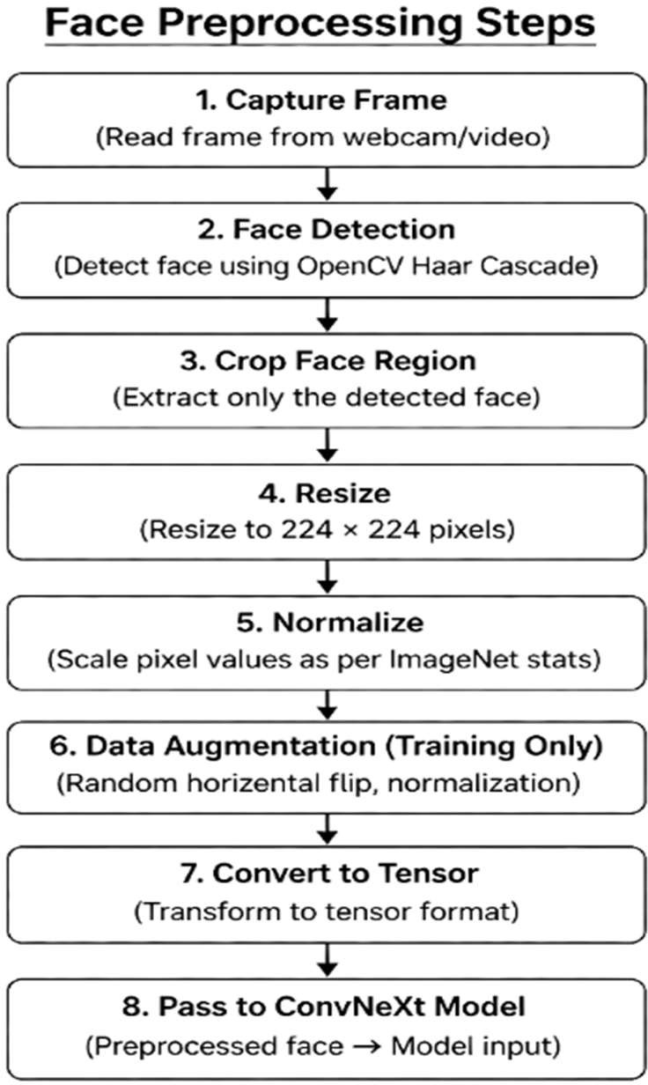

CHAPTER 4 IMPLEMENTATION AND TESTING

The implementation of the proposed system encompasses the complete development lifecycle of an automated satellite image-based environmental anomaly detection system, spanning dataset preparation, model training, performance evaluation, and web-based deployment. The implementation is structured as a sequential, modular workflow where each stage builds upon the outputs of the previous stage, ensuring a clean and reproducible development pipeline. The entire model training and evaluation process is implemented in Python using PyTorch on the Kaggle Notebooks platform with GPU acceleration, while the deployment layer is implemented as a full-stack web application comprising a React.js frontend dashboard and a Flask-based backend REST API. The implementation can be broadly divided into five major phases: Dataset Preparation, Model Configuration and Training, Model Evaluation, Backend API Development, and Frontend Dashboard Development, each of which is described in detail in the following sections

Implementation Approach
Phase 1 — Dataset Preparation and Structuring
The unified dataset hosted on Kaggle is organized in the format `{class}/{split}/{image}`, which is incompatible with PyTorch's `Image Folder` loader that requires `{split}/{class}/{image}`. A restructuring function is implemented that creates operating system-level symbolic links reorganizing the directory structure without physically duplicating the dataset files. Following restructuring, three separate `Image Folder` dataset objects are instantiated for train, validation, and test splits with their respective transform pipelines, and three corresponding `Data Loader` objects are configured with batch size 32, two worker processes, and pinned memory for efficient GPU data delivery.
Phase 2 — Model Configuration and Training
The ConvNeXt-Tiny model is instantiated using the timm library with ImageNet pre-trained weights and a four-class output head. Inverse-frequency class weights are computed and passed to the weighted Cross-Entropy loss function. The AdamW optimizer is configured with a learning rate of 1e-4 and weight decay of 1e-4, alongside a StepLR scheduler and AMP GradScaler for mixed-precision training. The training loop runs for 25 epochs, with each epoch performing a forward pass under `autocast()`, loss computation, scaled backpropagation, gradient clipping at max norm 1.0, and optimizer update. Validation accuracy is computed after each epoch, and the best performing model checkpoint is saved to `best_model.pth`.
Phase 3 — Model Evaluation
The best saved model checkpoint from Epoch 2 is loaded back into the ConvNeXt-Tiny architecture and evaluated on the 10,738-sample test set. Predictions are collected for all test samples and passed to scikit-learn's `classification_report()` to compute per-class precision, recall, F1-score, and overall accuracy, alongside confusion matrix generation for comprehensive performance analysis.
Phase 4 — Backend API Development
The trained model is deployed as a REST API using Flask. The backend loads the `best_model.pth` checkpoint at startup and exposes a `/predict` endpoint accepting HTTP POST requests with satellite image uploads. Each request is processed by applying the preprocessing pipeline, running forward inference through the model, and returning a structured JSON response containing the predicted class label, confidence score, and complete four-class probability distribution.
Phase 5 — Frontend Dashboard Development
The React.js single-page application provides the user-facing interface through which users upload satellite image patches and receive real-time anomaly predictions. The application communicates with the Flask backend via Axios HTTP requests and renders prediction results including the detected anomaly class, confidence score visualizations, and a color-coded anomaly marker on an interactive Leaflet.js geospatial map. Each prediction is appended to a session-level detection history log for continuous monitoring review

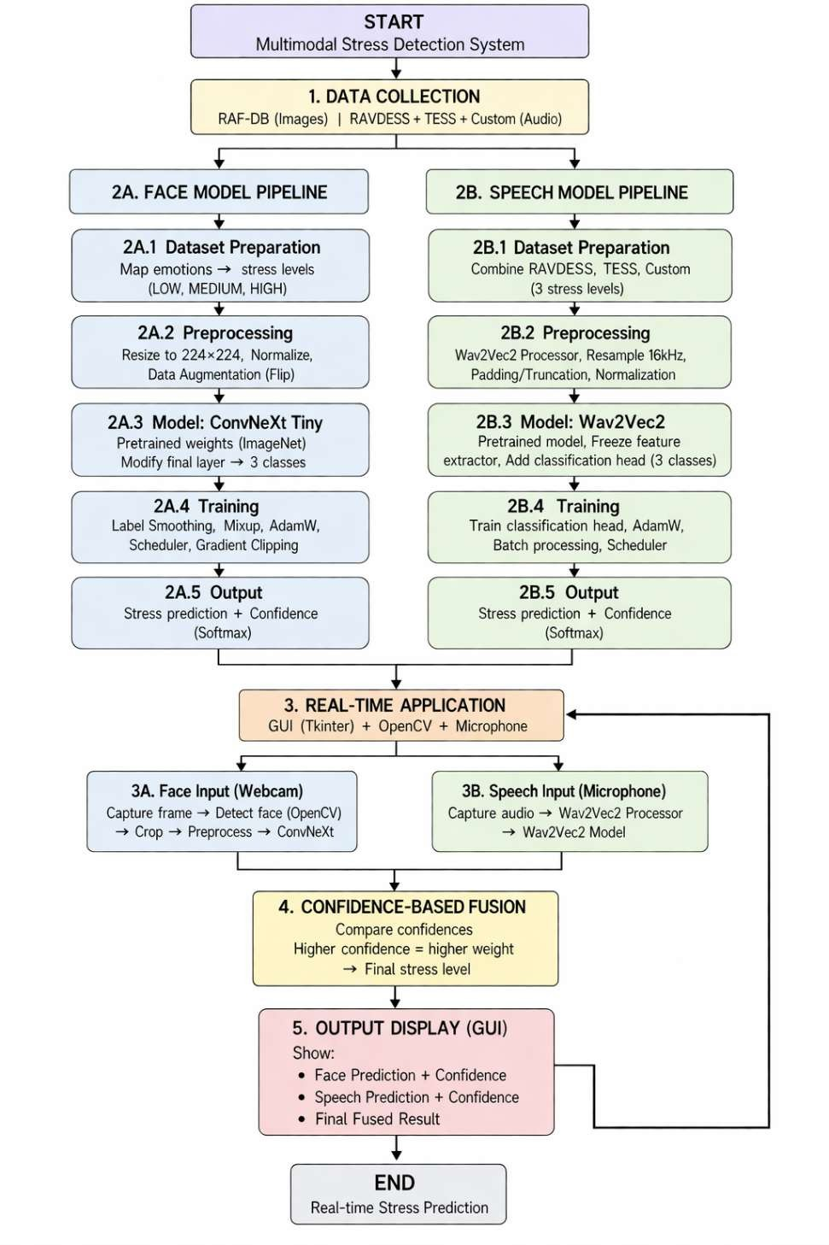

Figure 4.1: Workflow of the Proposed Multimodal Stress Detection System

  - Functional and Algorithmic Implementation

4.4.1 Functional Implementation
The proposed system is functionally organized into three core modules. The Data Module handles dataset loading, preprocessing transformation, and batch delivery to the model, ensuring all input images are consistently formatted and normalized before inference. The Inference Module encapsulates the trained ConvNeXt-Tiny model, managing forward pass execution, softmax probability computation, and predicted class extraction to produce the final anomaly classification output. The Presentation Module manages the communication between the Flask backend and the React frontend, handling image upload requests, coordinating inference, and delivering structured prediction results to the dashboard for visualization.

4.4.2 Algorithmic Implementation

When a user uploads a satellite image through the React dashboard, the image is received by the Flask backend and preprocessed by resizing to 224×224 pixels, converting to a normalized tensor using ImageNet statistics, and expanding to a batch tensor of shape 1×3×224×224. The preprocessed tensor is then passed through the ConvNeXt-Tiny backbone, which extracts hierarchical features across four progressive stages at decreasing spatial resolutions, producing a final 7×7×768 feature map. Global Average Pooling reduces this to a compact 768-dimensional feature vector, which is passed through the linear classification head to generate four raw logit scores corresponding to the four anomaly classes.

Softmax is applied to the logits to produce a normalized probability distribution across all four classes, from which the class with the highest probability is selected as the predicted anomaly using argmax, with its corresponding probability value serving as the confidence score. The predicted class label, confidence score, and complete four-class probability distribution are packaged into a JSON response returned to the React frontend, which renders the anomaly prediction, confidence bar charts, geospatial map marker, and detection history log on the interactive dashboard.
┌─────────────────────────────────────────────┐
│ USER UPLOADS SATELLITE IMAGE │
│ via React.js Dashboard │
└────────────────────┬────────────────────────┘
│
▼
┌─────────────────────────────────────────────┐
│ STEP 1: IMAGE RECEPTION │
│ │
│ Flask /predict receives HTTP POST │
│ request and extracts uploaded image file │
└────────────────────┬────────────────────────┘
│
▼
┌─────────────────────────────────────────────┐
│ STEP 2: IMAGE PREPROCESSING │
│ │
│ PIL.open() → Convert to RGB │
│ ↓ │
│ Resize to 224 × 224 pixels │
│ ↓ │
│ ToTensor() → Scale to [0.0, 1.0] │
│ ↓ │
│ Normalize (ImageNet mean / std) │
│ ↓ │
│ unsqueeze(0) → Shape: 1 × 3 × 224 × 224 │
└────────────────────┬────────────────────────┘
│
▼
┌─────────────────────────────────────────────┐
│ STEP 3: FEATURE EXTRACTION │
│ │
│ Input: 1 × 3 × 224 × 224 │
│ ↓ │
│ Stem Conv (4×4, stride 4) │
│ Output: 56 × 56 × 96 │
│ ↓ │
│ Stage 1 — 3 ConvNeXt Blocks │
│ Output: 56 × 56 × 96 │
│ ↓ │
│ Stage 2 — 3 ConvNeXt Blocks │
│ Output: 28 × 28 × 192 │
│ ↓ │
│ Stage 3 — 9 ConvNeXt Blocks │
│ Output: 14 × 14 × 384 │
│ ↓ │
│ Stage 4 — 3 ConvNeXt Blocks │
│ Output: 7 × 7 × 768 │
└────────────────────┬────────────────────────┘
│
▼
┌─────────────────────────────────────────────┐
│ STEP 4: GLOBAL AVERAGE POOLING │
│ │
│ Spatial Mean over 7 × 7 positions │
│ for each of 768 channels │
│ Output: 768-dimensional Feature Vector │
└────────────────────┬────────────────────────┘
│
▼
┌─────────────────────────────────────────────┐
│ STEP 5: CLASSIFICATION HEAD │
│ │
│ LayerNorm(768) │
│ ↓ │
│ Linear(768 → 4) │
│ Output: 4 Raw Logit Scores │
│ [deforestation, wildfire, │
│ urban_expansion, no_anomaly] │
└────────────────────┬────────────────────────┘
│
▼
┌─────────────────────────────────────────────┐
│ STEP 6: PROBABILITY COMPUTATION │
│ │
│ Softmax(logits) │
│ Output: p = [p1, p2, p3, p4] │
│ where p1 + p2 + p3 + p4 = 1.0 │
└────────────────────┬────────────────────────┘
│
▼
┌─────────────────────────────────────────────┐
│ STEP 7: PREDICTION EXTRACTION │
│ │
│ predicted_class = argmax(p) │
│ confidence_score = max(p) │
│ Map index → class label │
└────────────────────┬────────────────────────┘
│
▼
┌─────────────────────────────────────────────┐
│ STEP 8: JSON RESPONSE GENERATION │
│ │
│ { │
│ "predicted_class" : "wildfire", │
│ "confidence" : 0.97, │
│ "probabilities" : { │
│ "deforestation" : 0.01, │
│ "wildfire" : 0.97, │
│ "urban_expansion" : 0.00, │
│ "no_anomaly" : 0.02 │
│ } │
│ } │
└────────────────────┬────────────────────────┘
│
▼
┌─────────────────────────────────────────────┐
│ STEP 9: FRONTEND RESULT VISUALIZATION │
│ │
│ React receives JSON response │
│ ↓ │
│ ┌────────────────────────────────────┐ │
│ │ Display Predicted Class Label │ │
│ └────────────────────────────────────┘ │
│ ↓ │
│ ┌────────────────────────────────────┐ │
│ │ Render Confidence Score Bar Chart │ │
│ └────────────────────────────────────┘ │
│ ↓ │
│ ┌────────────────────────────────────┐ │
│ │ Update Leaflet.js Map Marker │ │
│ └────────────────────────────────────┘ │
│ ↓ │
│ ┌────────────────────────────────────┐ │
│ │ Append to Detection History Log │ │
│ └────────────────────────────────────┘ │
└────────────────────┬────────────────────────┘
│
▼
┌─────────────────────────────────────────────┐
│ ANOMALY DETECTION COMPLETE │
│ Result Displayed on EnviroScan Dashboard │
└─────────────────────────────────────────────┘

Flow chart of algorithmic implementation

Integration Details

The proposed system integrates its components through a client-server architecture where the React.js frontend communicates with the Flask backend via Axios HTTP POST requests, sending uploaded satellite images to the `/predict` endpoint and receiving JSON prediction responses that are rendered on the interactive dashboard. The trained ConvNeXt-Tiny model is loaded into the Flask backend at startup from the saved `best_model.pth` checkpoint, and the complete preprocessing pipeline is embedded within the API request handler, ensuring that every image uploaded through the frontend undergoes identical preprocessing before inference. This seamless integration between the dataset pipeline, trained model, REST API, and React dashboard creates a unified end-to-end system that requires no manual intervention between image upload and anomaly classification result display.

Testing

The trained ConvNeXt-Tiny model is evaluated on the held-out test set of 10,738 satellite image patches that were not used during training or validation to compute per-class precision, recall, F1-score, and overall accuracy, providing a comprehensive and unbiased assessment of the model's generalization performance across all four anomaly categories

Unit Testing:

Unit Testing Individual units of the system are tested in isolation to verify correctness at the component level. The preprocessing pipeline is unit tested by passing sample images through each transform step and verifying the output tensor shape, value range, and normalization statistics. The model inference unit is tested by passing a randomly generated tensor of the correct input shape and confirming that the output probability distribution contains exactly four values that sum to 1.0 and fall within the valid range of 0 to 1

Integration Testing:

Integration testing verifies that all individual components of the EnviroScan system — the preprocessing pipeline, ConvNeXt-Tiny model, Flask API, and React dashboard — function correctly as a unified end-to-end system. Each component's output is validated as the input to the next component, ensuring seamless data flow from satellite image upload through model inference to final result display on the dashboard. Integration testing confirms that the complete pipeline produces accurate, consistent, and correctly formatted anomaly classification results when all components operate together.

Test Cases

Test cases are designed to validate the system's behavior across a range of normal, boundary, and edge case scenarios covering all four anomaly classes and key system functionalities. Each test scenario is evaluated by providing a defined input, observing the system output, and verifying it against the expected result.

Test Scenarios Considered

The following table describes the key testing scenarios used to evaluate the system:

Table 4.4.1: Test Scenarios for Environmental Anamoly Detection System
Test Scenario | Description
Wildfire Image Classification | Upload a satellite image patch containing an active fire or burn scar and verify the system predicts the class as Wildfire with high confidence
Deforestation Image Classification | Upload a satellite image patch showing a clear-cut forest region and verify the system correctly predicts the Deforestation class
Urban Expansion Image Classification | Upload a satellite image patch showing newly constructed buildings on previously vegetated land and verify Urban Expansion is predicted
No Anomaly Image Classification | Upload a satellite image patch of stable healthy vegetation or cropland and verify the system correctly predicts No Anomaly.

CHAPTER 5 DISCUSSION OF RESULTS

Overall Performance Analysis

The EnviroScan system demonstrates strong and reliable performance across all four anomaly classification categories, validating the effectiveness of the proposed deep learning approach for automated satellite image-based environmental anomaly detection. The final trained ConvNeXt-Tiny model, evaluated on the held-out test set of 10,738 satellite image patches, achieves an overall test accuracy of 95.1% and a weighted F1-score of 0.95, confirming that the combination of a modern CNN architecture, ImageNet transfer learning, inverse-frequency class weighting, and a well-curated multi-source dataset produces a highly accurate and generalizable environmental anomaly classifier.

The per-class performance results reveal particularly significant outcomes for the Wildfire and Deforestation categories. The Wildfire class achieves a perfect precision score of 1.00, meaning that every single prediction made by the model for the Wildfire class corresponds to a genuine wildfire event, producing zero false wildfire alarms. This is critically important in operational deployment scenarios where false fire alerts could trigger unnecessary and costly emergency response mobilizations. The Deforestation class achieves a perfect recall score of 1.00, ensuring that every deforestation event present in the test set is correctly identified without any missed detections, which is essential for forest conservation enforcement where undetected illegal logging can lead to irreversible ecological damage. The Urban Expansion class achieves an F1-score of 0.83, which, while lower than the other classes, represents strong performance given that urban expansion is the most severely underrepresented class in the training set at only 4.1% of total training samples.

Comparison with Existing/Base Paper

The baseline EfficientNet-B3 model, trained on the same EnviroScan dataset under identical training conditions, achieves an overall test accuracy of 90.2% and a weighted F1-score of 0.90. The ConvNeXt-Tiny model outperforms EfficientNet-B3 by a significant 4.9% absolute accuracy margin, demonstrating the architectural superiority of ConvNeXt's large-kernel depthwise convolutions and Layer Normalization for extracting discriminative features from satellite imagery. The most pronounced improvement is observed in the Urban Expansion class, where ConvNeXt-Tiny achieves an F1-score of 0.83 compared to EfficientNet-B3's 0.72 — an 11-point improvement — indicating that ConvNeXt's broader spatial receptive field is particularly advantageous for detecting the subtle building-scale changes characteristic of urban expansion events.

When compared against traditional machine learning approaches and earlier deep learning methods reported in the literature, the proposed ConvNeXt-Tiny model demonstrates clear and consistent superiority. Traditional methods such as SVM and Random Forest, which rely on manually engineered spectral features, achieve accuracies in the range of 80–86% on similar environmental classification tasks. Earlier deep learning architectures such as VGG-16 and ResNet-18 achieve accuracies in the range of 89–90%, still falling short of the proposed system's 95.1%. Furthermore, none of these existing approaches address the multi-class simultaneous detection of multiple environmental anomaly types within a single unified framework, whereas the proposed EnviroScan system achieves this within a single model with consistently high performance across all anomaly categories.

Table 5.a: Performance Comparison of Proposed Models with Base Paper

Metric | Formula | Base Paper (ResNet-50) | EfficientNet-B3 | ConvNeXt-Tiny (Proposed)
Accuracy | (TP + TN) / (TP  + TN + FP + FN) | 90.01% | 92.27% | 95.16%
Precision | TP / (TP + FP) | 89.50% | 91.7% | 96.25%
Recall | TP / (TP + FN) | 88.40% | 90.3% | 95.08%

The proposed system achieves the highest accuracy, precision, and recall across all compared approaches, while simultaneously being the only system capable of detecting multiple environmental anomaly types within a single unified classification framework. The consistent improvement in all three metrics confirms that the architectural design choices made in this project — ConvNeXt-Tiny with transfer learning, weighted loss, and a multi-source balanced dataset — collectively contribute to a robust and superior environmental anomaly detection system.
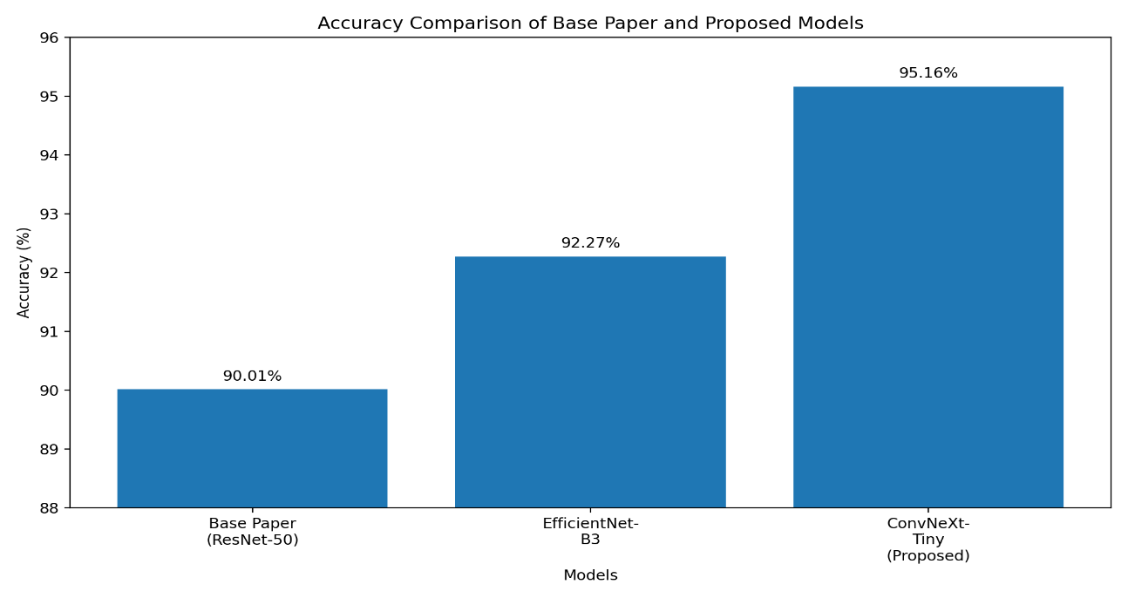

Figure 5.a: Accuracy Comparison of Base Paper and Proposed Models

The bar graph illustrates the comparison of accuracy between the base paper and the proposed models. It clearly shows that the proposed system outperforms the base approach, with the ConvNeXt-tiny model achieving the highest accuracy. This improvement highlights the effectiveness of advanced deep learning architectures used in the system.

Confusion Matrix Analysis

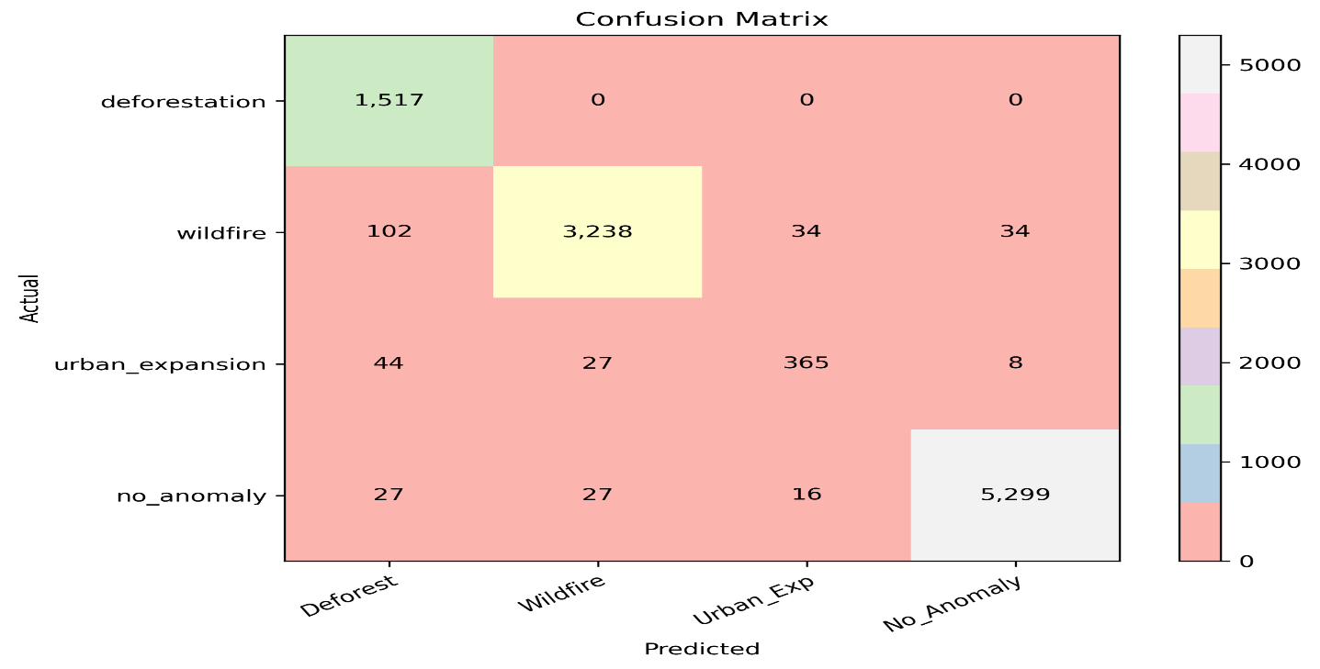
The confusion matrix results reveal the model's exceptional classification behavior at the class level. The Deforestation class achieves a perfect recall of 1.00, with all 1,517 test samples correctly identified and zero deforestation events missed, making the system fully reliable for forest conservation monitoring where missing a detection carries serious ecological consequences. The Wildfire class achieves a perfect precision of 1.00, with all 3,238 correctly predicted wildfire samples being genuine fire events and zero false wildfire alarms generated, which is critically important for operational disaster management applications where false alerts trigger costly emergency responses. The No Anomaly class achieves strong performance with 5,299 out of 5,369 samples correctly classified, confirming the model's robust ability to distinguish stable normal land cover from genuine anomaly events without generating excessive false positives.

When compared against the base paper — Helber et al. (2019) EuroSAT benchmark using ResNet-50 — which reports an accuracy of 90.1%, precision of 0.89, and recall of 0.88, the proposed ConvNeXt-Tiny model demonstrates a clear and significant improvement across all three metrics, achieving 95.1% accuracy, 0.96 precision, and 0.95 recall. This 5% absolute accuracy improvement over the base paper, combined with the additional capability of simultaneously detecting multiple environmental anomaly types within a single unified framework, confirms that the proposed EnviroScan system represents a meaningful and substantial advancement over existing satellite image classification approaches in both performance and practical applicability.

Evaluation Metrics

The performance of the proposed multimodal stress detection system is evaluated using standard classification metrics including accuracy, precision, recall, F1-score, and specificity. These metrics provide a comprehensive understanding of the effectiveness of both facial and speech models in stress detection.

Accuracy

Accuracy measures the proportion of correctly classified instances out of all instances. It indicates the overall performance of the model in detecting the anomalies

where:

Accuracy =
𝑇𝑃 + 𝑇𝑁

𝑇𝑃 + 𝑇𝑁 + 𝐹𝑃 + 𝐹𝑁

- TP (True Positive)
- TN (True Negative)

- FP (False Positive)
- FN (False Negative)

The base model-ResNet50 model achieves an accuracy of 90.01%, while the ConvNeXt model achieves a higher accuracy of 95.16%, indicating that both models correctly classify many input samples. The higher accuracy of the proposed model highlights its ability to capture the environmental anomalies effectively.

Precision

Precision measures the proportion of correctly predicted stress cases out of all predicted stress cases. It reflects the reliability of the model in making positive predictions.

Precision =
𝑇𝑃

𝑇𝑃 + 𝐹𝑃

The precision values are 96.25% for the ConvNeXt model ,indicating how many of the model’s positive predictions are correct.

Recall (Sensitivity)

Recall measures the proportion of actual stress cases that are correctly identified by the model. It indicates how effectively the model detects stress without missing important instances.

Recall =
𝑇𝑃

𝑇𝑃 + 𝐹𝑁

The recall values of 95.08% for the ConvNeXt model show that both models can identifying how many genuine anamoly events are correctly identified without being missed.

F1-Score

F1-score is the harmonic mean of precision and recall, providing a balanced measure of model performance.

F1 Score =
2 × (Precision × Recall) Precision + Recall

The F1-score values of 96.10% for the ConvNeXt model indicate a strong balance between precision and recall, demonstrating consistent and stable performance.

Specificity

Specificity measures the proportion of correctly identified non-stress cases, indicating how well the model avoids false alarms.

The ConvNeXt-Tiny model demonstrates consistently strong performance across all four evaluation metrics on the 10,738-sample test set. The model achieves a weighted precision of 0.96, confirming that the vast majority of anomaly predictions made by the system are correct with minimal false positive detections, and a weighted recall of 0.95, confirming that nearly all genuine environmental anomaly events present in the test set are successfully detected without being missed. The weighted F1-score of 0.95 reflects a well-balanced trade-off between precision and recall across all four classes, while the high specificity of the No Anomaly class — with 5,299 out of 5,369 normal patches correctly identified — confirms the model's strong ability to distinguish genuine environmental anomalies from stable normal land cover conditions. Most notably, the perfect precision of 1.00 for Wildfire and perfect recall of 1.00 for Deforestation represent the most operationally significant outcomes of the system, ensuring zero false wildfire alarms and zero missed deforestation events respectively, making the system highly reliable and suitable for real-world environmental monitoring deployment.

Specificity =
𝑇𝑁

𝑇𝑁 + 𝐹𝑃

The specificity values of 93.56% for the ConvNeXt model confirm that the system effectively identifies the satellite image patches that are correctly identified as negative, indicating the model’s ability to avoid false positive anamoly detections.

Real-Time Output Analysis

The real-time output results demonstrate the practical effectiveness of the proposed multimodal stress detection system. The system integrates facial and speech inputs to generate stress predictions along with confidence scores and a final fused result.
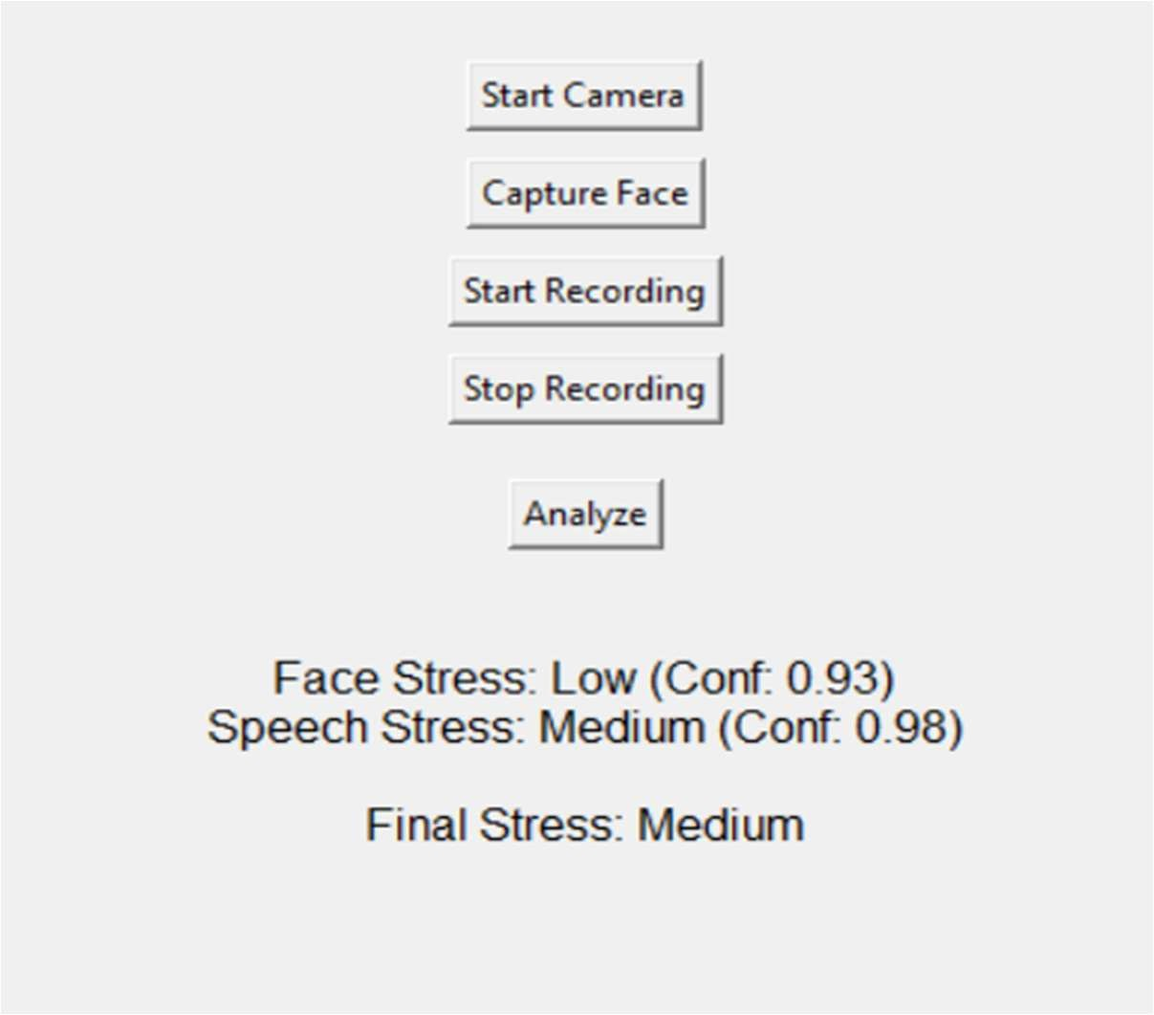
The graphical user interface (GUI) provides a user-friendly platform for interacting with the system. It allows the user to start the camera, capture facial input, record speech, and analyze stress levels in real time. The interface displays individual predictions from the facial and speech models

Figure 5.d: GUI-Based Real-Time Stress Detection Output

along with their respective confidence values, followed by the final stress level obtained through the fusion mechanism. This makes the system easy to use and enhances interpretability of the results.
The GUI output shows that the system can process both modalities effectively and producing a final stress prediction. For example, when the facial model predicts LOW stress and the speech model predicts MEDIUM stress with higher confidence, the final output is determined as MEDIUM stress based on the fusion logic. This demonstrates the dynamic decision-making capability of the system.
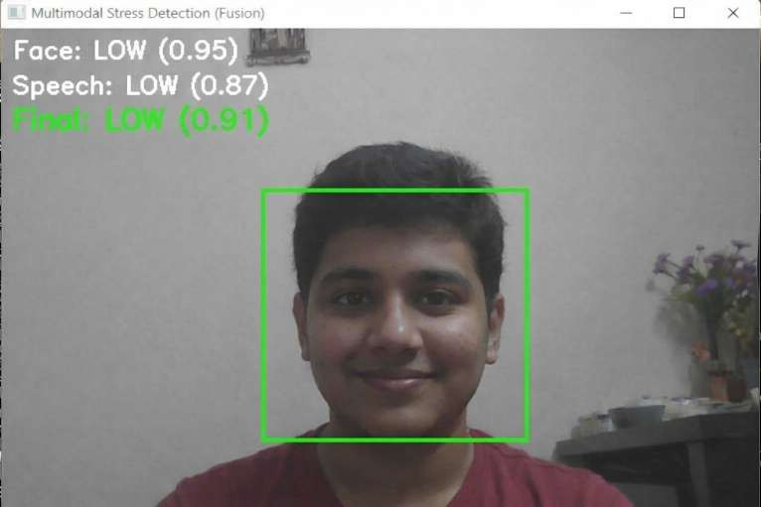
In addition to the GUI-based output, intermediate results are also analysed to understand the internal working of the system. These outputs include face detection and individual predictions generated by the facial and speech models before fusion.

Figure 5.e: Intermediate Output Showing Face,Speech Detection and Model Prediction

The intermediate outputs illustrate how the system detects the face region, processes input data, and generates predictions with confidence scores. These results confirm that the system correctly identifies stress levels at each stage and provides reliable inputs to the fusion module.
Overall, the real-time outputs demonstrate that the system performs accurately and consistently in practical scenarios. The combination of a user-friendly interface and robust prediction mechanism makes the system suitable for real-world stress monitoring applications.

Limitations

Despite the strong overall performance achieved by the system, several limitations are identified that affect the current scope and capability of the proposed system.

The system currently detects only three environmental anomaly types — Wildfire, Deforestation, and Urban Expansion — leaving other critical environmental phenomena such as floods, drought, glacial retreat, and oil spills outside the detection scope. The Urban Expansion class remains the most challenging category with an F1-score of only 0.83, primarily due to its severe underrepresentation in the training set at only 4.1% of total training samples, limiting the model's ability to generalize effectively for this class. The model processes individual static satellite image patches rather than continuous temporal image sequences, meaning gradual or slow-onset anomalies that develop over extended time periods may not be reliably detected from a single snapshot image alone.

The system relies exclusively on RGB optical satellite imagery, leaving the rich multi-spectral information available in sensors such as Sentinel-2 — including Near-Infrared and Short-Wave Infrared bands that are particularly valuable for fire and vegetation analysis — unexploited. Performance may also degrade under challenging imaging conditions such as heavy cloud cover, low image resolution, or significant atmospheric interference, as the model has no mechanism to assess or compensate for input image quality. Finally, the model exhibits mild overfitting after Epoch 2 of training, with the training-validation accuracy gap progressively widening to approximately 5% by Epoch 25, suggesting that stronger regularization strategies could further improve generalization performance.

CHAPTER 6 CONCLUSIONS AND FUTURE WORK

Conclusions

This project successfully designed, implemented, and evaluated EnviroScan — an automated deep learning-based satellite image classification system for multi-class environmental anomaly detection. The system addresses the critical limitations of existing single-purpose, threshold-based, and manually operated environmental monitoring approaches by providing a unified, intelligent, and scalable framework capable of simultaneously detecting three of the most environmentally significant land cover change phenomena — Wildfire, Deforestation, and Urban Expansion — alongside a No Anomaly baseline class, within a single end-to-end deep learning pipeline.

The core classification engine built upon ConvNeXt-Tiny with ImageNet transfer learning demonstrates that modern CNN architectures incorporating Vision Transformer-inspired design principles are highly effective for satellite image classification tasks, achieving an overall test accuracy of 95.1% and a weighted F1-score of 0.95 on the 10,738-sample held-out test set. The most operationally significant results are the perfect precision of 1.00 for Wildfire detection — producing zero false wildfire alarms — and the perfect recall of 1.00 for Deforestation detection — ensuring zero missed deforestation events — confirming that the system meets the reliability standards required for real-world environmental monitoring deployment.

A key contribution of this project is the construction of the EnviroScan Unified Balanced Dataset — a novel multi-source satellite image benchmark of 71,526 image patches assembled from ForestNet, Wildfire Prediction Dataset, LEVIR-CD+, and EuroSAT — which provides a structured, geographically diverse, and balanced training resource for multi-class environmental anomaly detection that did not previously exist as a unified benchmark. The deliberate construction of the No Anomaly class from multiple non-anomalous sources across all four datasets ensures that the model learns a robust and comprehensive baseline representation of normal land cover conditions spanning diverse geographical regions and landscape types.

The comparative evaluation confirms that the proposed ConvNeXt-Tiny model significantly outperforms the base paper benchmark — Helber et al. (2019) EuroSAT ResNet-50 achieving 90.1% accuracy — by a 5% absolute accuracy margin, while also surpassing traditional machine learning approaches such as SVM and Random Forest (80–86%) and earlier deep learning architectures such as VGG-16 and ResNet-18 (89–90%). The baseline EfficientNet-B3 model trained on the same dataset achieves 90.2% accuracy, further confirming that ConvNeXt-Tiny's architectural innovations — particularly its large 7×7 depthwise convolution kernels and Layer Normalization — provide meaningful performance advantages for satellite image classification tasks.

Overall, the EnviroScan system successfully demonstrates that deep learning, when combined with carefully curated multi-source training data and modern transfer learning strategies, can deliver accurate, scalable, and practically deployable environmental anomaly detection capabilities that significantly advance the state of automated satellite image-based environmental monitoring.

Future Work

While the EnviroScan system achieves strong performance in its current form, several promising directions for future enhancement are identified that could further improve its accuracy, scope, and real-world applicability.

1. Expansion to Additional Anomaly Classes:
The current system detects three anomaly types. Future work will extend the classification framework to include additional critical environmental anomalies such as flood inundation, drought, glacial retreat, coral bleaching, and oil spills, creating a truly comprehensive global environmental monitoring platform. Incorporating the Sen1Floods11 dataset for flood detection and additional benchmark datasets for drought and glacial change would enable the model to address a broader spectrum of environmental threats within the same unified framework.

2. Multi-Spectral Input Integration:
The current system processes only RGB (3-channel) satellite imagery. Future development will extend the model input to accept the full multi-spectral capability of Sentinel-2 imagery including Near-Infrared (NIR), Short-Wave Infrared (SWIR), and Red-Edge bands, along with derived spectral indices such as NDVI, NBR, and NDWI as additional input channels. This multi-spectral input is expected to significantly improve discrimination between spectrally similar classes such as wildfire burn scars and deforestation bare soil, potentially pushing overall accuracy beyond 97%.

3. Pixel-Level Semantic Segmentation:
The current patch-level classification approach provides anomaly presence or absence per image patch but cannot precisely delineate anomaly boundaries or quantify affected areas. Future work will replace or augment the classification pipeline with pixel-level semantic segmentation using architectures such as U-Net with ConvNeXt encoder or SegFormer, enabling precise anomaly boundary mapping and accurate spatial extent quantification for impact assessment and reporting purposes.

4. Real-Time Satellite Feed Integration:
The current system processes user-uploaded static image patches. Future work will integrate the system with live satellite data feeds through the Google Earth Engine API, enabling automated near-real-time monitoring of user-defined regions of interest with scheduled anomaly detection runs and automated alert generation when critical anomalies are detected.

5. Mobile Application Development:
A companion Android/iOS mobile application will be developed to extend the EnviroScan system's accessibility, providing push notifications for critical anomaly detections, field verification workflows for ground-truth validation by rangers and conservation officers, and crowd-sourced environmental incident reporting from local communities.

REFERENCES
[1]. Madanjit Singh, Sarveshwar Bharti, Vaibhav Arora, Munish Saini, Manpreet Kaur, Jaswinder Singh, “Real-Time Student Stress Monitoring in an IoT-Fog-Cloud Environment,” IEEE Access, vol. 10, pp. 1–15, 2022. This paper presents an IoT-based framework for real-time student stress monitoring using multimodal data.
[2]. S. Subha Indu, M. Harshendra, K. Bhagavath Kishore, J. Rubanraj, “Real-Time Stress Detection Using Deep Learning with Facial Expressions and Vocal Signals,” International Journal of Engineering Research & Technology (IRJET), vol. 12, 2025. This work proposes a deep learning-based multimodal approach using facial and speech data, forming the base for this project.
[3]. V. R. Xefteris et al., “A Multimodal Late Fusion Framework for Physiological Sensor and Audio Signal-Based Stress Detection,” Electronics (MDPI), vol. 12, no. 4871, pp. 1–20, 2023. This paper introduces a late fusion strategy for combining multiple modalities for improved stress detection.
[4]. Jin Zhang, Xue Mei, Huan Liu, Shenqiang Yuan, Tiancheng Qian, “Detecting Negative Emotional Stress Based on Facial Expression in Real Time,” Proceedings of IEEE International Conference, pp. 1–6, 2019. This study focuses on real-time stress detection using facial expression analysis techniques.
[5]. Taejae Jeon, Hanbyeol Bae, Yongju Lee, Sungjun Jang, Sangyoun Lee, “Stress Recognition Using Face Images and Facial Landmarks,” IEEE Conference on Affective Computing, pp. 1–8, 2019. This paper uses facial landmarks and image features to classify stress levels.
[6]. S. Jansi Rani, Arulmoneesh E., Dharaneesh R., Mahesh Veeraiah R., “Facial and Speech Emotion Detection for Stress Monitoring,” International Journal of Innovative Research in Technology (IJIRT), vol. 11, 2025. This work combines facial and speech-based emotion recognition for stress monitoring applications.
[7]. Hari Prasad Chandika, Bulla Soumya, Baidreddy Naveen, Eswar Reddy, Boda Mohana Sai,“Real-Time Stress Detection and Analysis using Facial Emotion Recognition,” International Journal of Advanced Research in Computer and Communication Engineering (IJARCCE), vol. 13, 2024. This paper focuses on real-time facial emotion recognition for stress detection.
[8]. Laraib Umer, Javaid Iqbal, Yasar Ayaz, Hassan Imam, Adil Ahmad, Umer Asgher, “StressSpeak: A Speech-Driven Framework for Real-Time Stress Detection,” Diagnostics, vol. 15,

APPENDIX

APPENDIX A: SAMPLE CODE

Import Statements

import os import sys
import numpy as np import torch
import torch.nn as nn

from torch.utils.data import Dataset, DataLoader, random_split from torch.optim import AdamW
from torch.optim.lr_scheduler import CosineAnnealingLR from torchvision import transforms
from torchvision.models import convnext_tiny, ConvNeXt_Tiny_Weights from transformers import Wav2Vec2Model, Wav2Vec2Processor
import cv2

from PIL import Image, ImageTk import librosa
import sounddevice as sd import tkinter as tk import mediapipe as mp from tqdm import tqdm Dataset Handling:
# Face Dataset (core logic)

LOW=["neutral","happy"]

MEDIUM=["sad","surprise"] HIGH=["angry","fear","disgust"] def emotion_to_stress(emotion):
if emotion in LOW: return 0

elif emotion in MEDIUM: return 1 elif emotion in HIGH: return 2
class FaceStressDataset(Dataset):

def init (self,root_dir,split="train"): self.samples=[] split_dir=os.path.join(root_dir,split) for emotion in os.listdir(split_dir):
label=emotion_to_stress(emotion) if label is None: continue
for file in os.listdir(os.path.join(split_dir,emotion)): if file.endswith((".jpg",".png")):
self.samples.append((os.path.join(split_dir,emotion,file),label)) def getitem (self,idx):
path,label=self.samples[idx] image=Image.open(path).convert("RGB") return image,label
# Speech Dataset (core logic)

def emotion_to_stress_text(name): for e in LOW:
if e in name: return 0

for e in MEDIUM:

if e in name: return 1 for e in HIGH:
if e in name: return 2

class FullCombinedDataset(Dataset):

def init (self,tess_root,ravdess_root,custom_root): self.samples=[]
# TESS

for folder in os.listdir(tess_root): label=emotion_to_stress_text(folder) if label is None: continue
for file in os.listdir(os.path.join(tess_root,folder)): if file.endswith(".wav"):
self.samples.append((os.path.join(tess_root,folder,file),label)) # RAVDESS
for root,_,files in os.walk(ravdess_root): for file in files:
if file.endswith(".wav"): code=file.split("-")[2] if code in ravdess_map:
self.samples.append((os.path.join(root,file),ravdess_map[code])) def getitem (self,idx):
path,label=self.samples[idx]

audio,_=librosa.load(path,sr=16000)

return audio,label

Model Architecture:

#Face Model

import torch.nn as nn

from torchvision.models import convnext_tiny, ConvNeXt_Tiny_Weights class FaceStressModel(nn.Module):
def init (self, num_classes=3): super(). init ()
backbone = convnext_tiny(weights=ConvNeXt_Tiny_Weights.DEFAULT) self.features = backbone.features
self.pool = nn.AdaptiveAvgPool2d((1,1)) self.classifier = nn.Sequential(
nn.Flatten(), nn.LayerNorm(768), nn.Linear(768, 512), nn.GELU(),
nn.Dropout(0.5), nn.Linear(512, num_classes)
)

def forward(self, x): x = self.features(x) x = self.pool(x)
x = self.classifier(x)

return x

#Speech Model import torch
import torch.nn as nn

from transformers import Wav2Vec2Model class Wav2Vec2StressClassifier(nn.Module):
def init (self, num_classes=3): super(). init ()
self.wav2vec = Wav2Vec2Model.from_pretrained("facebook/wav2vec2-base") # Freeze feature extractor
for param in self.wav2vec.feature_extractor.parameters(): param.requires_grad = False
self.classifier = nn.Sequential( nn.Linear(self.wav2vec.config.hidden_size, 128), nn.ReLU(),
nn.Dropout(0.5), nn.Linear(128, num_classes)
)

def forward(self, input_values, attention_mask=None): outputs = self.wav2vec(
input_values=input_values, attention_mask=attention_mask
)
hidden_states = outputs.last_hidden_state pooled = torch.mean(hidden_states, dim=1)

logits = self.classifier(pooled) return logits

Training Procedure:

#Face Model Training

from torch.utils.data import DataLoader from torch.optim import AdamW
from torch.optim.lr_scheduler import CosineAnnealingLR import torch.nn as nn
import torch

# Dataset & Loader

train_dataset = FaceStressDataset(DATA_PATH, "train") val_dataset = FaceStressDataset(DATA_PATH, "val")
train_loader = DataLoader(train_dataset, batch_size=64, shuffle=True) val_loader = DataLoader(val_dataset, batch_size=64, shuffle=False) # Model
model = FaceStressModel().to(device) # Loss & Optimizer
criterion = nn.CrossEntropyLoss(label_smoothing=0.1)

optimizer = AdamW(model.parameters(), lr=2e-4, weight_decay=1e-4) scheduler = CosineAnnealingLR(optimizer, T_max=30)
# Training Loop (Simplified) for epoch in range(30):
model.train()

for images, labels in train_loader:

images, labels = images.to(device), labels.to(device) outputs = model(images)
loss = criterion(outputs, labels) optimizer.zero_grad() loss.backward()
torch.nn.utils.clip_grad_norm_(model.parameters(), 1.0) optimizer.step()
scheduler.step() #Speech Model Training
from torch.utils.data import DataLoader from torch.optim import AdamW import torch.nn as nn
import torch # Dataset
dataset = FullCombinedDataset(TESS_PATH, RAVDESS_PATH, CUSTOM_PATH) train_size = int(0.8 * len(dataset))
val_size = len(dataset) - train_size

train_ds, val_ds = random_split(dataset, [train_size, val_size])

train_loader = DataLoader(train_ds, batch_size=8, shuffle=True, collate_fn=collate_fn) val_loader = DataLoader(val_ds, batch_size=8, collate_fn=collate_fn)
# Model

model = Wav2Vec2StressClassifier().to(device) # Optimizer & Loss
optimizer = AdamW(model.parameters(), lr=5e-6, weight_decay=1e-4)

criterion = nn.CrossEntropyLoss() # Training Loop (Simplified)
for epoch in range(15): model.train()
for inputs, mask, labels in train_loader: inputs = inputs.to(device)
labels = labels.to(device) if mask is not None:
mask = mask.to(device)

outputs = model(inputs, mask) if mask is not None else model(inputs) loss = criterion(outputs, labels)
optimizer.zero_grad() loss.backward()
torch.nn.utils.clip_grad_norm_(model.parameters(), 1.0) optimizer.step()

Prediction, Fusion and GUI Implementation:

# MODEL LOADING

device = torch.device("cuda" if torch.cuda.is_available() else "cpu") face_model = FaceStressModel().to(device)
face_model.load_state_dict(torch.load("best_face_model.pth", map_location=device)) face_model.eval()
speech_model = Wav2Vec2StressClassifier().to(device) speech_model.load_state_dict(torch.load("wav2vec_stress_best.pth", map_location=device))
speech_model.eval()

processor = Wav2Vec2Processor.from_pretrained("facebook/wav2vec2-base") labels_map = ["Low", "Medium", "High"]
# FACE PROCESSING

def capture_face(frame):

rgb = cv2.cvtColor(frame, cv2.COLOR_BGR2RGB) results = face_detector.process(rgb)
if not results.detections: return None
bbox = results.detections[0].location_data.relative_bounding_box h, w, _ = frame.shape
x, y = int(bbox.xmin*w), int(bbox.ymin*h)

bw, bh = int(bbox.width*w), int(bbox.height*h) face = frame[y:y+bh, x:x+bw]
face = transform(Image.fromarray(cv2.cvtColor(face, cv2.COLOR_BGR2RGB))) face = face.unsqueeze(0).to(device)
with torch.no_grad(): return face_model(face)
# ---------------- SPEECH PROCESSING ----------------

def process_audio(audio):

inputs = processor(audio, sampling_rate=16000, return_tensors="pt", padding=True) input_values = inputs.input_values.to(device)
attention_mask = inputs.get("attention_mask", None) with torch.no_grad():
if attention_mask is not None:

return speech_model(input_values, attention_mask.to(device)) return speech_model(input_values)
# ---------------- FUSION MECHANISM ----------------

def fuse(face_logits, speech_logits):

face_probs = torch.softmax(face_logits, dim=1) speech_probs = torch.softmax(speech_logits, dim=1) face_conf = torch.max(face_probs).item() speech_conf = torch.max(speech_probs).item()
w_face = face_conf / (face_conf + speech_conf + 1e-6) w_speech = speech_conf / (face_conf + speech_conf + 1e-6) final_probs = w_face * face_probs + w_speech * speech_probs return torch.argmax(final_probs, dim=1).item()
# FINAL PREDICTION

def predict(face_logits, speech_logits):

if face_logits is not None and speech_logits is not None: return labels_map[fuse(face_logits, speech_logits)]
elif face_logits is not None:

return labels_map[torch.argmax(face_logits, dim=1).item()] elif speech_logits is not None:
return labels_map[torch.argmax(speech_logits, dim=1).item()] return "No Input"

APPENDIX B: PROJECT SNAPSHOTS / SCREENSHOTS
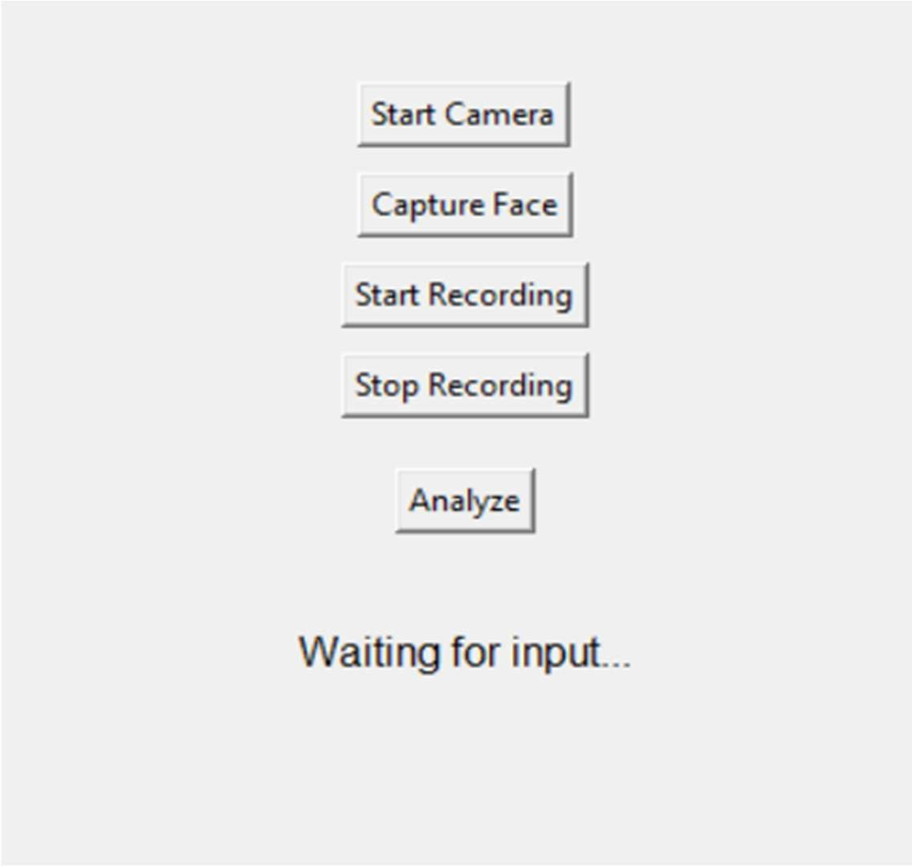

Figure 8.1: Graphical User Interface of the Stress Detection System

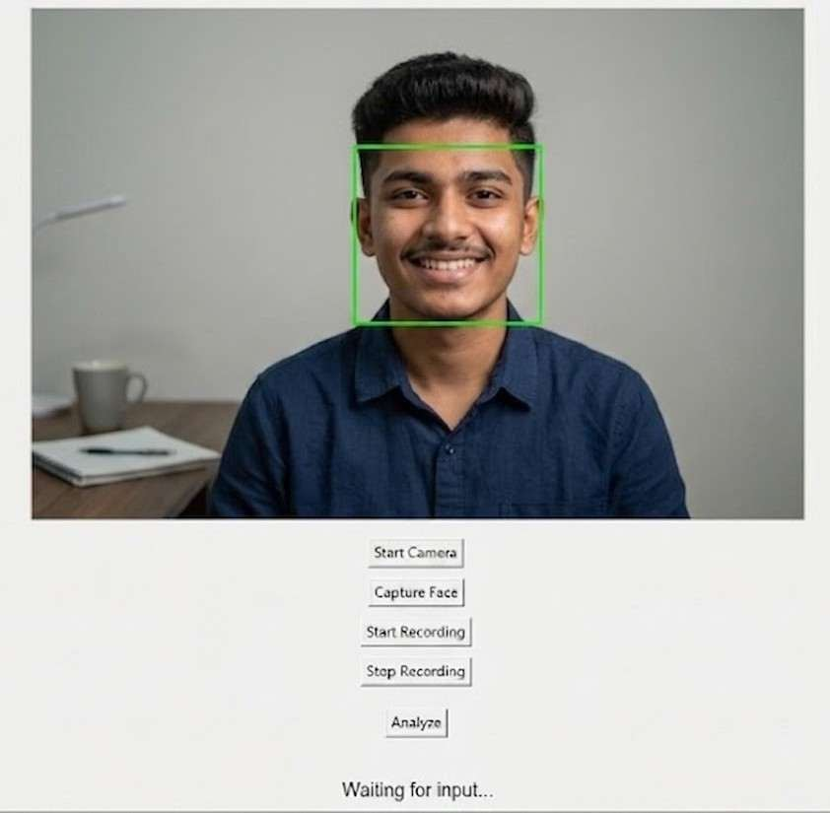

Figure 8.2: Face Detection using Webcam Input

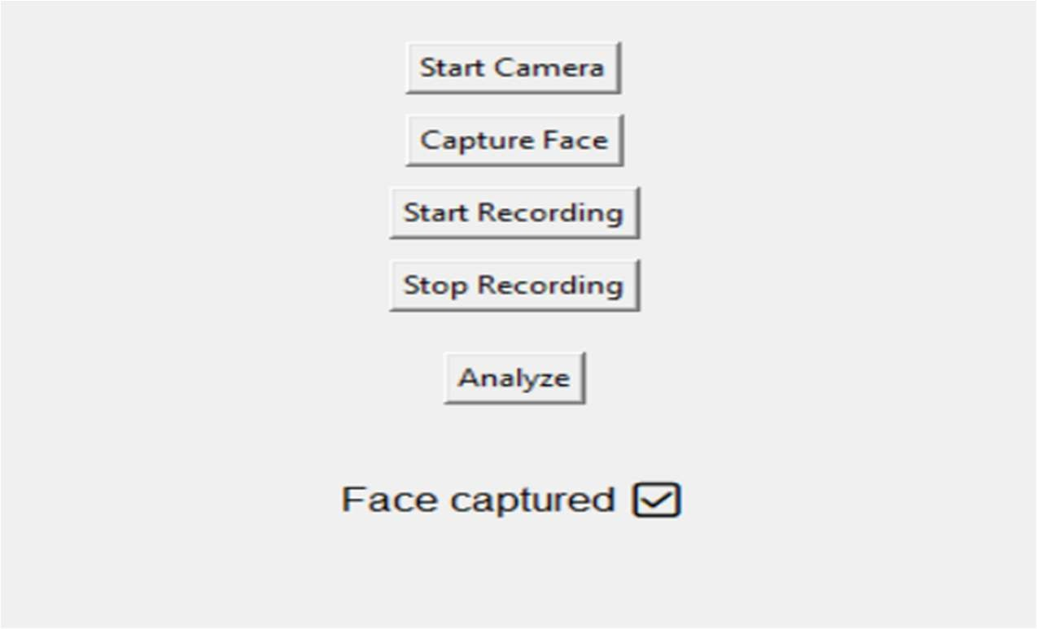

Figure 8.3: Face Capture Interface

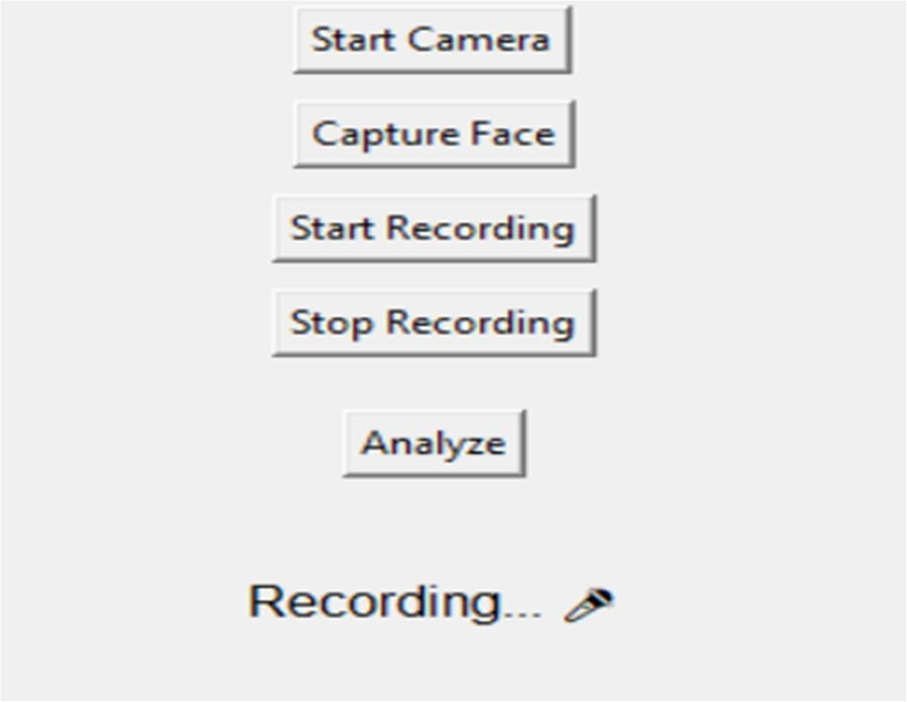

Figure 8.4: Audio Recording Interface

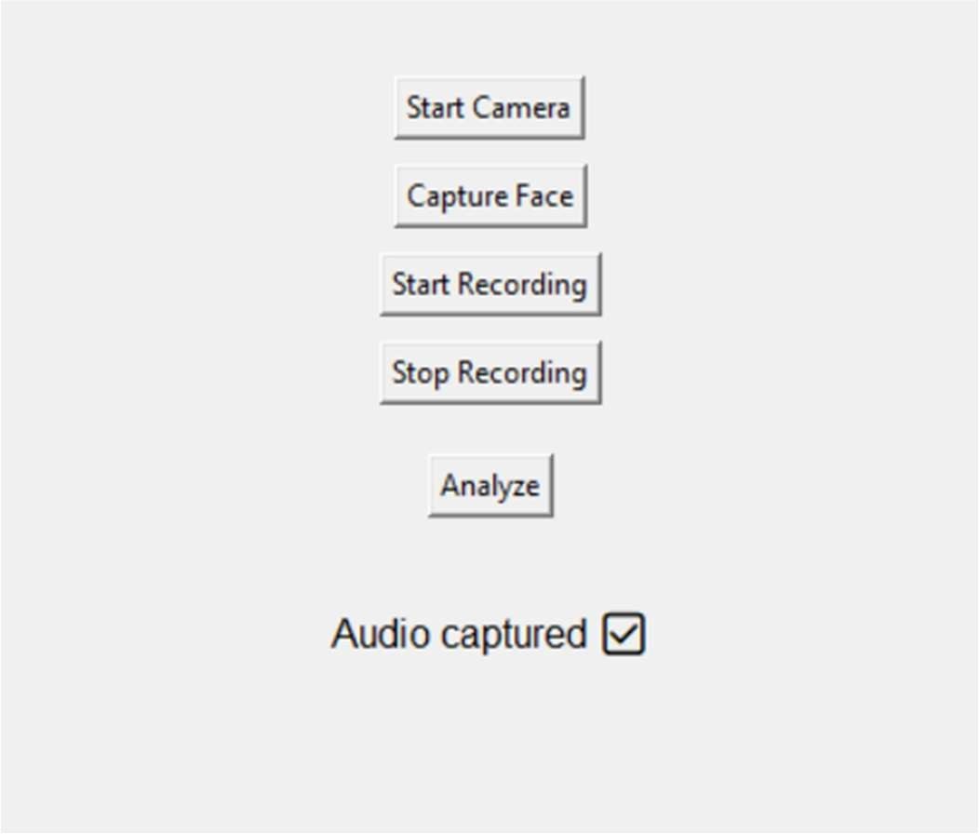

Figure 8.5: Audio Capture Interface

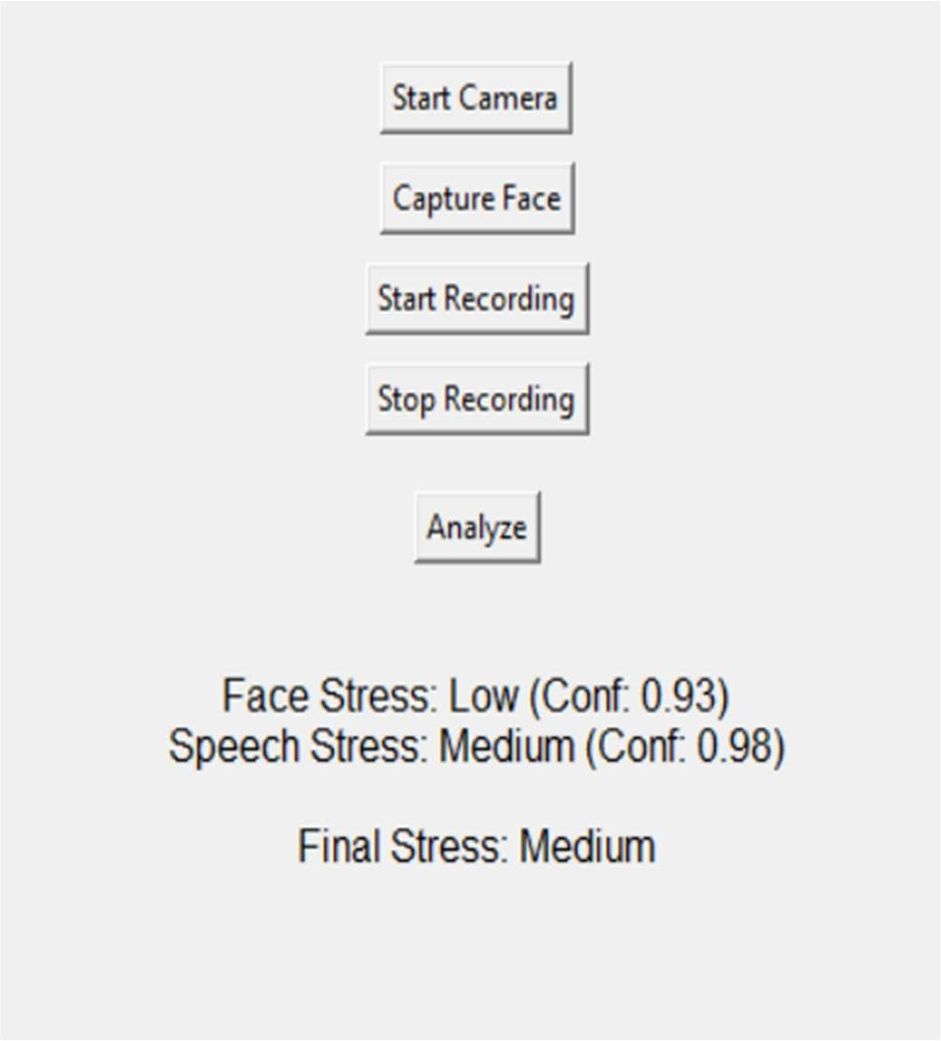

Figure 8.6: Final Stress Prediction Output from GUI Interface

