Projections of Ellipses and Circles

by

Gabrielle Renee Schrantz

(Supervised by Professor Ioannis M. Roussos)

Department of Mathematics, Hamline University
Spring 2004

Abstract: In this paper we combine geometry and calculus to study the projections of ellipses and circles in space onto planes. We find that, apart from the trivial cases, these projections are ellipses and in a special nontrivial case circles. We give their explicit parametric equations. The results are very useful in geometry, in studying all sorts of elliptical motions (e.g., planetary motions) and in determining the domains in the x-y plane of certain surfaces in space with boundary the given ellipses or circles.

- Main work and results

We consider an ellipse with semi-axes a > b > 0 and with center the origin of an x-y system of axes. This has implicit equation
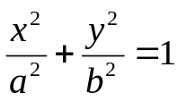
A parameterization of this ellipse (in the positive direction) is
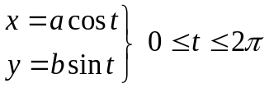
(If then we have a circle of radius 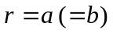.)
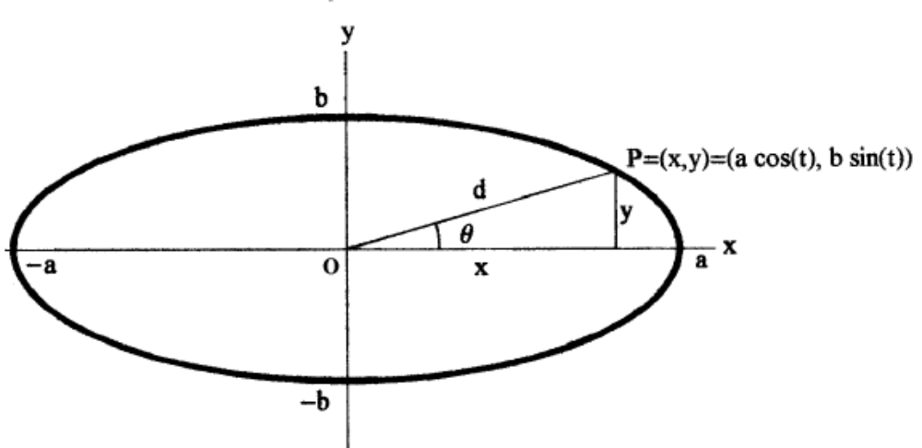
Figure 1
The relation between the parameter-angle  and the central angle  (as in figure 1) is found by the relations:
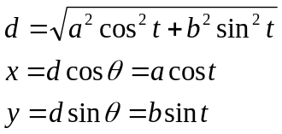
So,
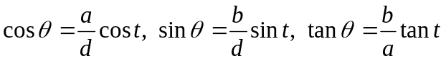
We observe that .

Now suppose we have an ellipse with semi-axes a and b on a plane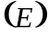 in space and we want to determine its orthogonal projection onto a plane 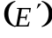 in space. Without loss of generality, we consider to pass through the center of the ellipse. For this work apart from the semi-axes a and b, we also need the angle 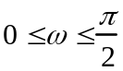 between the two planes and and the angle 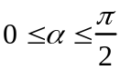 between the major axis of the ellipse and the straight line of the intersection of and.
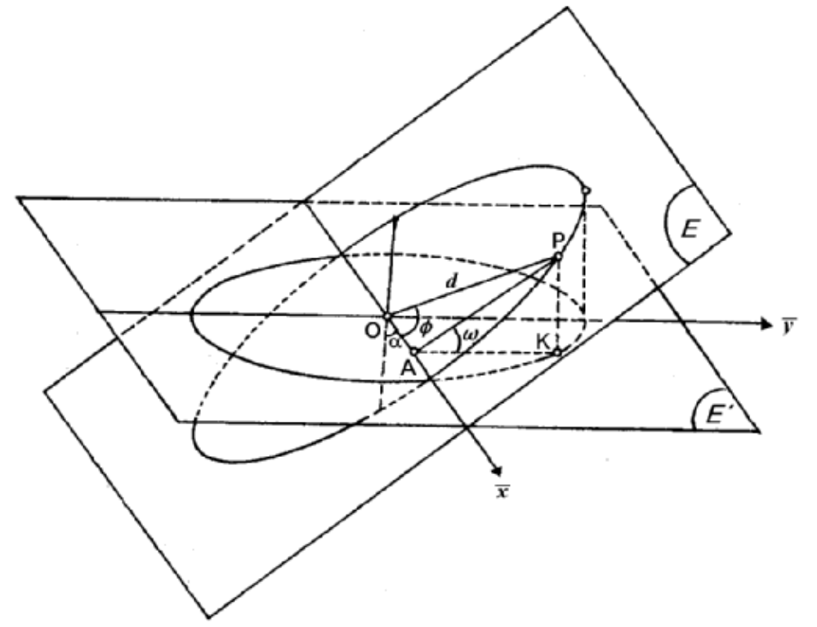
Figure 2
Since the projection lies on , we introduce coordinate to be the straight line 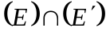 and 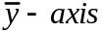 the straight line on perpendicular to the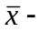axis at the center of the ellipse, which is the origin (O) of the 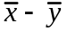system of axes in (see figure 2). The projection of the point P, as in the figure 2, is let us say K=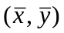. We now have that d = length of OP, 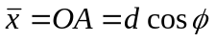 and 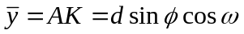, with angle 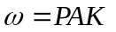. The central angle is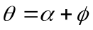.
If we know the equations 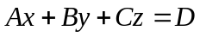 of (E) and 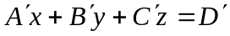 of in some space coordinate system x-y-z with standard basis 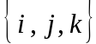, then we can solve these two equations to find the straight line of their intersection. This is the -axis of the new 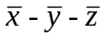 coordinate system, in which the plane is . For instance, if (E), the plane that contains the ellipse in the standard position as above, is the x-y plane, that is z = 0, then 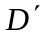= 0 and the straight line has parametric equations:

The angle satisfies
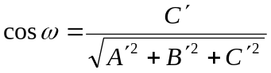
The standard basis 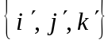 of the system is given in terms of by

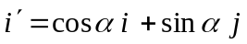
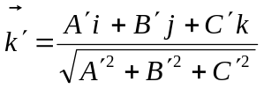
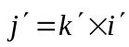

Going back to the problem of determining the projection of the ellipse, we have:

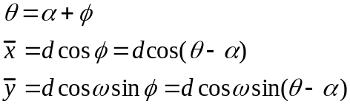

So,

Hence,
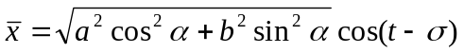

where  is the angle determined by

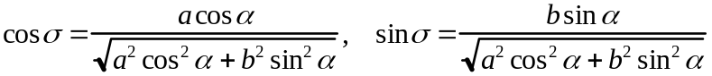

Similarly,
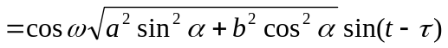

where  is the angle determined by

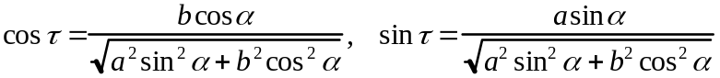

We observe that
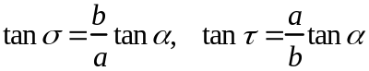

Now we are in the position to conclude the following results:

Case of a circle of radius

In the case of a circle, we can take 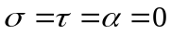, since and any diameter may be considered as major axis. So, we get
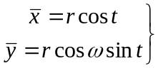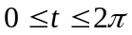
Hence:
1.) If 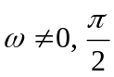, this case is not trivial. The projection of such a circle in onto is an ellipse in the standard position with semi-axes:
a = r and b = r cosω

2.) If , then 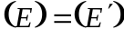. This case is trivial and the circle projects onto itself.
3.) If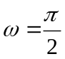, then 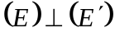. This case is trivial, because 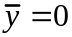 for all the values of and so the circle projects onto the straight segment of the

Case of ellipse 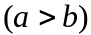.

1.) If , then. We can take 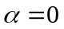. This case is trivial and the ellipse projects onto itself.
2.) If 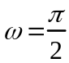, then . This case is trivial, because for all the values of and so the ellipse projects onto the straight segment of the

3.) Suppose 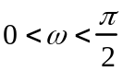. This case is non-trivial and we have the following three interesting sub-cases:
3a.) If, then the projection on the 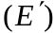 plane is an ellipse in the standard position, with respect to the 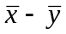 system of axes, with major axis the . In fact we have and
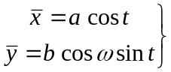

Hence, the semi-axes of the projection are > .
3b.) If 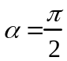, then the projection on the plane is an ellipse in the standard position, with respect to the system of axes. In fact we have 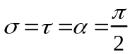 and
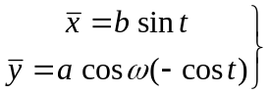

Hence, this ellipse has semi-axes b and a cosω. Consequently, if 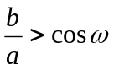, then b is the major semi-axis and if 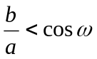, then b is the minor semi-axis.
Finally, if 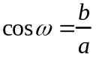, then the projection is a circle. This is the only nontrivial case in which the respected projection is a circle (that is, when and b = a cosω).
3c.) If 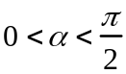, then the projection on the plane is an ellipse parameterized by
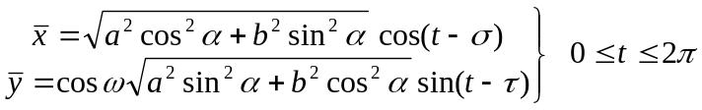

This ellipse has center the origin of the system of axes, but it is not in the standard position, since in this case and so we have a phase-difference between the and the coordinates of any point 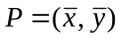of this projection. This ellipse is tilted.

To understand this sub-case fully we must first examine in some detail the equations

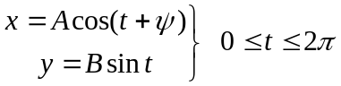
where 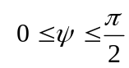is the phase-shift and A > 0, B > 0 are constants.
If 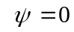, then we get the ellipse
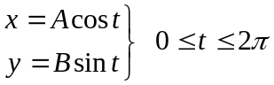
in the standard position.
If 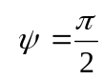, then we get
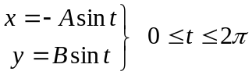
This is a straight segment joining the points (A, -B) and (-A, B) of the x-y plane with slope 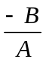, traversed twice starting from the origin (0, 0).
If 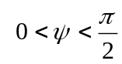, then we eliminate the parameter t between the two equations and we reach the equation
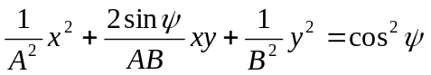

Note that this equation, by the theory of the general second-degree equation in two variables, represents an ellipse. We observe that it is also valid for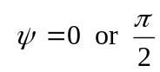. To obtain the standard position of the ellipse with respect to a rotated system of axes we need the angle of rotation (mod 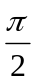) to be given by the relation

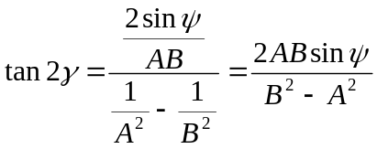

Notice that if A = B > 0 then =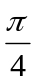 (mod ) regardless of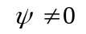.
Now the ellipse found in (3c.) can be written as

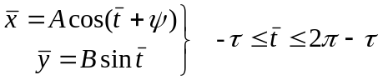
with

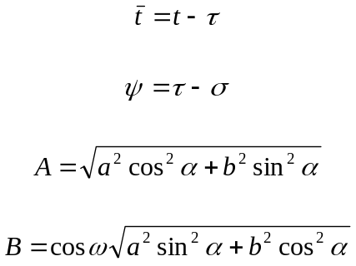

Notice that for 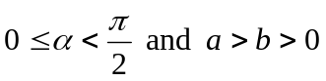, by using the expressions for the tangents of 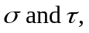 stated earlier, we find that

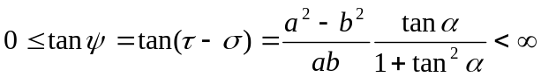

and so

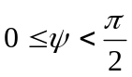

Now, using the expressions for sine and cosine of 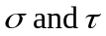, stated earlier, we find that the angle (mod ) of the rotation of the axes in the plane is found from the equation

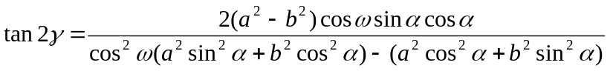

So, depends on the parameters a, b, 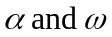. This formula also agrees with the results in the other cases.

A note about the lengths of the semi-axes of

We compute the two positive eigenvalues 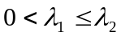of the 2x2 symmetric and positive definite matrix of the coefficients of this second degree equation

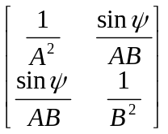

After the rotation, in the new u-v coordinate system, the equation transforms to

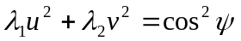

or to the standard form

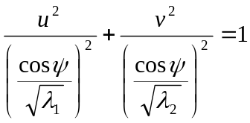

Then, with , the lengths of the semi-axes are

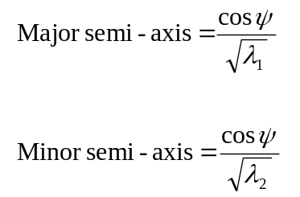

The rotation matrix that achieves the above transformation, from the x-y coordinates to u-v coordinates, is precisely the 2x2 matrix with columns the unit eigenvectors corresponding to the eigenvalues 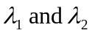 of the initial matrix.

2. Parameterization of an Ellipse (or Circle) in Space

To parameterize an ellipse in space we need to know:

1) Its center 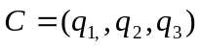
2) The plane on which it lies 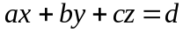 (with normal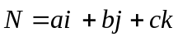)
3) The direction of the major axis . We consider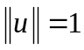. (Also, 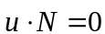)
4) The lengths of the major and minor semi-axes and .

The direction of the minor axis is found by:
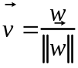
where
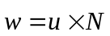

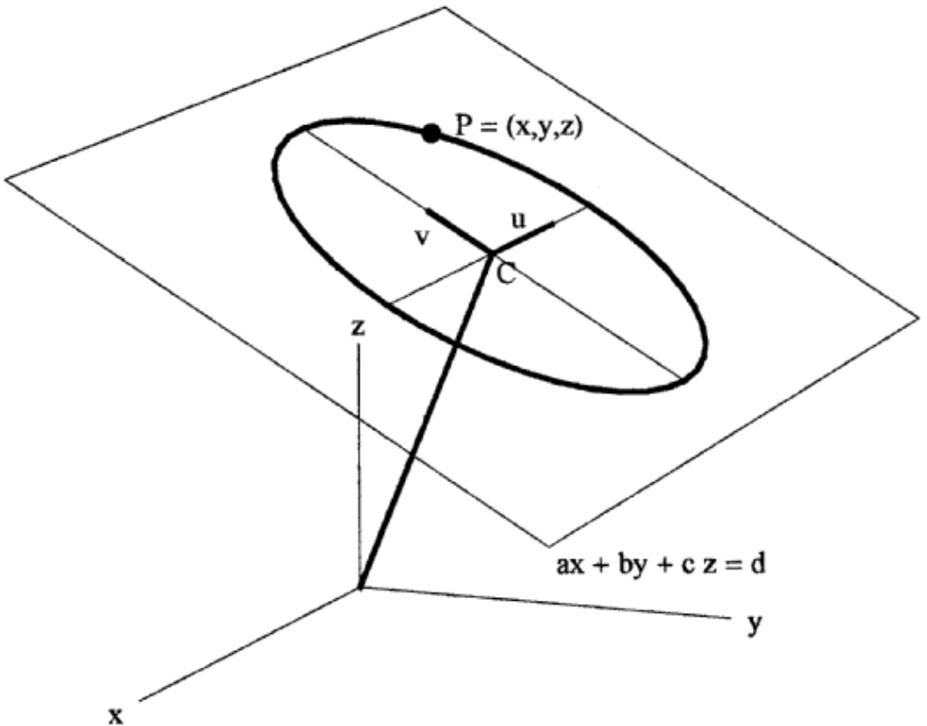

Figure 3
Then any point 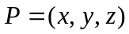 of the ellipse satisfies

,

Writing this as 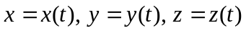 we have a parameterization of the ellipse.
If we have a circle of radius 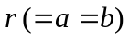, then we simply find two orthonormal solutions of 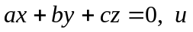 and , and since any diameter of the circle is major axis we have:
,

3. Derivation of Equations by Vector Calculus

We can now re-derive the previous equations using purely vector calculus, that is, without much need of the geometry of figures 1 and 2. However, some geometrical suggestions are still present.
Let again be the intersection of 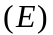and and 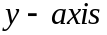 the line perpendicular to it at the center of the ellipse (or circle) and lying in . Here we write x, y instead of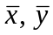. So, we have in ³ the usual basis 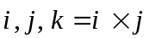. Since the ellipse has center the origin, if 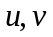 are its axial directions, its parameterization is given by

or

where 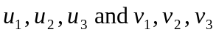 are the components of and respectively. So component-wise we have
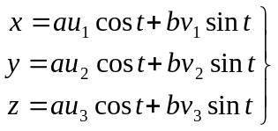

Therefore, the projection of the ellipse onto the plane is the curve with parameterization the first two equations

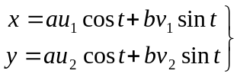

If these equations for x and y are transformed to the equations found earlier then the remaining work is exactly the same as done before.
We need to replace the 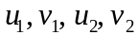. We have that 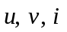 are in the plane and let 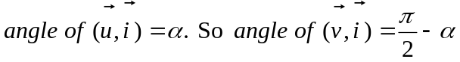. Then
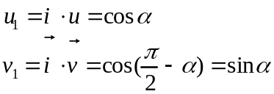

Hence

which is the same equation as before for.

Next we have that
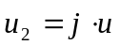 and 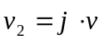
To evaluate these we need the fact that , the unit normal to , and so 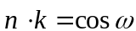, where ω is the angle between and .
We now have the following straightforward computations:

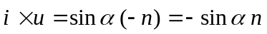 (notice the – sign here)
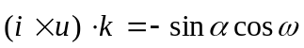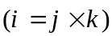
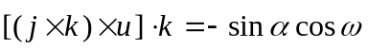 (by the familiar identity of vector calculus)
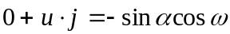
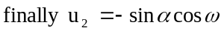
Also
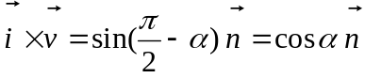
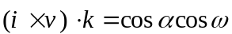
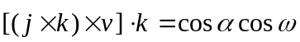
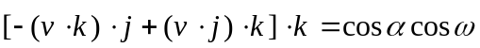
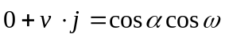
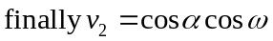

So we get

which is the same equation as before for (done!).

An Interesting Example from the Classical Euclidean Geometry
The Steiner’s Ellipse of a Triangle

It is a fairly straightforward fact that every triangle ABC is the orthogonal projection of a unique equilateral triangle 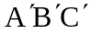, up to the parallel translations perpendicular to the plane ABC (prove this!). Then, the circumscribed circle of projects onto the plane of ABC as an ellipse, in general, that passes through the points A, B and C. This ellipse is called the Steiner’s Ellipse of the triangle ABC, after the German Mathematician J. Steiner (1796-1863), who introduced it first. This ellipse was studied by a good many and famous mathematicians in the years 1880-1900, for the properties that it possesses. Here we cite two of them:

- Steiner himself proved that this ellipse besides containing the points A, B, C of the circumscribed circle of the triangle ABC, it also contains another fourth point of this circle, called Steiner’s point. This point and its diametrically opposite one (Tarry’s point) have many properties that have been studied extensively.

- 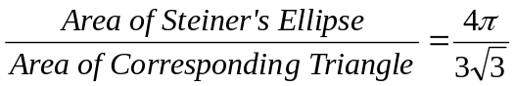

(fixed ratio, independent of the initial triangle).

For some details and a lot references on this matter, see the authoritative work:
F. M. G., Exercises De Géométrie, Librairie Générale, Paris, Septiéme Edition,
pp. 1112-1114.

Address

Miss Gabrielle Schrantz (MB 1463)
Department of Mathematics
1536 Hewitt Ave.
Hamline University
Saint Paul, MN, 55104

E-mails:
gschrantz01@gw.hamline.edu
iroussos@gw.hamline.edu

