Chips:

1. LDO (Near - End) (代替TPS7A470，3mm\*3mm)

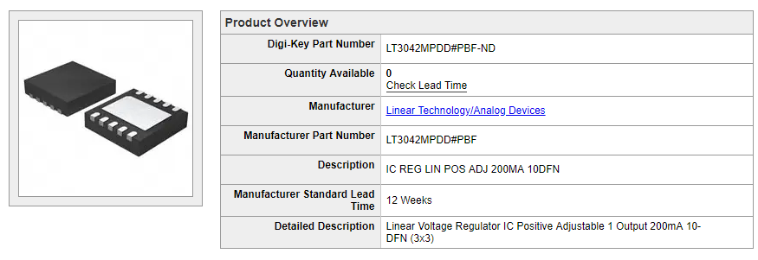

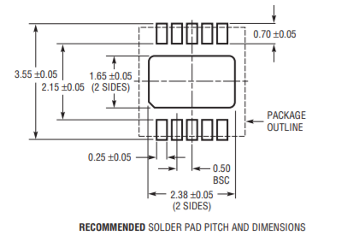

1557848704(1)

1557848624(1)1557848819(1)

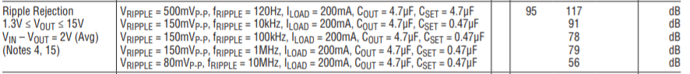

1557848737(1)器件手册：

<https://www.analog.com/media/en/technical-documentation/data-sheets/3042fb.pdf>