Accidents and fatality
per vehicle type

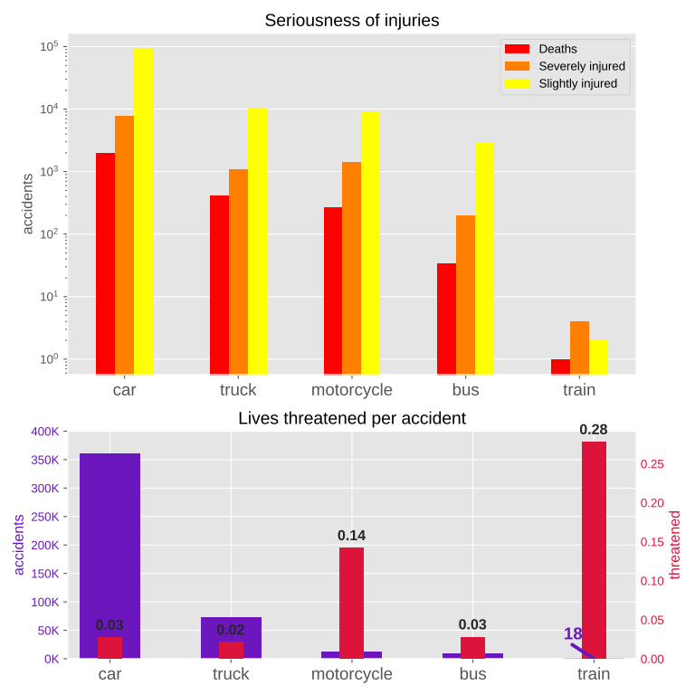
The seriousness of injuries has similar distribution among different vehicle types.

Trains are responsible for 440x less injuries than the next safest vehicle - a bus.

Train accidents are least likely to occur, but have the highest probability to cause life threatening injuries.
An accident involving a train is 10x times more likely to cause a life threatening injury than a car.

Motorcycles are among the least frequent causes of accidents, but are almost guaranteed to cause an injury. Accidents caused by motorcycles are 4x times more likely to result in an injury than the ones caused by cars.

Vehicles | Accidents |  |  | Injured |  | Injuries |  |  | Per accident
Vehicles | Count | Of total | With injury | Count | Of total | Fatal | Severe | Slight | Injured | Lives threatened
Cars | 360,420 | 80% | 21% | 101,965 | 80% | 1970 | 7835 | 92160 | 0.28 | 0.03
Trucks | 72,087 | 16% | 13% | 11,780 | 9% | 414 | 1097 | 10269 | 0.16 | 0.02
Motorcycles | 11,919 | 3% | 80% | 10,536 | 8% | 271 | 1421 | 8844 | 0.88 | 0.14
Buses | 8,428 | <2% | 25% | 3,078 | 2% | 34 | 200 | 2844 | 0.37 | 0.03
Trains | 18 | <1% | 28% | 7 | <1% | 1 | 4 | 2 | 0.39 | 0.28

Car accidents are responsible for 80% of all road accidents.

