
Tribhuvan University
Faculty of Humanities and Social Science

STOCK PORTFOLIO TRACKER

A PROJECT PROPOSAL

Submitted to
Department of Computer Application
Pascal National College

In partial fulfillment of the requirements for the Bachelors in Computer Application

Submitted by
Bikash Shrestha | 6-2-1226-5-2020
Yogendra Saud | 6-2-1226-31-2020
December 2023

Under Supervision of
Ashok Kumar Pant

TABLE OF CONTENTS
1. INTRODUCTION 1
2. PROBLEM STATEMENT 2
3. OBJECTIVES 3
4. METHODOLOGY 4
A. Requirement Identification 5
Study of existing system 5
Requirement Collection 6
B. Feasibility Analysis 7
Technical 7
Operational 7
Economic 7
C. High Level Design of System 8
Entity-Relationship Diagram 8
Data Flow Diagram 9
System Flowchart 10
5. GANTT CHART 12
6. EXPECTED OUTCOME: 14
REFERENCES 15

INTRODUCTION
Portfolio is partly based on the Latin folium, meaning "leaf, sheet". A portfolio usually represents a portable showcase of your talents. [1]
A portfolio is a collection of financial investments like stocks, bonds, commodities, cash, and cash equivalents, including closed-end funds and exchange traded funds (ETFs). [2]
The stock portfolio tracker application is the tool to create and manage their stock portfolios, analyze performance, and generate meaningful summaries which helps in gaining insights and overview of user’s historical investments and also look at the current performance of the stock.
Users are able to analyze portfolio diversification by filtering based on sectors, instruments and type of stocks, evaluate performance metrics, and reports based on their history transactions. The application also provides users with a seamless and intuitive user interface, enabling them to add or upload stocks transactions, track stock prices, and access historical transactions data. The application provides an overview of how specific stock transactions has benefitted the user or not. The project uses the third-party API to gain the stock day prices and closing prices which even helps more for making investment decisions further.
The application's intuitive interface, day to day data updates, and summarizing capabilities will empower users to optimize their investment strategies and achieve their financial goals in the dynamic world of the Nepalese stock market.

PROBLEM STATEMENT
With the increasing popularity of stock trading and investment, there is a growing need for a user-friendly tool that provides real-time data updates, portfolio tracking capabilities, and analytical insights tailored to the context of the Nepalese stock market.
As investments develop and become more diversified, keeping an eye on everything becomes more difficult. [3]
Many people throw a lot of money for managing their portfolio. [4]
The problem is that for people with investments scattered across several sectors and industries platforms and asset classes. How does user stay up-to-date and on top of their investments and their performance?
User could either use a spreadsheet or automate the process with an investment portfolio tracker. Since using spreadsheet software is time consuming which requires manual effort to input data and doesn’t provide the informative summary and insights from it. It also lacks the ability to visualize the changing data effectively to the user. It requires even more harder to display the diversification insights of the stock and their performance in spreadsheet.
The user doesn’t have enough time to add entire transactions manually to get portfolio status and summary, which is just frustrating to user. This project is focused to solve that problem by giving user to option to upload their transactions data.
Also, the most of available tools in current market doesn’t support the ability to upload transactions, still requires manual input of every single transaction and doesn’t provide the detailed summary of the portfolio. Existing solutions in the market often lack user-friendly interfaces as well. After buying and selling thousands of companies’ stock, it’s hard to remember all the profits and losses that investor gained or loss.
So, these challenges create a need for a simple and intuitive tool that allows users to effortlessly track their stock holdings and monitor their performance and generate report or information on based of transactions which can be used for making further investments decision.

OBJECTIVES
- To develop a system that provide stock’s performance such as profit & loss information to individuals.
- To develop a system that provide stocks summaries based on their selection of sectors and type of stock.
- To develop a system that provide user transaction upload features and generate portfolio, sectors, instruments and holdings summaries based on transactions data.

METHODOLOGY
This project will be done by using waterfall model with additional development and revision phase since most of the requirement of the project is already identified and well understood.
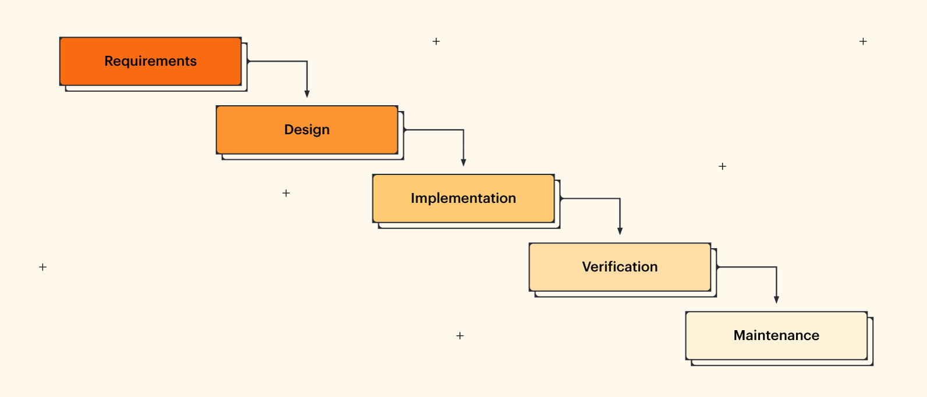
Figure 4. 1 Methodology of stock portfolio tracker

Requirement Identification
In order to calculate summaries and generate stats of the portfolio the application need user transactions details. Since, Meroshare provides all the necessary transactions details of user. But Meroshare transactions doesn’t include the buying or selling price of the stock so this project needs to make assumptions that buying and selling price is given in order to calculate overall profits and losses. For real report generation, user can add their transactions traded unit price details from their brokerage TMS, which needs to be added manually.

Study of existing system
The project topic is very comparatively new and the research paper and the article directly related to this topic were not easily reviewed in context of Nepalese stock market. So, there is not enough availability of research papers and project-based on portfolio management.
Many references and ideas were gathered from third-party portfolio management tools such as Sastoshare, Nepali Paisa, MeroLagani, Chukul, Smart Wealth Pro, Nepal Share, Neex etc. are only available commercially. The idea of differentiation of portfolio summary and holdings is referenced from the India based stock brokerage company Zerodha, the primary features such as averaging investment cost, profit and loss etc. are calculated observing the Kite demo website. Also, the design feature such as minimal and subtle looks to website is also referenced from it.
Portfolio management is an important financial skill for active investing. [2]
Diversification is a key concept in portfolio management. [5]
One of the key concepts in portfolio management is the wisdom of diversification—which simply means not putting all of your eggs in one basket. Diversification tries to reduce risk by allocating investments among various financial instruments, industries, and other categories. [6]
After reviewing the article from web, we found out that portfolio management is the must skill for investing and to maximize the profits and gains from diversification of assets is also important. So, this application focuses to solve that problem of diversification which are hard to visualize without the portfolio management tool, it makes user conscious about their investment by providing user the report and summaries based on selection of sectors and instruments for making better financial decision.

Requirement Collection

Functional Requirement:
- The application should be able to register new users.
- The application should be given access the user with their valid login credentials.
- The application should be able to upload valid transactions file.
- The application should be able to show information about stock companies.
- The application should generate reports about stocks profit and losses.
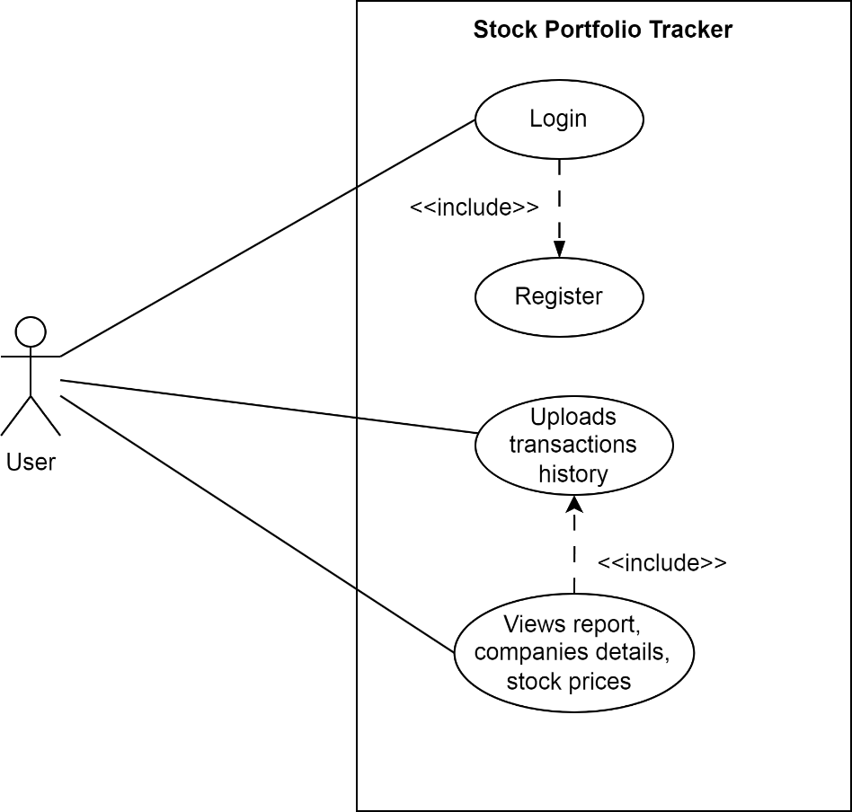
Figure 4. 2 Use-case diagram of stock portfolio tracker

Non-Functional Requirement:
- The application should be secured.
- The application should have easy to use interface.
- The application should be faster in performance.
- The application should have feature to search for stock information.
- The application should be interactive user interface.

Feasibility Analysis

Technical
This project only needs the user transactions and stock information which is available. It can be done using existing web technologies and tools so there is no difficulty in developing this project. Since, this project is based on assumptions of user’s transactions data.

Operational
This project is simple and intuitive, using this application doesn’t require extra knowledge. It is very user-friendly and can be easily adapted by any new user that will use this website. As it uses well-known web technologies, it is easy to maintain.

Economic
This project is very cost-friendly as it uses existing free technologies like FastAPI, SQLite, VS Code and open-source tools. There is no cost for the tools that are being used. This project didn’t require money for its development. The only thing is to be done is making an environment for the development with an effective supervision.

High Level Design of System

Entity-Relationship Diagram
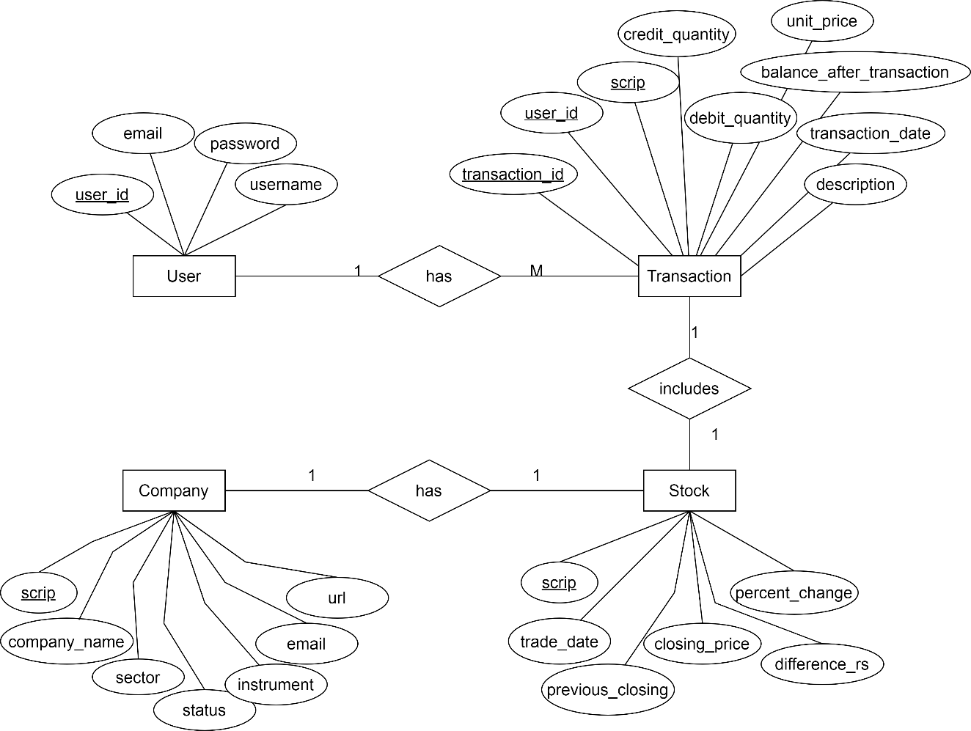
Figure 4. 1 Entity-relation diagram of stock portfolio tracker
In this ER Diagram, a User have their own Stock Transaction history. Each Stock Transaction is associated with a specific Stock, representing the transaction details for a particular stock. The Stock entity represents different stocks available for trading. The Stock entity stores the price information for each stock on different dates, including the closing price (Last Traded Price) and the price of the previous day (previous_closing). Company entity provides the Stock symbol and further information such as status, instrument, sector ...etc.
The relationships in this schema are as follows:
- The "has" relationship connects User to Transaction, indicating that a User can have multiple stock transactions.
- The "includes" relationship connects Transaction to Stock, specifying the stock involved in a particular transaction.
- The "has" relationship connects Stock to Company, indicating that a Stock can have only one company.

Data Flow Diagram

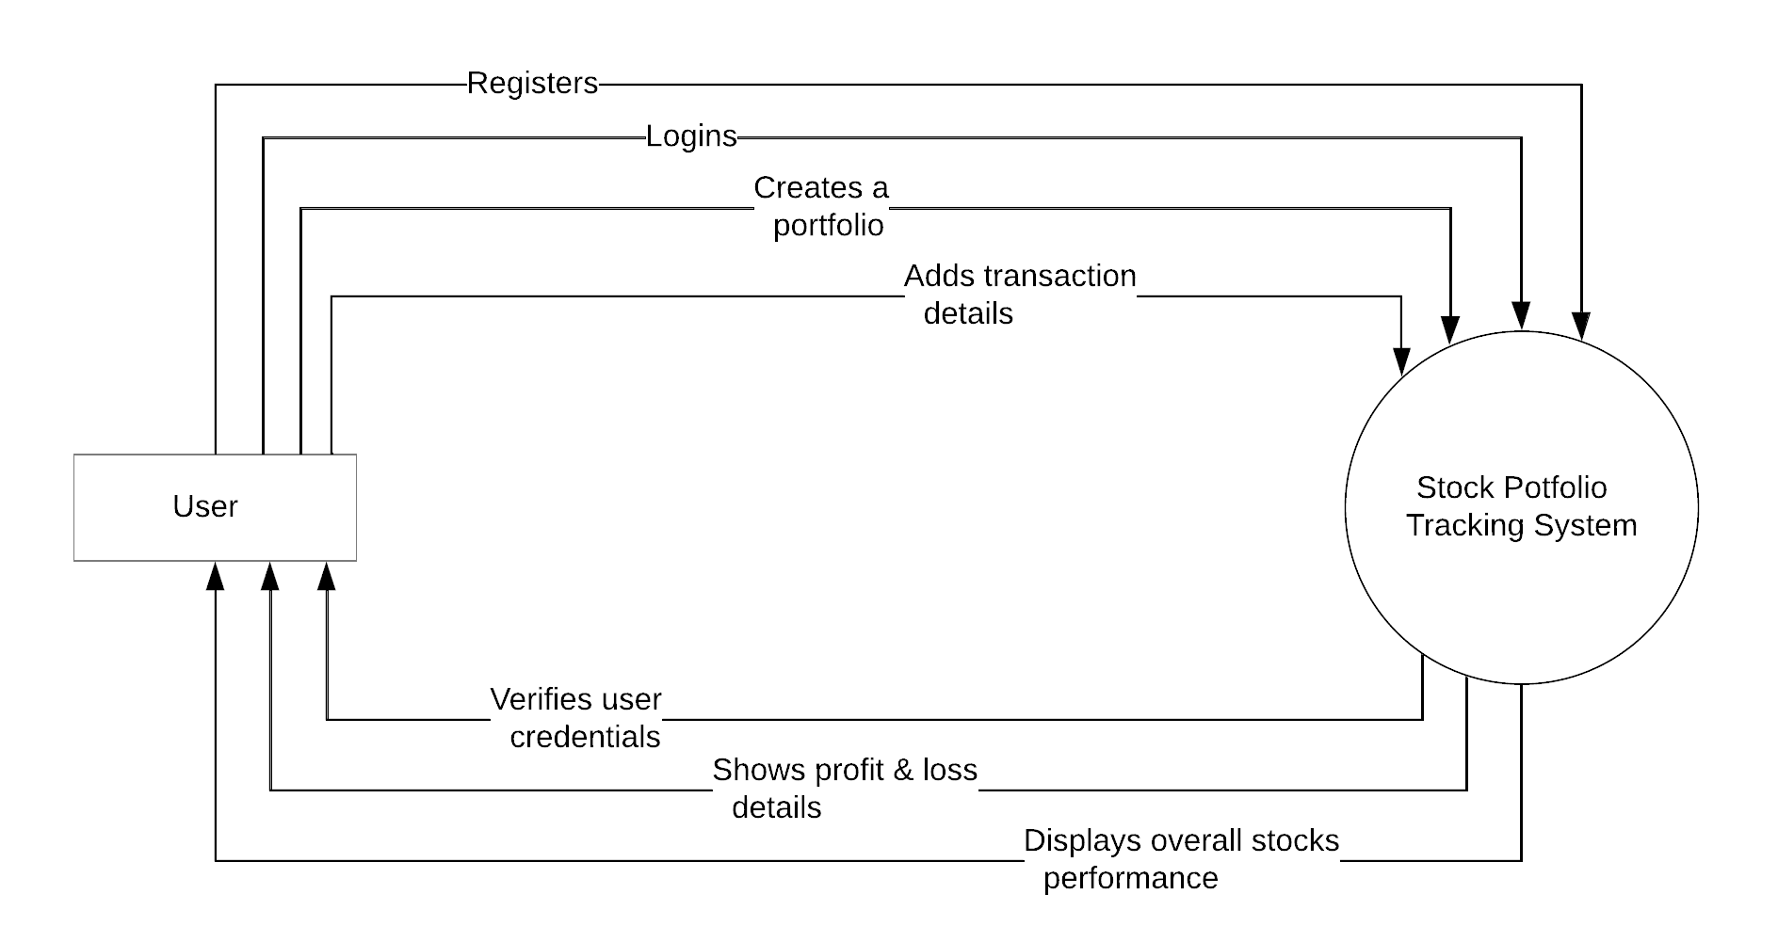
Figure 4. 2 Level 0 DFD of stock portfolio tracker
Explanation:
- The Stock portfolio tracking application interacts with two main entities: the User and the Stock Portfolio Tracking System.
- The User represents the individuals who interact with the application through the web interface.
- The Web Interface provides the user interface through which users can interact with the application, including logging in, managing portfolios, adding/removing stocks, and accessing reports.
- The Stock Portfolio Database stores all the relevant data, including user information, portfolio details, stock information, and generated reports.
- The flow of data in this context level diagram is represented as a single arrow from the User to the Web Interface and from the Web Interface to the Stock Portfolio Database, indicating the exchange of information and data between these components
This context level data flow diagram provides a high-level overview of the stock portfolio web application, focusing on the key entities and their interactions. It serves as a foundation for developing more detailed data flow diagrams that capture the processes, data transformations, and interactions within the application.

System Flowchart

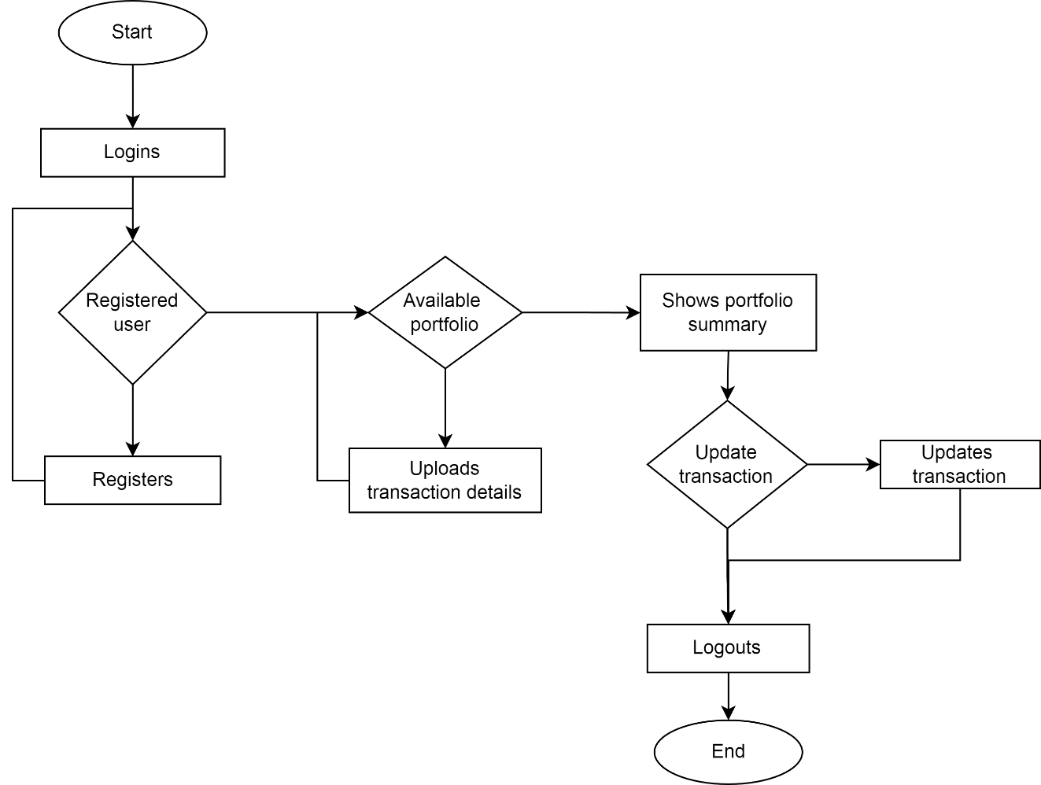
Figure 4. 5 System Flowchart of stock portfolio tracker
User Registration and Login:
  - Prompt user to enter credentials or register a new account
  - Validate user input and check if the user is registered
  - If user is registered, prompt for login; if not, prompt for registration
Dashboard:
  - Display the user's dashboard with portfolio information and options
Manage Portfolios:
- Show list of existing portfolios and options to create, select, or delete portfolios
- If user selects an existing portfolio:
  - Display portfolio summary and options to add, remove, or view stocks
- If user chooses to create a new portfolio:
  - Prompt user to enter a name for the new portfolio and create it

Manage Stocks in Portfolio:
  - Show list of stocks in the selected portfolio and options to add, remove, or view details
  - If user chooses to add a stock:
  - Prompt user to enter stock symbol or search for a stock
  - Validate stock symbol or search results
  - If valid, prompt user to enter quantity and purchase price and add stock to the portfolio
  - If invalid, display error message and prompt user to try again
  - If user chooses to remove a stock:
  - Prompt user to select a stock to remove from the portfolio and remove it
  - If user chooses to view stock details:
  - Display detailed information about the selected stock
Portfolio Analysis and Reports:
  - Provide options for portfolio performance, diversification analysis, and report generation
Log Out:
  - End the user session and return to the login/register screen

GANTT CHART
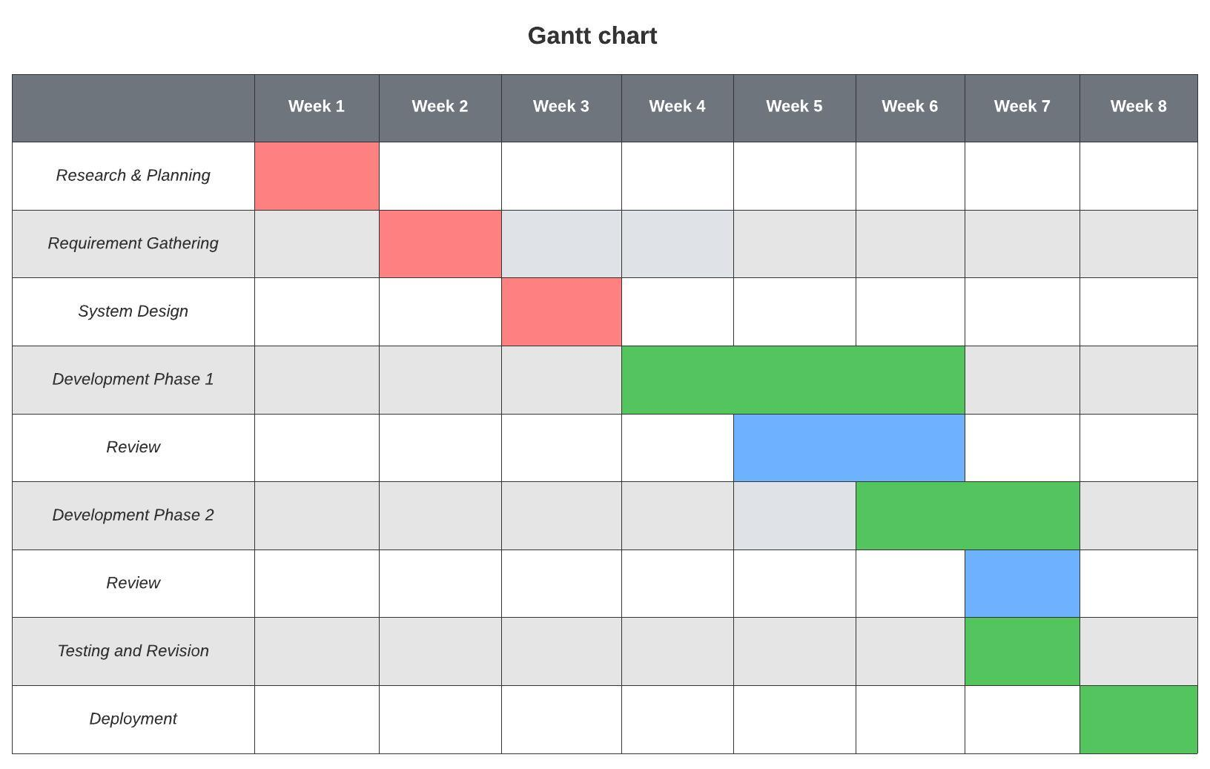
Figure 5. 1 Gantt chart of schedule timeline
- Project Initiation | 1 week:
  - Define project scope and objectives
  - Identify project users
  - Conduct initial research and requirements gathering
- Requirement Gathering & System Design | 2 weeks:
  - Design user interface and wireframes
  - Define database structure and relationships
  - Plan system architecture and components
- Front-end Development | 3 weeks:
  - Implement user interface using HTML, CSS, and JavaScript
  - Develop login, registration, and dashboard screens
  - Integrate stock data API
- Back-end Development | 3 weeks:
  - Set up server infrastructure and database
  - Implement user authentication and authorization
  - Develop APIs for portfolio and stock management

- Database Implementation | 1 week:
  - Design and create the database schema
  - Implement data storage and retrieval mechanisms
  - Ensure data integrity and security measures
- Analytics and Reporting | 2 weeks:
  - Implement portfolio performance analysis tools
  - Develop diversification analysis functionalities
  - Integrate reporting capabilities
- Testing and Revision | 2 weeks:
  - Conduct unit testing for individual components
  - Identify and fix bugs and issues
- Documentation review | 1 week:
  - Prepare documentation and guides
- Project Review and Closure | 1 week:
  - Evaluate project success and achievement of objectives
  - Gather feedback and make necessary improvements
  - Document lessons learned and finalize project closure

EXPECTED OUTCOME:
We expected that our project will provide the portfolio tracking platform that provides accessible and easy-to-understand information about stocks status of the individuals and generates stats of their portfolio performance based on the user provided transactions details.

REFERENCES

[1] | Merriam-Webster, "Dictionary," 24 April 2023. [Online]. Available: https://www.merriam-webster.com/dictionary/portfolio. [Accessed 05 September 2023].
[2] | Tardi, Carla;, "Financial Portfolio," Investopedia, 25 April 2023. [Online]. Available: www.investopedia.com/terms/p/portfolio.asp. [Accessed 23 May 2023].
[3] | Jonathan Anthony, "How Investment Portfolio Trackers Can Help You Earn More Money," StockMarketEye, 17 February 2023. [Online]. Available: https://www.stockmarketeye.com/blog/how-investment-portfolio-trackers-help-you-earn-money/. [Accessed 04 September 2023].
[4] | K. Khatiwada, "The secret of portfolio management in Nepalese capital market," Sharesansar, 26 July 2018. [Online]. Available: https://www.sharesansar.com/newsdetail/the-secret-of-portfolio-management-in-nepalese-capital-market.
[5] | T. Jalan, "Portfolio Diversification," ScripBox, 24 October 2023. [Online]. Available: https://scripbox.com/pf/portfolio-diversification/. [Accessed 12 April 2023].
[6] | R. Oli, "What is Portfolio Management?," Investopaper, [Online]. Available: https://www.investopaper.com/news/what-is-portfolio-management/. [Accessed 08 April 2023].

