
Tribhuvan University
Faculty of Humanities and Social Science

Stock Trading System with Automated Order Triggers

A PROJECT REPORT

Submitted to
Department of Computer Application
Pascal National College

In partial fulfillment of the requirements for the Bachelors in Computer Application

Submitted by
Bikash Shrestha | 6-2-1226-5-2020
Sandhya Adhikari | 6-2-1226-21-2020
November 2024

Under Supervision of
Ashok Kumar Pant

Tribhuvan University
Faculty of Humanities and Social Science
Pascal National College

SUPERVISOR’S RECOMMENDATION

I hereby recommend that this project prepared under my supervision by BIKASH SHRESTHA and SANDHYA ADHIKARI entitled “Stock Trading System with Automated Order Triggers” in partial fulfillment of the requirements for the degree of Bachelor of Computer Application is recommended for the final evaluation.

Ashok Kumar Pant
SUPERVISOR
Principal, Faculty Member
Department of Computer Application
Pascal National College, Satdobato, Lalitpur


Tribhuvan University
Faculty of Humanities and Social Science
Pascal National College

LETTER OF APPROVAL
This is to certify that this project prepared by BIKASH SHRESTHA and SANDHYA ADHIKARI entitled “Stock Trading System with Automated Order Triggers” in partial fulfillment of the requirements for the degree of Bachelor in Computer Application has been evaluated. In our opinion it is satisfactory in the scope and quality as a project for the required degree.
Ashok Kumar Pant  Principal, Faculty Member  Department of Computer Application  Pascal National College  Satdobato, Lalitpur | Suresh Thapa  BCA Coordinator  Department of Computer Application  Pascal National College  Satdobato, Lalitpur
Basanta Chapagain  (Internal Examiner) | Er. Shree Krishna Maharjan  (External Examiner)

ABSTRACT
This project presents a stock trading system with the implementation of Automated Order Trigger (AOT) Algorithm, a feature which allows to set a trigger price, if trigger price is hit in a future date, an order will be placed. It simulates a real broker and exchange system, integrating real-time market data and algorithmic strategies to execute trades based on predefined criteria. This enhances efficiency and reduces human error. The system leverages WebSocket for live data streaming, REST APIs for secure communication, and message queues for sending and receiving orders and trade information between brokers and exchanges.
Keywords: Stock Trading System, Trade Management System (TMS), Automated Stock Order Triggers

ACKNOWLEDGEMENT
We would like to express our heartfelt gratitude and appreciation to all those who have supported and guided us throughout the development of the Stock Trading System application.
First and foremost, we would like to extend our deepest thanks to our project supervisor, Ashok Kumar Pant and our coordinator Suresh Thapa, for their invaluable guidance, expertise, and constant support. Their mentorship and constructive feedback have been instrumental in shaping the project and pushing us to deliver our best.
Lastly, we would like to acknowledge the countless individuals who have shared their knowledge and expertise, either through discussions, feedback, or research materials. Your contributions have greatly enriched our understanding and helped shape the final outcome of this project.

Sincerely,
Bikash Shrestha and Sandhya Adhikari

LIST OF ABBREVIATIONS
AOT Automated Order Triggering
API Application Programming Interface
ATS Automated Trading System
CDS Central Depository System
CNC Cash and Carry
DFD Data Flow Diagram
ERD Entity Relation Diagram
GTT Good Till Triggered
HTML Hyper Text Markup Language
IDE Integrated Development Environment
IPO Initial Public Offering
JS JavaScript
LTP Last Transaction Price
MVC Model View Controller
NEPSE Nepal Stock Exchange
NOTS NEPSE Online Trading System
REST Representational State Transfer
TMS Trading Management System
UI User Interface
VS Code Visual Studio Code

LIST OF FIGURES
Figure 1. 1 Development Methodology of stock trading system 2
Figure 3. 1 Use-case diagram of stock trading system 5
Figure 3. 2 Gantt chart of schedule timeline 6
Figure 3. 3 Entity-relation diagram of exchange system 7
Figure 3. 4 Entity-relation diagram of broker system 8
Figure 3. 5 Context level DFD of stock trading system 9
Figure 3. 6 Architecture design of stock trading system 10
Figure 3. 7 Database schema of exchange system 11
Figure 3. 8 Database schema of broker system 12
Figure 3. 9 Interface design for dashboard of stock trading system 13
Figure 3. 10 Interface design for order modal box of stock trading system 14
Figure 3. 11 Interface design of login and signup 14
Figure 3. 12 Physical DFD of the stock trading system 15

LIST OF TABLES
Table 4. 1 Test table for signup 21
Table 4. 2 Test table for login 22
Table 4. 3 Test table for logout 22
Table 4. 4 Test table for order 23
Table 4. 5 Test table for update 23
Table 4. 6 Test table for delete 24

TABLE OF CONTENTS
SUPERVISOR’S RECOMMENDATION i
LETTER OF APPROVAL ii
ABSTRACT iii
ACKNOWLEDGEMENT iv
LIST OF ABBREVIATIONS v
LIST OF FIGURES vi
LIST OF TABLES vii
1. INTRODUCTION 1
1.1 Introduction 1
1.2 Problem Statement 1
1.3 Objectives 1
1.4 Scopes and Limitation 2
1.4.1 Scopes 2
1.4.2 Limitations 2
1.5 Development Methodology 2
1.5 Report Organization 3
2. BACKGROUND STUDY AND LITERATURE REVIEW 4
2.1 Background Study 4
2.2 Literature Review 4
3. SYSTEM ANALYSIS AND DESIGN 5
3.1 System Analysis 5
3.1.1 Requirement Analysis 5
3.1.2 Feasibility Analysis 6
3.1.3 Data Modelling 7
3.1.4 Process Modelling 9
3.2 System Design 10
3.2.1 Architectural Design 10
3.2.2 Database Schema Design 11
3.2.3 Interface Design 13
3.2.3 Physical DFD 15
3.3 Description of Algorithm 16

4. IMPLEMENTATION AND TESTING 17
4.1 Implementation 17
4.1.1 Tools Used 17
4.1.2 Implementation Details of Modules 18
4.2 Testing 21
4.2.1 Test Cases for Unit Testing 21
5. CONCLUSION AND FUTURE RECOMMENDATIONS 25
5.1 Conclusion 25
5.2 Lesson Learnt / Outcome 25
5.3 Future Recommendations 25
REFERENCES 26

CHAPTER 1

INTRODUCTION

1.1 Introduction
Stock exchange is a marketplace where stocks, bonds and other securities are bought and sold. Popular examples of stock exchange are New York Stock Exchange (NYSE), Bombay Stock Exchange (BSE), Shanghai Stock Exchange (SSE) etc.
Stock exchanges now utilize Automated Trading System (ATS) instead of traditional methods. Nepal Stock Exchange also launched its internet-based fully automated online trading system (NOTS) on November 6, 2018 [1]. When a company issues new securities, it enters the primary market through an IPO. Investors buy these securities, and the company becomes listed on a stock exchange. Subsequently, in the secondary market, investors trade these shares among themselves, facilitated by the stock exchange [2].
Stock exchanges have licensed brokerage firms in which traders must register to participate. The online trading system enables remote stock trading in the secondary market. This project aims to create an automated online trading system with a focus on automated order triggering features.

1.2 Problem Statement
In Nepal, the existing trading management system, doesn’t include any risk management features like target and stoploss triggers. Traders aiming to enter or exit the stock market at a specific price must actively monitor market conditions during trading hours. However, this may not be feasible for all traders. In order to resolve the mentioned issue related to secondary market, this project is primarily going to focus on risk management by implementing Automated Order Triggering (AOT) algorithm.

1.3 Objectives
The objectives of this project are follows as:
- To develop a system that provide traders to buy and sell the stocks in real time.
- To develop a system that provides feature of stoploss/target triggers and automates the buy/sell order.

1.4 Scopes and Limitation

1.4.1 Scopes
- This project simulates a real broker and exchange environment for real-time trading.
- System executes trades automatically based on predefined criteria to enhance efficiency and reduce human error.
- Utilizes WebSockets, REST APIs, and message queues for efficient and reliable data flow.

1.4.2 Limitations
- May struggle with rapid price fluctuations in highly volatile markets.
- Does not support customizable trading strategies, restricting user adaptability.

1.5 Development Methodology
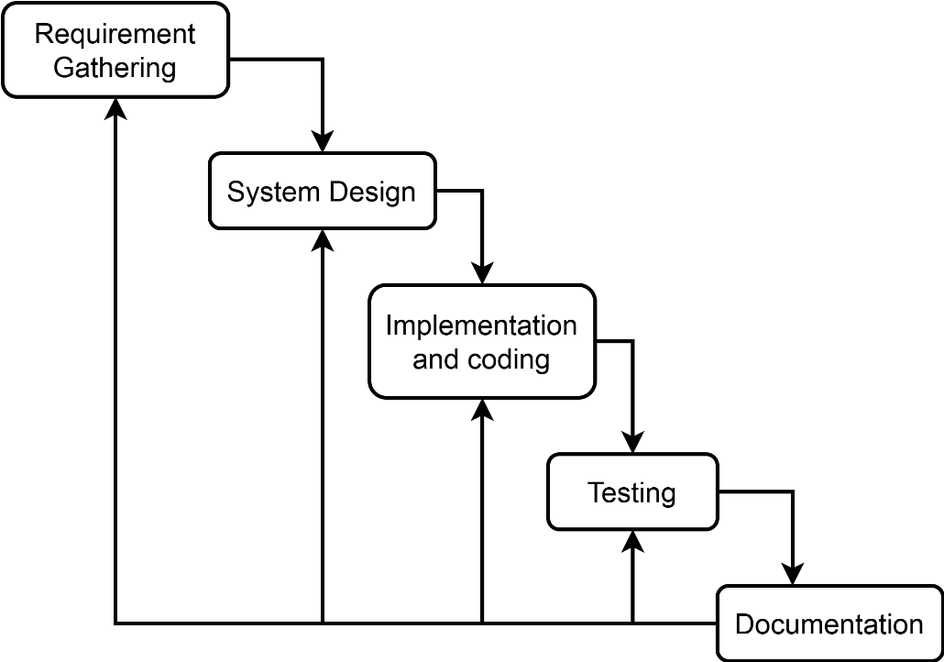
Figure 1. 1 Development Methodology of stock trading system
For this project development, Waterfall methodology is used, the functional requirements are gathered first. High level and low-level system design such as data flow diagram, system flowchart, working mechanism of system, database schema, interface design, system architecture is designed based on the requirements. After designing all the system necessary modules and components, the system is implemented based on those designs. Testing of the each modules and functions is done, further new requirements is gathered for more feature and repeat some of cycle steps.

1.5 Report Organization
The first chapter of the report contains the summarized introduction of the whole project report. It includes the overview, scope and limitation, problem statement and objectives of this project.
The second chapter includes background study i.e., description of fundamental theories, general concepts and terminology related to the project. It also includes the literature review i.e. review of the similar projects, research and theories done by others.
The third chapter includes the system analysis and design phase in which the report of functional and non-functional requirements of the project is stated using use case and system diagrams. It includes the feasibility study, shows the technical, operational and economic feasibility of the project development phase. The explanation of the designing of the system is also done in this chapter. It includes data modeling and process modeling which is explained by using ER diagram and Data Flow Diagram. The architectural design, database designs, user interface designs and algorithms are also listed in this chapter.
The fourth chapter includes the implementation and testing phase includes how the tools like CASE tools, programming languages and database platforms are implemented. In testing, it includes the test cases tables for unit testing and system testing.
The fifth chapter includes conclusion and future recommendation. It contains the final paragraphs of the report and in this phase the overall outcome and the developer point of view is written. The lesson learned through all the phases is included in this chapter.

CHAPTER 2

BACKGROUND STUDY AND LITERATURE REVIEW

2.1 Background Study
Stock trading systems like TMS, Robinhood and Kite were studied for this project to understand how the overall trading system and automated trigger works. Nepal Stock Exchange’s TMS only supports Cash and Carry (CNC) limit and market order [3]. In all studied trading systems, broker server gets the trade and stock information from main exchange server. It depends on the brokerage end to provide order trigger features other than market order and limit order. Robinhood and Kite trading systems have featured that traders can enter or exit stock holdings until his/her price condition is met. It includes extra trade trigger orders like stop order, stop limit order, trailing order and One Cancel Other (OCO) orders [4] [5].

2.2 Literature Review
The literatures related to stock trading system and automated order triggers such as conference papers and tons of website articles were reviewed for this project. As reviewed, for stock trading system to function, it requires broker, CDS, banking, clearing & settlement systems. All trade execution is done by exchange server and those trade information are published to all connected brokers in real time. And the traders communicate with their own brokerage for market orders and trade execution status. It depends on the brokerage system to handle all the automated trade triggers [6]. Automated triggers in stock market can eliminate the need for manual monitoring and constant order adjustments. Trade triggers help traders automate their entry and exit strategies. Once set, they may remain active until triggered, saving traders time and effort in managing trades [7] [8].

CHAPTER 3

SYSTEM ANALYSIS AND DESIGN

3.1 System Analysis

3.1.1 Requirement Analysis

I. Functional Requirement:
- The application should be able to register and login valid users.
- The application should be able to show balance and holdings information.
- The application should be able to buy and sell stocks.
- The application should be able to set and place stoploss/target triggers.
- The application should be able to place limit and market orders.
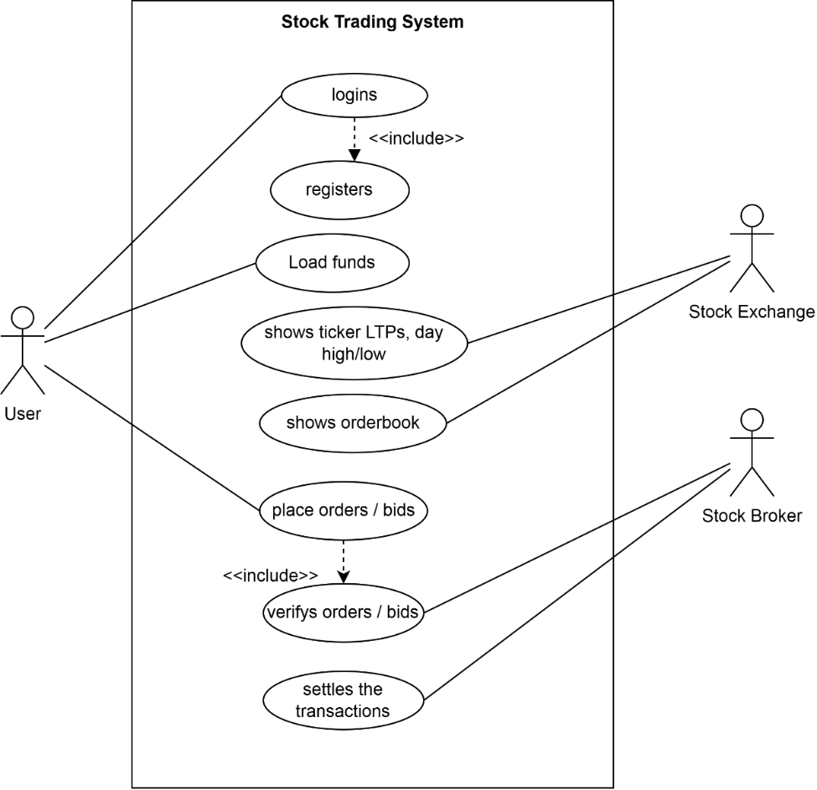
Figure 3. 1 Use-case diagram of stock trading system

II. Non-Functional Requirement:
- The application should be secured.
- The application should have easy to use and interactive user interface.
- The application should be faster in performance.

3.1.2 Feasibility Analysis

I. Technical
This project will only require two different systems for broker and stock exchange. The exchange server requires the message broker to share real-time trade data. The broker server is responsible for verifying the orders before publishing it, placing the automated GTT orders and show the status of placed orders. The stock exchange server is responsible for publishing all valid orders and last transactions of stocks to all subscribers (brokers) as orders are placed by users. All those mentioned functions can be done using existing web technologies and tools so there will be no technical difficulty in developing this project.

II. Operational
This project is simple and intuitive, using this application doesn’t require extra knowledge. It is very user-friendly and can be easily adapted by any new user that will use this website. As it uses well-known web technologies, it is easy to maintain.

III. Economic
This project will be very cost-friendly as it uses existing free open-source technologies like RaabitMQ, Spring boot, VS Code and open-source tools. This project won’t require money for its development. The only thing is to be done is making an environment for the development with an effective supervision.

IV. Schedule
This project is completed following below schedule.
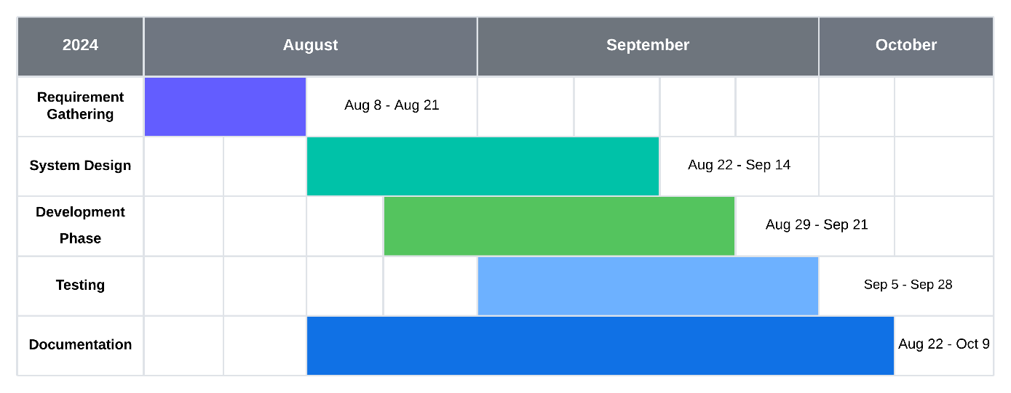
Figure 3. 2 Gantt chart of schedule timeline

3.1.3 Data Modelling
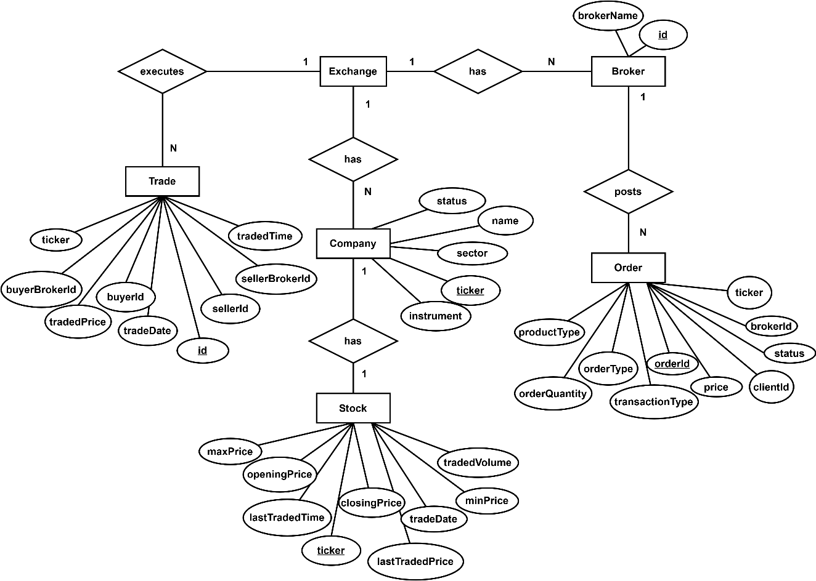
Figure 3. 3 Entity-relation diagram of exchange system
The above ER diagram shows the relations between entities used in exchange part of the system which includes the entity:
Trade with attributes (id, ticker, buyerBrokerId, sellerBrokerId, sellerId, buyerId, tradedPrice, tradeDate, tradedTime, tradedQuantity)
Company with attributes (ticker, name, instrument, sector, status)
Stock with attributes (ticker, lastTradedPrice, lastTradedTime, openingPrice, closingPrice, tradeDate, maxPrice, minPrice, lastTradedVolume)
Order with attributes (orderId, ticker, brokerId, productType, orderQuantity, transactionType, price, clientId, status)
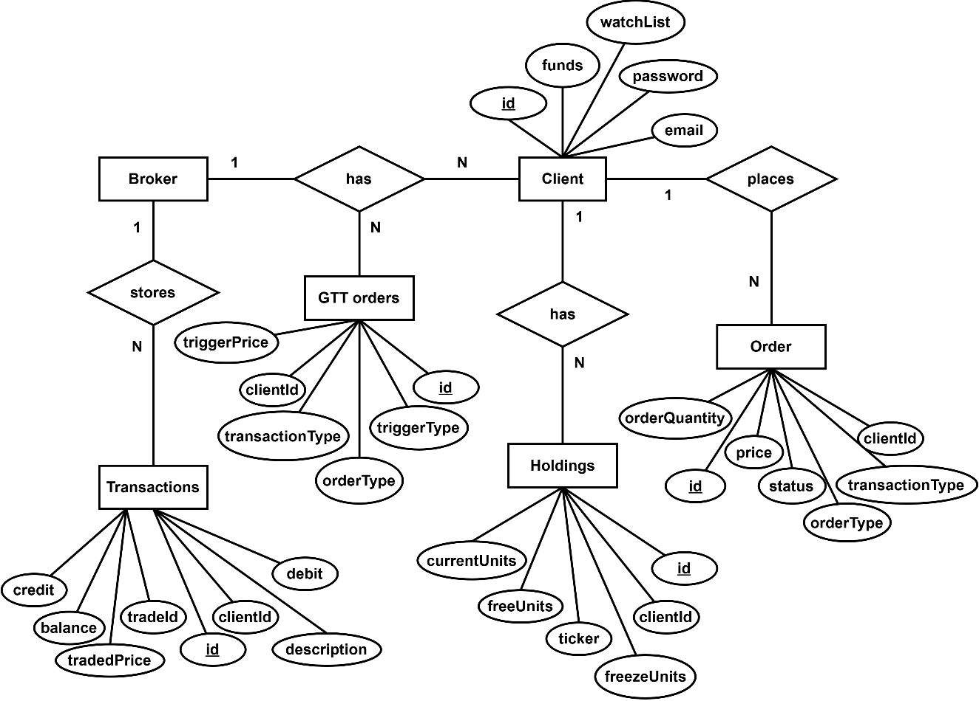
Figure 3. 4 Entity-relation diagram of broker system
The above ER diagram shows the relations between entities used in broker part of the system which includes the entity:
Client with attributes (id, email, password, funds, watchlist)
Holdings with attributes (id, clientId, ticker, freeUnits, freezeUnits, currentUnits)
Order with attributes (orderId, ticker, productType, orderQuantity, transactionType, price, clientId, status)
GttOrder with attributes (id, ticker, orderQuantity, transactionType, price, clientId, triggerPrice, triggerType, status)
Transactions with attributes (id, ticker, clientId, creditQuantity, debitQuantity, tradedPrice, tradeId, description, balanceQuantity)

3.1.4 Process Modelling
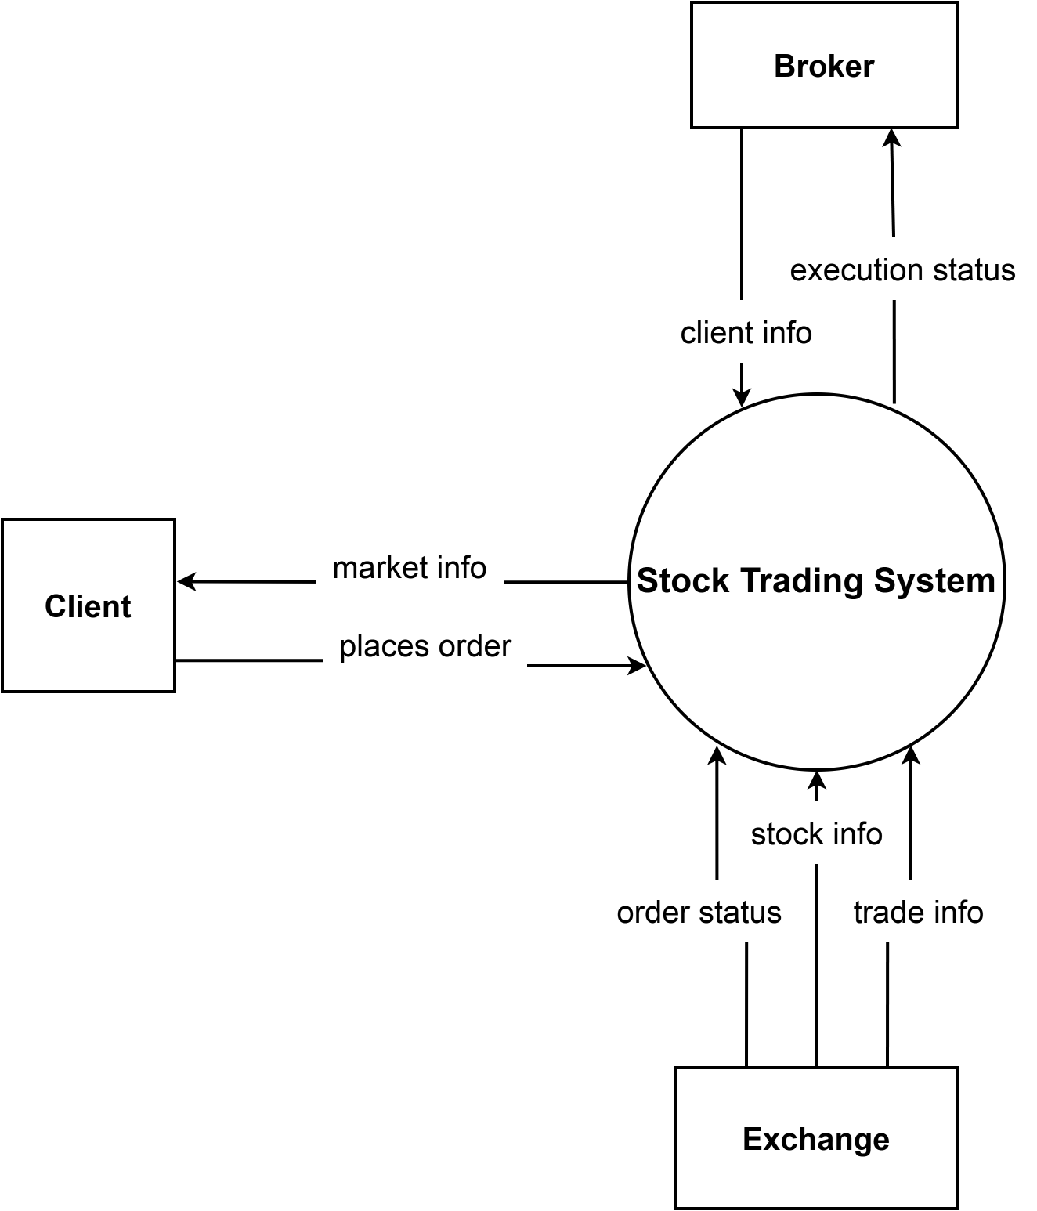
Figure 3. 5 Context level DFD of stock trading system
This context level data flow diagram provides a high-level overview of the stock trading system, focusing on the key entities (Client, Broker and Exchange) and their interactions. It serves as a foundation for developing more detailed data flow diagrams that capture the processes, data transformations, and interactions within the application.

3.2 System Design

3.2.1 Architectural Design

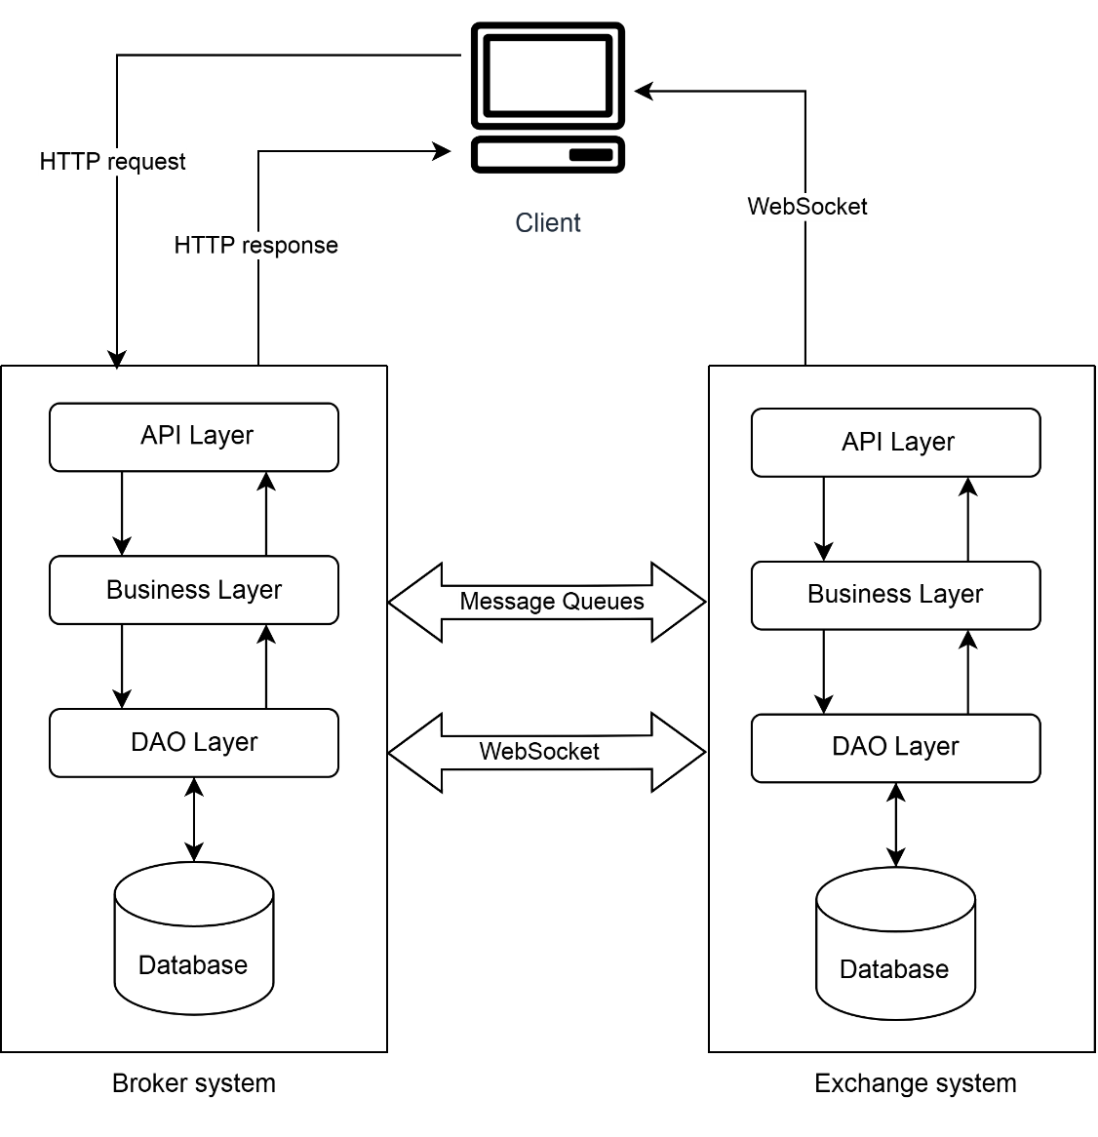
Figure 3. 6 Architecture design of stock trading system
This project is based on microservices architecture design, showcasing how different components interact within a system. The broker and exchange services interact with the services through HTTP requests and WebSocket connections, providing a means for real-time and asynchronous communication. API Layer: This layer handles incoming HTTP requests from the client, acting as an entry point to the service. Business Layer: Contains the core business logic that processes requests and implements the service's functionality. DAO (Data Access Object) Layer: Responsible for interacting with the database, performing CRUD operations. Database: Stores data related to the service's operations, ensuring persistence and retrieval of information.

3.2.2 Database Schema Design
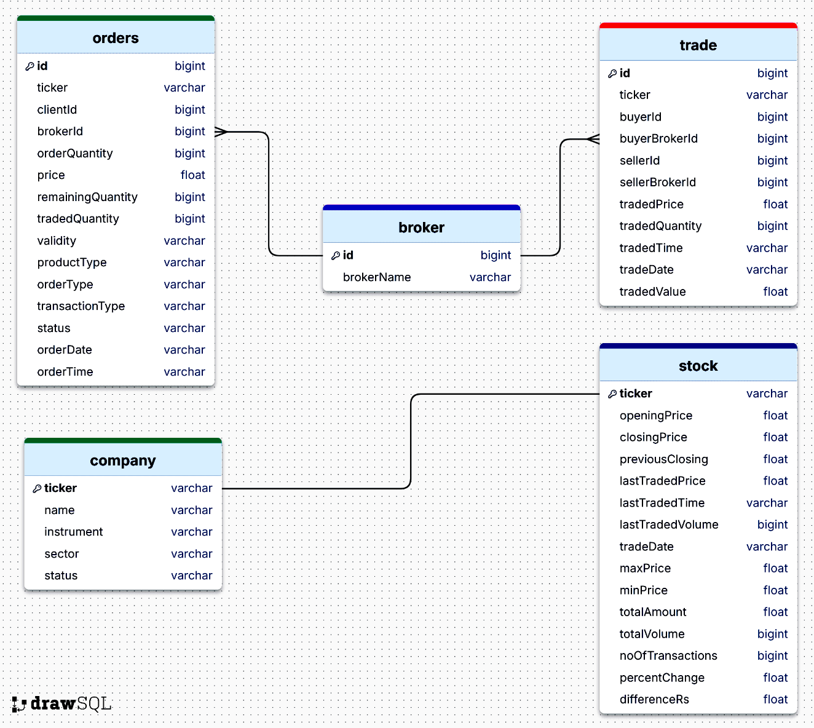
Figure 3. 7 Database schema of exchange system
The above figure is an Entity-Relationship Diagram (ERD) for an exchange system database schema. It showcases five tables: orders, broker, trade, company and stock along with their respective fields and data types.
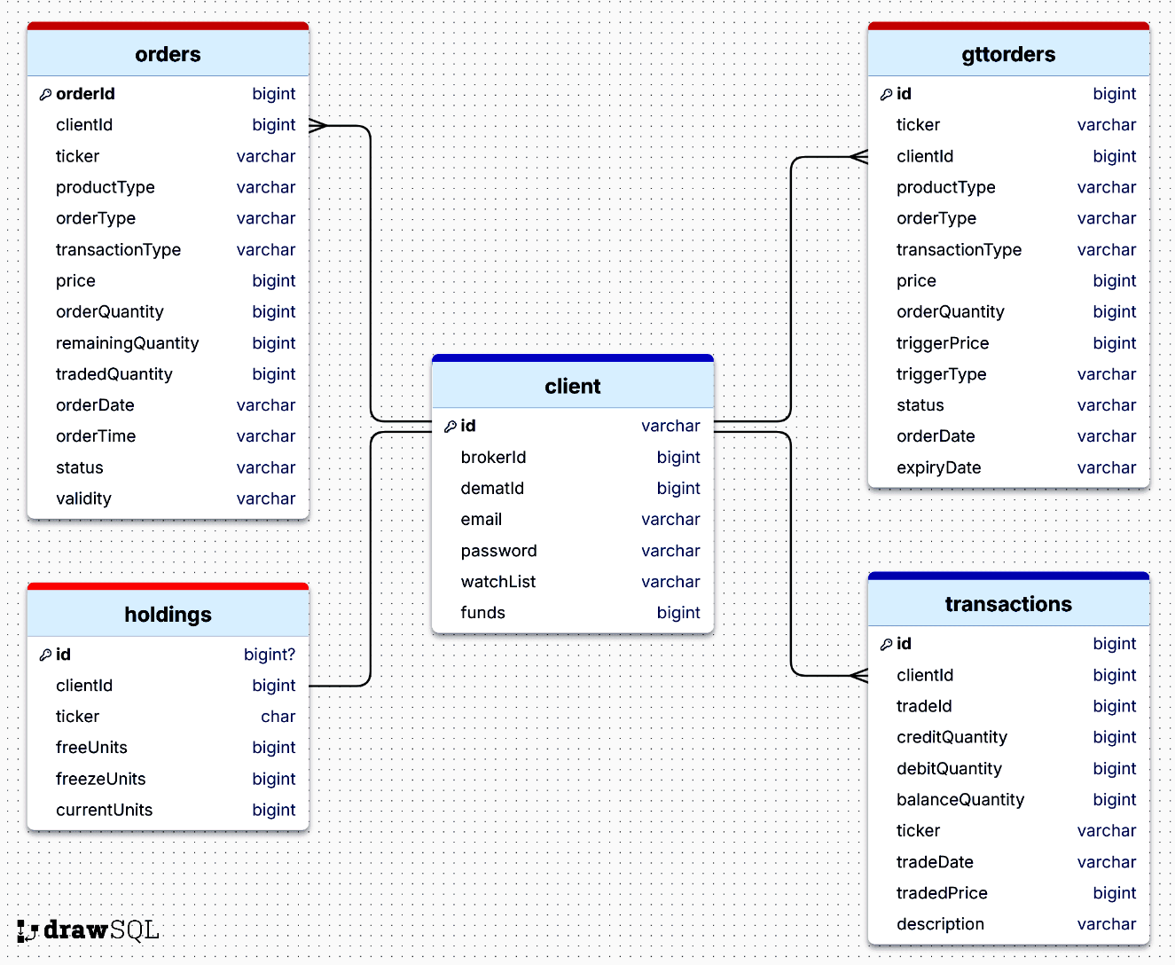
Figure 3. 8 Database schema of broker system
The above figure is an Entity-Relationship Diagram (ERD) for a trading system database schema. It showcases five tables: orders, gttorders, client, holdings, and transactions, along with their respective fields and data types.

3.2.3 Interface Design
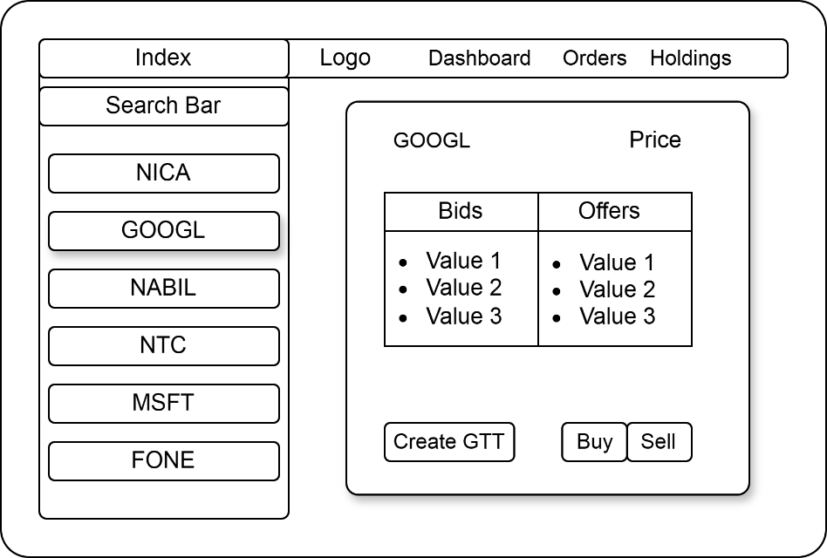
Figure 3. 9 Interface design for dashboard of stock trading system
The above diagram showcases a user interface of a stock trading application, structured for ease of navigation and functionality. At the top, there's a navigation bar with tabs providing quick access to different sections of the application. Below the navigation bar, on the left side, there is a search bar followed by a list of stock symbols allowing users to quickly select and view stock information. The main section of the interface displays detailed information for the selected stock symbol which is organized into two columns labeled "Bids" and "Offers." Each column contains values of current bid and offer prices. There are three buttons labeled "Create GTT," "Buy," and "Sell”, facilitating user actions for creating Good-Till-Triggered orders, buying, and selling stocks.

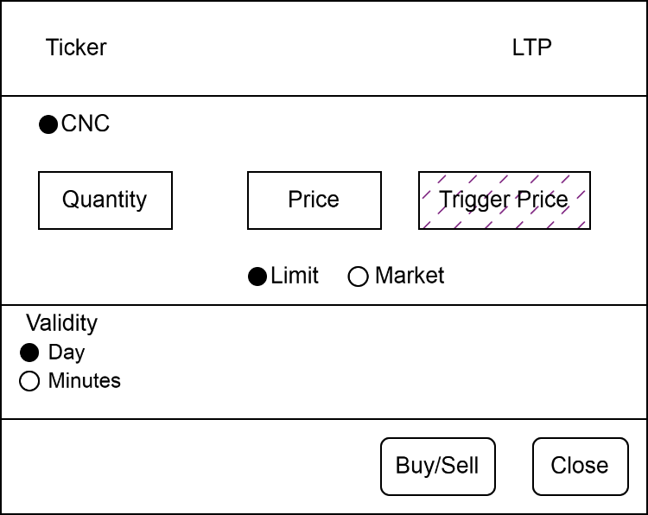
Figure 3. 10 Interface design for order modal box of stock trading system
The above diagram is the interface design of the order dialog box which takes client orders input such as Product type, Transaction type, Quantity, Price, Order type, Validity etc.
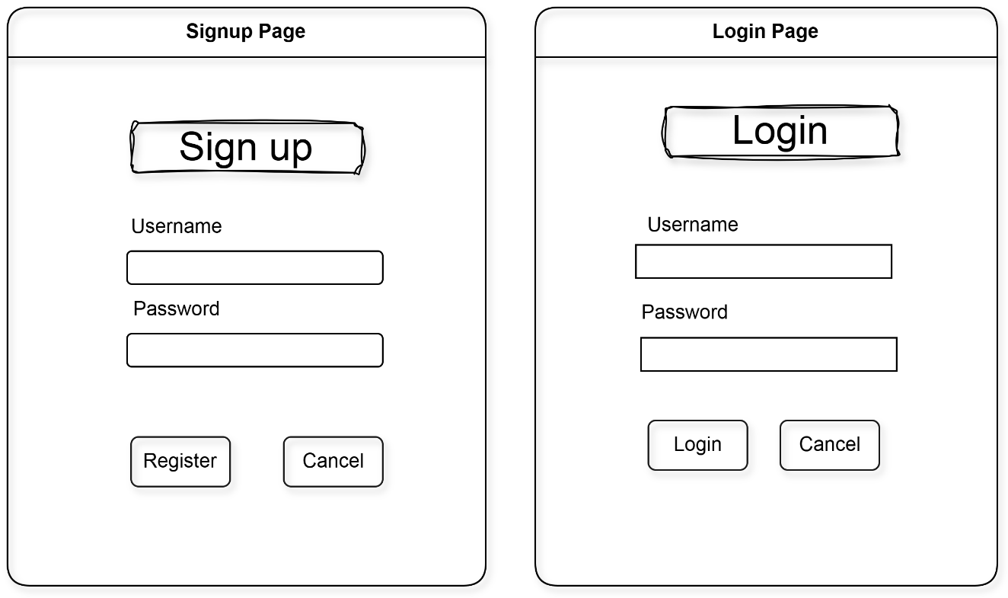
Figure 3. 11 Interface design of login and signup
The above diagram is the interface design for the login and sign-up page box which takes username and password field as input.

3.2.3 Physical DFD
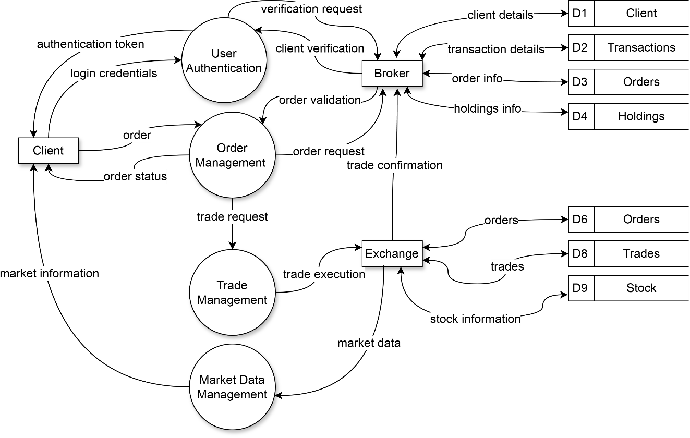
Figure 3. 12 Physical DFD of the stock trading system
The above diagram is a Physical Data Flow Diagram (DFD) of a trading system. It illustrates how information flows between different processes, data stores, and external entities within the system. The key components include the client, who interacts with the User Authentication process verifies client credentials with the Broker and issues authentication tokens upon successful verification. Order Management process receives and processes client orders, validating them through the Broker, and then initiates trade requests with the Trade Management process while updating clients on their order status. Trade Management process executes trade requests by interacting with the Exchange, confirms trades, and communicates back to Order Management. Meanwhile, the Market Data Management process collects and distributes market data from the Exchange, providing this information to Trade Management. Broker is responsible for validating client credentials and orders, managing client details, transactions, orders, and holdings. Exchange executes trades, provides market data, and interacts with the Trade Management and Market Data Management processes.

3.3 Description of Algorithm
Automated Order Trigger (AOT) is a feature which allows user to set a trigger price, such that; if user trigger price is hit in a future date, an order will be placed on the exchange as per the price and preset conditions set by user.
Conditions:
- A user can have single leg triggers (stop market order and stop limit order).
- All AOTs are cancelled after 365 days from placing such request in case they are not triggered as per the trigger conditions.
- For stop limit order, once the trigger price is breached and such limit price selected is outside the circuit limits of the particular scrip then it is rejected.

Algorithm for implementing automated order trigger:
- While stock market is live:
  - When last traded price of stock is changed
  - Fetch the GTT orders list of that stock
  - If LTP is updated then:
    - Fetch all limit orders having (trigger_price <= LTP)
    - For each order in limit orders list
      - Place buy/sell order
      - Set order status from "active" to "triggered"
    - End for
    - Fetch all market orders having (trigger_price <= LTP)
    - For each order in market orders list
      - Place buy/sell order
      - Set order status from "active" to "triggered"
    - End for
  - End If
  - End For
- End While
- End

CHAPTER 4

IMPLEMENTATION AND TESTING

4.1 Implementation

4.1.1 Tools Used

Integrated Development Environment:
IntelliJ Idea: Used as a main IDE for backend development.
VS code: Used for developing frontend development of application.

Diagram tool:
Draw.io: Used for making ER models, User Interface, Database schema and System architecture.

Backend:
Java: Used as a primary language for application backend logic.
Spring Boot: Used as a web framework for building RESTful APIs.

Frontend:
React and Typescript: Used for rendering the dynamic interface.
Tailwind CSS: used for all styling of webpages.

Database platform:
PostgreSQL: Used as a database for storing data.

Documentation Tool:
MS Word: Used as a documentation tool.

4.1.2 Implementation Details of Modules

Order Module:
This module is responsible for checking the requested order is valid or not and returns OrderInfo with success (boolean) and message (string).
public OrderInfo checkOrderValidity(Order order){
Stock stock = restTemplate.getForObject(
STR."\{EXCHANGE_URL}/stock-prices/today?ticker=\{order.getTicker()}",
Stock.class
);
assert stock != null;
float previousClosing = stock.getPreviousClosing();
float upperCircuit = (float) (previousClosing + (previousClosing*0.1));
float lowerCircuit = (float) (previousClosing - (previousClosing*0.1));
if(order.getPrice() >= lowerCircuit && order.getPrice() <= upperCircuit){
if(Objects.equals(order.getTransactionType(), "sell"))
return holdingsService.isSellUnitsAvailable(order);
else
return clientService.isFundsAvailable(order);
}
return new OrderInfo(
false,
STR."Price should be within circuit \{lowerCircuit} - \{upperCircuit}");
}

GTT Module:
This module handles all the automated triggers by executing GTT orders using multi-threading.
@Async("AsyncExecutor")
public void executeGTTOrders(Stock stock){
List<GTTOrder> singleGttOrders = getActiveGttByTickerAndTrigger(
stock.getTicker(),
stock.getLastTradedPrice(),
"single");
for(GTTOrder gttOrder: singleGttOrders){
orderService.placeOrder(orderService.mapGttToOrder(gttOrder));
setStatusTriggered(gttOrder.getId());
}
}

Transaction Module:
This module is for consuming trades sent by exchange to message queues and handling transactions logics.
@RabbitListener(queues = SubscriberMQConfig.BROKER_82_TRANSACTION_QUEUE)
public void consumeTransactions(TransactionDto transactionDto){
float averageCost;
long newFreezeUnits = 0;
long newFreeUnits;
Transaction transaction = saveTransaction(transactionDto);
Holdings holdings = holdingsService.getHoldingsInfo(
transaction.getClientId(),
transaction.getTicker());
if(holdings != null){
averageCost = (holdings.getAverageCost() + transaction.getTradedPrice())/2 ;
if(transaction.getDebitQuantity() == 0 && transaction.getCreditQuantity() > 0) {
newFreeUnits = holdings.getFreeUnits() + transaction.getCreditQuantity();
holdingsService.updateHoldingsCurrentAndFreezeUnits(
holdings.getId(),
averageCost,
newFreezeUnits,
newFreeUnits,
transaction.getBalanceQuantity());
}else {
holdingsService.updateHoldingsCurrentAndFreezeUnits(
holdings.getId(),
averageCost,
newFreezeUnits,
transaction.getBalanceQuantity(),
transaction.getBalanceQuantity());
}
} else{
averageCost = transaction.getTradedPrice();
newFreeUnits = transaction.getCreditQuantity();
holdingsService.saveHoldings(new Holdings(
transaction.getClientId(),
transaction.getTicker(),
averageCost,
newFreezeUnits,
newFreeUnits,
transaction.getBalanceQuantity(), "secondary"));
}
}

Holdings Module:
This module is responsible checking the client holdings and return OrderInfo.
public OrderInfo isSellUnitsAvailable(Order order) {
Optional<Holdings> optionalHoldings = holdingsRepository.getHoldingsInfoByTicker(order.getClientId(),
order.getTicker());
if (optionalHoldings.isPresent()) {
Holdings holdings = optionalHoldings.get();
if (holdings.getFreeUnits() >= order.getOrderQuantity()) {
long newFreeUnits = holdings.getFreeUnits()-order.getOrderQuantity();
holdingsRepository.updateHoldingsFreeAndFreezeUnits(holdings.getId(),
newFreeUnits, order.getOrderQuantity());
return new OrderInfo(true, "Valid holdings!");
}
return new OrderInfo(false,
STR."Insufficent holdings of \{holdings.getTicker()}! Available units: \{holdings.getFreeUnits()} ");
}
return new OrderInfo(
false,
STR."There's no holdings of \{order.getTicker()}!");
}

Client Module:
This module is responsible authenticating the client and check for the client funds availability.
public AuthResponse loginClient(LoginRequest loginRequest) {
Authentication authentication = authenticationManager.authenticate(
new UsernamePasswordAuthenticationToken(
loginRequest.getUsername(),
loginRequest.getPassword()));
if (authentication.isAuthenticated()) {
return new AuthResponse(
jwtTokenUtil.generateToken(loginRequest.getUsername()),
loginRequest.getUsername());
} else {
return null;
}

public OrderInfo isFundsAvailable(Order order){
float totalFundsNeeded = order.getPrice() * order.getOrderQuantity();
if(getAvailableFunds(order.getClientId()) >= totalFundsNeeded){
return new OrderInfo(true, "Funds is available!");
}
return new OrderInfo(false, "Insufficient funds!");
}

4.2 Testing

4.2.1 Test Cases for Unit Testing

Test Cases for Signup:
T01: Check user signup with valid data
T02: Check user signup with invalid data
T03: Check user signup with null data
Table 4. 1 Test table for signup
ID | Description | Test Data | Expected Results | Actual Results | Pass/Fail
T01 | Check user signup with valid data | Username= KingofHearts  Password = password | User should register. | Registered Successful! | Pass
T02 | Check user signup with invalid data | Username=DonofKtm  Password = pass269 | User should not register. | Username invalid! | Pass
T03 | Check user signup with null data | Username=Null  Password = Null | User should not register. | Username required! | Pass
T04 | Check user signup with same data | Username=DonofKtm  Password = password | User should not register. | User already exists! | Pass

Post-condition: After successful registration, user credential is stored in database.

Test Cases for Login:
T05: Check user login with valid data
T06: Check user login with invalid data
T07: Check user login with invalid password

Table 4. 2 Test table for login
ID | Description | Pre-conditions | Test Data | Expected Results | Actual Results | Pass/Fail
T05 | Check customer login with valid data | User is registered. | Username=domingo  Password = password | User should login into an application | Login successful! | Pass
T06 | Check user login with invalid username | User is not registered. | Username =dumbcom  Password = rick@67 | User should not login. | User not found! | Pass
T07 | Check user login with invalid password | User is registered. | Username= bikash  Password= Null | User should not login. | Invalid Password! | Pass

Post-condition: After successful login, id and username are stored in session.

Test cases for Logout:
T08: Check user clicks logout button

Table 4. 3 Test table for logout
ID | Description | Expected Results | Actual Results | Pass/Fail
T08 | Check user clicks logout button | User logged out of application. | Redirected to homepage | Pass

Pre-condition: User is already logged in.
Post-condition: After successful logout, user session is cleared.

Test cases for placing order:
T09: Check user adds with valid order
T10: Check user places order with invalid data

Table 4. 4 Test table for order
ID | Description | Test Data | Expected Results | Actual Results | Pass/Fail
T09 | Check user places valid order | Order request data | Order should be placed. | Order  placed! | Pass
T10 | Check user inputs invalid order | Order request data | Order should not be placed. | Order rejected! | Pass

Pre-condition: User is already logged in.
Post-condition: After successful order, user orders is placed.

Test cases for Update:
T10: Check user updates with invalid password
T11: Check user updates with valid password

Table 4. 5 Test table for update
ID | Description | Test Data | Expected Results | Actual Results | Pass/Fail
T10 | Check user updates with invalid password | Password = nsudffd | User detail should not be updated. | Update successful! | Pass
T11 | Check user updates with valid password | Password = password | User detail should be updated. | Password Invalid! | Pass

Pre-condition: User is already logged in whose valid password is “password”.
Post-condition: After successful update, user credentials are updated in database.

Test cases for Delete:
T12: Check user deletes with invalid password
T13: Check user deletes with valid password

Table 4. 6 Test table for delete
ID | Description | Test Data | Expected Results | Actual Results | Pass/Fail
T12 | Check user deletes with invalid password | Password = nsudd | User detail should not be deleted. | Update successful! | Pass
T14 | Check user deletes with valid password | Password = password | User detail should be deleted. | Password Invalid! | Pass

Pre-condition: User is already logged in whose valid password is “password”.
Post-condition: After successful delete, user credentials are deleted from database.

CHAPTER 5

CONCLUSION AND FUTURE RECOMMENDATIONS

5.1 Conclusion
The development of stock trading system with automated order triggering capabilities has demonstrated the potential of integrating real-time data analysis with algorithmic trading strategies. By simulating a real broker and exchange environment, the system enhances trading efficiency and accuracy, reducing the likelihood of human error. The robust communication framework, employing WebSockets, REST APIs, and message queues, ensures reliable data flow and timely order execution. While the system shows significant promise, its performance in highly volatile markets and the lack of customizable trading strategies highlight areas for future improvement.

5.2 Lesson Learnt
Throughout the development of this stock trading system, we learned several key lessons. Real-time data is crucial for executing trades accurately and efficiently, emphasizing the need for low-latency data streaming and processing. Algorithmic efficiency is paramount, requiring continuous refinement to adapt to market changes. The importance of scalability and resilience was also highlighted, ensuring the system can handle high data volumes and maintain uptime. Lastly, we recognized the challenges posed by market volatility and the necessity for ongoing improvements to better handle rapid price fluctuations.

5.3 Future Recommendations
To improve the stock trading system, several future enhancements are recommended. First, developing advanced algorithms will better handle market volatility, allowing the system to manage sudden fluctuations more effectively. Enabling customizable strategies will allow users to tailor their trading preferences, providing greater flexibility and adaptability. Integrating AI and machine learning will enhance predictive analytics and decision-making, leading to more advanced and adaptive trading strategies. Finally, expanding data sources to include additional information, such as social media sentiment and economic indicators, will improve the accuracy of trading decisions, offering a more comprehensive view of the market.

REFERENCES

[1] | The Kathmandu Post, "Nepse Online Trading System goes live," The Kathmandu Post, 7 November 2018. [Online]. Available: https://kathmandupost.com/money/2018/11/07/nepse-online-trading-system-goes-live. [Accessed 08 June 2024].
[2] | Corporate Finance Institute, "Stock Exchange," Corporate Finance Institute, [Online]. Available: https://corporatefinanceinstitute.com/resources/equities/stock-exchange/. [Accessed 22 July 2024].
[3] | Sharesansar, "Frequently Asked Questions (FAQ)," [Online]. Available: https://www.sharesansar.com/faq. [Accessed 26 July 2024].
[4] | Zerodha Kite, "Introducing GTT – Good Till Triggered orders," 22 July 2019. [Online]. Available: https://zerodha.com/z-connect/kite/introducing-gtt-good-till-triggered-orders. [Accessed 22 July 2024].
[5] | Robinhood, "Investing with stocks: The basics," [Online]. Available: https://robinhood.com/us/en/support/articles/stop-limit-order/. [Accessed 25 July 2024].
[6] | B. Dhakal and M. K. Gupta, "A System Model of Online Trading System for Nepal," in 2014 International Conference on Computing for Sustainable Global Development (INDIACom), 2014.
[7] | Srishti Mathur, "What is GTT Order? Learn Meaning of Good Till Triggered Orders & How to Execute them," 3 April 2024. [Online]. Available: https://www.smallcase.com/learn/what-is-gtt-good-till-triggered-order/#why-use-gtt. [Accessed 29 June 2024].
[8] | A. Ganti, "Trade Trigger: Meaning, Overview, Pros and Cons," Investopedia, 21 January 2022. [Online]. Available: https://www.investopedia.com/terms/t/trade-trigger.asp. [Accessed 21 July 2024].

APPENDICES

Screenshots

Login Page
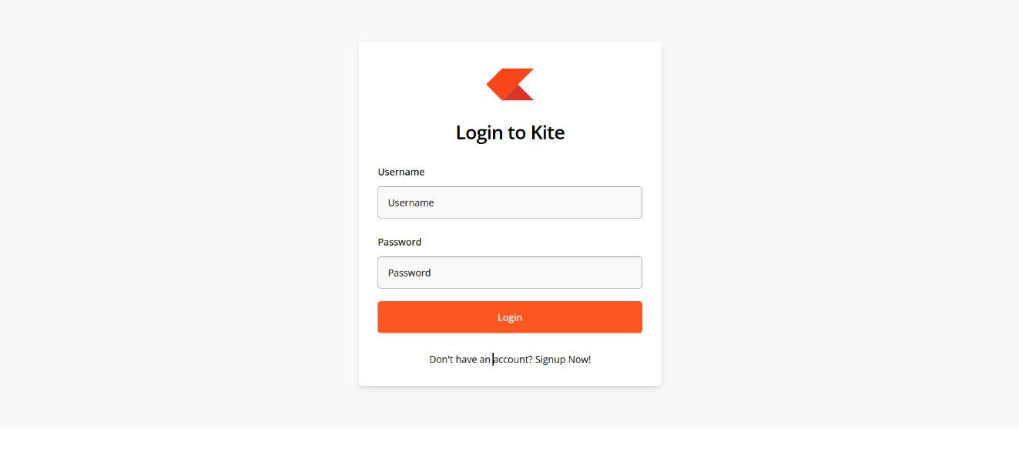

Market
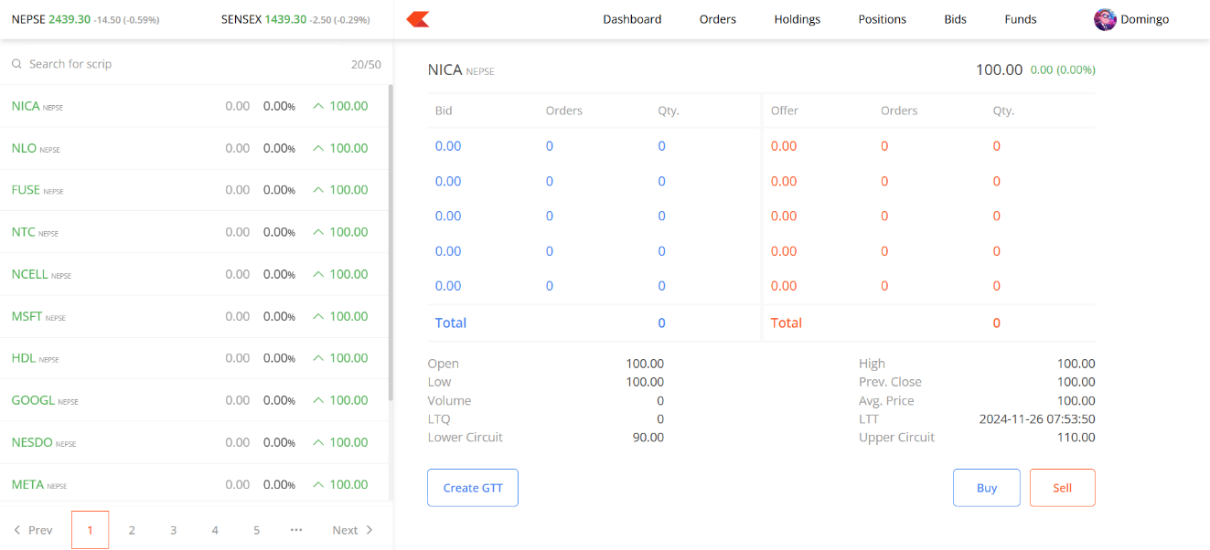

Funds Page
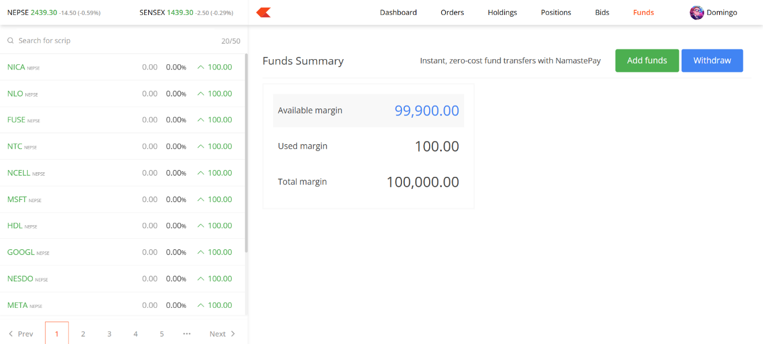

Holdings
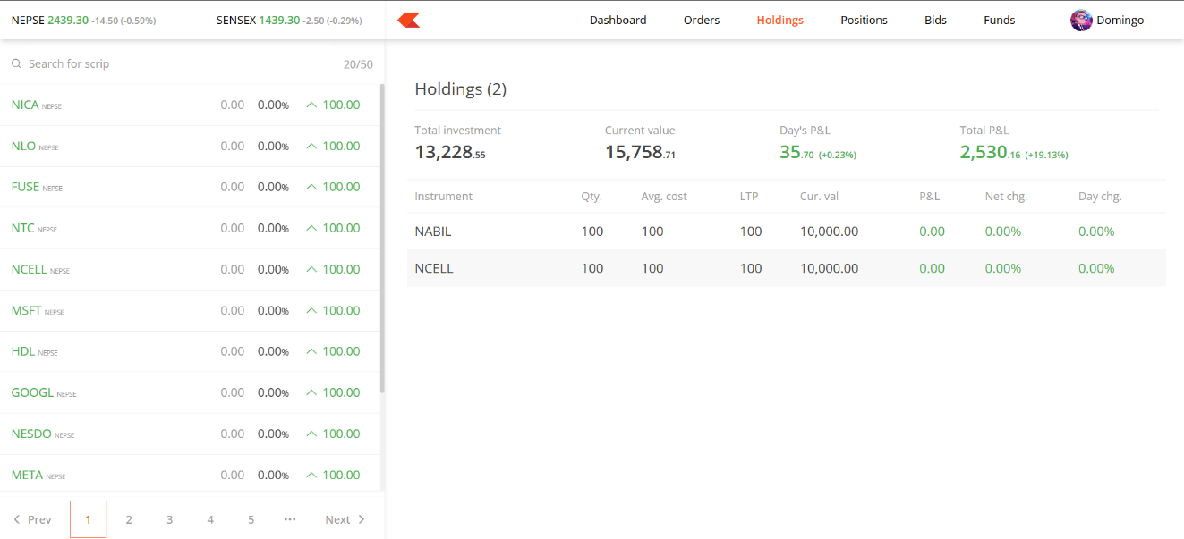

Orders
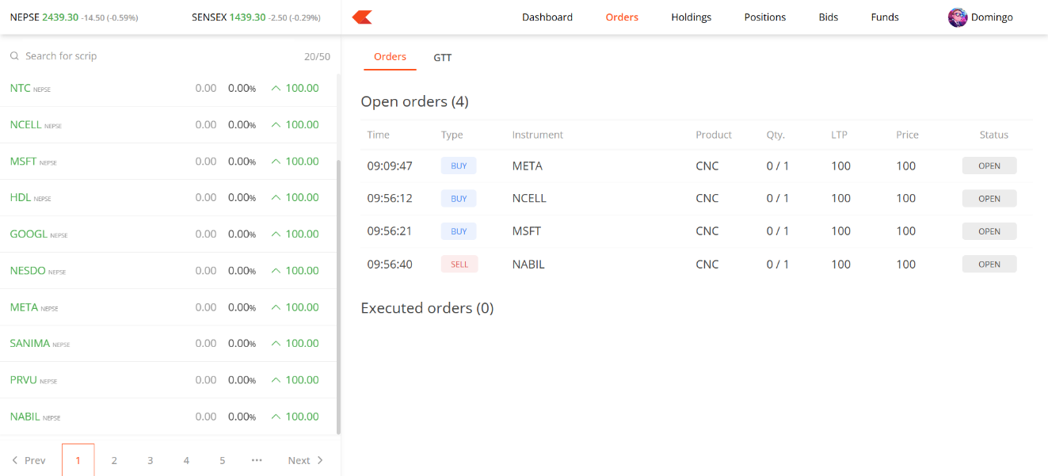

GTT orders
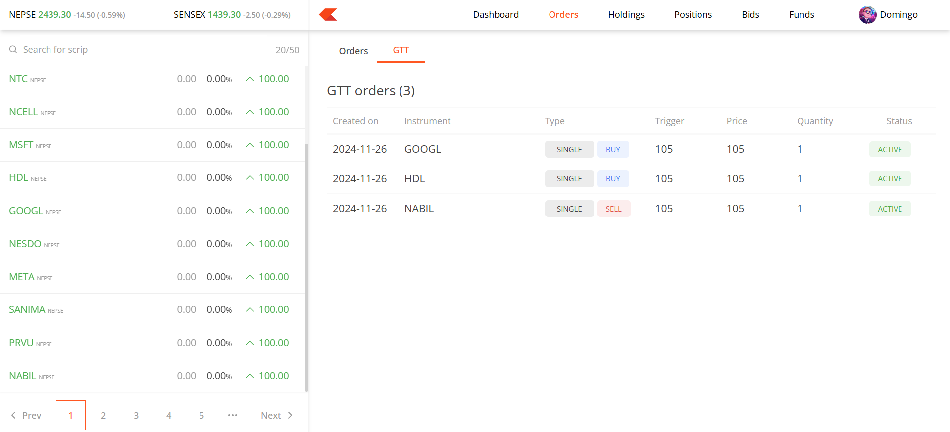

GTT Dialog
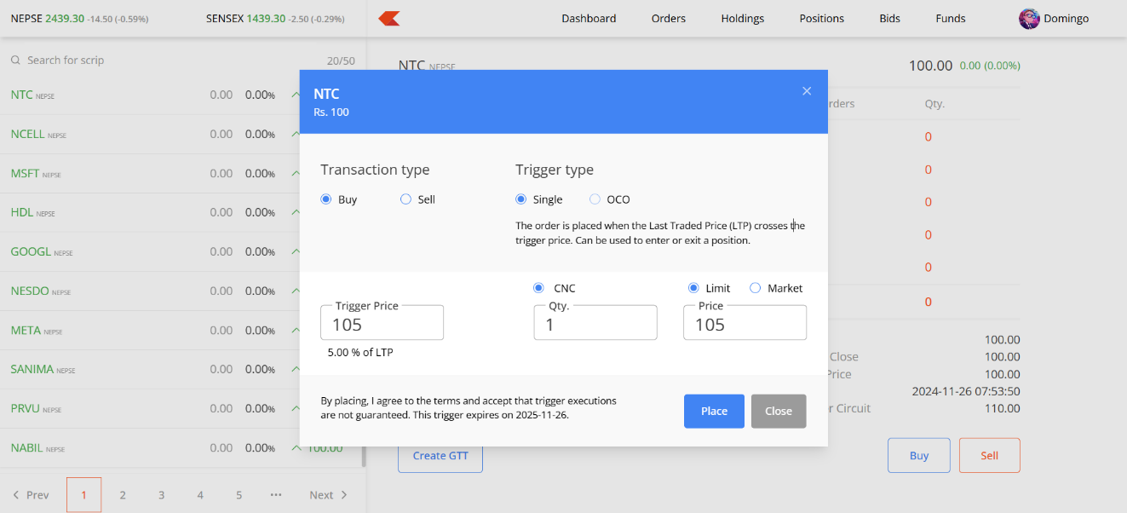

Order Dialog
