(P1) C/ GOIETA 1
 | 3 | 1 | 2
9041976972  L01
  17 | 18 | 19
  E/A | LC1 | LC2
  01 | 02 | 03 | 04
  1A | 1B | 1C | 1D
  09 | 10 | 11 | 12
  3A | 3B | 3C | 3D
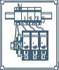
  20 | 21 | 22
  05 | 06 | 07 | 08
  2A | 2B | 2C | 2D
  13 | 14 | 15 | 16
  4A | 4B
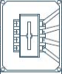 | 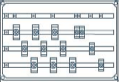

(P2) C/ AITA GOTZON 21B
1 | 1 | 2
 |  |  | 9041977046  L08
  01 | 02 | 03 | 04
  1A | 1B | 1C | 1D
  09 | 10 | 11 | 12
  3A | 3B | 3C | 3D
  17 | 18
  E/A | LC1
  05 | 06 | 07 | 08
  2A | 2B | 2C | 2D
  13 | 14 | 15 | 16
  4A | 4B
  19 | 20

(B3) C/ MAMARIGA Nº39
1 | 2
01 | 02 | 03 | 04
1A | 1B | 2A | 2B

 |  | L?
  05 | 06 | 07 | 08
  3A | 3B | 4A | 4B
  13 | 14
  EA
  09 | 10 | 11 | 12
  5A | 5B | AA
  15 | 16

(B4) C/ MAMARIGA Nº37
 | 1 | 2
05 | 06 | 07
BA | BB | 1A

08 | 09 | 10 | 11
1B | 2A | 2B | 3A

L?
  01 | 02
  EA
  12 | 13 | 14 | 15
  3B | 4A | 4B | 5A
  03 | 04
  16 | 17 | 18 | 19
  5B | AA

 | 1
01 | 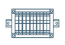
GARAJE

 | 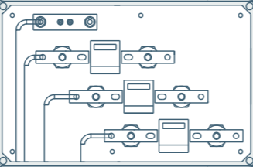
 | 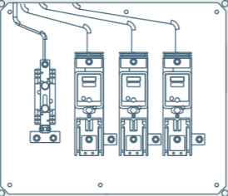 | L?

 |  | 1
 | 
  01
  SOCORRO
L? |  | 

(B5) C/ MAMARIGA Nº35
1 | 2
01 | 02 | 03
BA | BB | 1A

04 | 05 | 06 | 07
1B | 2A | 2B | 3A

 |  | L?
  08 | 09 | 10 | 11
  3B | 4A | 4B | 5A
  16 | 17
  EA
  12 | 13 | 14 | 15
  5B | AA | AB
  18 | 19

(B6) C/ MAMARIGA Nº33
1 | 2
01 | 02 | 03
BA | BB | 1A

04 | 05 | 06 | 07
1B | 2A | 2B | 3A

 |  | L?
  08 | 09 | 10 | 11
  3B | 4A | 4B | 5A
  16 | 17
  EA | SC
  12 | 13 | 14 | 15
  5B | AA
  18 | 19

