Last Name: Bi First Name: Xingjian Student ID: 1096970

1.

a) CQL Query:

DESCRIBE "hoofers";

b) Result:

CREATE KEYSPACE hoofers WITH replication = {'class': 'NetworkTopologyStrategy', 'us-east1': '3'} AND durable_writes = true;

CREATE TABLE hoofers.boats (

bid int PRIMARY KEY,

bname text,

color text

) WITH additional_write_policy = '99PERCENTILE'

AND bloom_filter_fp_chance = 0.01

AND caching = {'keys': 'ALL', 'rows_per_partition': 'NONE'}

AND comment = ''

AND compaction = {'class': 'org.apache.cassandra.db.compaction.UnifiedCompactionStrategy'}

AND compression = {'chunk_length_in_kb': '64', 'class': 'org.apache.cassandra.io.compress.LZ4Compressor'}

AND crc_check_chance = 1.0

AND default_time_to_live = 0

AND gc_grace_seconds = 864000

AND max_index_interval = 2048

AND memtable_flush_period_in_ms = 0

AND min_index_interval = 128

AND read_repair = 'BLOCKING'

AND speculative_retry = '99PERCENTILE';

c) Answers:

The Hoofers keyspace maintains 3 copies of data using the NetworkTopologyStrategy replication strategy in the 'us-east1' cloud region. Assuming a replication factor of 3, for strong consistency, R = 2 and W = 2.

2.

a) CQL CREATE Statements:

CREATE TABLE interchange.Users (

user_id text PRIMARY KEY,

email text,

first_name text,

last_name text,

joined_date date,

street text,

city text,

state text,

zip text,

categories text

);

CREATE TABLE interchange.Items (

item_id text PRIMARY KEY,

name text,

price decimal,

category text,

description text,

seller_user_id text,

list_date date,

buyer_user_id text,

purchase_date date,

) ;

CREATE TABLE interchange.Ads (

ad_id text PRIMARY KEY,

plan text,

content text,

pic_num int,

item_id text,

seller_user_id text,

placed_date date

);

CREATE TABLE interchange.Ratings (

buyer_id text,

seller_id text,

quality int,

pricing int,

delivery int,

rating_date date,

PRIMARY KEY (buyer_id, seller_id)

);

3.

a) PostgreSQL COPY commands:

\COPY interchange.Users TO '/Users/bixingjian/Nutstore Files/Nutstore/UCI 2023S/CS122D/HW2/users.csv' WITH(FORMAT CSV, HEADER)

\COPY interchange.Items TO '/Users/bixingjian/Nutstore Files/Nutstore/UCI 2023S/CS122D/HW2/items.csv' WITH(FORMAT CSV, HEADER)

\COPY interchange.Ads TO '/Users/bixingjian/Nutstore Files/Nutstore/UCI 2023S/CS122D/HW2/ads.csv' WITH(FORMAT CSV, HEADER)

\COPY interchange.Ratings TO '/Users/bixingjian/Nutstore Files/Nutstore/UCI 2023S/CS122D/HW2/ratings.csv' WITH(FORMAT CSV, HEADER)

4.

a) First CQL Query:

select user_id, first_name, last_name, email from users where last_name='Harris';

b) Result:

InvalidRequest: Error from server: code=2200 [Invalid query] message="Cannot execute this query as it might involve data filtering and thus may have unpredictable performance. If you want to execute this query despite the performance unpredictability, use ALLOW FILTERING"

c) Modified CQL Query:

select user_id, first_name, last_name, email from users where last_name='Harris' allow filtering;

b) Result:

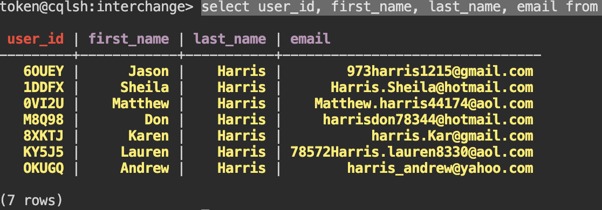

5.

a) CQL Create Statement:

CREATE TABLE users_q5 (

user_id text ,

email text ,

first_name text ,

last_name text ,

joined_date date ,

street text,

city text,

state text,

zip text,

categories text,

PRIMARY KEY (last_name, user_id)

);

b) CQL Query:

select user_id, first_name, last_name, email from users_q5 where last_name='Harris' allow filtering

c) Result:

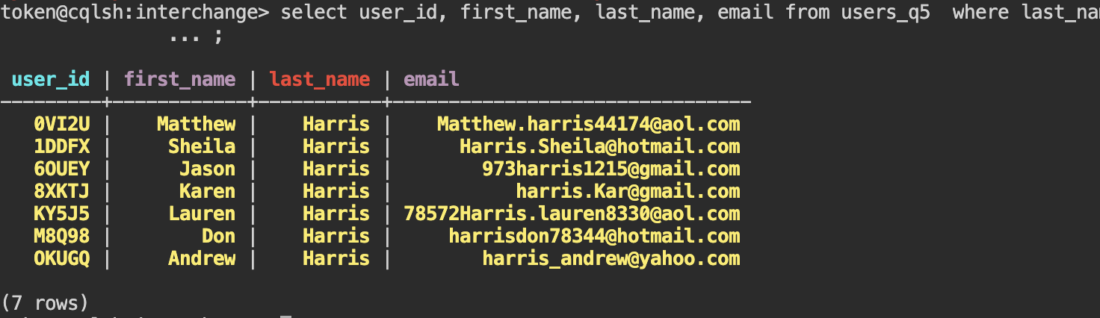

d) Explanation:

Because last_name is not unique across all users. There may be multiple users with the same last_name, so we need to include user_id to make the primary key unique. The primary key is used to locate the data, so it must be unique.

6.

a) CQL Query:

select first_name, last_name, email, user_id from users where last_name = 'Davis' order by joined_date desc limit 10 allow filtering;

select first_name, last_name, email, user_id from users_q5 where last_name = 'Davis' order by joined_date desc limit 10 allow filtering;

select first_name,last_name,email,user_id from users_q6 where last_name = 'Davis' limit 10;

b) CQL CREATE Statement:

CREATE TABLE users_q6 (

user_id text ,

email text ,

first_name text ,

last_name text ,

joined_date date ,

street text,

city text,

state text,

zip text,

categories text,

PRIMARY KEY ((last_name), joined_date, user_id)

)

WITH CLUSTERING ORDER BY (joined_date DESC,user_id DESC);

c) Results:

InvalidRequest: Error from server: code=2200 [Invalid query] message="ORDER BY is only supported when the partition key is restricted by an EQ or an IN."

InvalidRequest: Error from server: code=2200 [Invalid query] message="Order by is currently only supported on the clustered columns of the PRIMARY KEY, got joined_date"

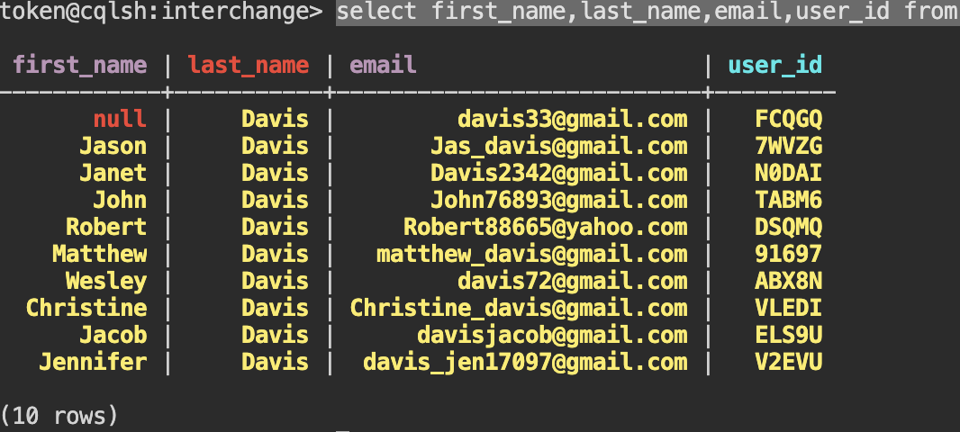

d) Explanation:

The ordering of the clustering keys matter as they determine the order of the results within each partition. We specify the order, in each partition, each information will be sorted by joined_date first and then user_id.

7.

a) CQL Create Statement:

CREATE TABLE items_7a (

item_id text,

price decimal,

seller_user_id text,

PRIMARY KEY ((seller_user_id), price, item_id)

)

WITH CLUSTERING ORDER BY (price DESC, item_id DESC);

b) CQL Create Statement:

CREATE TABLE items_7b (

category text,

item_id text,

PRIMARY KEY (category, item_id) )

c) CQL Create Statement:

CREATE TABLE ads_7c (

ad_id text ,

item_id text ,

seller_user_id text ,

placed_date date ,

PRIMARY KEY (seller_user_id,placed_date,ad_id) )

WITH CLUSTERING ORDER BY (placed_date DESC, ad_id DESC);

d) CQL Create Statement:

CREATE TABLE ratings_7d (

buyer_id text,

seller_id text,

quality int,

rating_date date,

PRIMARY KEY (seller_id,rating_date,buyer_id) )

WITH CLUSTERING ORDER BY (rating_date DESC, buyer_id DESC);

8.

a)

* CQL Query:

select item_id, price from items_7a where seller_user_id ='67EYU' order by price desc;

* Result:

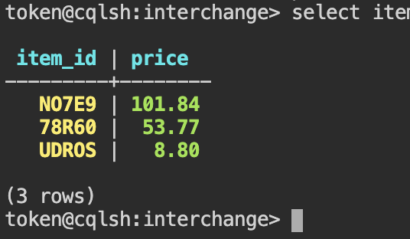

b)

* CQL Query:

select category, count(*) as nums from items_7b where category ='Electronics';

* Result:

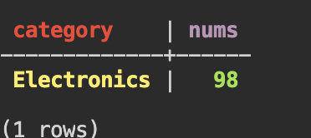

c)

* CQL Query:

select item_id,ad_id from ads_7c where seller_user_id = 'DNCLE' order by placed_date desc;

* Result:

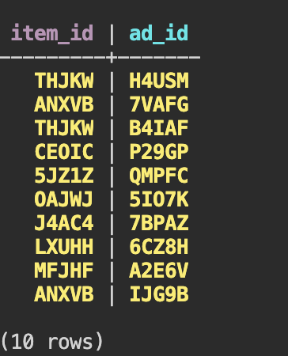

d)

* CQL Query:

select seller_id, avg(quality) as quality_avg from ratings_7d where seller_id = 'AWFGJ' and rating_date <='2022-10-01' and rating_date >='2022-01-01';

* Result:

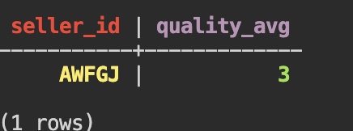

9.

a) CQL INSERT statements:

insert into "ratings" (buyer_id, seller_id, delivery, pricing, quality, rating_date) values ('LFIR9', 'AWFGJ', 5, 4, 3, '2022-02-10');

insert into "ratings_7d" (buyer_id, seller_id, quality, rating_date) values ('LFIR9', 'AWFGJ', 3, '2022-02-10');

10.

Python script:



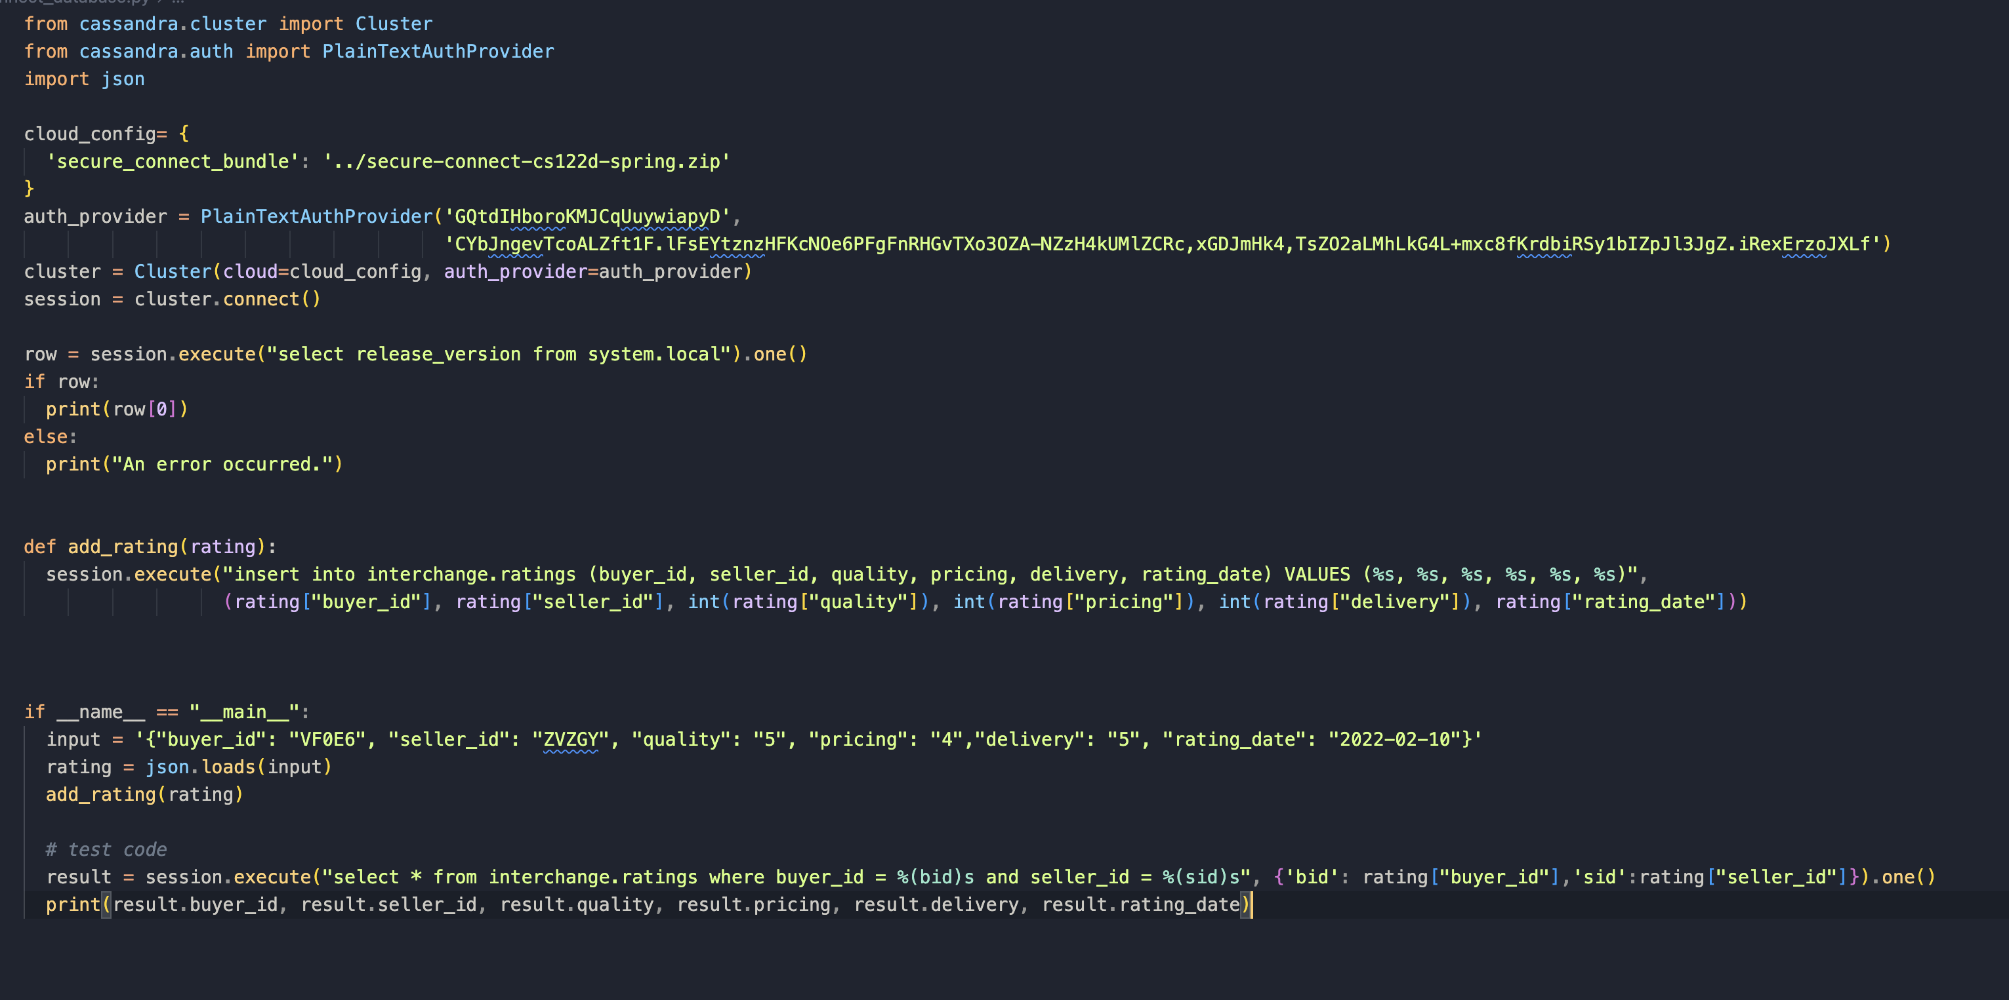

from cassandra.cluster import Cluster

from cassandra.auth import PlainTextAuthProvider

import json

cloud_config= {

'secure_connect_bundle': '../secure-connect-cs122d-spring.zip'

}

auth_provider = PlainTextAuthProvider('GQtdIHboroKMJCqUuywiapyD',

'CYbJngevTcoALZft1F.lFsEYtznzHFKcNOe6PFgFnRHGvTXo3OZA-NZzH4kUMlZCRc,xGDJmHk4,TsZO2aLMhLkG4L+mxc8fKrdbiRSy1bIZpJl3JgZ.iRexErzoJXLf')

cluster = Cluster(cloud=cloud_config, auth_provider=auth_provider)

session = cluster.connect()

row = session.execute("select release_version from system.local").one()

if row:

print(row[0])

else:

print("An error occurred.")

def add_rating(rating):

session.execute("insert into interchange.ratings (buyer_id, seller_id, quality, pricing, delivery, rating_date) VALUES (%s, %s, %s, %s, %s, %s)",

(rating["buyer_id"], rating["seller_id"], int(rating["quality"]), int(rating["pricing"]), int(rating["delivery"]), rating["rating_date"]))

if __name__ == "__main__":

input = '{"buyer_id": "VF0E6", "seller_id": "ZVZGY", "quality": "5", "pricing": "4","delivery": "5", "rating_date": "2022-02-10"}'

rating = json.loads(input)

add_rating(rating)

# test code

result = session.execute("select * from interchange.ratings where buyer_id = %(bid)s and seller_id = %(sid)s", {'bid': rating["buyer_id"],'sid':rating["seller_id"]}).one()

print(result.buyer_id, result.seller_id, result.quality, result.pricing, result.delivery, result.rating_date)