Celix

External Customer Quick Start Guide
This guide explains how external customers request access, receive approval, sign in for the first time, and start using Celix.
Access URL: https://celix.baicells.com
All dates and times shown in the web pages follow your local browser time zone.
Use the path that matches your situation:
- If you already received an access invitation email, open the invite link and sign in with your work email.
- If your company does not have access yet, submit Apply for Trial Access first.

Before You Start
Prepare the following information before you submit your request:
- Your company email address
- Contact Name
- Your company name
- Country / Region
- History Purchase Date
- History PO Number
- One Baicells product SN Number
- Your Baicells sales contact email
- Purchased Devices information

Registration And First Sign-In

1. Open the external customer sign-in page
Go to the access URL and choose Continue with Email.
If your company does not have access yet, choose Apply for Trial Access.
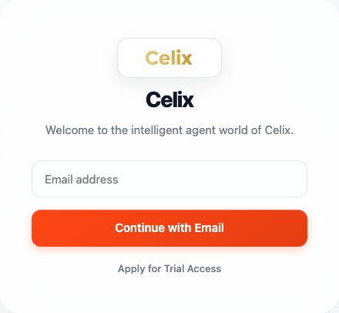
External customer sign-in

2. Submit an access request
Select Apply for Trial Access and complete the request form.
Required fields:
- Business Email
- Contact Name
- Company
- Country / Region
- History Purchase Date
- History PO Number
- SN Number
- Baicells Sales Email
- Purchased Devices
Optional field:
- Notes
The system uses this information for internal review and access approval.
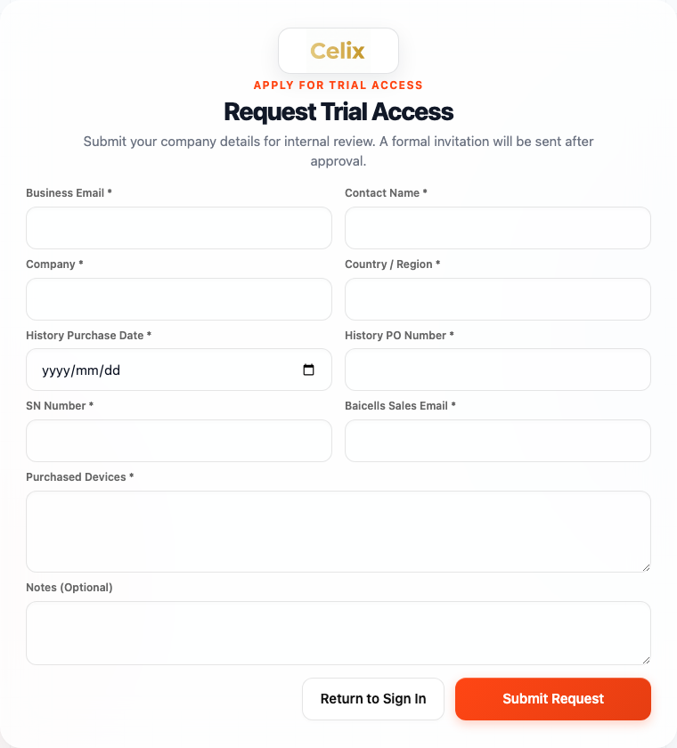
Trial access application form

3. Check your request status
After submission, the system sends you a confirmation email and gives you a request status link.
Use that link to check whether your request is still under review, needs more information, or has been approved.
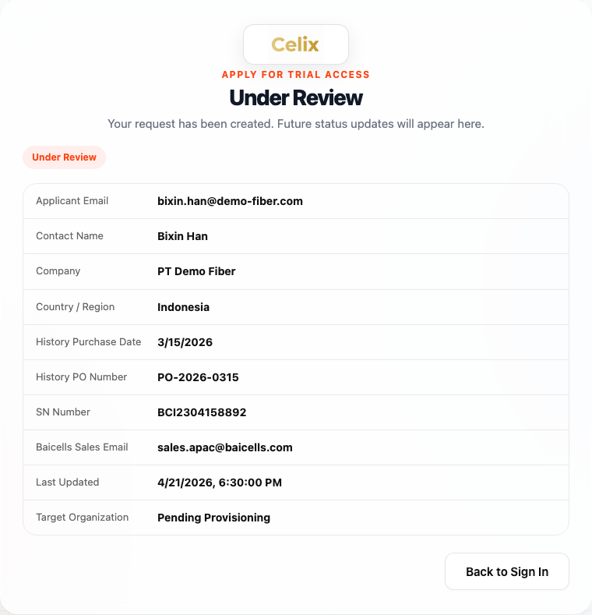
Public request status page

4. Wait for the approval email
After your request is approved and access is provisioned, you will receive an access is ready email.
Open the email and select the invite link.
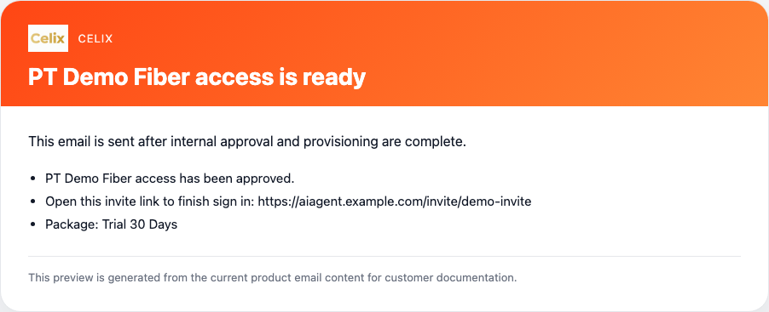
Access ready email

5. Open the invitation sign-in page
The invitation page shows your organization, masked email address, membership type, and expiration time.
Select Continue with Email to request a verification code.
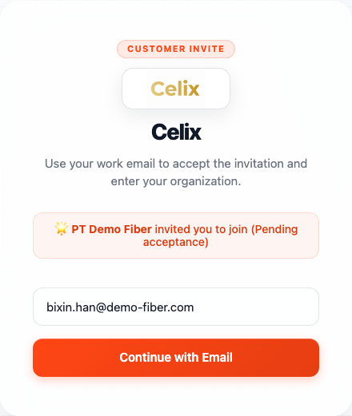
Invite sign-in page

6. Enter the verification code
Check your mailbox for the verification email, enter the code, and select Verify & Sign In.
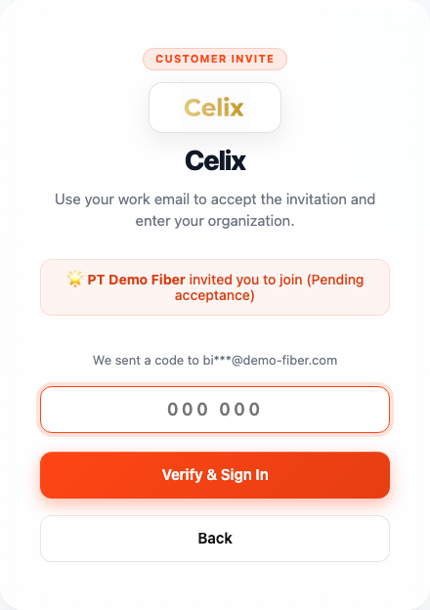
Verification step
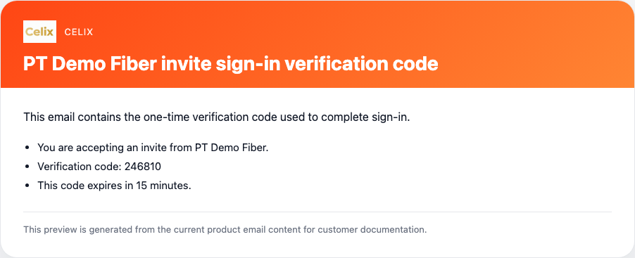
Verification code email
After verification succeeds, your account is activated and you enter the external customer workspace.

Possible additional follow-up emails
Depending on the review result, you may also receive:
- A request for more information
- A rejection notice with the review outcome

After Sign-In
After you enter the workspace, you can:
- Use the Celix workspace assigned to your organization
- Access the resources and package enabled for your company
- Return later with the same email-based sign-in flow
If your organization has multiple users, each invited user signs in with their own work email and verification code.

If You Need Help
- If you have not submitted a request yet, use Apply for Trial Access.
- If you already received an invite, always sign in from the invite link first.
- If you do not receive the verification code, check your spam folder and then contact your Baicells sales representative or Celix support team.

