“Co-construction” in Deliberative Democracy? Lessons from the French Citizens’ Convention for Climate

30 September 2021

Louis-Gaëtan GIRAUDET, Bénédicte APOUEY, Hazem ARAB, Simon BAECKELANDT, Philippe BEGOUT, Nicolas BERGHMANS, Nathalie BLANC, Jean-Yves BOULIN, Eric BUGE, Dimitri COURANT, Amy DAHAN, Adrien FABRE, Jean-Michel FOURNIAU, Maxime GABORIT, Laurence GRANCHAMP, Hélène GUILLEMOT, Laurent JEANPIERRE, Hélène LANDEMORE, Jean-François LASLIER, Antonin MACE, Claire MELLIER-WILSON, Sylvain MOUNIER, Théophile PENIGAUD, Ana POVOAS, Christiane RAFIDINARIVO, Bernard REBER, Romane ROZENCWAJG, Philippe STAMENKOVIC, Selma TILIKETE, Solène TOURNUS.

*In 2019, enacting a presidential decision, France’s Prime Minister tasked an assembly of 150 randomly drawn citizens – the Citizens’ Convention for Climate (CCC) – with “defining structuring measures to achieve, in a spirit of social justice, a reduction of greenhouse gas emissions of at least 40% by 2030 compared to 1990.” Importantly, this was to be fulfilled through an “innovative procedure of co-construction” involving a wide range of actors alongside the citizens. How did such an external input affect the citizens’ deliberation? What are the implications for political uptake among the broader public? To address these questions, we build on quantitative and qualitative data collected during our unique experience with participatory observation of the CCC. We find that the approach to co-construction that prevailed throughout the CCC induced significant framing effects, yet remained flexible enough to preserve the citizens’ creativity and freedom of choice. While succeeding in creating consensus among citizens, the approach failed to generate significant support among the broader public. This could be addressed by providing more visibility ex ante on how the citizens’ proposals might be followed up on ex post.*

**Contact for correspondence**: [giraudet@centre-cired.fr](mailto:giraudet@centre-cired.fr).

**Affiliations.** **LGG**: Ecole des Ponts ParisTech, UMR Cired. **BA**: Paris School of Economics, CNRS. **HA**: Université Paris 1-Panthéon Sorbonne. **SB**: Université de Lille. **PB**: Independent Researcher. **NiB**: Iddri. **NaB**: CNRS, UMR Ladyss. **JYB**: Université Paris-Dauphine, IRISSO. **EB**: Assemblée Nationale. **DC**: University of Lausanne. **AD**: CNRS, Centre Alexandre Koyré. **AF**: ETH Zürich. **JMF**: Université Gustave Eiffel. **MG**: Université Saint-Louis. **LG**: CNRS, Université de Strasbourg, DynamE. **HG**: CNRS, Centre Alexandre Koyré. **LJ**: Université Paris 1 Panthéon-Sorbonne. **HL**: Yale University. **JFL**: CNRS, Paris School of Economics. **AM**: CNRS, Paris School of Economics. **CMW**: Cardiff University, CAST. **SM**: Independent Researcher. **TP**: Ecole Normale Supérieure de Lyon, UMR Triangle. **AP**: Rhizome Chôros, Université Libre de Bruxelles. **CR**: LCF Université de la Réunion, Sciences Po CEVIPOF. **BR**: CNRS, Sciences Po CEVIPOF. **RR**: Université Paris 8, Labtop-CRESPPA. **PS**: Independent Researcher. **SeT**: Université Paris 8, Centre Alexandre Koyré. **SoT**: CNRS.

**Acknowledgements.** All authors participated in the observation of the Citizens’ Convention for Climate (CCC) and contributed to the analysis. L.-G. Giraudet wrote the initial draft. All authors contributed to the review and editing of the initial draft. J.-M. Fourniau was a member of the Governance Committee of the CCC. We thank Graham Smith and Jane Mansbridge for their invaluable comments on the draft paper.

# Introduction

Deliberative mini-publics are gaining traction across the world to address a number of complex issues that have proved difficult to solve with the traditional democratic apparatus (Dryzek et al., 2019). The most studied examples include assemblies on electoral laws in British Columbia and Oregon (Fournier et al., 2011; Warren and Gastil, 2015) and on same-sex marriage and abortion in Ireland (Farrell et al., 2019; Devaney et al., 2020; Courant, 2020). Deliberative mini-publics involve lay citizens who are drawn by lot and invited to come together, deliberate and produce policy recommendations. Citizens’ assemblies are a specific form of deliberative mini-publics involving a sufficiently large number of participants and lasting long enough for them to submit policy proposals to government executives or elected authorities.

From a normative perspective, citizens’ assemblies both complement and feed into representative democracy in an attempt to increase the quality of deliberation and, ultimately, the legitimacy and effectiveness of policy-making. To achieve this, citizens’ assemblies are intended to foster authentic, inclusive and consequential deliberation (Dryzek, 2009). Deliberation is a form of structured exchange of arguments, information and stories that can, when conducted properly, produce and harness collective intelligence. Deliberation is considered to result in decisions that more effectively reflect the will of the many than does rhetoric – the main vehicle in conventional democracy (Chambers, 2009). Random selection of participants is expected to make deliberation in citizens’ assemblies both more authentic and more inclusive, enabling all types of citizens – chiefly including those who do not normally participate in popular votes (Neblo et al. 2010) – to bring and share their first-hand experience of practical yet complex problems – which representatives often lack. The citizens’ assembly in turn serves as a “recommending force” or “corpus of trustee” to the broader public (Mansbridge et al., 2012; Warren and Gastil, 2015; Warren 2017). There is growing evidence from the United States (Gastil et al., 2016; Ingham and Levin, 2018), Canada (Boulianne, 2018), and Ireland (Suiter et al., 2020) that mini-public indeed are effective at generating support among the broader public. Such adherence is thought to rely on different processes, including trust – the broader public perceiving the mini-public as representative, hence trustworthy – and heuristics – assuming some division of cognitive labor is inevitable in democratic decision-making, the broader public can thus rely on “information cues” produced by the mini-public (McKenzie and Warren, 2012).

The degree to which deliberation in citizens’ assemblies should be consequential is less consensual. While most theorists agree that participants who have devoted significant time and effort in such a process should at least “have a say” on its outcomes (Goodin and Dryzek, 2006; Chambers, 2009; Caluwaerts and Reuchamps, 2015), arguments differ as to the form this should take. On the sanguine side, some advocate for citizens’ assemblies producing binding decisions which governments should endorse as is (Fishkin, 2016). On the skeptical side, in contrast, others view citizens’ assemblies as “democratic shortcuts” that, if overly relied on, illegitimately bypass the will of the broader public (Lafont, 2015). In between, some suggest that pairing citizens’ assemblies and a referendum (perhaps in an iterative way) can bring the best of the two worlds (Setälä, 2011, 2017; Landemore, 2018; Parkinson, 2020). In practice, with increasing empirical evidence gathered from nearly 200 experiences with deliberative mini-publics (Smith, 2009; Paulis et al., 2020; Jacquet and van der Does, 2020), the device has proved mostly inconsequential so far, with politicians cherry-picking among its conclusions. One important exception is Ireland, where citizens’ assemblies were followed up with three referenda, two of which resulted in the same outcome as that recommended by the mini-public (Suiter and Reidy, 2020).

Among the many issues debated in citizens’ assemblies, climate policy has been prominent in the past few years. From a normative perspective, it has been noted that deliberative democracy and climate change are closely connected. Climate change is a complex, urgent, and, by and large, intangible problem. In particular, it lacks salience – its effects are felt with distance across both space and time –, a feature representative democracy has proved limited in its ability to tackle (Niemeyer, 2013). The inclusiveness inherent in deliberative democracy is thought to be better fitted to overcome this limitation (Dryzek and Stevenson, 2011; Burnell, 2012; Baber and Bartlett, 2021). Perhaps most crucially, climate assemblies uniquely question the role experts should play in deliberative democracy. The sheer scale of the problem at hand and its highly technical aspect make expert input essential in the citizens’ deliberation. Specifically, expert input can serve as a “selectively convergent” base for judgement and thus contribute to building trust among citizens (Hendriks, 2006; Warren and Gastil, 2015). Reaching these benefits however requires a great deal of transparency about experts’ interests and careful oversight of their interaction with the citizens.

The French Citizens’ Convention for Climate (CCC) is the largest-scale experiment to date with climate assemblies, owing at least to the resources it involved (€5.5 million) and the period it spanned (nine months).[1] The CCC was initiated in 2019 by the President of the Republic in response to what had come to be known as the Gilets jaunes crisis, a protest movement against the perceived unfairness of governmental policies – environmental ones in particular (Nature, 2018; Brancaccio, 2020). It was formally implemented by a mandate letter from the Prime Minister tasking 150 randomly drawn citizens with “defining structuring measures to achieve, in a spirit of social justice, a reduction of greenhouse gas emissions of at least 40% by 2030 compared to 1990.” Nine months later, the selected participants submitted 149 policy proposals, which since then have generated intense parliamentary activity.

The CCC had a peculiar feature which makes it a particularly interesting case to study climate assemblies.[2] In his mandate letter, the Prime Minister referred to the process as an “innovative procedure of co-construction of solutions.” An increasingly popular concept in applied management, the notion of co-construction lacks a clear articulation in social sciences, in particular in the theory of deliberative democracy. As Jacoby and Ochs (1995) put it, “as a free-standing term, the word co-construction is quite elliptical, implying some nonspecified joint activity of creation, deliberately leaving one in the dark as to who (or what) might be acting in concert and what exactly is being jointly created.” In the context of the CCC, the concept was brought up as a means to cope with the social justice imperative, but the government failed to provide any practical guidance as to how to implement it.

Taken in the broadest sense that something is being jointly created, the notion of co-construction raises two important questions in relation to citizens’ assemblies, and climate assemblies in particular: If there is to be an external input, what remains of the legitimacy of the citizens’ output? What then are the implications of such a co-constructed process for one of the most crucial aspects of citizens’ assemblies, namely gaining support from the broader public?

We examine these questions in the context of the French CCC. We proceed in three steps. To begin with, we provide a synthetic account of the CCC proceedings and subsequent developments. We then examine in greater detail the interactions that took place between the citizens and the steering bodies so as to pinpoint how external input affected the citizens’ creativity and freedom of choice. In doing so, we focus on three key stages of the deliberation process – agenda-setting, proposals elaboration and decision-making. We find that the steering bodies, in particular the legal advisory group, exerted significant framing effects on citizens’ deliberation. Yet the framework remained flexible enough to preserve the citizen’s independence, which for instance allowed the citizens to evict the carbon tax issue from the agenda. Did such an approach generate support among the broader public? In a third step, we examine the two-way relationship between the two, more specifically the citizens’ engagement toward the broader public – in particular their handling of the referendum issue – on the one hand, the broader public’s perception of the CCC proceedings on the other. We find that, despite mutual interest, each side manifested some form of skepticism toward the other, which resulted in macro support being minimal. Crucially, the citizens turned down the opportunity given to them to submit their proposals to referendum. Taken together, these results lead us to the conclusion that the approach to “co-construction” that prevailed throughout the CCC succeeded in building consensus among citizens, but not in gathering support from the broader public. In closing, we call for building a transparent commitment structure providing more visibility ex ante on how the citizens’ proposals might be followed up on ex post.

Our analysis builds on our unique experience as participant observers of the CCC. We were part of a group of accredited researchers in social sciences who worked collaboratively to document and analyze the CCC.[3] In this paper, we exploit three different sources of research material: the voting results generated during the process; quantitative data from specifically designed participant surveys; and the qualitative observations each of us collected and shared with the group.

The remainder of the paper is organized as follows. In Section 2, we describe the CCC proceedings, detailing its structure, process and early outcomes. In Section 3, we focus on how the citizens and the steering bodies interacted in setting the agenda, elaborating proposals and making final decisions. In Section 4, we examine the engagement the citizens and the broader public manifested toward each other. We discuss our main findings and conclude with some policy recommendations in Section 5. The research protocol is described at the end of the paper.

# Materials and methods

Through an open call, the governance committee of the CCC invited researchers to closely follow the process. This led to the formation of a group of social scientists from various disciplines – political science, economics, sociology, philosophy, geography, law – working together to collect qualitative and quantitative data during the process.

## Survey data

We prepared questionnaires to survey the citizens’ values, their attitudes toward climate change and their feelings and views about the Convention. We initially planned to survey the citizens both at the beginning and at the end of each session. In an attempt to capture changes, the questionnaires included repeated questions alongside more session-specific questions. Unfortunately, while the response rate was high in the first two sessions, it sharply declined thereafter, a trend we did not manage to counter by switching from paper to electronic questionnaire forms. As a result, the later questionnaires are challenging to exploit. In this paper, we provide some results for the two most responded sessions, namely the beginning of Session 1 (N=111 to 136) and Session 7 (N=63 to 65).

## Voting results

In addition to our own survey data, we exploited the quantitative data generated during the voting sessions (CCC, 2020, 2021).

## Qualitative observations

The governance committee and the facilitators granted us access to plenary and group discussions, which gave us the opportunity to observe citizens’ interactions, take notes and make audio recordings of their conversations. We were also allowed (with camera and audio turned off) to attend the webinars that took place between the face-to-face sessions. Lastly, we had access to an online internal platform that was set up for the citizens to aid circulation of information and enable collaboration. In return, we adhered to a charter in which each of us committed not to interfere with the process. This implied observing debates at reasonable distance, engaging as little as possible with participants and organizers, refraining from publicly expressing personal views on the CCC during the process and from communicating preliminary research results (see Appendix A).

Our group set out to cover the whole process as systematically as possible. We formed small teams of one to five researchers, grouped either by discipline, thematic interest or home institution. We then scheduled individual attendance with two constraints: have all events covered at the whole-group level, including both the plenary sessions and the parallel group discussions; and maintain a permanent presence of each team throughout the process. These requirements were demanding, considering the three-week notice between the circulation of the call and the beginning of the CCC, the planning of all CCC sessions on weekends and the many disruptions that occurred in the CCC schedule (see Section 2). Yet they were to a large extent fulfilled, with attendance never falling below 20 researchers, about two-third of us being able to follow at least than 50% of the proceedings, and five of us even following 100% of it. At the beginning of each session, our plenary group would meet in person to discuss the protocol and agree on an allocation of teams and researchers across parallel sessions. In between sessions, we would meet remotely to share observations and discuss preliminary findings. A follow-up discussion was organized in July 2020 and the different teams shared their observations and findings in a public workshop held remotely on November 17-18 of 2020. The observations reported here are those that proved most convergent among us.

# The CCC proceedings: An overview

After briefly introducing the context that brought about the CCC, we describe its proceedings using the common structure-process-outcome framework (Goold et al., 2012)[4] and discuss the extent to which the citizens’ proposals have been followed up on.

## Inception

In November 2018, France was hit by a major political crisis. In response to a set of governmental measures deemed unfair to the poor – a planned increase in the carbon tax, a reduction of speed limits from 90 to 80 km/h mainly applying in rural areas and tax cuts benefiting the rich – protesters started gathering every Saturday and occupying roundabouts on a daily basis (Nature, 2019; Brancaccio, 2020). What came to be known as the Gilets Jaunes movement made the headlines of French political life for nearly six months, with aftershocks still being felt. Among other responses, the government organized in early 2019 what was termed the “Grand National Debate,” which included elements of participatory and deliberative democracy, in particular through eighteen “regional citizen conferences,” each inviting about a hundred of randomly selected citizens to deliberate for a day and a half. In closing the Grand National Debate in April 2019, President Macron took a step further, announcing the creation of a dedicated citizens’ assembly on climate – the CCC (See Appendix B). The President committed that the measures submitted by the citizens’ assembly would be brought “without filter” to the appropriate level: referendum, governmental or parliamentary action. In so committing to take the citizens’ proposals as is, the President asked in return of the citizens to produce readily implementable bills.

The CCC was formally initiated in July 2019 by a mandate letter from the Prime Minister inviting participants to “define structuring measures to manage, in a spirit of social justice, to cut France’s greenhouse gas (GHG) emissions by at least 40% by 2030 compared to 1990” (see Appendix C).[5] The letter was addressed to the head of the Economic, Social and Environmental Council (CESE), to whom the organization of the CCC was delegated.[6]

The 40% target corresponded at the time to France’s intended nationally-determined contribution submitted in compliance with the Paris Agreement.[7] The emphasis on social justice was meant to overcome the shortcomings that had led to the Gilets jaunes crisis.

## Structure

At the Prime Minister’s request, two committees were set up to organize and scrutinize the work of the citizens – a governance committee and a college of guarantors. Bringing together representatives from various organizations, the governance committee was tasked with setting up the agenda, defining procedures, supervising the process and providing legal and technical support (cf. Appendix C). In effect, the Prime Minister nominated two think tank representatives, Thierry Pech and Laurence Tubiana, as co-chairs of the governance committee; they in turn appointed thirteen fellows from various organizations (think tanks, unions, businesses, academia). The governance committee further included a chair of two citizens rotating between sessions. The governance committee further appointed two spin-off groups: a technical advisory group of 19 experts with different backgrounds – policy, business, economics, sociology – and a legal advisory group of six experts. The latter was to provide support for the legal transcription of the proposals, a prerequisite for them being followed up “without filter” by the President of the Republic. To our knowledge, such legal support has no precedent in other citizens’ assemblies.

The participating citizens were selected in August and September 2019. From an initial pool of 300,000 randomly generated phone numbers, contact was made with 11,400 people to survey their socio-economic characteristics and their willingness to participate. Among the positive respondents, 190 were selected so as to fulfill quotas based on age, gender, education level, geographic origin, settlement (urban versus rural) and type of job (if any). Importantly, unlike in other citizens’ assemblies (e.g., CAUK), attitudes toward climate change were not part of the selection criteria. Of the 190 candidate participants, 178 were effectively summoned, of which 104 effectively participated in all sessions, 56 participated in some but not all sessions, 10 never showed up and eight dropped out along the way. The number of citizens that were ultimately considered official participants is 159. The composition of the Convention is provided in Table 1.

The question naturally arises as to the degree to which the selected participants are representative of the general population based on a broader set of criteria. As it turns out, the views expressed in questionnaires by participants on general issues such as education and political leanings match fairly well those expressed by 1,003 representative respondents surveyed in an external study (Fabre et al., 2021). The key difference is a more pronounced concern for climate change in the Convention sample.[8] Since participation was voluntary and selection ignored attitudes toward climate change, such a bias could not be avoided.

Alongside the citizens, the governance committee, its spin-off committees and the college of guarantors, a consortium of facilitators was procured the role of leading the debates. In what follows, we refer to them collectively as the “steering bodies.”

A budget of €4.5 million was initially planned to organize the CCC, most of which dedicated to logistics, compensations for citizens – participants received a daily allowance of 84€ (hence €1,462 over the whole course of events), plus specific benefits for child care and lost income – and the facilitators’ fees. Total costs eventually reached €5.5 million. Table 1: Composition of the CCC. Source: Governance Committee of the CCC

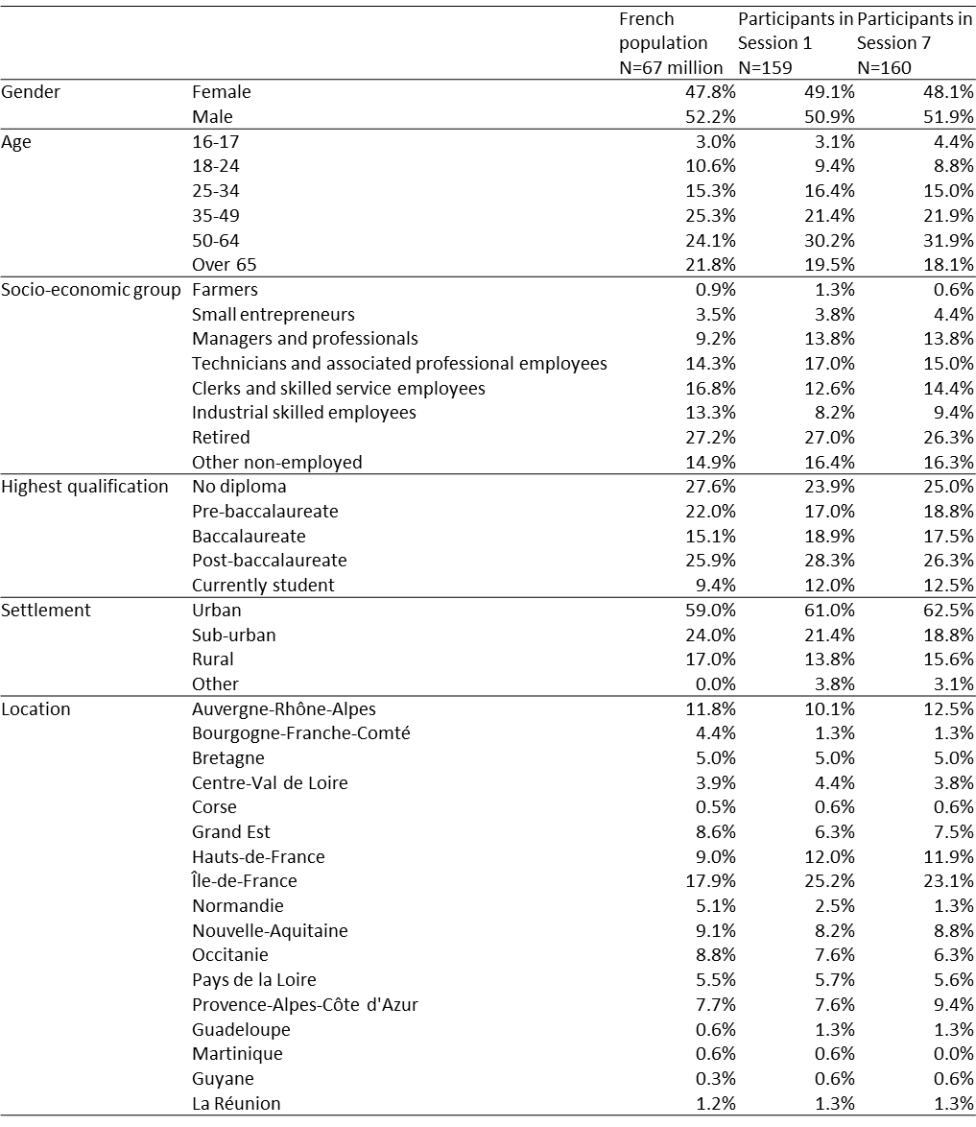

## Process

The CCC was initially scheduled to span six three-day sessions (Friday through Sunday), from October 2019 to early February 2020. Two major events disrupted these plans. First, protests against a pension reform led to the longest strike in France in decades. Public transport was nearly shut down from early December 2019 to mid-January 2020, thus delaying Session 4. By that time, the citizens requested and were granted a seventh session. Second, soon after Session 6, lockdown was ordered to fight the COVID-19 outbreak. After two interim sessions were held remotely during the lockdown period, the final session was held at CESE with social distancing measures on June 19-21 – four months later than initially planned.

The CCC sessions combined plenary gatherings and parallel gatherings held in smaller thematic groups. The thematic groups were defined by the Governance Committee so as to cover five relevant aspects of France’s GHG emissions: housing (*Se loger*), labor and production (*Travailler et produire*), transport (*Se déplacer*), food (*Se nourrir*), and consumption (*Consommer*). Citizens were randomly assigned to a thematic group. Within this governance committee-imposed framework, the citizens found room to adjust the agenda, as we will discuss in Section 4.

The CCC was structured in several phases (See Table 2). In Session 1, citizens heard from experts on the science of climate change and were introduced to the objectives and the schedule. In a second sequence spanning Sessions 2 to 6, they interrogated experts, debated and elaborated policy proposals. Under the guidance of facilitators, they would alternate hearings of external experts and stakeholders and table discussions, in either plenary or thematic gatherings. Between sessions, members of the experts’ group would assess the proposals and legal experts would reformulate the citizens’ proposals in a more precise and formal fashion. At the beginning of each session, the citizens would then review the reworked version of their proposals and use it as a basis for further discussion. In Session 6, each group presented their work in plenary gatherings to get feedback from other groups. After Session 6, once each group had completed their proposals, citizens from all groups were invited to suggest amendments to the proposals, to support amendments, and to vote (remotely due to social distancing) on those supported by at least 20 citizens. Altogether, this second sequence of activity resulted in a list of 150 measures submitted by the thematic groups to the Convention as a whole.

In the third and final element of the process (Session 7), the full body of citizens participated in a series of votes. In a first voting phase, they were asked whether they approved of each of the measures (grouped into 44 blocks of 1 to 13 measures). In a second phase, they voted to designate those legislative measures they found appropriate to submit to a referendum, as the Prime Minister’s mandate letter invited them to do (see Appendix C). All voting procedures abided by the majority rule of the votes cast.

Table 2: Timeline of the CCC. Source: CCC's website

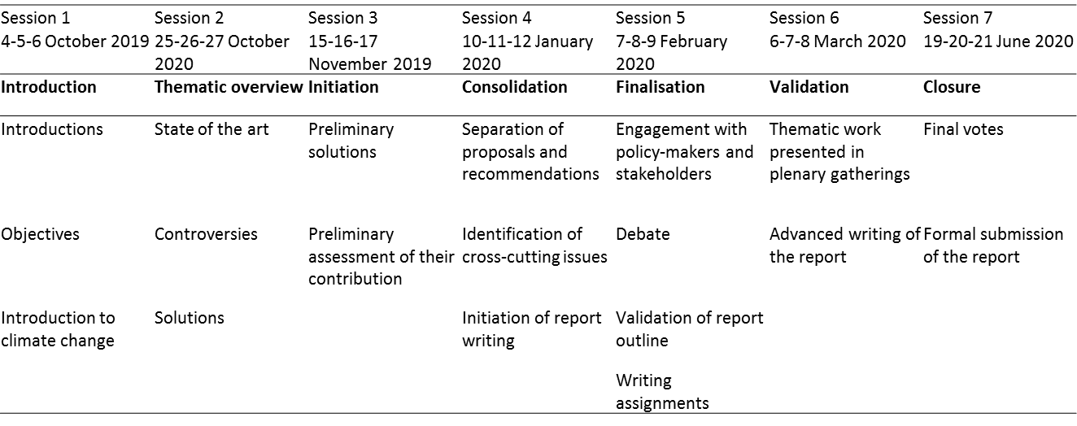

The publicity of the CCC was relatively open. The media were given extensive access to the CCC’s gatherings and proceedings. The citizens had their anonymity (i.e., their surnames) preserved by default but they were free to go public on social or traditional media. They were also encouraged by the organizers to reach out to their local community between sessions and meet with various stakeholders such as businesses, unions, members of parliament and local elected representatives. While some plenary gatherings were broadcast on YouTube, the Governance Committee decided that group deliberations and the drafting proposals were kept confidential from Session 6 onwards in an effort to prevent external influences from impinging on the content of the measures.

At different points in the process, plenary meetings were organized between the citizens and the highest executives of the French State – the Minister of the Ecological and Inclusive Transition (Session 1), the Prime Minister (Session 1) and the President of the Republic (Session 4) – to clarify their mutual expectations.

## Outcome

The first voting phase resulted in all blocks of measures being approved but one – a proposal to reduce working time from 35 to 28 hours a week. Other blocks of measures were approved with rates in the 85% to 100% range, save for one block – comprising a lowering of speed limits from 130 km/h to 110 km/h on motorways – which was only approved by 60% of the votes cast. Vote results are summarized in Figure 1. Altogether, 149 measures from 43 blocks were approved. In the second voting phase, participants approved two constitutional reforms – rephrasing the Preamble and Article 1 of the Constitution – and recognition of the crime of ecocide be proposed for referendum. Meanwhile, a majority voted against a subset of their technical measures deemed legally fit be proposed for referendum.

Most of the measures proposed by the CCC are national in scope. Yet other relevant dimensions of the problem were also considered. On the one hand, a number of measures on agriculture, land-use, and public transportation were differentiated at the local level to take into account stronger vulnerability to climate change, in particular in overseas territories. On the other hand, the citizens made recommendations for France’s foreign policy in relation to climate action, in particular by recommending that negotiations over trade agreements (in particular, Comprehensive Economic and Trade Agreement with Canada) be paused so environmental conditions could be added.

Whether the measures will lead to a reduction of France’s GHG emissions by 40% by 2030 had not been comprehensively assessed at the time of voting. Only rough estimates of the impact (low, medium, high) of each measure were provided to the participants, with no assessment of their combined impact (Table 3). These estimates were put together by the technical advisory group and shared with the citizens only days before the final vote was held. Likewise, the degree to which the measures met the social justice imperative was not systematically assessed. Yet most of the proposed incentive programs were designed in a way that provided extra-benefits to low-income households. In contrast to GHG emissions estimates, the financial cost of a few measures deemed most impactful was assessed earlier in the process, and in more detail. The technical advisory group estimated four blocks of measures to be most impactful, each with an annual public cost exceeding €1 billion. These included: an obligation to retrofit energy inefficient dwellings, increasing fuel efficiency standards, encouraging the development of rail transport, and putting restrictions on air travel. Taken together, the 146 measures would require €6 billion every year in public spending (I4CE, 2020).

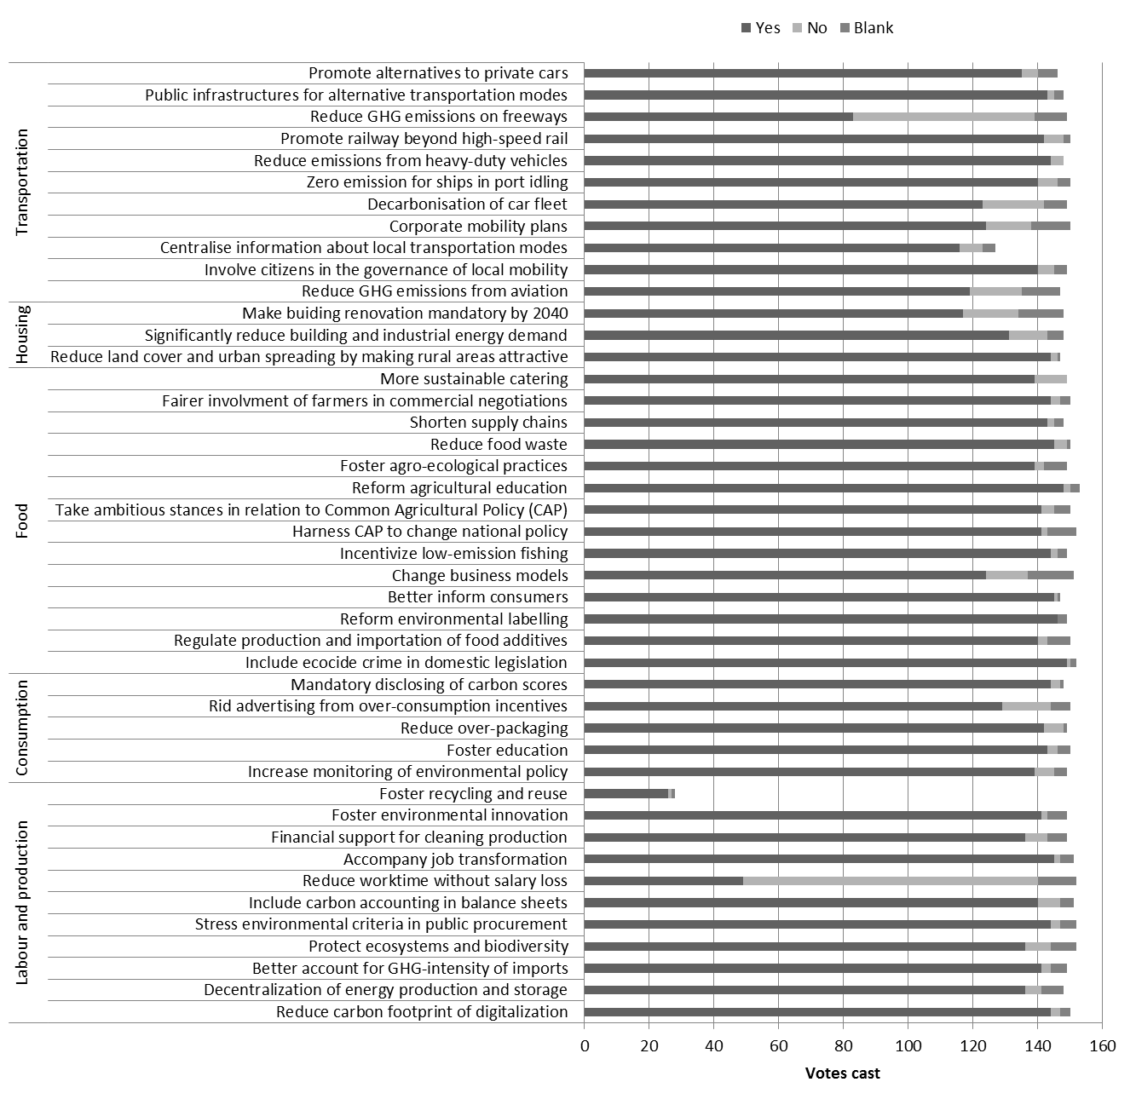

Figure 2: Approval of the 44 blocks of measures. Source: Governance Committee of the CCC

## Follow-up

A week after the final session, President Macron hosted a public meeting with the citizens at the Elysée Palace.[9] He committed to supporting 146 of the 149 proposed measures, invoking three “trump cards” (*jokers*) to reject the following measures: changing the Preamble of the Constitution, arguing it threatened to place the protection of Nature above all liberties; imposing a 4% tax on corporate dividends to finance climate action, arguing it would be too damaging for France’s competitiveness; and reducing speed limits on motorways, arguing he had made a similar mistake in the past, thus referring to one of the measures that sparked the Gilets Jaunes movement.[10]

In the Fall of 2020, the government started taking forward the Conventions’ proposals, which included implementing decrees, passing new bills and organizing the only referendum that had not been vetoed by the President – changing Article 1 of the Constitution.[11] The government drafted an all-encompassing bill reworking the CCC’s proposal. Several meetings were organized to share this work with the members of the CCC throughout its elaboration, one meeting even involving the President of the Republic in December 2020. The draft bill was submitted by the government on February 10th, 2021. It was accompanied by an impact assessment study estimating that, if enacted, the measures would allow reaching between a half and two thirds of the target (Assemblée nationale, 2021). The High Council on Climate later pointed to limitations in this assessment, which, taken together, led to an overestimated impact (HCC, 2021).

Later in February 2021, the citizens were summoned for an eighth and last three-day session to evaluate the government’s response to their proposals, as the Prime Minister’s letter had recommended (see Appendix C). They were first provided feedback from the CCC’s technical and legal advisory groups on whether and how accurately their measures had been followed up on. In a series of 58 votes, they were then asked to give feedback (on a 0-10 scale) on their appraisal of the whole process and government’s follow-up. As Table 3 illustrates, they judged the outcome severely (Q1 and Q2), with scores in the 2-3 range. In Q1 as well as in many other measures-by-measures votes (not disclosed here; see CCC, 2021), a block of about 20 ballots systematically gave the lowest grade (0), whatever the strength of follow-up that had been assessed by the advisory groups, which suggests that some citizens strategically voted to express strong disapproval. In contrast, the citizens expressed positive feelings about citizens’ assemblies in general (Q3 and Q4).

Table 3: Voting results on four general questions

|  |  |  |  |  |  |  |  |
| --- | --- | --- | --- | --- | --- | --- | --- |
|  | Registered | Null | Blank | Counted | Average grade | Median grade | Standard error |
| What is your feeling about the government's follow-up on the Convention's proposals? | 123 | 25 | 2 | 96 | 3.3 | 3 | 2.6 |
| To which extent does the government's follow-up on the Convention's proposals permit attainment of the 40% GHG emissions reduction target in a spirit of social justice? | 123 | 25 | 6 | 92 | 2.5 | 2 | 2.4 |
| To which extent did the Convention contribute to climate change mitigation in France? | 123 | 24 | 15 | 84 | 6.0 | 7 | 2.7 |
| In your opinion, can citizens' assemblies improve democratic life in our country? | 123 | 23 | 2 | 98 | 7.6 | 8 | 2.3 |

After this eigth session, the bill was debated in Parliament for several weeks in the Spring, generating over 7,000 amendment proposals in the National Assembly – a high number by the Assembly’s standards. The Senate and the National Assembly agreed on a final bill on July 20th. Meanwhile, the President did not obtain the congressional support he needed to organize the referendum on changing the Constitution, thus failing to follow up on this measure. At this stage, many decrees remain to be passed for the law to come into force.

Meanwhile, the participants to the CCC have created a non-profit organization with the goal of monitoring follow-up on their recommendations in the long term (*Les 150. L’association des Citoyens de la Convention Climat*). Around a dozen citizens from the Convention have risen to prominence in the public arena, owing to their activity on social media or repeated appearance in the traditional media, one even publishing a book about his own experience (Fraty, 2021). At least 6 citizens have joined some of the leading political parties and made it public. Some of them and a few others are now in office after having won elections at different levels – regional, municipal and European.

# Co-construction and the framing of deliberation

A naïve interpretation of the notion of co-construction in relation to citizens’ assemblies suggests that the citizens worked together with other bodies. In the context of the CCC, there were many candidates for such interactions – the governance committee, the college of guarantors, the technical and legal advisory groups and the facilitators, which we collectively refer to as the steering bodies. We examine here the framing effects these bodies might have exerted on the citizens in agenda setting, proposals elaboration and decision making.

## Agenda-setting

The task of setting the agenda was handed by the Prime Minister to the governance committee. Perhaps its most important intervention in this regard was in framing the five thematic groups in a way that emphasized energy demand, leaving energy supply issues – and in particular the role nuclear power should play in electricity generation – mostly unaddressed.[12] Yet the agenda was not unilaterally set by the governance committee, as the citizens intervened on two important occasions to adjust it.

The first adjustment occurred when some citizens opposed that the carbon tax be part of the agenda. The issue had been sensitive from the beginning, as the carbon tax was widely regarded as the spark that had ignited the Gilet jaunes crisis. Important expectations therefore followed as to what the CCC would do of the carbon tax, in particular whether it would keep its rate frozen or resume the planned increase. When surveyed in Session 1, 72 citizens out of 136 respondents (hence at least 45% of the 159 participants) supported an increase in the carbon tax to limit GHG emissions. At the beginning of Session 2, support was still significant, with 111 citizens expressing high approval rates for a tax increase, provided its revenue were used to finance mitigation measures (Figure 3). Then in the course of Session 2, during a plenary session in which economic experts were invited to discuss the pros and cons of the carbon tax, a few citizens vehemently interrupted the discussion, arguing they refused to have to make up for the government’s shortcomings on the carbon tax. After this dramatic episode, the issue was never raised again. Meanwhile, support for the carbon tax dropped. When asked in Session 7 to approve of funding measures from among a menu of 20 options, only 10 out of 63 respondents approved increasing the carbon tax five years from now and 15 approved increasing it now and refunding its proceeds on an income-level basis (Figure 4).[13]

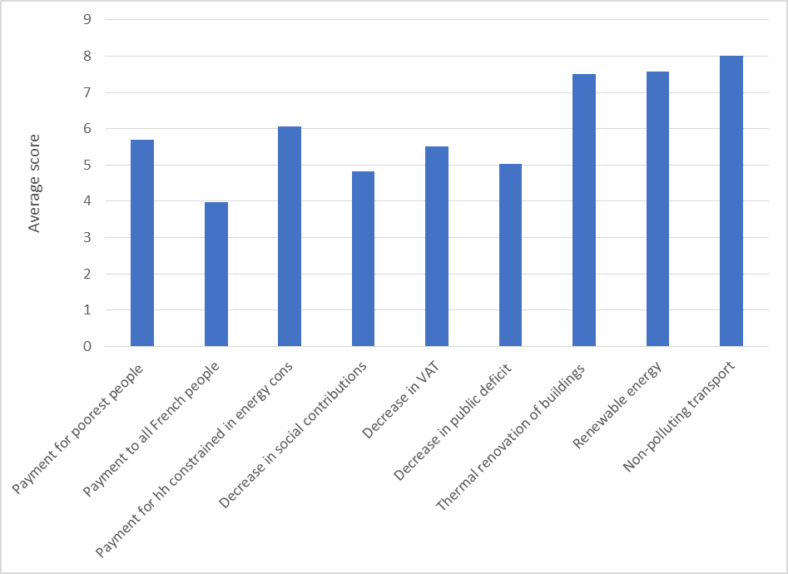

Figure 3: Survey results. Question asked: “To which extent [on a 0-10 scale] would you accept an increase in the carbon tax if the revenue were used to…” Session 2, between 111 and 118 respondents, depending on the options.

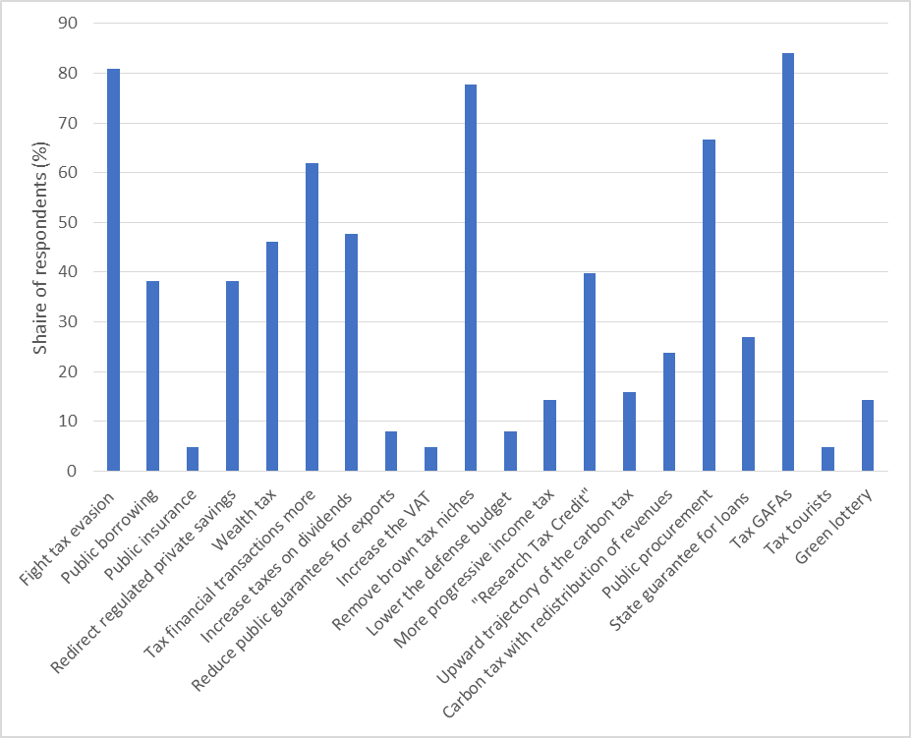

Figure 4: Survey results. Question asked: “Do you support the following option?” Session 7, 63 respondents.

Another adjustment occurred in the way cross-cutting issues were handled. The governance committee had initially planned to create a cross-cutting group on the carbon tax. After the citizens discarded the issue, it shifted the focus of the cross-cutting group on financing issues and constitutional changes. A group called “the squad” (*l’escouade*) was thus formed in Session 3, gathering both voluntary citizens and randomly drawn others, all leaving their home thematic group when deliberating on cross-cutting issues. This raised two major criticisms from non-participating citizens, many of them arguing that cross-cutting issues could not formally be separated from specific ones, and that having members – often the most actively engaged ones – temporarily leave their home group to join the cross-cutting one was weakening the former. To relieve tension, the governance committee terminated the cross-cutting group at the end of Session 4 and scheduled cross-cutting issues to be discussed in plenary sessions.

Table 4: Rough assessment of the impact of each block of measures. Source: CCC (2020)

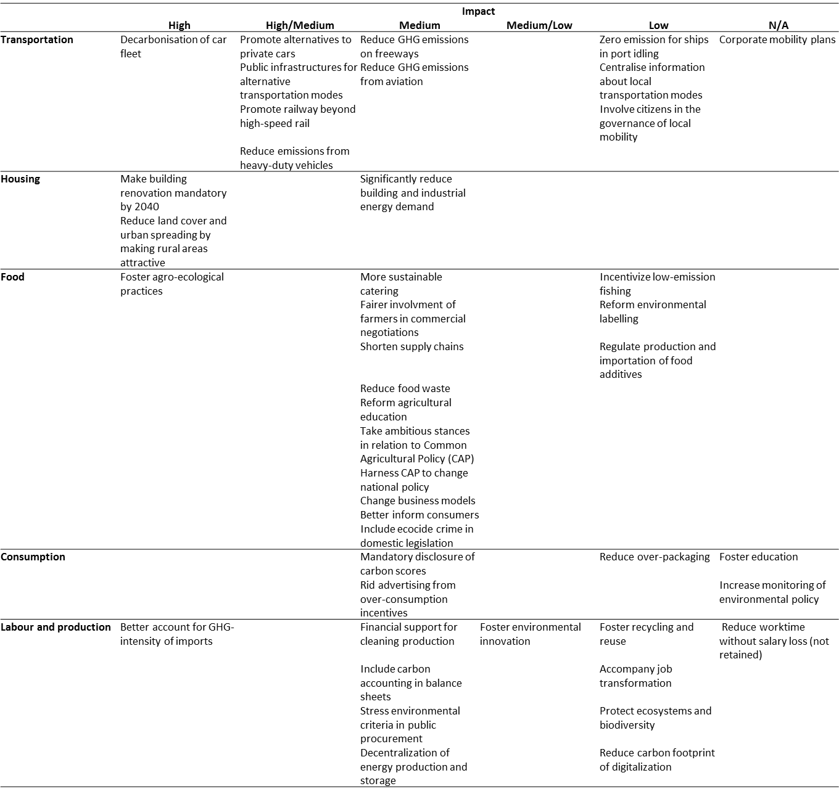

## Proposals elaboration

The CCC asked the citizens to formulate policy proposals, not just to approve of measures from a pre-defined list, as is the case in many other assemblies (OECD, 2020). Furthermore, the proposed measures had to be readily implementable – a counterpart to the President’s “no filter” commitment. These requirements strengthened the need for expert input already inherent in deliberations over climate policy, a particularly wide-ranging and complex issue. The 460-page report submitted by the citizens and the profusion of legal appendices it contains (CCC, 2020) is stark evidence that expert input turned out to be significant. This owes in particular to the contribution of the legal advisory group, a body with no precedent in other citizens’ assemblies, as we have noted before. Was expert input so significant as to diminish the citizens’ creativity and ultimately their role as primary contributor to their proposals? To answer this question, we examine the experts’ contributions in providing background, support and feedback to the citizens.

The background knowledge was provided by external speakers invited by the governance committee. We noted a lack of structure in the way technical information was conveyed to the citizens. Tnot explicitly stated and no clear distinction was made between scholarly expertise and advocacy. When several experts were invited on a specific topic, they were typically given turns to articulate their views, but no opportunity to challenge each other’s evidence.

Support in elaborating the proposals was provided by the experts from the technical and legal advisory groups. The interactions between experts and citizens were sustained in all thematic groups – not without frictions. We witnessed situations in which experts went beyond their role, either unduly pushing for certain measures or discarding others. In some cases, some citizens would complain, and sometimes the facilitators would intervene to make sure the citizens’ views prevailed, but this was not systematic. Moreover, in contrast with most other citizens’ assemblies (OECD, 2020), the steering bodies did not observe strict neutrality. We witnessed for instance one of the Governance Committee’s co-chairs intervene as an expert and some members of the Governance Committee and a Guarantor give their own opinions to the citizens on some measures.

Against these shortcomings, we observed strong demand from citizens for experts’ input and a sincere gratitude toward them. The citizens reacted strongly to the introductory presentations on climate change, many of them publicly expressing in different media how radically it had changed their attitude toward climate change. When asked in Session 7 about the most important sources from which they had formed their opinions, they most frequently mentioned the external experts (92.3%), the experts from the technical advisory group (73.9%) and the documentation made available by the organizers (72.3%) (65 respondents, Figure 5). The citizens further pointed to an important role of the different steering bodies in refining and enabling their proposals, but a limited role in proposing measures they had not already thought of (63 respondents, Table 4).

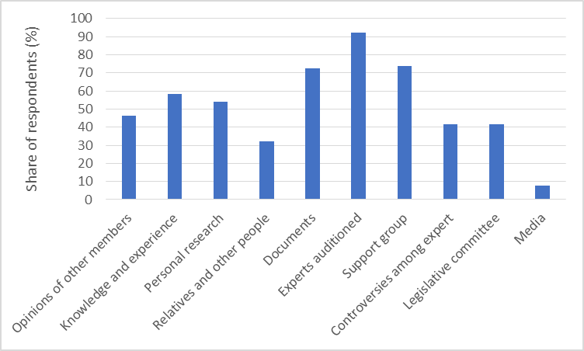

Figure 5: Survey results. Most important sources from which the citizens formed their opinions. Session 7, 65 respondents.

Table 5: Survey results. Citizens’ perception of the role of different bodies. Session 7, 63 respondents.

|  |  |  |  |  |
| --- | --- | --- | --- | --- |
|  | Facilitators | Experts from the legal and technical advisory group | External experts | Governance committee |
| They helped clarify our intentions | 52 | 42 | 48 | 33 |
| They respected our intentions so we could formulate them in the best possible way | 52 | 38 | 22 | 28 |
| They were directly involved in the formulation of intentions and objectives | 21 | 20 | 13 | 5 |
| They proposed measures that the citizens hadn’t thought of | 10 | 16 | 27 | 7 |

As a result of these sustained interactions, o – –

Lastly, albeit significant, expert input did not go as far providing feedback to the citizens on their proposals’ fitness for the 40% GHG emissions reduction target. While this might be a concern from a normative perspective, it can be argued that resources were too limited to produce such an analysis, considering for instance that it typically takes France several governmental officials working full-time for several months to assess the country’s emission pathways.[14]

## Decision-making

The steering bodies designed the deliberation and voting procedures framing the citizens’ decisions. Did their intervention affect the citizens’ freedom of choice?

As for deliberation, we noticed a lack of training given to the citizens in deliberative methods, which includes the prerequisites of listening to others, not interrupting, giving the floor to all, elaborating arguments and avoiding bargaining and coercion (Reber, 2016). Perhaps as a consequence, the debates were sometimes confused, with citizens interrupting one another without intervention from the facilitators. Yet at the same time, the facilitators systematically sought to avoid conflict and favored reaching consensus among citizens over organizing interim votes.[15]

We noted a similar lack of preparation when it comes to voting procedures. Voting rules were communicated to the citizens only in Session 7 Many reacted negatively to the short notice and to the voting-by-block procedure, arguing that voting instead on a measure-by-measure basis would allow them to more finely express their views. Our view is that voting by block effectively contributed to generating high approval rates, making it more difficult for citizens to reject a specific measure without rejecting a whole block.

Despite these shortcomings, we witnessed trust build up among citizens throughout the process, partly as a result of the facilitators’ efforts. When asked in Session 7 to rate their degree of “confidence in the work of the other groups to come up with the best proposals to achieve the objectives of the Convention,” 63 respondents gave a mean grade of 7.79 (standard deviation 1.14) on a 0-10 scale. These results are higher than those expressed by other citizens surveyed in an external survey (Fabre et al., 2021). This provides another explanation for the high approval rates that applied to nearly all measures, despite the fact that participants had been actively involved in the elaboration of only about a fifth of them – those produced by their thematic group.

## Taking stock: The CCC approach to co-construction

The framework of the CCC generated sustained interactions between the citizens and the steering bodies. This resulted in significant framing effects. On the other hand, a flexible planning left significant room for adjustment to the citizens’ concerns. This resulted in a responsive framework that succeeded in creating consensus among citizens. We now examine whether it was so successful as to generate broader support among the general public, perhaps the most crucial challenge in citizens’ assemblies.

# The citizens and the broader public

The design of citizens’ assemblies can affect the two-way relationship between the citizens and the broader public in two ways. First, publicity of a citizens’ assembly generates an indirect connection between the two, the broader public forming beliefs and perceptions about the legitimacy of the citizens’ work. Second, a citizens’ assembly may create a more direct connection with the broader public if it serves as a preparatory device for a referendum. We review here how the co-construction approach taken to the CCC affected these two aspects.

## The citizens’ engagement toward the broader public

The citizens adopted a relatively distant attitude toward the broader public. When asked in Session 1 what best described their role in deliberations, 36% reported to speak for themselves, 22% to speak on behalf of people like them, 21% for particular causes, 19% for the broader public and 3% for other groups and special interests (116 respondents).

This attitude was somewhat echoed by their handling of the referendum issue. Submitting proposals to referendum is one vehicle by which to reach out to the broader public, as the Irish example illustrates. The CCC had a quite original feature in this regard, the Prime Minister’s mandate letter giving the citizens the opportunity to make the call – however subject to the President’s endorsement. Iprominent figures among the governance committee and the college of guarantorsgo for referendaYet in a striking move, the citizens strongly disapproved (with 60%-80% rates) to take that route for their technical proposals – not without having hotly debated the issue shortly before. In turn, they approved to submit constitutional reforms to referendum. Yet unlike with the former, going forward with the latter requires the President to get congressional approval. In other words, from a pure procedural perspective, the citizens agreed to go for the tough referendum, but not for the easy one. In the end, with the recent congressional veto on the proposed referendum, none will be organized. How did the citizens get there?

An argument commonly advanced by opponents to the referendum was that the general public would not be as “enlightened” in their voting as the members of the Convention had become. We note here that, from a normative perspective, such an argument gives support to Lafont (2015)’s concern that a mini-public could be an illegitimate short-cut to the broader public. Another argument was that the broader public would vote for or against the President of the Republic, instead of voting for or against the Convention’s proposals. Some counter-argued that such a voting strategy could be avoided by allowing people to approve of items from a menu of options, instead of approving of a single package.

Yet another widely shared motive for not supporting the referendum was the anxiety many citizens expressed at the prospect of having to campaign for the Convention’s measures in the public debate, were a referendum to be held. Getting involved in this way was resented as well beyond what they had consented to upon accepting to participate in the CCC.

## The broader public’s perception of the citizens’ work

Over the course of the CCC, the citizens’ responses to our survey were compared to those of representative samples of the French population (Fabre et al., 2021). Administered to two distinct samples (N=1,000 each) before (late April-early May) and after (late October-early November) the citizens had submitted their proposals, this external survey generated two important, and somewhat contradictory, insights. On the one hand, support for the CCC’s proposals was found to be broad among the population and stable across the two waves. Specifically, when asked to approve of the candidate measures for referendum, the respondents in the external survey expressed majority support for all the technical measures and for one of the three constitutional changes (Fabre et al., 2021, fig.12). On the other hand, despite lacking awareness of the CCC (22% knew about it in Wave 1, 42% in Wave 2), the respondents expressed strong skepticism (68% in W1, 71% in W2) about the ability of randomly drawn citizens to deliberate productively on complex issues and quite negative feelings about the CCC, primarily considering it “useless as the government will only take back the measures it likes” and “a communication operation of the government.”

## Referendum: A missed opportunity?

These results might together suggest that, had the citizens seized the opportunity given to them to submit their proposals to referendum, the broader public would have approved of them. The citizens’ work would thus have had a much stronger impact on France’s political life (and perhaps on is climate policy) than it did so far. This is however subject to two important caveats. First, as the subsequent experience has showed, nothing guarantees that the President would not have used some “filter” of any sort. Second, nothing guarantees that support among the population would have remained high until the referendum, especially not with the high level of skepticism that transpired among the population. In that regard, the citizens’ fear that the broader public might vote insincerely were not ungrounded and it is interesting to note that about 20 citizens engaged in such insincere voting in Session 8.

The lesson here is that the citizens showed independence in not following the recommendation of some among the steering bodies. There was some tension

# Conclusion

The CCC was the central part of a three-year political sequence that shook France’s climate policy, from the Gilets jaunes crisis to the Grand Nationale Debate to the law bill adapting the CCC’s proposals. Its proceedings were seriously disrupted by a strike movement and a global pandemic. Despite adverse context, the largest experiment to date with climate assemblies produced an outcome rich of 149 measures, some of which could be game changing for France’s climate policy. While the CCC’s work can be said to have created political momentum, owing to the intense parliamentary activity it generated, effective follow-up is actually quite limited – to the citizens’ disappointment. What can we learn from this experience, in light of its specificities?

The CCC was to follow an “innovative approach of co-construction of solutions.” Albeit elliptical, this injunction implied that citizens would be accompanied in their deliberation. While the need for external input can be justified by the complexity inherent in climate issues, the extent to which it can undermine the citizens’ independence is an important concern in citizens’ assemblies. Our analysis provides evidence that the framework developed for the CCC was quite flexible, permitting sustained interactions between the citizens and the steering bodies. This created a subtle balance between framing effects – e.g., in the type of expertise the citizens were exposed to – and responsiveness to the citizens’ concerns – allowing them for instance to adjust the agenda, in particular by dropping the carbon tax issue. This framework proved affective at building consensus among the citizens and trust vis-à-vis the steering bodies, to the point of creating a strange situation in which the citizens ex post express satisfaction with the process, but not with the outcome. The framework, however, did not create the conditions for generating a positive perception of the process among the broader public. Perhaps more strikingly, skepticism from the broader public was somewhat reciprocated by the citizens, who did not submit their proposals to the broader public, despite being given the opportunity to make that call. In other words, the approach taken to “co-construction” succeeded in the narrow sense of bringing closer the citizens and policy-makers, but not in the broader sense of bringing closer the citizens and the broader public.

With climate assemblies mushrooming at the sub-national, national (e.g., in Germany, Spain, Scotland) and European levels, what then should be emulated from the French CCC, and what should not? As for the dos, the responsiveness of the framework helped empower the citizens and keep them engaged even after deliberation was completed. While we view this as a positive outcome, we note that it raises a yet unspoken issue as to the extent to which individual citizens should be kept in the loop in the post-assembly phase.

As for the don’ts, the French CCC lacked a clear commitment structure, such that, despite a co-construction approach, no political uptake occurred among the broader public. While this is a common concern with citizens’ assemblies, the issue took a dramatic turn with the intense personification of the CCC, framed as a “no filter” interaction between the President himself and the citizens. The “no filter” commitment generated widespread comment and, whatever it meant, it can be said to have been defected on by the President on at least two occasions – first by claiming “trump cards,” second by having the government rework the citizens’ proposals before submitting them to Parliament. Ironically, the outcome could have been different had the citizens seize the opportunity to submit their proposals to referendum. Our view here is that a more transparent and outspoken commitment structure as to how the executive might respond to the citizens’ proposals could make the assembly’s mandate more straightforward to both the participating citizens and the general public.

# References

Assemblée Nationale, 2021. Etude d’impact. Projet de loi portant lutte contre le dérèglement climatique et renforcement de la résilience face à ses effets. https://www.assemblee-nationale.fr/dyn/15/textes/l15b3875_etude-impact.pdf

Baber, W., Bartlett, R., 2021. Deliberative Democracy and the Environment 14.

Boulianne, S., 2018. Mini-publics and Public Opinion: Two Survey-Based Experiments. Political Studies 66, 119–136. <https://doi.org/10.1177/0032321717723507>

Brancaccio, F., 2020. Introduction: The Space-Time of the Gilets Jaunes. South Atlantic Quarterly 119, 846–855. <https://doi.org/10.1215/00382876-8663747>

Burnell, P., 2012. Democracy, democratization and climate change: complex relationships. Democratization 19, 813–842. <https://doi.org/10.1080/13510347.2012.709684>

Caluwaerts, D., Reuchamps, M., 2015. Strengthening democracy through bottom-up deliberation: An assessment of the internal legitimacy of the G1000 project. Acta Polit 50, 151–170. <https://doi.org/10.1057/ap.2014.2>

Chambers, S., 2009. Rhetoric and the Public Sphere: Has Deliberative Democracy Abandoned Mass Democracy? Political Theory 37, 323–350. <https://doi.org/10.1177/0090591709332336>

CCC [Convention Citoyenne pour le Climat], 2020. Les propositions de la Convention Citoyenne pour le Climat. <https://propositions.conventioncitoyennepourleclimat.fr/pdf/ccc-rapport-final.pdf>

CCC [Convention Citoyenne pour le Climat], 2021

Courant, D., 2020. Citizens’ Assemblies for Referendums and Constitutional Reforms: Is there an “Irish model” for Deliberative Democracy? Front. Polit. Sci. 2. <https://doi.org/10.3389/fpos.2020.591983>

Devaney, L., Torney, D., Brereton, P., Coleman, M., 2020. Ireland’s Citizens’ Assembly on Climate Change: Lessons for Deliberative Public Engagement and Communication. Environmental Communication 14, 141–146. <https://doi.org/10.1080/17524032.2019.1708429>

Dryzek, J.S., 2009. Democratization as Deliberative Capacity Building. Comparative Political Studies 42, 1379–1402. <https://doi.org/10.1177/0010414009332129>

Dryzek, J.S., Bächtiger, A., Chambers, S., Cohen, J., Druckman, J.N., Felicetti, A., Fishkin, J.S., Farrell, D.M., Fung, A., Gutmann, A., Landemore, H., Mansbridge, J., Marien, S., Neblo, M.A., Niemeyer, S., Setälä, M., Slothuus, R., Suiter, J., Thompson, D., Warren, M.E., 2019. The crisis of democracy and the science of deliberation. Science 363, 1144–1146. <https://doi.org/10.1126/science.aaw2694>

Dryzek, J.S., Stevenson, H., 2011. Global democracy and earth system governance. Ecological Economics, Special Section - Earth System Governance: Accountability and Legitimacy 70, 1865–1874. https://doi.org/10.1016/j.ecolecon.2011.01.021

Fabre, A., Apouey, B., Douenne, T., Fourniau, J.-M., Giraudet, L.-G., Laslier, J.-F., Tournus, S., 2021. Who Are the Citizens of the French Convention for Climate? https://halshs.archives-ouvertes.fr/halshs-03265053

Farrell, D.M., Suiter, J., Harris, C., 2019. ‘Systematizing’ constitutional deliberation: the 2016–18 citizens’ assembly in Ireland. Irish Political Studies 34, 113–123. <https://doi.org/10.1080/07907184.2018.1534832>

Fishkin, J., 2016. Deliberative Democracy, in: Emerging Trends in the Social and Behavioral Sciences. American Cancer Society, pp. 1–16. <https://doi.org/10.1002/9781118900772.etrds0405>

Fournier, P., Kolk, H. van der, Carty, R.K., Blais, A., Rose, J., 2011. When Citizens Decide: Lessons from Citizen Assemblies on Electoral Reform. Oxford University Press.

Fraty, G., 2021. Moi citoyen, L’aventure de la Convention citoyenne pour le climat vue de l’intérieur: L’aventure de la convention citoyenne pour le climat vue de l’intérieur. edi8.

Gastil, J., Rosenzweig, E., Knobloch, K.R., Brinker, D., 2016. Does the public want mini-publics? Voter responses to the Citizens’ Initiative Review. Communication and the Public 1, 174–192. <https://doi.org/10.1177/2057047316648329>

Goodin, R.E., Dryzek, J.S., 2006. Deliberative Impacts: The Macro-Political Uptake of Mini-Publics. Politics & Society 34, 219–244. <https://doi.org/10.1177/0032329206288152>

Goold, S.D., Neblo, M.A., Kim, S.Y.H., Vries, R.D., Rowe, G., Muhlberger, P., 2012. What Is Good Public Deliberation? Hastings Center Report 42, 24–26. <https://doi.org/10.1002/hast.29>

Hendriks, C.M., 2006. When the Forum Meets Interest Politics: Strategic Uses of Public Deliberation. Politics & Society 34, 571–602. <https://doi.org/10.1177/0032329206293641>

I4CE, 2020. Convention citoyenne: une ambition climat réhaussée, un coût raisonné. <https://www.i4ce.org/convention-citoyenne-une-ambition-climat-rehaussee-un-cout-raisonne/>

Ingham, S., Levin, I., 2018. Effects of Deliberative Minipublics on Public Opinion: Experimental Evidence from a Survey on Social Security Reform. International Journal of Public Opinion Research 30, 51–78. <https://doi.org/10.1093/ijpor/edw030>

Lafont, C., 2015. Deliberation, Participation, and Democratic Legitimacy: Should Deliberative Mini-publics Shape Public Policy?: Deliberation, Participation & Democratic Legitimacy. J Polit Philos 23, 40–63. <https://doi.org/10.1111/jopp.12031>

Landemore, H., 2018. Referendums Are Never Merely Referendums: On the Need to Make Popular Vote Processes More Deliberative. Swiss Political Science Review 24, 320–327. <https://doi.org/10.1111/spsr.12314>

MacKenzie, M.K., Warren, M.E., 2012. Two trust-based uses of minipublics in democratic systems. Deliberative systems: Deliberative democracy at the large scale 95–124.

Mansbridge, J., Bohman, J., Chambers, S., Christiano, T., Fung, A., Parkinson, J., Thompson, D., Warren, M., 2012. A systemic approach to deliberative democracy, in: Deliberative Systems. pp. 1–26. https://doi.org/10.1017/CBO9781139178914.002

Neblo, M.A., Esterling, K.M., Kennedy, R.P., Lazer, D.M.J., Sokhey, A.E., 2010. Who Wants To Deliberate—And Why? American Political Science Review 104, 566–583. <https://doi.org/10.1017/S0003055410000298>

Niemeyer, S., 2013. Democracy and Climate Change: What Can Deliberative Democracy Contribute? Australian Journal of Politics & History 59, 429–448. <https://doi.org/10.1111/ajph.12025>

Parkinson, J., 2020. The Roles of Referendums in Deliberative Systems. Representation 56, 485–500. <https://doi.org/10.1080/00344893.2020.1718195>

Paulis, E., Pilet, J.-B., Panel, S., Vittori, D., Close, C., 2020. The POLITICIZE dataset: an inventory of deliberative mini-publics (DMPs) in Europe. Eur Polit Sci. <https://doi.org/10.1057/s41304-020-00284-9>

OECD, 2020

Reber, B., 2016. Precautionary Principle, Pluralism and Deliberation: Science and Ethics. ISTE and John Wiley & Sons, Ltd. <https://doi.org/10.1002/9781119335931.fmatter>

Setälä, M., 2017. Connecting deliberative mini-publics to representative decision making. European Journal of Political Research 56, 846–863. https://doi.org/10.1111/1475-6765.12207

Setälä, M., 2011. The Role of Deliberative Mini-Publics in Representative Democracy: Lessons from the Experience of Referendums. Representation 47, 201–213. <https://doi.org/10.1080/00344893.2011.581080>

Smith, G., 2009. Democratic Innovations: Designing Institutions for Citizen Participation, Theories of Institutional Design. Cambridge University Press, Cambridge. <https://doi.org/10.1017/CBO9780511609848>

Suiter, J., Muradova, L., Gastil, J., Farrell, D.M., 2020. Scaling up Deliberation: Testing the Potential of Mini-Publics to Enhance the Deliberative Capacity of Citizens. Swiss Political Science Review 26, 253–272. <https://doi.org/10.1111/spsr.12405>

Suiter, J., Reidy, T., 2020. Does Deliberation Help Deliver Informed Electorates: Evidence from Irish Referendum Votes. Representation 56, 539–557. <https://doi.org/10.1080/00344893.2019.1704848>

Nature, 2018. Wanted: a fair carbon tax. Editorial. Nature 564, 161. <https://doi.org/10.1038/d41586-018-07717-y>

Warren, M.E., Pearse, H., 2008. Designing Deliberative Democracy: The British Columbia Citizens’ Assembly. Cambridge University Press.

Warren, M.E., Gastil, J., 2015. Can Deliberative Minipublics Address the Cognitive Challenges of Democratic Citizenship? The Journal of Politics 77, 562–574. https://doi.org/10.1086/680078

# Appendix A: Observation charter

*The charter was translated with* [*www.DeepL.com/Translator*](http://www.DeepL.com/Translator)*, with only minor edits by the authors.*

The Citizens’ Convention for Climate is an unprecedented event in French democratic life and a crucial moment for the orientation of climate policies. The Governance Committee wishes to facilitate access to research teams who want to make direct observations of its proceedings and produce data useful for various research works. The resulting observation, analysis and critique will be valuable in order to draw lessons for the future from this original exercise in deliberative democracy.

At the invitation of the Governance Committee, various French and foreign researchers and doctoral students, as well as participation practitioners have expressed their interest in observing the deliberations of the Citizens’ Convention and studying its proceedings for research purposes. The Committee will be careful to coordinate the planned work and will ensure the diversity and plurality of approaches proposed by the researchers. To this end, the Governance Committee deems it necessary to come up with a single common questionnaire proposed to the participants. It wishes to define by mutual agreement a framework for the presence of observers that does not disrupt the smooth running of the Citizens’ Convention and, above all, the work of the citizens.

The Governance Committee asks the observers to respect the following rules and guidance for the relations they will establish during their observations of the Citizens’ Convention.

In order to fully understand how the Citizens’ Convention will unfold and the facilitation protocol that will be used, the Governance Committee invites them to attend a presentation with the facilitators that will take place on Friday, October 4 at 11:00 a.m. at the CESE.

***Relations and exchanges with the Governance Committee and the facilitators***

Observers are requested to identify themselves to the Convention’s chief facilitators at its first working session on Friday, 4 October, upon arrival in the Convention room.

At the opening of each session of the Citizens’ Convention, the main moderator will inform the participants of the presence of observers (role and nature), except in those moments when a closed session seems necessary for the smooth running of the session.

The total number of observers who may take part in a session is limited to one person per table during group work, i.e., 20 people in plenary session.

***Relations and exchanges with participants during the work of the Citizens’ Convention tables***

In order not to disrupt the work of the citizens during the table deliberations, only one observer will be allowed to attend their discussions.

He or she will have to introduce him or herself to the table participants and indicate whether he or she wishes to make an audio recording of the proceedings. The participants are free to refuse him or her access or the recording of their comments.

Above all, he or she must respect the dynamics of each table, without interfering in any way in the exchanges between the participants during all working hours. His or her presence will remain discreet and mute.

He or she will have to adopt a neutral stance in all his or her exchanges with the participants with regard to the Citizens’ Convention and the issues being discussed, so as not to influence them.

During breaks or lunch, observers will be able to freely exchange with participants, maintaining a neutral stance and taking care not to take them away from the group for more than a few minutes, for which informal collective moments are important. For this reason, observers will not be able to participate in dinners with citizens.

***Questionnaires to participants and personal data***

In order not to overly solicit citizens, only one anonymous questionnaire may be submitted to participants at the beginning and one at the end of each session of the Citizens’ Convention. Each questionnaire should not exceed 15 minutes in order to fit easily into the planned facilitation process. The wish to submit these questionnaires will be communicated to the participants at the opening of each session. The facilitators will encourage them to answer them on a voluntary basis. Before each session of the Citizens’ Convention, the questionnaires to be submitted at the beginning and end of the session will be sent to the Governance Committee for information. The database containing the questionnaires at the end of the Citizens’ Convention will be made available to all research teams wishing to analyse them.

Personal data may be requested from participants during the last session of the Citizens’ Convention, for the purpose of interviews to be conducted with consenting persons after the end of the Convention. The collection of this data can only be done with the person’s written and informed consent. Observers will forward the planned informed consent form to the Governance Committee prior to its release. The database collecting these personal data will be kept by the CESE and may be made available to teams who justify the need for it for research purposes.

***Relations and exchanges with the media***

Observers may respond to the media if questioned. However, the Governance Committee asks them not to do so during the sessions of the Citizens’ Convention, so as not to disrupt the work of the Convention. It also asks them to maintain a neutral stance throughout the Citizens’ Convention with regard to its proceedings and the issues addressed. The Governance Committee reserves the right to exclude any observer who does not comply with the rules set out in this charter, or whose behavior in any way disrupts the proceedings of the Convention.

# Appendix B: Presidential announcement of the CCC

*This is an extract of the press conference President Macron gave on April 25th, 2019 in closing the Grand National Debate. The text is fully available at:* [*https://www.elysee.fr/emmanuel-macron/2019/04/25/conference-de-presse-grand-debat-national*](https://www.elysee.fr/emmanuel-macron/2019/04/25/conference-de-presse-grand-debat-national)*. The extract was primarily translated with www.DeepL.com/Translator, with minor by the authors. We emphasize the elements that are discussed in the paper.*

The first of these transitions, the most urgent, the most imperative, is obviously the climate. The climate must be at the heart of the national and European project. The climate emergency is here, our youth are telling us so at every moment and our fellow citizens want to act. They are already taking action on a daily basis, they want us to help them go further, to accompany them, to help them find concrete solutions, but there is a citizen's awareness of these issues that has been profoundly transformed in recent years and is moving much faster than many public policies. So a lot has been done in the last two years, I can come back to this when answering your questions. Next week we will go further in terms of energy policy and in the coming weeks in terms of circular economy to fight against all forms of waste. But I want us to be able to change our method more strongly to respond more concretely and radically to expectations. **Changing the method means first of all using more collective intelligence on this subject. We have many solutions, I have often said, but they are often too complex for our citizens, not used, not well known, not well adapted, whether it is the help to change the boiler, to change the vehicle, it is improving but finally there is much to do. This is why the first mission of the citizens' convention, 150 citizens drawn by lot in June, will be to work on this subject, to redesign all the concrete measures of aid to citizens on the climate transition in the field of transport, housing renovation (whether insulation or heating) to make them more efficient, to define if necessary other incentives or constraints and, if necessary, to define additional resources and propose funding to do so. What comes out of this convention, I pledge, will be submitted without filter either to a vote in parliament or to a referendum or to direct regulatory application.** And then the second change in method is that I want us to set up an ecological defense council that will bring together the Prime Minister, the main ministers in charge of this transition, and the major State operators, which I will chair on a regular basis in order to both make strategic choices and put this climate emergency at the heart of all our policies, and to ensure that it is followed up in all ministerial changes when a direction is taken. Finally, the success of this transition will be ensured in all ministerial changes when a direction is taken. Finally, the success of this transition depends on our European ambition, i.e. our ability to defend a minimum carbon price at the European level, a carbon tax at the borders and a more ambitious green finance. I can also come back to this if you have any questions.

# Appendix C: Prime Minister’s mandate letter

*The mandate letter was addressed by Prime Minister Edouard Philippe to Head of CESE Patrick Bernasconi on July 2nd, 2019. It is reproduced in full here. The translation primarily used* [*www.DeepL.com/Translator*](http://www.DeepL.com/Translator)*, with minor edits added by the authors. We emphasize some of the key elements discussed in the paper.*

Mr. President,

The yellow vests crisis, the success of the Grandeat National Debate, the numerous signatories of the petition known as the “Case of the century,” the mobilization of the youth, demonstrate the desire of many of our fellow citizens to participate more closely in the development of public policies, starting with environmental policies.

On April 25, the President of the Republic announced the creation of a citizens' convention to respond to the dual demand for more participation and more ecology expressed by the French. Its purpose is to involve the whole society in the ecological transition, through a representative sample of citizens, and to mobilize collective intelligence to move from consensus on the diagnosis to compromise on solutions, and to initiate a profound transformation of our lifestyles. In addition to the High Council for the Climate and the Ecological Defense Council, it represents a change in method and governance to accelerate the ecological transition.

The convention will be composed of 150 citizens chosen by lot and representative of the diversity of society. Its mandate will be to define structuring measures to achieve, in a spirit of social justice, a reduction of greenhouse gas emissions of at least 40% by 2030 compared to 1990. At the end of its work, the Convention will publicly submit a report to the Government and the President of the Republic on its discussions, as well as all of the legislative and regulatory measures that it deems necessary to achieve the objective of reducing greenhouse gas emissions. **It may designate, among the legislative measures, those it deems appropriate to submit to a referendum.** The government will respond publicly to the proposals made by the Citizens' Convention and will publish a provisional timetable for the implementation of these proposals. **The Convention will be able, if necessary and if it wishes, to express an opinion on the government's responses.**

**I would like the Economic, Social and Environmental Council to organize the work of this citizens' convention by setting up a governance committee bringing together the Ministry of Ecological Transition and Solidarity, personalities qualified in the field of ecology, participatory democracy and economic and social issues, and representatives of the Citizens' Convention who will be appointed later.**

**This committee will have autonomy of decision in the accomplishment of its missions which will be the following: to ensure the steering of the convention, to support it in setting up the agenda, to supervise its implementation, to define its rules of procedure and its working methods. Finally, technical and legal support will be provided to ensure the legal transcription of the proposals.**

In order to allow the organization of the first meeting of the Citizens' Convention by mid-September at the latest, the governance committee will have to define the modalities of the drawing of lots and all the points necessary for its launch by mid-July at the latest.

To guarantee the independence of the Convention, **a college of guarantors will also be appointed: it will ensure that the work of the Convention is carried out in accordance with the principles of impartiality and sincerity**. I propose that you, the President of the Senate and the President of the Economic, Social and Environmental Council each appoint a guarantor.

**This innovative procedure of co-construction of** **solutions** is a process to which the President of the Republic attaches a determining importance in order to accelerate the ecological transition, which is a priority of the governmental action. I know that I can count on your involvement and that of the whole of organized civil society represented within the EESC, which you chair, to carry out this important mission.

Please accept, Mr. President, the assurance of my best wishes.

1. The second most significant example is the United Kingdom’s Climate Assembly (CAUK). Ireland also held a climate assembly in 2016 (Devaney et al., 2020).
2.
3. https://www.conventioncitoyennepourleclimat.fr/chercheurs-observateurs/
4. This is also known as the input-throughput-output framework (Caluwaerts and Reuchamps, 2015; Courant, 2020).
5.
6. Note that adaptation to climate change was not within the scope defined by the engagement letter. As it turns out, adaptation issues were effectively left unaddressed. The CESE represents civil society in the third Assembly of the Republic, alongside the National Assembly and the Senate. It is a Constitutional Assembly which advises the Executive on legislation. Its members include non-governmental organizations, unions, business representatives and students.
7. In December 2020, EU member states agreed to tighten this target to 55%.
8. The protection of the environment was deemed important with an average score of 8.95 (on a 0-10 scale) by the CCC participants, versus 7.87 in the population.
9. https://www.elysee.fr/front/pdf/elysee-module-15714-fr.pdf
10. Despite claiming to play only three “trump cards,” the President effectively rejected more measures. While the citizens proposed to ban domestic flights when a train alternative of less than four hours was available, he lowered this threshold to two and a half hours. He also rejected organizing a referendum on the recognition of the ecocide crime, a measure he nevertheless committed to re-work with the government and push at the European level.
11. The citizens recommended that the following part be added: “The Republic guarantees the preservation of biodiversity and the environment and fights against climate change.”
12. The issue was deemed settled by the Governance Committee, due to the fact that nuclear power already significantly contributes to France’s relatively low GHG emissions.
13. If we focus on the 40 citizens that answered both this question and the one asked in Session 1, the decline is confirmed, with 19 supporting the carbon tax in Session 1 and only 7 and 11 supporting the two carbon tax options in Session 7.
14. By citizens’ assemblies standards, the budget of the CCC was already substantial. To put its cost (€5.5. million) in perspective, the budget of the CAUK, its closest counterpart, was only £500,000.
15. On rare occasions, citizens’ opinions were sought by show of hands, which does not preserve anonymity and thus threatens sincere voting.