Title: International Attitudes Toward Global Policies

**Authors:** Adrien Fabre1,2*, Thomas Douenne3, Linus Mattauch4,5,6

**Affiliations:** 1Centre National de la Recherche Scientifique; Paris, France.

2Centre International de Recherches sur l’Environnement et le Développement; Nogent-sur-Marne, France.

3University of Amsterdam; Amsterdam, Netherlands.

4Technical University Berlin; Berlin, Germany.

5Potsdam Institute for Climate Impact Research; Potsdam, Germany.

6University of Oxford; Oxford, United Kingdom.

*Corresponding author. Email: [adrien.fabre@cnrs.fr](mailto:adrien.fabre@cnrs.fr).

**Abstract:** Major climate mitigation and climate justice objectives could be achieved by global approaches, yet evidence on the support for global policies is scarce. Using surveys over 48,000 respondents from 20 countries, we find strong support for an effective way to jointly combat climate change and poverty: a global carbon price funding a global basic income, called the “Global Climate Scheme” (GCS). Using different experiments, we show that the support for the GCS is sincere and that electoral candidates could win votes by endorsing it. We document widespread support for other global redistribution policies, such as a wealth tax funding low-income countries. Our findings indicate that global policies are genuinely supported by majorities of the population, even in wealthy nations that would bear the burden.

**Main Text:**

Major climate and sustainability objectives could be achieved by global cooperation policies involving transfers from high- to lower-income countries.*1–7* We examine a key condition for climate justice: the support of citizens for globally redistributive policies, studied only by scant prior attitudinal surveys.*8–11* Using surveys over 40,000 respondents from 20 high- and middle-income countries, we document substantial support for global policies.

To gain insights into the factors shaping public support for global policies in high-income countries, we conduct complementary surveys among 8,000 respondents from France, Germany, Spain, the U.S., and the UK. The focus of our approach is a specific policy aimed at addressing both climate change and poverty, referred to as the “Global Climate Scheme” (GCS). It implements a cap on carbon emissions to limit global warming below 2°C. The emission rights are auctioned each year to polluting firms and fund a global basic income, alleviating extreme poverty. The GCS is supported by three quarters of Europeans and half of Americans. We test whether support of the expressed preference is sincere: a list experiment shows no evidence of social desirability bias in survey responses, majorities are willing to sign a real-stake petition, and global redistribution ranks high in the prioritization of policies. Conjoint analyses reveal that a political platform is more likely to be preferred if it contains the GCS or a global tax on millionaires. In sum, our findings indicate that global redistributive policies are genuinely supported by a majority of the population.

**Results**

***Data***

We assess the stated support for different global policies in a survey on climate attitudes conducted in 2021 on 40,680 respondents from 20 countries. The questions on national policies are analyzed in another paper.*9*

To test the strength and sincerity of the support for global policies, we conduct complementary surveys in the U.S. and Europe in 2023. The U.S. survey has been divided in two waves, with respectively 3,000 and 2,000 respondents. The European questionnaire combines the two U.S. ones. It was conducted on 3,000 respondents representative of France, Germany, Spain, and the UK.

The surveys are administrated online. The samples are representative along the dimensions of gender, income, age, highest diploma, region, and degree of urbanization.

Supplementary Materials include methods, a comprehensive literature review, questionnaires, raw results, representativeness, attrition and balance analyses. The project was preregistered on [osf.io/fy6gd](https://osf.io/fy6gd).

***Stated support for global policies***

*Global support*

The global survey shows strong support for climate policies enacted at the global level (Fig. 1). When asked “At which level(s) do you think public policies to tackle climate change need to be put in place?”, 70% (in the U.S.) to 94% (in Japan) choose the global level.

Three policies (out of four) garner high support across all countries: a global democratic assembly on climate change, a global tax on millionaires funding low-income countries, and a global emissions trading system (or “global quota”). The three policies obtain a majority of absolute support (i.e., “somewhat” or “strong” support) in all countries (except in the U.S. for the global assembly, 48% absolute support). In high-income countries, the global quota obtains 64% absolute support and 84% relative support (i.e., excluding “indifferent” answers).

Following the support for the global quota, respondents are asked about their preferences for dividing the carbon budget among countries. An equal per capita allocation of emission rights emerges as the preferred burden-sharing principle, garnering absolute majority support in all countries and never below 84% relative support. Taking into account historical responsibilities or vulnerability to climate damages is also popular, albeit with less consensus, while grandfathering (i.e., allocation of emission shares in proportion to current emissions) receives the least support in all countries.

A global quota with equal per capita emission rights produces the same distributional outcomes as a global carbon tax that funds a global basic income. The support for such global carbon tax is also tested and its redistributive effects – the average increase in expenditures along with the amount of the basic income – are specified to the respondents explicitly. The support for the carbon tax is lower than for the quota, particularly in high-income countries, and there is no relative majority for the tax in Anglo-Saxon countries. Two possible reasons for this lower support are that distributive effects are made salient in the case of the tax, and that citizens may find a quota more effective than a tax to reduce emissions. This interpretation is consistent with the level of support for the global quota once we make the distributive effects salient, as we do in the complementary surveys.

Fig. 1 Relative support for global climate policies (Percentage of "Somewhat" or "Strongly support" among non-"indifferent" answers, n = 40,680). Source: (9). For absolute support, see fig. S1.   
*In Denmark, France and the U.S., the questions with an asterisk were asked differently.

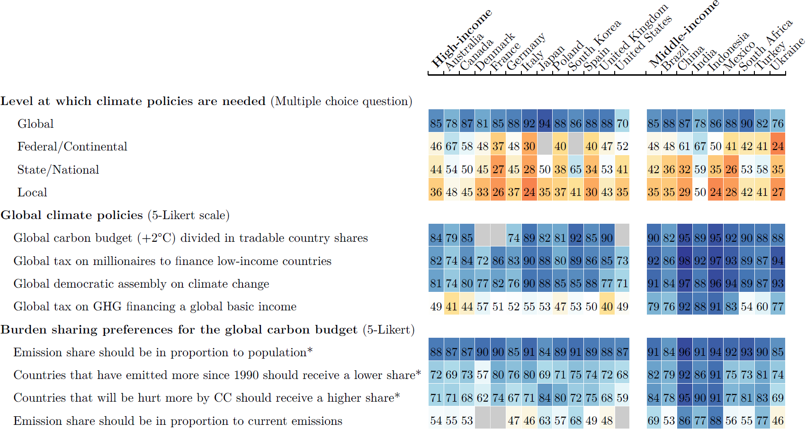

*Global Climate Scheme*

The complementary surveys (*US1*, *US2*, *Eu*) include a comprehensive exploration of citizens’ attitudes toward the GCS. The GCS consists of global emissions trading with emission rights auctioned each year to polluting firms, and of a global basic income of $30/month, funded by the auction revenues. Using incentivized comprehension questions and providing the correct answers afterwards, we make sure that the respondents understand the redistributive effects of the GCS: The 700 million people with less than $2/day would be lifted out of extreme poverty, and fossil fuel price increases would cost the typical person in their country a specified amount. The monthly median net cost is $85 in the U.S., €10 in France, €25 in Germany, €5 in Spain, £20 in the UK. Its estimation relies on the price and emissions trajectories from the Stern-Stiglitz report,12 and in particular a carbon price of $90/tCO2 in 2030.

Respondents are asked to express their support for the GCS using a simple Yes/No question. The stated support for the GCS is 54% in the U.S. and 76% in Europe.

*Global wealth tax*

Consistent with the results of the global survey, a “tax on millionaires of all countries to finance low-income countries” garners absolute majority support of over 67% in each country, only 5 p.p. lower than a national millionaires tax overall (Fig. 2). In random subsamples, we inquire about respondents’ preferences regarding the redistribution of revenues from a global tax on individual wealth. We ask certain respondents (n = 1,283) what percentage of global tax revenues should be pooled to finance low-income countries. In each country, at least 88% of respondents indicate a positive amount, with an average ranging from 30% (Germany) to 36% (U.S., France) (fig. S3). To other respondents (n = 1,233), we inquire whether they would prefer each country to retain all the revenues it collects or that half of the revenues be pooled to finance low-income countries. Approximately half of the respondents opt to allocate half of the tax revenues to low-income countries.

Fig. 2 Relative support for various global policies. (Percentage of "Somewhat" or "Strongly support" among non-"indifferent" answers – *except for the GCS: Share of “Yes” in a simple Yes/No question, n = 8,000). For absolute support, see fig. S2.

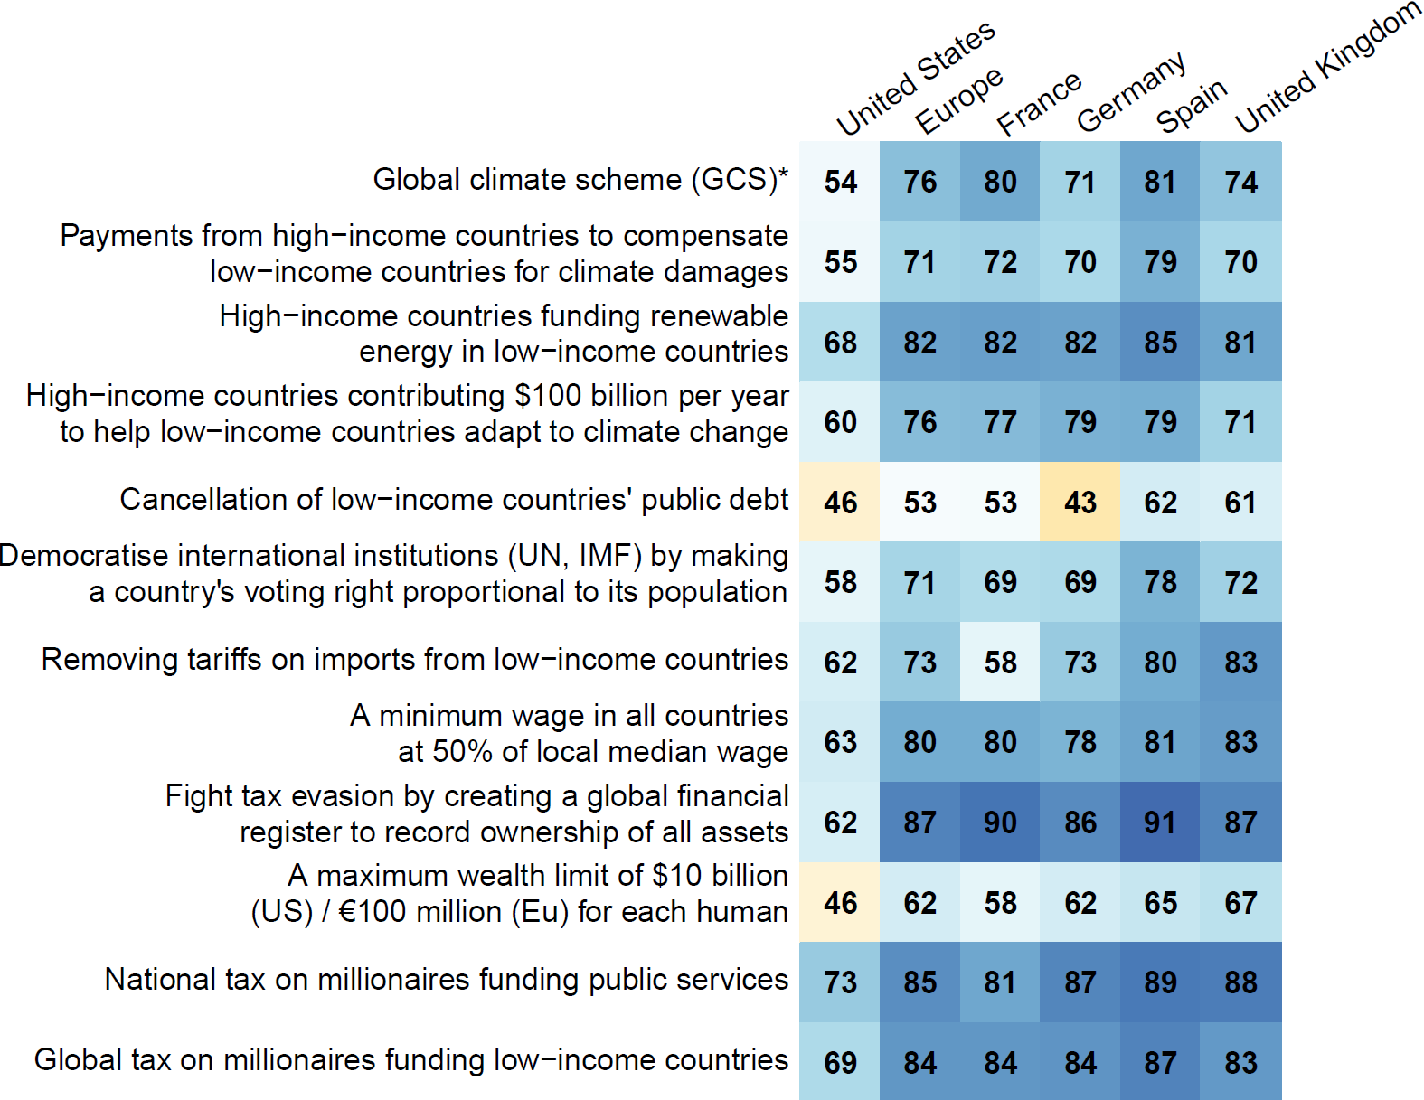

*Other global policies*

Other global redistributive policies garner majority support across all countries (Fig. 2).

*Foreign aid*

We provide respondents with information about the actual amount “spent on foreign aid to reduce poverty in low-income countries” relative to their country’s government spending and GDP. Less than 16% of respondents state that their country’s foreign aid should be reduced, while 62% express support for increasing it, including 17% who support an unconditional increase (fig. S4). Among the 45% who think aid should be increased under certain conditions, we subsequently ask them to specify the conditions they deem necessary (fig. S5). The three most commonly selected conditions are: “we can be sure the aid reaches people in need and money is not diverted” (73% chose this condition), “that recipient countries comply with climate targets and human rights” (67%), and “that other high-income countries also increase their foreign aid” (48%). On the other hand, respondents who do not wish to increase their country’s foreign aid primarily justify their view by prioritizing the well-being of their fellow citizens or by perceiving each country as responsible for its own fate (fig. S6). In response to an open-ended question regarding measures high-income countries should take to fight extreme poverty, a large majority of Americans expressed that more help is needed. The most commonly suggested form of aid is financial support, closely followed by investments in education.

We also inquire about the perceived amount of foreign aid. Most people overestimate the actual amount of foreign aid. We then elicit respondents’ preferred amount of foreign aid, after randomly presenting them with either the actual amount or no information. Most of the respondents who learn the actual amount choose a bracket at least as high as the actual one, and most of those without the information choose a bracket at least as high as the perceived one.

Finally, we ask a last question to the respondents who received the information. To those who prefer an increase of foreign aid, we ask how they would finance it and find that the preferred source of funding is overwhelmingly higher taxes on the wealthiest. To those who prefer a reduction, we ask how they would use the funds becoming available:

In every country, more people choose higher spending on education or healthcare rather than lower taxes.

***Robustness and sincerity of support for the GCS***

We use several methods to assess the sincerity of the support for the GCS. All methods suggest that the support is either completely sincere, or the share of insincere answers is limited.

*List experiment*

By asking *how many* policies within a list respondents support, and adding for some respondents the GCS in the list, we identify the tacit support for that policy. It is not significantly different from the stated support (table S1). Hence, we do not find a social desirability bias: people faithfully report their opinion on the GCS.

*Petition*

In a real-stake question, we ask respondents whether they are willing to sign a petition in support of the GCS, informing them that the results of that question will be sent to the head of state’s office. In the U.S., we find no significant difference between the support in the real-stake petition and the simple question (p = 0.30). In Europe, the petition leads to a lower support (-7 p.p., p=10-5), but the support remains strong, at 69%.

*Conjoint analyses*

To assess the electoral potential of endorsing the GCS, we present to two random branches hypothetical progressive and conservative platforms that differ only by the presence (or not) of the GCS in the progressive platform. Table 1 shows that a progressive candidate would not significantly lose voting share by endorsing the GCS in any country, and may even gain 11 p.p. (p = .005) in voting intention in France and 3 p.p. (p = .13) in the U.S.

Table 1 Preference for a progressive platform depending on whether it includes the Global Climate Scheme.

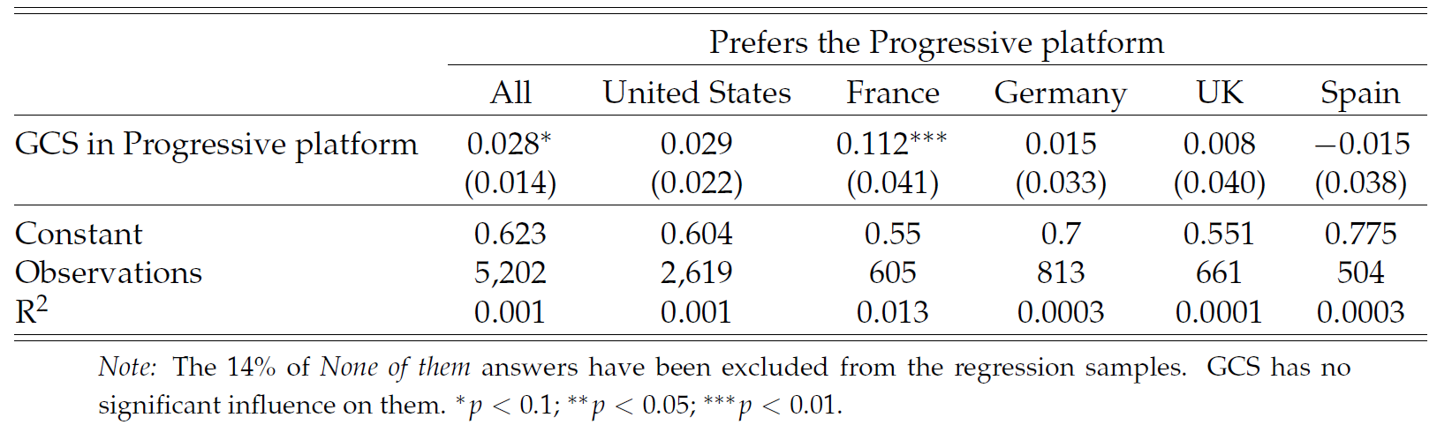

We also make respondents choose between two pairs of random platforms (in the U.S., these questions are framed as a Democratic primary and asked only to non-Republicans). In the first question, a policy (or an absence of policy) is randomly drawn for each platform in each of five categories. In the UK, Germany, and France, a platform is about 9 to 13 p.p. more likely to be preferred if it includes the GCS rather than no foreign policy (fig. S7). This effect is between 1 and 4 p.p. and no longer significant in the U.S. and in Spain. Moreover, a platform that includes a global tax on millionaires rather than no foreign policy is 5 to 13 percentage points (p.p.) more likely to be preferred in all countries (the effect is significant and at least 9 p.p. in all countries but Spain). Similarly, a global democratic assembly on climate change has a significant effect of 8 to 12 p.p. in the U.S., Germany, and France. These effects are large, and not far from the effects of the policies most influential on the platforms, which range between 15 and 18 p.p. in most countries (and 27 p.p. in Spain), and all relate to improved public services.

The second question draws random platforms similarly, except that candidate A’s platform always contains the GCS while B’s includes no foreign policy. In this case, A is chosen by 60% in Europe and 58% in the U.S. (fig. S8).

Overall, taking the U.S. as an example, our conjoint analyses indicate that a candidate at the Democratic primary would have more chances to obtain the nomination by endorsing the GCS, and this endorsement would not penalize her or him at the presidential election.

*Prioritization*

Toward the end of the survey, we ask respondents to allocate 100 points among six randomly selected policies from the previous conjoint analyses, using sliders. The instruction was to distribute the points based on their level of support, with a higher allocation indicating greater support for a policy. In each country, the GCS ranks in the middle of all policies or above, with an average number of points from 15.4 in the U.S. to 22.9 in Germany. Interestingly, in Germany, the most prioritized policy is the global tax on millionaires, while the GCS came in as the second most prioritized policy. The global tax on millionaires consistently ranks no lower than fifth position (out of 15 or 17 policies) in every country, garnering an average of 18.3 points in Spain to 22.9 points in Germany.

*Pros and Cons*

We survey respondents to gather their perspectives on the pros and cons of the GCS, utilizing either an open-ended or a closed question. Due to the limited variation in the ratings for each element, the closed question format is inconclusive. Analyzing keywords in the responses (automatically translated into English), the most frequently mentioned topic is the environmental benefit of the GCS, while obstacles to implementation or agreement on the proposal are relatively infrequently mentioned.

In the *US2* survey, we divided the sample into four random branches. Two branches were presented the pros and cons questions (either in open or closed format) *before* being asked about their support for the GCS. Another branch received information on the actual level of support for the GCS (estimated in *US1*), and one control group received none of these treatments. The objective of this “pros and cons treatment” was to simulate a “campaign effect”, which refers to the shift in opinion resulting from media coverage of the proposal. To conservatively estimate the effect of a (potentially negative) campaign, we intentionally included more cons (6) than pros (3). Interestingly, the support for the GCS decreased by 11 p.p. after participants viewed a list of its pros and cons. Notably, the support also decreased by 7 p.p. after participants were asked to consider the pros and cons in an open-ended question. Although support remains significant, these results suggest that the public success of the GCS would be sensitive to the content of the debate about it, and subject to the discourse adopted by interest groups.

***Universalistic values***

We also elicit underlying values, to test whether values are consistent with people’s support for specific policies. Most people express some degree of universalism, consistently with the support for specific policies.

When we ask participants which group they defend when they vote, 20% choose “sentient beings (humans and animals),” 22% choose “humans,” 33% select their “fellow citizens” (or “Europeans”), 15% choose “My family and myself,” and the remaining 10% choose another group (mainly “My State or region” or “People sharing my culture or religion”). Notably, a majority of left-wing voters choose “humans” or “sentient beings”.

When asked what their country’s diplomats should defend in international climate negotiations, only 11% prefer their country’s “interests, even if it goes against global justice”. In contrast, 30% prefer global justice (with or without consideration of national interests), and the bulk of respondents (38%) prefer their country’s “interests, to the extent it respects global justice.”

Furthermore, when we ask participants to assess the extent to which climate change, global poverty, and inequality in their country are issues, climate change is generally viewed as the most significant problem (with a mean score of 0.59 after recoding answers between -2 and 2). This is followed by global poverty (0.42) and national inequality (0.37).

Finally, we conducted a lottery experiment. Respondents had to choose the proportion of the $100 prize they would keep for themselves versus give to a person living in poverty. The charity donation is directed either to an African individual or a fellow citizen, depending on the respondent’s random assignment. In Europe, we observe no significant variation in the willingness to donate based on the recipient’s origin. In the U.S., the donations to Africans are 3 p.p. lower, but the slightly lower donations to Africans are entirely driven by Trump voters and non-voters.

***Second-order Beliefs***

To explain the strong support for the GCS despite its absence from political platforms and public debate, we hypothesized pluralistic ignorance, i.e. that the public and policymakers mistakenly perceive the GCS as unpopular. The evidence for pluralistic ignorance is limited based on an incentivized question about perceived support.

Beliefs about the level of support for the GCS are fairly accurate for U.S. subjects (fig. S9). The mean perceived support is 52% (with quartiles of 36%, 52%, and 68%), which closely aligns with the actual support of 53%. Europeans, on the other hand, underestimate the support by 17 p.p. Nonetheless, 65% of them correctly estimate that the GCS garners majority support, and the mean perceived support is 59% (and quartiles of 43%, 61%, and 74%). Finally, consistent with U.S. subjects accurately perceiving the levels of support for the GCS, providing information on the actual level had no significant effect on their support in the *US2* survey.

**Discussion**

Having ruled out insincerity and underestimation of fellow citizens’ support as potential explanations for the scarcity of global policies in the public debate, we propose different alternative explanations.

First, there may be pluralistic ignorance *among policymakers*. Second, policymakers may believe that globally redistributive policies are politically or technically infeasible in some key countries. Third, political discourse centrally happens at the national level, shaped by media and institutions such as voting. In turn, national framing may suppress universalistic values.

In any case, our findings indicate that public opinion is not the reason why global redistributive policies do not prominently enter political debates.

**References and Notes**

1. Budolfson, M. et al. Climate action with revenue recycling has benefits for poverty, inequality and well-being. *Nature Climate Change* (2021).
2. Franks, M., Lessmann, K., Jakob, M., Steckel, J. C. & Edenhofer, O. Mobilizing domestic resources for the Agenda 2030 via carbon pricing. *Nature Sustainability* (2018).
3. Dennig, F., Budolfson, M. B., Fleurbaey, M., Siebert, A. & Socolow, R. H. Inequality, climate impacts on the future poor, and carbon prices. *Proceedings of the National Academy of Sciences* (2015).
4. Soergel, B., Kriegler, E., Bodirsky, B. L., Bauer, N., Leimbach, M. & Popp, A. Combining ambitious climate policies with efforts to eradicate poverty. *Nature Communications* (2021).
5. Bauer, N. et al. Quantification of an efficiency–sovereignty trade-off in climate policy. *Nature* (2020).
6. Cramton, P. C., MacKay, D. J. C. & Ockenfels, A. (eds.) Global Carbon Pricing: The Path to Climate Cooperation (MIT Press, Cambridge, MA, 2017).
7. Fehr, D., Mollerstrom, J. & Perez-Truglia, R. Your Place in the World: Relative Income and Global Inequality. *American Economic Journal: Economic Policy* (2022).
8. Andre, P., Boneva, T., Chopra, F. & Falk, A. Globally representative evidence on the actual and perceived support for climate action. *Nature Climate Change* (2024)
9. Dechezleprêtre, A., Fabre, A., Kruse, T., Sanchez Chico, A., Planterose, B. & Stantcheva, S. Fighting Climate Change: International Attitudes toward Climate Policies. *NBER Working Paper* (2022)
10. Carattini, S., Steffen K., & Orlov A. How to Win Public Support for a Global Carbon Tax. *Nature* (2019)
11. Ghassim, F., Koenig-Archibugi M., & Cabrera L. Public Opinion on Institutional Designs for the United Nations: An International Survey Experiment. *International Studies Quarterly* (2022)
12. Stern, N. & Stiglitz, J. E. Report of the High-Level Commission on Carbon Prices. 2017

**Acknowledgments:** We thank Antoine Dechezleprêtre, Tobias Kruse, Bluebery Planterose, Ana Sanchez Chico, and Stefanie Stantcheva for their invaluable inputs for the project. We thank Antonio Bento, Dietmar Fehr, and Auriane Meilland for feedback. We further thank Jakob Niemann, Laura Schepp, Martín Fernández-Sánchez, Samuel Gervais, Samuel Haddad, and Guadalupe Manzo for assistance.

**Funding:** University of Amsterdam; TU Berlin; Robert Bosch Foundation

**Author contributions:** Conceptualization: AF, TD, LM; Methodology: AF, TD, LM; Investigation: AF; Visualization: AF; Funding acquisition: TD, LM; Project administration: AF; Writing – original draft: AF; Writing – review & editing: AF, TD, LM

**Competing interests:** Fabre serves as president of Global Redistribution Advocates.

**Data and materials availability:** All data and code of the *Complementary* surveys as well as figures of the paper are available on [github.com/bixiou/international_attitudes_toward_global_policies](https://github.com/bixiou/international_attitudes_toward_global_policies). Data and code for the *Global* survey will be made public upon publication.

Supplementary Materials

Supplementary Materials include *Supplementary Figures and Tables*,and *Materials and Methods*, itself including different sections: *Methods*, *Literature Review*, *Raw results*, *Questionnaires*, *Net gains from the GCS*, *Determinants of support*, *Representativeness of the survey*, *Attrition analysis*, *Balance analysis* and *Placebo tests*.