International Attitudes Toward Global Policies

Adrien Fabre,[1] Thomas Douenne,[2] and Linus Mattauch[3]

**1 Introduction**

We document majority support for policies entailing global redistribution and climate mitigation. Recent surveys on 40,680 respondents in 20 countries covering 72% of global carbon emissions show strong support for an effective and progressive way to combat climate change and poverty: a global carbon price funding a global basic income, called the “Global Climate Scheme” (GCS). Using complementary surveys on 8,000 respondents in the U.S., France, Germany, Spain, and the UK, we test several hypotheses that could reconcile strong stated support with a lack of salience in policy circles. A list experiment shows no evidence of social desirability bias, majorities are willing to sign a real-stake petition, and global redistribution ranks high in the prioritization of policies. Conjoint analyses reveal that a platform is more likely to be preferred if it contains the GCS or a global tax on millionaires. Universalistic attitudes are confirmed by an incentivized donation. In sum, our findings indicate that global policies are genuinely supported by a majority of the population. Public opinion is therefore not the reason that they do not prominently enter political debates.

*Literature*

Few prior attitudinal surveys have examined policies for global redistribution (Carattini et al., 2019; Ghassim et al., 2022).

**2 Results**

**2.1 Data**

We assess the stated support for different global policies in a survey on climate attitudes conducted in 2021 on 40,680 respondents from 20 countries (the questions on national policies are analyzed in another paper: Dechezleprêtre et al., 2022).

We conduct complementary surveys in the U.S. and Europe. The U.S. survey has been divided in two waves, with respectively 3,000 and 2,000 respondents. The European questionnaire combines the two U.S. ones. It was conducted on 3,000 respondents representative of France, Germany, Spain, and the UK.

The surveys are administrated online. The samples are representative along the dimensions of gender, income, age, highest diploma, region, and degree of urbanization.

**2.2 Stated support for global policies**

*Global support*

The global survey shows strong support for climate policies enacted at the global level (Figure 1).

Three policies garner high support across all countries: a global assembly on climate change, a global tax on millionaires, and a global emissions trading system.

Consistent with the existing literature, an equal per capita allocation of emission rights emerges as the preferred burden-sharing principle.

Figure 1 Relative support for global climate policies (Percentage of "Somewhat" or "Strongly support" among non-"indifferent" answers, n = 40,680).

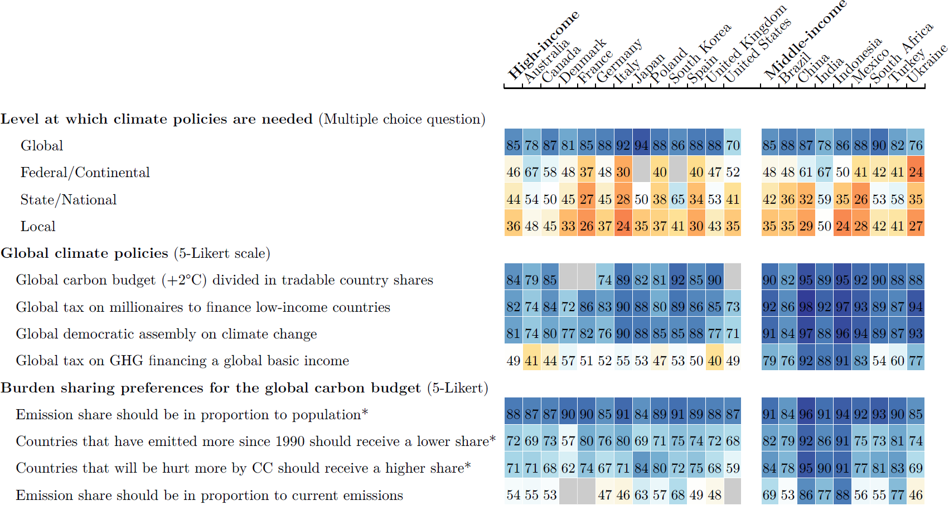

*Global Climate Scheme*

The GCS consists of global emissions trading with emission rights being auctioned each year to polluting firms, and of a global basic income of $30/month, funded by the auction revenues. We make sure that the respondents understand the redistributive effects of the GCS: The 700 million people with less than $2/day would be lifted out of extreme poverty, and fossil fuel price increases would cost the typical person in their country a specified amount, e.g. $85/month in the U.S. or £20/month in the UK.

The stated support for the GCS is 54% in the U.S. and 76% in Europe.

*Global wealth tax*

We inquire about respondents' preferences regarding the redistribution of revenues from a global wealth tax. In each country, at least 88% of respondents prefer to allocate 10% or more to low-income countries, with a median of 30%.

*Other global policies*

Other global redistributive policies garner majority support across all countries.

*Foreign aid*

In each country, a majority supports increased foreign aid, with or without conditions. The most cited condition is the guarantee that aid is not diverted.

**2.3 Robustness and sincerity of support for the GCS**

All our analyses suggest that the support is sincere.

*List experiment*

By asking *how many* policies within a list respondents support, and adding for some respondents the GCS in the list, we identify the tacit support for that policy. It is not significantly different from the stated support.

*Petition*

The GCS receives comparable support in a real-stake question, knowing that the results of that question will be sent to the head of state's office.

*Conjoint analyses*

We present to two random branches hypothetical progressive and conservative platforms that differ only by the presence (or not) of the GCS in the progressive platform. Table 1 shows that a progressive candidate would not significantly lose voting share by endorsing the GCS in any country, and may even gain 11 p.p. (p = .005) in voting intention in France and 3 p.p. (p = .13) in the U.S.

Table 1 Preference for a progressive platform depending on whether it includes the Global Climate Scheme.

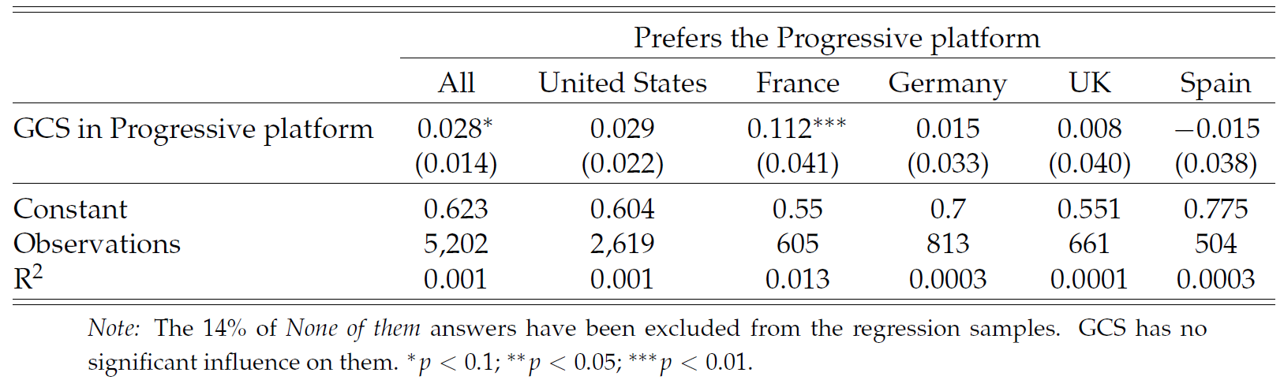

We make respondents choose between two pairs of random platforms (in the U.S., these questions are framed as a Democratic primary and asked only to non-Republicans). In the first question, a policy (or an absence of policy) is randomly drawn for each platform in each of five categories. In the UK, Germany, and France, a platform is about 9 to 13 p.p. more likely to be preferred if it includes the GCS rather than no foreign policy. *This effect is between 1 and 4 p.p. and no longer significant in the U.S. and in Spain.* Moreover, a platform that includes a global tax on millionaires rather than no foreign policy is 5 to 13 percentage points (p.p.) more likely to be preferred in all countries.

The second question draws random platforms similarly, except that candidate A's platform always contains the GCS while B's includes no foreign policy. In this case, A is chosen by 60% in Europe and 58% in the U.S.

In the U.S. for example, our conjoint analyses indicate that a candidate at the Democratic primary would have more chances to obtain the nomination by endorsing the GCS, and this endorsement would not penalize her or him at the presidential election.

*Prioritization*

The global tax on millionaires consistently ranks no lower than fifth position (out of 15 or 17 policies) in every country, and the GCS is prioritized over prominent national climate policies.

*Pros and Cons*

The support for the GCS decreased by 11 p.p. after simulating a campaign by showing participants a list of its pros and cons, where the cons were over-represented.

**2.4 Universalistic values**

Answers to broad value questions are consistent with majority support for global redistribution: people are almost as much willing to give to poor Africans than to poor fellow citizens in an incentivized donation experiment, find that global issues are among the biggest problems, almost half of them are universalist when they vote, and most of them wish that their diplomats take into account global justice.

**2.5 Second-order Beliefs**

The evidence for pluralistic ignorance is limited based on an incentivized question: The mean perceived support of the GCS is 52% in the U.S. and 59% in Europe.

**3 Discussion**

Having ruled out insincerity and underestimation of fellow citizens' support as potential explanations for the scarcity of global policies in the public debate, we propose different alternative explanations.

First, there may be pluralistic ignorance *among policymakers*. Second, policymakers may believe that globally redistributive policies are politically infeasible in some key countries like the U.S. Third, political discourse centrally happens at the national level, shaped by media and institutions such as voting. In turn, national framing may suppress universalistic values.

**Bibliography**

Carattini, Stefano, Steffen Kallbekken, and Anton Orlov. 2019. “How to Win Public Support for a Global Carbon Tax.” *Nature*.

Dechezleprêtre, Antoine et al. 2022. “Fighting Climate Change: International Attitudes toward Climate Policies.” *NBER Working Paper*.

Ghassim, Farsan, Mathias Koenig-Archibugi, and Luis Cabrera. 2022. “Public Opinion on Institutional Designs for the United Nations: An International Survey Experiment.” *International Studies Quarterly*.

1. CNRS, CIRED. E-mail: adrien.fabre@cnrs.fr (corresponding author).
2. University of Amsterdam
3. Technical University Berlin, Potsdam Institute for Climate Impact Research -- Member of the Leibniz Association and University of Oxford