**Please use this template** to create your text, overwriting the guidelines in black with your answers (note, grey text will be completed by us), deleting red instructional paragraphs and submitting this Word document. These guidelines give an overview of the type of questions that should be addressed in each section. If you use an AI tool such as ChatGPT to draft your text, please let us know as we must declare it in the Research Briefing.

The Briefing will not be peer-reviewed but, in consultation with you, it will be robustly edited for scientific clarity, language, consistency and house style to maximize its accessibility. You will receive an edited Word file for approval prior to production, in which you will see the comments from a referee and/or editor to be included in the Briefing.

**Insert title here**

Title should be different to that of the research paper, highlight the key findings and be short and accessible [6 lines max or 90 characters]

Standfirst — a brief summary. Please replace this paragraph with one to two sentences that succinctly summarize what has been achieved. [50 words max]

This is a summary of:  
Name, A. A. et al. Title. *Nature* https://doi.org/10.1038/xxxx (202x)   
[We will complete this]

**Published online:** xx xx xxxx

**Publisher’s note**

Springer Nature remains neutral with regard to jurisdictional claims in published maps and institutional affiliations.

SECTION 1: The question / The mission / The project / The problem (please select preferred title and delete section number and other titles)

Please add four to five sentences giving some introduction and context to the work. What is the historical context? If you are answering a question or solving a problem, what is it and why is it of academic or societal importance? Keep in mind that you are trying to help academics in other disciplines appreciate the big picture significance of why you have undertaken this project. [120–150 words]

SECTION 2: The solution / The observation / The discovery (please select preferred title and delete section number and other titles)

Paragraph 1: What form did your investigation take? What experiments, observations or analyses did you perform, and why were they suited to the goals of the work? Here you are trying to help the reader understand the rationale for the specific approach that you have adopted. [100–150 words]

Paragraph 2: What did you find? What immediate conclusions can you draw from these findings? [100–150 words]

SECTION 3: The implications / Future directions / The interpretation (please select preferred title and delete section number and other titles)

Paragraph 1: Are there broader implications or applications of your findings? If so, what are they? [ 50–100 words]

Paragraph 2: What are the obvious limitations or caveats; what does this research not allow you to say? [50–100 words]

Paragraph 3: What are the obvious next questions/steps to take this further/ aspects of the research to strengthen? What do you hope or plan to do next? [30–50 words]

There is some flexibility with the word limit for each section; together sections 1, 2 and 3 should not exceed the limits of this page, including the sign off. It is about 650 words in total; 550 words minimum are recommended.

**SIGNING OFF:** Please ‘sign off’ the final paragraph (which will appear on the first page of the briefing) with the names of the researchers (**2 max**) that completed this template, in the following format:

Name 1 (& Name 2)  
Institution name, Town or City, Country. Please include only one institution/affiliation per person.

Expert opinion

This will be added by the briefing editor and included in the edited version of the Briefing you see.  
Name of source, role

[max 80 words, including sign-off]

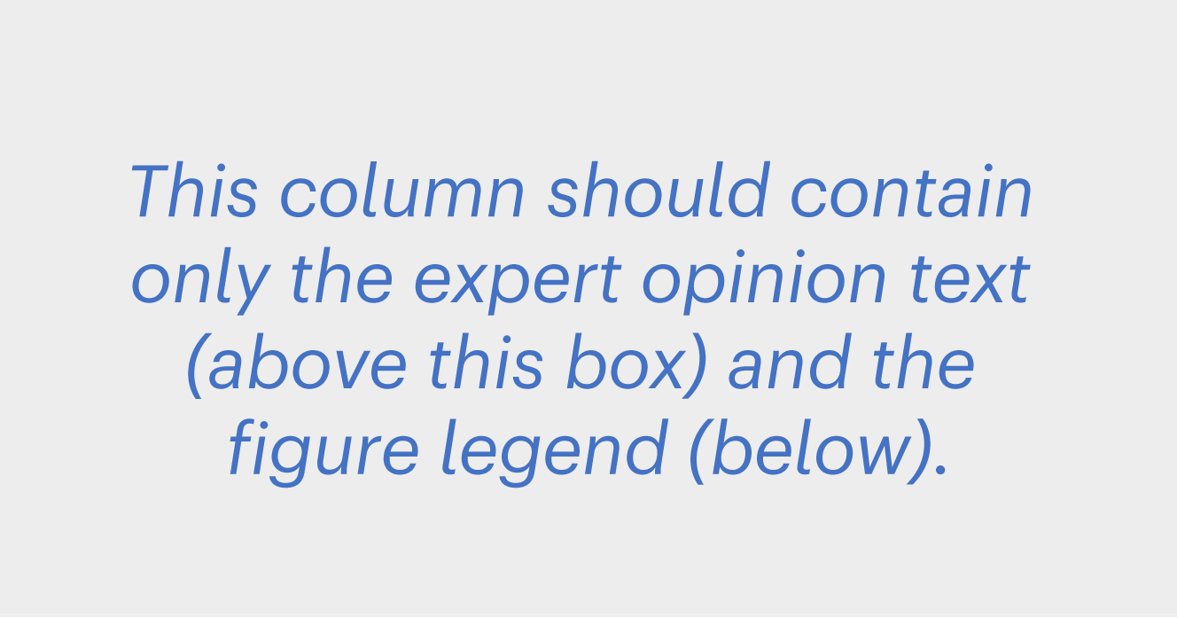Figure

Please submit a figure or compilation of figure panels **(2 panels maximum)** from your research paper that best illustrates your findings. **Only original, unaltered figures** can be used as they will be added to the Briefing **directly from the paper** (extended data and suppl. info figures are not suitable). The figure will be sized to fit exactly **115mm width x 85mm height**; please keep this in mind when selecting your panels and follow the research paper guidance on figure formatting.

Please replace ‘**xx**’ in the following statements:

The figure for this Briefing is composed of **xx** panels.

- Panel a = Fig **xx** from the original paper

- Panel b = Fig **xx** from the original paper

**Fig.1 | Figure legend short title**. The Figure legend should be presented here (not below the figure) and should be distinct from the legend in the primary paper. Start with a short title, followed by a short description of each panel and the symbols and abbreviations used. Please remember to cite the figure (as Fig. 1) at an appropriate place in the text. © 202x, XXX [Max 100 words, including title and credit line]

Behind the paper

This is an informal section that will be boxed-off on the second page of the briefing and signed with the initials of the researchers completing the template. It is an opportunity for you to provide more personal insights into how the research was carried out. For instance, how did the research question come about? How difficult was it to get the research funded? Were there any serendipitous experiments that changed the direction of, or accelerated, the research? What did you consider to be the most important experiment in the research? Was there a ‘eureka!’ moment? How did collaborations come about? What was the most difficult period of the research?

Please ‘sign off’ the final paragraph with the initials of the researcher that wrote this (it must be one or more of the researchers listed above).

Write over these instructional paragraphs with your text. Please write no more than the space available here. A.B. & X.Y. [140 words]

References

A maximum of **5** **references** can be cited.   
In addition to primary papers, please consider citing associated protocols, preprints and key reviews, to enable researchers to further their reading. Underneath each reference, please provide a single sentence that indicates the significance or relevance of the work.

All references must be **numbered and cited sequentially** in the text (using a superscript number)1 in the following order: main text, then figure legend. The numbered references should be listed in this column in the format shown below. These instructions, should be deleted.

1. Author, A. B. & Author, B. C. Title of the paper. *Journal abbr*. **vol**, page–page (2021).   
A Review article that presents xxx xxx.

2. Author, A. B. & Author, B. C. Title of the paper. *Journal abbr*. **vol**, page–page (2021).   
This paper reports xxx xxx.

3. Author, A. B. & Author, B. C. Title of the paper. *Journal abbr*. **vol**, page–page (2021).   
A Review article that presents xxx xxx.

4. Author, A. B. & Author, B. C. Title of the paper. *Journal abbr*. **vol**, page–page (2021).   
A Review article that presents xxx xxx.

5. Author, A. B. & Author, B. C. Title of the paper. *Journal abbr*. **vol**, page–page (2021).   
A Review article that presents xxx xxx.

From the editor

This will be added by the briefing editor and included in the edited version of the Briefing you see. Name of editor   
[max 75 words, including sign-off]