**Majorities genuinely support global redistributive and climate policies   
worldwide**

Surveys in 20 countries reveal strong public support for global policies such as a tax on millionaires financing low-income countries or a carbon price financing a global basic income. Survey experiments in Western countries confirm that support is sincere and that citizens prefer political platforms that include global redistribution policies.

This is a summary of:  
Fabre, A. et al. Majority Support for Global Climate and Redistributive Policies. *Nature Human Behaviour* https://doi.org/10.1038/s41562-025-02175-9

SECTION 1: The question

Global policies could address climate change and finance sustainable development. For example, a global 2% tax on individual wealth above $5 million could increase the national income of low-income countries by 50%, if merely one third of the revenue were used for this purpose. The focus of our study is a specific policy aimed at addressing both climate change and poverty, called the “Global Climate Scheme” (GCS). It imposes a cap on carbon emissions to limit global warming below 2°C. Emission rights would be auctioned each year to polluting firms and fund a global basic income, alleviating extreme poverty.

While several governments are advocating for global solidarity levies, a key unknown is whether populations in wealthier nations are ready for such global policies. Although attitudes towards redistributive and climate policies at the national level have been studied extensively1, few studies have examined attitudes towards global policies2–4.

SECTION 2: The observation

The first piece of evidence on stated support for global policies is a large-scale global survey of 40,680 respondents in 20 countries. To assess the sincerity and robustness of support in Western countries, we surveyed 8,000 respondents from France, Germany, Spain, the UK, and the U.S., and used a wide variety of experiments. We tested social desirability bias with a list experiment, assessed universalistic values with a donation experiment, and simulated the effects of including global policies in a political platform on vote intentions with conjoint analyses.

The global survey reveals that 85% of people think climate policies should be enacted at the global level (Fig. 1a). Support for a global emissions trading system is similarly high, and there is a consensus on an equal per capita allocation of emissions rights, which corresponds to the GCS.

In the surveys in Western countries, we made sure that the respondents understood the net cost of the GCS (e.g. $85 per month for the average American, £20 for a British person). Nevertheless, 76% of Europeans and 54% of Americans support the GCS.

There is also strong support for other global redistribution policies, such as a global tax on millionaires that would finance low-income countries (69% in the U.S., 84% in Europe). When asked how much of the revenue from such a tax should go to low-income countries as opposed to funding domestic health and education, the average respondent prefers to allocate one third of the revenue to low-income countries. When asked about their preferred amount of foreign aid, most of the respondents who have learnt the actual amount choose a bracket at least as high as the actual amount, and most of those without this information choose a bracket at least as high as the perceived amount. Another question confirms that majorities are willing to increase foreign aid (Fig. 1b), but only if certain conditions are met, such as ensuring that the aid is well spent and that other high-income countries also increase their contributions. In other words, its unilateral nature is one of the reasons why foreign aid is not as popular as global policies.

The robustness of support for global policies is confirmed by our experiments. A list experiment shows no evidence that people would exaggerate their support due to social desirability concerns. An experiment in which respondents could donate to someone in need shows that Europeans and Americans who voted for Joe Biden donate as much when the recipient is an African rather than a fellow citizen, although Trump voters donate less. Conjoint analyses show that a political platform is more likely to be preferred if it includes the GCS or a global tax on millionaires, and that global policies rank high in policy prioritisation. Our randomised experiments also show that a candidate would not lose vote intentions by supporting the GCS, and could even gain up to 11 points in France.

SECTION 3: Future directions

Our findings suggest an untapped potential for addressing global inequality and climate change through collaborative international action.

While we have used state-of-the-art methods to test the robustness of stated preferences, attitudes themselves may not be crystallised as global redistribution is not salient in political discussions. Therefore, opinions might change once the issue is publicly debated.

Future research could use qualitative interviews to uncover how people feel and reason about global solidarity.

Adrien Fabre  
Centre International de Recherche sur l’Environnement et le Développement (CIRED), Paris, France.

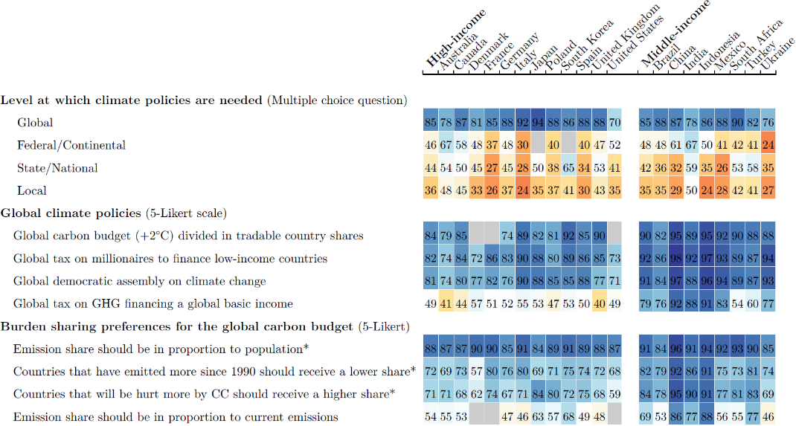

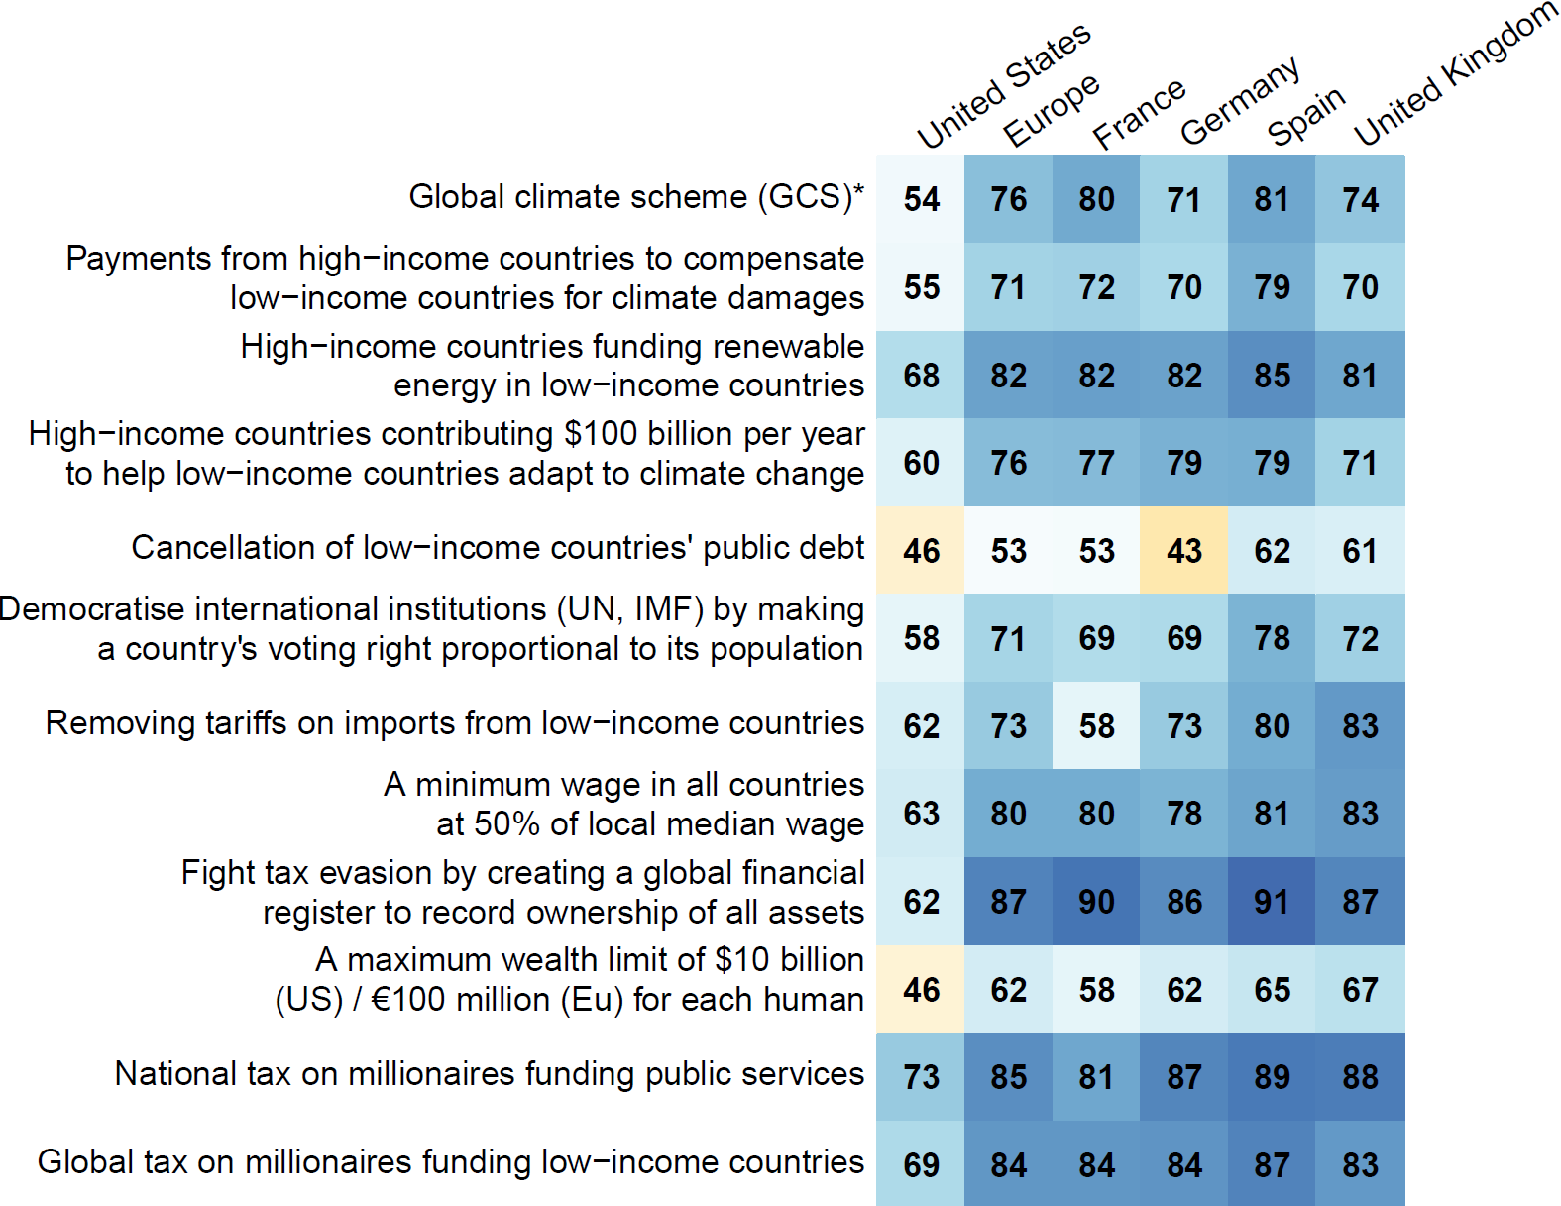

**Fig.1 | Support for global redistributive and climate policies.** **a-b,** The numbers represent *relative* support, i.e. the percentage of *Somewhat* or *Strongly* *support* among non-*indifferent* answers, *except in **a** for the multiple choice question, and in **b** for GCS (percentage of *Yes* in a *Yes*/*No* question), preferred share (percentage of answers ≥ 30%), and foreign aid (percentage of unconditional or conditional increase rather than decrease or stable aid). Shares of *indifferent* answers range from 10% to 37%, with quartiles 15%, 20%, and 26%. **a,** Global survey (n = 40,680). **b,** Western survey (n = 8,000). © 202x,

References

1. Dechezleprêtre, A. et al. Fighting Climate Change: International Attitudes Toward Climate Policies. *Am. Econ. Rev.* (forthcoming).   
An article presenting attitudes towards climate change and national climate policies using representative surveys in twenty countries.

2. Andre, A., Boneva, T., Chopra, Felix. & Falk, A. Globally representative evidence on the actual and perceived support for climate action. *Nature Clim. Change*. **14**, 253–259 (2024).   
An article reporting strong support for climate action and underestimation of the support using representative surveys in 125 countries.

3. Carattini, D., Kallbekken, S. & Orlov, A. How to win public support for a global carbon tax. *Nature*. **565**, 289-291 (2019).   
An article surveying attitudes towards a global carbon tax in five countries.

4. Ghassim, F. & Pauli, M. Who on Earth Wants a World Government, What Kind, and Why? An International Survey Experiment. *Int. Stud. Q*. **68**, 1–16 (2024).   
An article reporting strong support for a democratic world government focused on global issues using representative surveys in 17 countries.

5. Fabre, A. The Global Climate Plan: A Global Plan to End Climate Change and Extreme Poverty. (2024).   
An essay developing a policy proposal elaborated from the Global Climate Scheme.