Title: International Attitudes Toward Global Policies

**Authors:** Adrien Fabre1,2*, Thomas Douenne3, Linus Mattauch4,5,6

**Affiliations:** 1Centre National de la Recherche Scientifique; Paris, France.

2Centre International de Recherches sur l’Environnement et le Développement; Nogent-sur-Marne, France.

3University of Amsterdam; Amsterdam, Netherlands.

4Technical University Berlin; Berlin, Germany.

5Potsdam Institute for Climate Impact Research; Potsdam, Germany.

6University of Oxford; Oxford, United Kingdom.

*Corresponding author. Email: [adrien.fabre@cnrs.fr](mailto:adrien.fabre@cnrs.fr).

**Abstract:** Major sustainability objectives could be achieved by global approaches to climate change and inequality, yet evidence on the support for global policies is scarce. Using surveys over 48,000 respondents from 20 countries, we find strong support for an effective way to jointly combat climate change and poverty: a global carbon price funding a global basic income, called the “Global Climate Scheme” (GCS). Using different experiments, we show that the support for the GCS is sincere and that electoral candidates could win votes by endorsing it. We document widespread support for other global redistribution policies, such as a wealth tax funding low-income countries. Our findings indicate that global policies are genuinely supported by majorities of the population, even in wealthy nations that would bear the burden.

**One-Sentence Summary:** Representative surveys reveal strong and genuine support worldwide for global climate and redistribution policies.

**Main Text:**

Major sustainability objectives could be achieved by global cooperation policies involving transfers from high- to lower-income countries (*1–7*). We examine a key condition for sustainability: the support of citizens for globally redistributive policies, studied only by scant prior attitudinal surveys (*8–10*). Using surveys over 40,000 respondents from 20 high- and middle-income countries, we document substantial support for global policies.

To gain insights into the factors shaping public support for global policies in high-income countries, we conduct complementary surveys among 8,000 respondents from France, Germany, Spain, the U.S., and the UK. The focus of our approach is a specific policy aimed at addressing both climate change and poverty, referred to as the “Global Climate Scheme” (GCS). It implements a cap on carbon emissions to limit global warming below 2°C. The emission rights are auctioned each year to polluting firms and fund a global basic income, alleviating extreme poverty. The GCS is supported by three quarters of Europeans and half of Americans. We test whether support of the expressed preference is sincere: a list experiment shows no evidence of social desirability bias in survey responses, majorities are willing to sign a real-stake petition, and global redistribution ranks high in the prioritization of policies. Conjoint analyses reveal that a political platform is more likely to be preferred if it contains the GCS or a global tax on millionaires. In sum, our findings indicate that global redistributive policies are genuinely supported by a majority of the population.

**Results**

***Data***

We assess the stated support for different global policies in a survey on climate attitudes conducted in 2021 on 40,680 respondents from 20 countries. The questions on national policies are analyzed in another paper (*8*).

To test the strength and sincerity of the support for global policies, we conduct complementary surveys in the U.S. and Europe. The U.S. survey has been divided in two waves, with respectively 3,000 and 2,000 respondents. The European questionnaire combines the two U.S. ones. It was conducted on 3,000 respondents representative of France, Germany, Spain, and the UK.

The surveys are administrated online. The samples are representative along the dimensions of gender, income, age, highest diploma, region, and degree of urbanization.

Supplementary Materials include methods, a comprehensive literature review, questionnaires, raw results, representativeness and attrition analyses. The project was preregistered on [osf.io/fy6gd](https://osf.io/fy6gd).

***Stated support for global policies***

*Global support*

The global survey shows strong support for climate policies enacted at the global level (Fig. 1). When asked “At which level(s) do you think public policies to tackle climate change need to be put in place?”, 70% (in the U.S.) to 94% (in Japan) choose the global level.

Three policies (out of four) garner high support across all countries: a global democratic assembly on climate change, a global tax on millionaires funding low-income countries, and a global emissions trading system (or “global quota”). The three policies obtain a majority of absolute support (i.e., “somewhat” or “strong” support) in all countries (except in the U.S. for the global assembly, 48% absolute support). In high-income countries, the global quota obtains 64% absolute support and 84% relative support (i.e., excluding “indifferent” answers).

Following the support for the global quota, respondents are asked about their preferences for dividing the carbon budget among countries. An equal per capita allocation of emission rights emerges as the preferred burden-sharing principle, garnering absolute majority support in all countries and never below 84% relative support. Taking into account historical responsibilities or vulnerability to climate damages is also popular, albeit with less consensus, while grandfathering (i.e., allocation of emission shares in proportion to current emissions) receives the least support in all countries.

A global quota with equal per capita emission rights produces the same distributional outcomes as a global carbon tax that funds a global basic income. The support for such global carbon tax is also tested and its redistributive effects – the average increase in expenditures along with the amount of the basic income – are specified to the respondents explicitly. The support for the carbon tax is lower than for the quota, particularly in high-income countries, and there is no relative majority for the tax in Anglo-Saxon countries. Two possible reasons for this lower support are that distributive effects are made salient in the case of the tax, and that citizens may find a quota more effective than a tax to reduce emissions. This interpretation is consistent with the level of support for the global quota once we make the distributive effects salient, as we do in the complementary surveys.

Fig. 1 Relative support for global climate policies (Percentage of "Somewhat" or "Strongly support" among non-"indifferent" answers, n = 40,680). Source: (8). For absolute support, see fig. S1.   
*In Denmark, France and the U.S., the questions with an asterisk were asked differently.

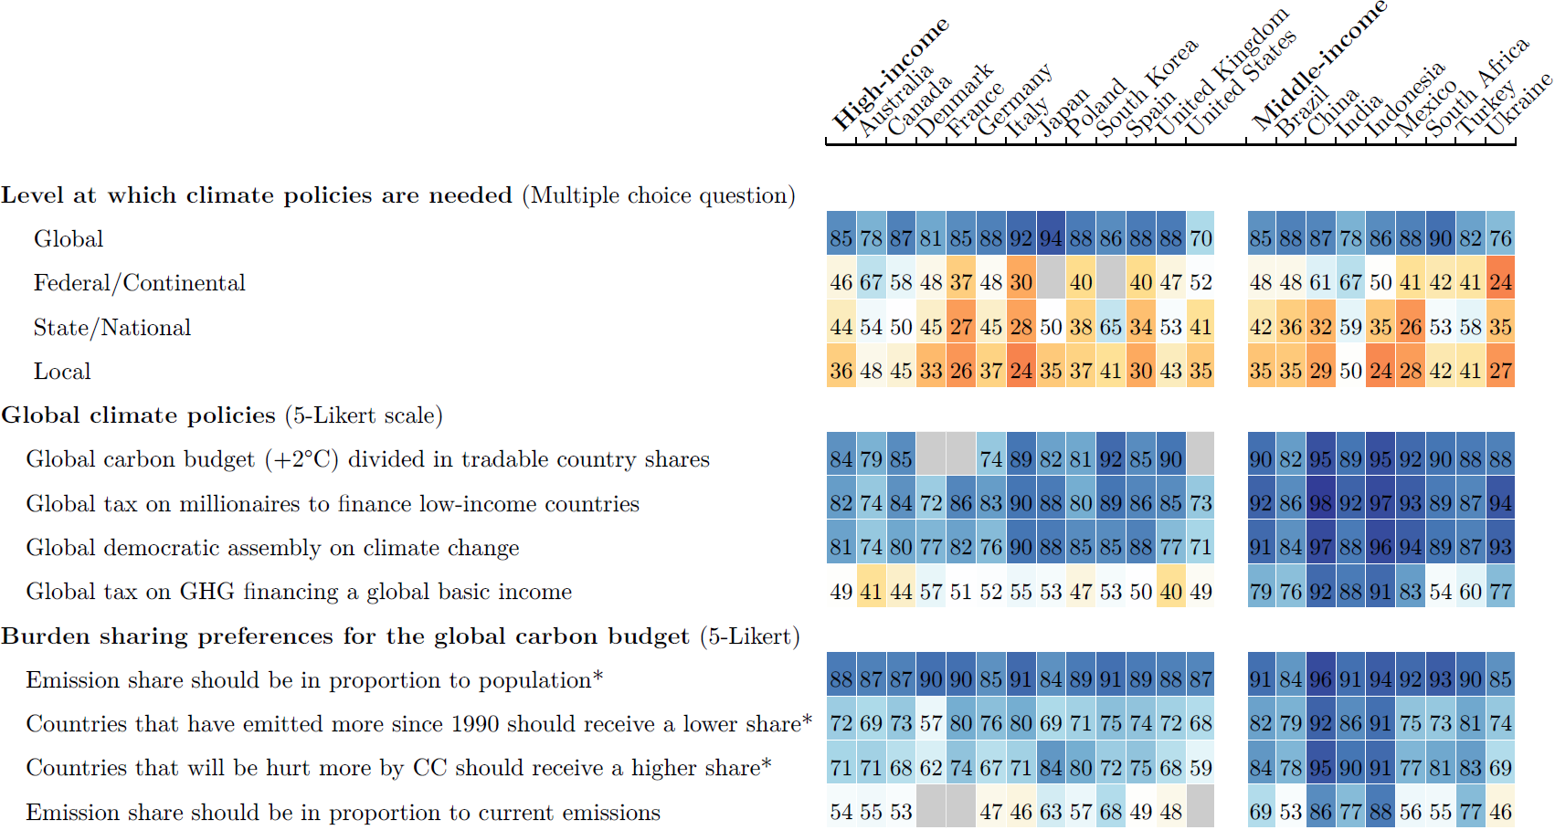

*Global Climate Scheme*

The complementary surveys (*US1*, *US2*, *Eu*) include a comprehensive exploration of citizens’ attitudes toward the GCS. The GCS consists of global emissions trading with emission rights auctioned each year to polluting firms, and of a global basic income of $30/month, funded by the auction revenues. Using incentivized comprehension questions and providing the correct answers afterwards, we make sure that the respondents understand the redistributive effects of the GCS: The 700 million people with less than $2/day would be lifted out of extreme poverty, and fossil fuel price increases would cost the typical person in their country a specified amount, e.g. $85/month in the U.S.[1]

Respondents are asked to express their support for the GCS using a simple Yes/No question. The stated support for the GCS is 54% in the U.S. and 76% in Europe.

*Global wealth tax*

Consistent with the results of the global survey, a “tax on millionaires of all countries to finance low-income countries” garners absolute majority support of over 67% in each country, only 5 p.p. lower than a national millionaires tax overall (Fig. 2). In random subsamples, we inquire about respondents’ preferences regarding the redistribution of revenues from a global tax on individual wealth. We ask certain respondents (n = 1,283) what percentage of global tax revenues should be pooled to finance low-income countries. In each country, at least 88% of respondents indicate a positive amount, with an average ranging from 30% (Germany) to 36% (U.S., France) (fig. S3). To other respondents (n = 1,233), we inquire whether they would prefer each country to retain all the revenues it collects or that half of the revenues be pooled to finance low-income countries. Approximately half of the respondents opt to allocate half of the tax revenues to low-income countries.

Fig. 2 Relative support for various global policies. (Percentage of "Somewhat" or "Strongly support" among non-"indifferent" answers – *except for the GCS: Share of “Yes” in a simple Yes/No question, n = 8,000). For absolute support, see fig. S2.

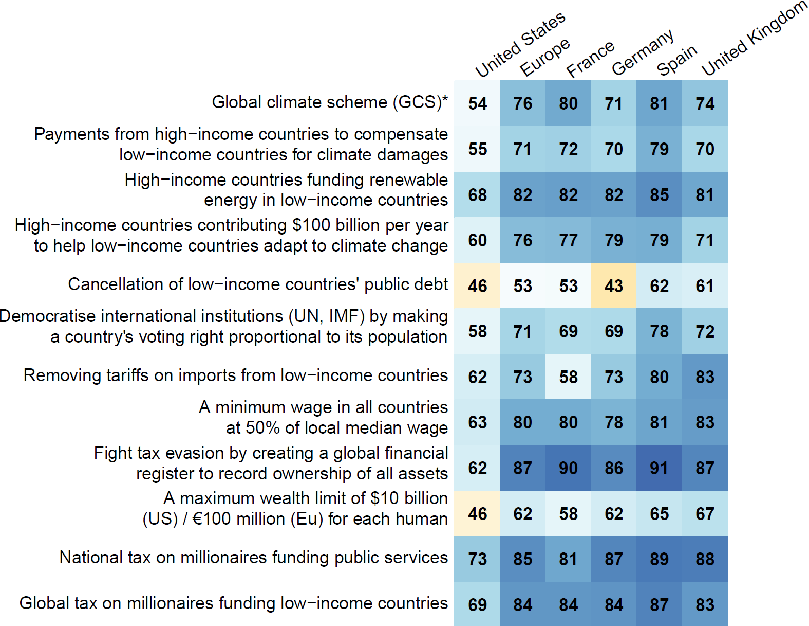

*Other global policies*

Other global redistributive policies garner majority support across all countries (Fig. 2).

*Foreign aid*

We provide respondents with information about the actual amount “spent on foreign aid to reduce poverty in low-income countries” relative to their country’s government spending and GDP. Less than 16% of respondents state that their country’s foreign aid should be reduced, while 62% express support for increasing it, including 17% who support an unconditional increase (fig. S4). Among the 45% who think aid should be increased under certain conditions, we subsequently ask them to specify the conditions they deem necessary (fig. S5). The three most commonly selected conditions are: “we can be sure the aid reaches people in need and money is not diverted” (73% chose this condition), “that recipient countries comply with climate targets and human rights” (67%), and “that other high-income countries also increase their foreign aid” (48%). On the other hand, respondents who do not wish to increase their country’s foreign aid primarily justify their view by prioritizing the well-being of their fellow citizens or by perceiving each country as responsible for its own fate (fig. S6). In response to an open-ended question regarding measures high-income countries should take to fight extreme poverty, a large majority of Americans expressed that more help is needed. The most commonly suggested form of aid is financial support, closely followed by investments in education.

We also inquire about the perceived amount of foreign aid. Most people overestimate the actual amount of foreign aid. We then elicit respondents’ preferred amount of foreign aid, after randomly presenting them with either the actual amount or no information. Most of the respondents who learn the actual amount choose a bracket at least as high as the actual one, and most of those without the information choose a bracket at least as high as the perceived one.

Finally, we ask a last question to the respondents who received the information. To those who prefer an increase of foreign aid, we ask how they would finance it and find that the preferred source of funding is overwhelmingly higher taxes on the wealthiest. To those who prefer a reduction, we ask how they would use the funds becoming available:

In every country, more people choose higher spending on education or healthcare rather than lower taxes.

***Robustness and sincerity of support for the GCS***

We use several methods to assess the sincerity of the support for the GCS. All methods suggest that the support is either completely sincere, or the share of insincere answers is limited.

*List experiment*

By asking *how many* policies within a list respondents support, and adding for some respondents the GCS in the list, we identify the tacit support for that policy. It is not significantly different from the stated support (table S1). Hence, we do not find a social desirability bias: people faithfully report their opinion on the GCS.

*Petition*

In a real-stake question, we ask respondents whether they are willing to sign a petition in support of the GCS, informing them that the results of that question will be sent to the head of state’s office. In the U.S., we find no significant difference between the support in the real-stake petition and the simple question (p = 0.30). In Europe, the petition leads to a lower support (-7 p.p., p=10-5), but the support remains strong, at 69%.

*Conjoint analyses*

To assess the electoral potential of endorsing the GCS, we present to two random branches hypothetical progressive and conservative platforms that differ only by the presence (or not) of the GCS in the progressive platform. Table 1 shows that a progressive candidate would not significantly lose voting share by endorsing the GCS in any country, and may even gain 11 p.p. (p = .005) in voting intention in France and 3 p.p. (p = .13) in the U.S.

Table 1 Preference for a progressive platform depending on whether it includes the Global Climate Scheme.

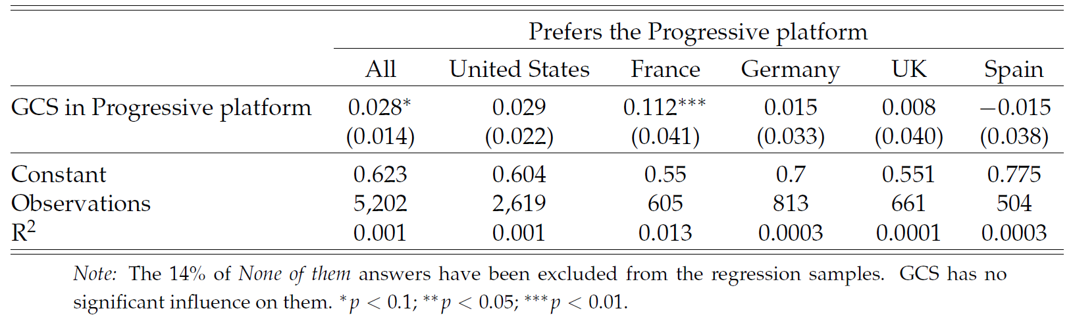

We also make respondents choose between two pairs of random platforms (in the U.S., these questions are framed as a Democratic primary and asked only to non-Republicans). In the first question, a policy (or an absence of policy) is randomly drawn for each platform in each of five categories. In the UK, Germany, and France, a platform is about 9 to 13 p.p. more likely to be preferred if it includes the GCS rather than no foreign policy (fig. S7). This effect is between 1 and 4 p.p. and no longer significant in the U.S. and in Spain. Moreover, a platform that includes a global tax on millionaires rather than no foreign policy is 5 to 13 percentage points (p.p.) more likely to be preferred in all countries (the effect is significant and at least 9 p.p. in all countries but Spain). Similarly, a global democratic assembly on climate change has a significant effect of 8 to 12 p.p. in the U.S., Germany, and France. These effects are large, and not far from the effects of the policies most influential on the platforms, which range between 15 and 18 p.p. in most countries (and 27 p.p. in Spain), and all relate to improved public services.

The second question draws random platforms similarly, except that candidate A’s platform always contains the GCS while B’s includes no foreign policy. In this case, A is chosen by 60% in Europe and 58% in the U.S. (fig. S8).

Overall, taking the U.S. as an example, our conjoint analyses indicate that a candidate at the Democratic primary would have more chances to obtain the nomination by endorsing the GCS, and this endorsement would not penalize her or him at the presidential election.

*Prioritization*

Toward the end of the survey, we ask respondents to allocate 100 points among six randomly selected policies from the previous conjoint analyses, using sliders. The instruction was to distribute the points based on their level of support, with a higher allocation indicating greater support for a policy. In each country, the GCS ranks in the middle of all policies or above, with an average number of points from 15.4 in the U.S. to 22.9 in Germany. Interestingly, in Germany, the most prioritized policy is the global tax on millionaires, while the GCS came in as the second most prioritized policy. The global tax on millionaires consistently ranks no lower than fifth position (out of 15 or 17 policies) in every country, garnering an average of 18.3 points in Spain to 22.9 points in Germany.

*Pros and Cons*

We survey respondents to gather their perspectives on the pros and cons of the GCS, utilizing either an open-ended or a closed question. Due to the limited variation in the ratings for each element, the closed question format is inconclusive. Analyzing keywords in the responses (automatically translated into English), the most frequently mentioned topic is the environmental benefit of the GCS, while obstacles to implementation or agreement on the proposal are relatively infrequently mentioned.

In the *US2* survey, we divided the sample into four random branches. Two branches were presented the pros and cons questions (either in open or closed format) *before* being asked about their support for the GCS. Another branch received information on the actual level of support for the GCS (estimated in *US1*), and one control group received none of these treatments. The objective of this “pros and cons treatment” was to simulate a “campaign effect”, which refers to the shift in opinion resulting from media coverage of the proposal. To conservatively estimate the effect of a (potentially negative) campaign, we intentionally included more cons (6) than pros (3). Interestingly, the support for the GCS decreased by 11 p.p. after participants viewed a list of its pros and cons. Notably, the support also decreased by 7 p.p. after participants were asked to consider the pros and cons in an open-ended question. Although support remains significant, these results suggest that the public success of the GCS would be sensitive to the content of the debate about it, and subject to the discourse adopted by interest groups.

***Universalistic values***

We also elicit underlying values, to test whether values are consistent with people’s support for specific policies. Most people express some degree of universalism, consistently with the support for specific policies.

When we ask participants which group they defend when they vote, 20% choose “sentient beings (humans and animals),” 22% choose “humans,” 33% select their “fellow citizens” (or “Europeans”), 15% choose “My family and myself,” and the remaining 10% choose another group (mainly “My State or region” or “People sharing my culture or religion”). Notably, a majority of left-wing voters choose “humans” or “sentient beings”.

When asked what their country’s diplomats should defend in international climate negotiations, only 11% prefer their country’s “interests, even if it goes against global justice”. In contrast, 30% prefer global justice (with or without consideration of national interests), and the bulk of respondents (38%) prefer their country’s “interests, to the extent it respects global justice.”

Furthermore, when we ask participants to assess the extent to which climate change, global poverty, and inequality in their country are issues, climate change is generally viewed as the most significant problem (with a mean score of 0.59 after recoding answers between -2 and 2). This is followed by global poverty (0.42) and national inequality (0.37).

Finally, we conducted a lottery experiment. Respondents had to choose the proportion of the $100 prize they would keep for themselves versus give to a person living in poverty. The charity donation is directed either to an African individual or a fellow citizen, depending on the respondent’s random assignment. In Europe, we observe no significant variation in the willingness to donate based on the recipient’s origin. In the U.S., the donations to Africans are 3 p.p. lower, but the slightly lower donations to Africans are entirely driven by Trump voters and non-voters.

***Second-order Beliefs***

To explain the strong support for the GCS despite its absence from political platforms and public debate, we hypothesized pluralistic ignorance, i.e. that the public and policymakers mistakenly perceive the GCS as unpopular. The evidence for pluralistic ignorance is limited based on an incentivized question about perceived support.

Beliefs about the level of support for the GCS are fairly accurate for U.S. subjects (fig. S9). The mean perceived support is 52% (with quartiles of 36%, 52%, and 68%), which closely aligns with the actual support of 53%. Europeans, on the other hand, underestimate the support by 17 p.p. Nonetheless, 65% of them correctly estimate that the GCS garners majority support, and the mean perceived support is 59% (and quartiles of 43%, 61%, and 74%). Finally, consistent with U.S. subjects accurately perceiving the levels of support for the GCS, providing information on the actual level had no significant effect on their support in the *US2* survey.

**Discussion**

Having ruled out insincerity and underestimation of fellow citizens’ support as potential explanations for the scarcity of global policies in the public debate, we propose different alternative explanations.

First, there may be pluralistic ignorance *among policymakers*. Second, policymakers may believe that globally redistributive policies are politically infeasible in some key countries like the U.S. Third, political discourse centrally happens at the national level, shaped by media and institutions such as voting. In turn, national framing may suppress universalistic values.

In any case, our findings indicate that public opinion is not the reason why global redistributive policies do not prominently enter political debates.

**References and Notes**

1. Budolfson, M. et al. Climate action with revenue recycling has benefits for poverty, inequality and well-being. *Nature Climate Change* (2021).
2. Franks, M., Lessmann, K., Jakob, M., Steckel, J. C. & Edenhofer, O. Mobilizing domestic resources for the Agenda 2030 via carbon pricing. *Nature Sustainability* (2018).
3. Dennig, F., Budolfson, M. B., Fleurbaey, M., Siebert, A. & Socolow, R. H. Inequality, climate impacts on the future poor, and carbon prices. *Proceedings of the National Academy of Sciences* (2015).
4. Soergel, B., Kriegler, E., Bodirsky, B. L., Bauer, N., Leimbach, M. & Popp, A. Combining ambitious climate policies with efforts to eradicate poverty. *Nature Communications* (2021).
5. Bauer, N. et al. Quantification of an efficiency–sovereignty trade-off in climate policy. *Nature* (2020).
6. Cramton, P. C., MacKay, D. J. C. & Ockenfels, A. (eds.) Global Carbon Pricing: The Path to Climate Cooperation (MIT Press, Cambridge, MA, 2017).
7. Fehr, D., Mollerstrom, J. & Perez-Truglia, R. Your Place in the World: Relative Income and Global Inequality. *American Economic Journal: Economic Policy* (2022).
8. Dechezleprêtre, A., Fabre, A., Kruse, T., Sanchez Chico, A., Planterose, B. & Stantcheva, S. Fighting Climate Change: International Attitudes toward Climate Policies. *NBER Working Paper* (2022)
9. Carattini, S., Steffen K., & Orlov A. How to Win Public Support for a Global Carbon Tax. *Nature* (2019)
10. Ghassim, F., Koenig-Archibugi M., & Cabrera L. Public Opinion on Institutional Designs for the United Nations: An International Survey Experiment. *International Studies Quarterly* (2022)

**Supplementary Material references**

A. Agarwal & S. Narain. Global Warming in an Unequal World: A Case of Environmental Colonialism. Technical report, India Centre for Science and Environment, 1991.

M. Aklin & M. Mildenberger. Prisoners of the Wrong Dilemma: Why Distributive Con-flict, Not Collective Action, Characterizes the Politics of Climate Change. Global Envi-ronmental Politics, 2020.

F. H. Allport. Social Psychology. Journal of Philosophy Inc, 1924.

A. Alsamawi, J. Murray, & M. Lenzen. The Employment Footprints of Nations. Journal of Industrial Ecology, 2014.

Americans for Tax Fairness. Support for Biden’s Tax and Economic Plans. Technical report, 2021.

P. Andre, T. Boneva, F. Chopra, & A. Falk. Misperceived Social Norms and Willingness to Act Against Climate Change. 2022.

D. Archibugi, M. Koenig-Archibugi, & R. Marchetti. Global Democracy: Normative and Empirical Perspectives. Cambridge University Press, 2011.

E. Arghiri. Unequal Exchange: A Study of the Imperialism in Trade. 1972.

T. Athanasiou, C. Holz, & S. Kartha. Fair Shares – Lessons from Practice, Thoughts on Strategy. 2022.

P. Baer, J. Harte, B. Haya, A. V. Herzog, J. Holdren, N. E. Hultman, D. M. Kammen, R. B. Norgaard, & L. Raymond. Equity and Greenhouse Gas Responsibility. Science, 2000.

P. Baer, G. Fieldman, T. Athanasiou, & S. Kartha. Greenhouse Development Rights: To-wards an equitable framework for global climate policy. Cambridge Review of Interna-tional Affairs, 2008.

F. Bastagli, J. Hagen-Zanker, L. Harman, V. Barca, G. Sturge, & T. Schmidt. Cash transfers: What does the evidence say? Technical report, ODI, 2016.

N. Bauer, K. Calvin, J. Emmerling, O. Fricko, S. Fujimori, J. Hilaire, J. Eom, V. Krey, E. Kriegler, I. Mouratiadou, H. Sytze de Boer, M. van den Berg, S. Carrara, V. Daioglou, L. Drouet, J. E. Edmonds, D. Gernaat, P. Havlik, N. Johnson, D. Klein, P. Kyle, G. Marangoni, T. Masui, R. C. Pietzcker, M. Strubegger, M. Wise, K. Riahi, & D. P. van Vuuren. Shared Socio-Economic Pathways of the Energy Sector – Quantifying the Narratives. Global Environmental Change, 2017.

M. Bauhr, N. Charron, & N. Nasiritousi. Does Corruption Cause Aid Fatigue? Public Opinion and the Aid-Corruption Paradox. International Studies Quarterly, 2013.

A. B. Bayram. What drives modern Diogenes? Individual values and cosmopolitan alle-giance. European Journal of International Relations, 2015.

A. B. Bayram. Aiding Strangers: Generalized Trust and the Moral Basis of Public Support for Foreign Development Aid. Foreign Policy Analysis, 2017.

M. M. Bechtel & K. F. Scheve. Mass support for global climate agreements depends on institutional design. Proceedings of the National Academy of Sciences, 2013.

L. F. Beiser-McGrath & T. Bernauer. Commitment failures are unlikely to undermine public support for the Paris agreement. Nature Climate Change, 2019.

L. F. Beiser-McGrath & T. Bernauer. Could revenue recycling make effective carbon taxa-tion politically feasible? Science Advances, 2019.

T. Bernauer & R. Gampfer. How robust is public support for unilateral climate policy? Environmental Science & Policy, 2015.

G. Bertram. Tradeable emission permits and the control of greenhouse gases. The Journal of Development Studies, 1992.

O. Blanchard & J. Tirole. Major Future Economic Challenges. 2021.

T. Bodenstein & J. Faust. Who Cares? European Public Opinion on Foreign Aid and Political Conditionality. JCMS: Journal of Common Market Studies, 2017.

K. B. Bolch, L. Ceriani, & L. F. Lopez´-Calva. The arithmetics and politics of domestic resource mobilization for poverty eradication. World Development, 2022.

A. W. Cappelen, B. Enke, & B. Tungodden. Universalism: Global Evidence, 2022.

S. Carattini, S. Kallbekken, & A. Orlov. How to win public support for a global carbon tax. Nature, 2019.

F. Carlsson, M. Kataria, E. Lampi, A˚. Lofgren,¨ & T. Sterner. Is fairness blind?—The effect of framing on preferences for effort-sharing rules. Ecological Economics, 2011.

F. Carlsson, M. Kataria, A. Krupnick, E. Lampi, A˚. Lofgren,¨ P. Qin, & T. Sterner. A fair share: Burden-sharing preferences in the United States and China. Resource and Energy Economics, 2013.

L. Chancel & T. Piketty. Carbon and inequality: From Kyoto to Paris. 2015.

L. Chancel, T. Piketty, E. Saez, & G. Zucman. World Inequality Report 2022. 2022.

T. L. Cherry, S. Kallbekken, & S. Kroll. Accepting market failure: Cultural worldviews and the opposition to corrective environmental policies. Journal of Environmental Economics and Management, 2017.

P. Cramton, A. Ockenfels, & S. Stoft. An International Carbon-Price Commitment Pro-motes Cooperation. Economics of Energy & Environmental Policy, 2015.

E. Dabla-Norris, T. Helbling, S. Khalid, H. Khan, G. Magistretti, A. Sollaci, & K. Srini-vasan. Public Perceptions of Climate Mitigation Policies: Evidence from Cross-Country Surveys. Staff Discussion Notes, 2023.

A. Dechezlepretre,ˆ A. Fabre, T. Kruse, B. Planterose, A. Sanchez Chico, & S. Stantcheva. Fighting climate change: International attitudes toward climate policies. NBER Working Paper, 2022.

D. f. I. D. DFID. Aid under Pressure: Support for Development Assistance in a Global Economic Downturn, Fourth Report of Session 2008-09, Vol. 1: Report, Together with Formal Minutes. The Stationery Office, 2009. ISBN 978-0-215-53050-9.

S. Drews, I. Savin, & J. C. J. M. van den Bergh. Biased perceptions of other people’s attitudes to carbon taxation. Energy Policy, 2022.

D. Egger, J. Haushofer, E. Miguel, P. Niehaus, & M. Walker. General Equilibrium Effects of Cash Transfers: Experimental Evidence From Kenya. Econometrica, 2022.

A. Einstein. To the General Assembly of the United Nations, 1947.

B. Enke, R. Fisman, L. Mota Freitas, & S. Sun. Universalism and Political Representation:

Evidence from the Field, 2023.

B. Enke, R. Rodr´ıguez-Padilla, & F. Zimmermann. Moral universalism and the structure of ideology. Review of Economic Studies, 2023.

B. Enke, R. Rodr´ıguez-Padilla, & F. Zimmermann. Moral Universalism: Measurement and Economic Relevance. Management Science, 2023.

A. Fabre. The Global Climate Plan – Policy Brief. Technical report, Global Redistribution Advocates, 2023.

A. L. Fanning & J. Hickel. Compensation for atmospheric appropriation. Nature Sustain-ability, 2023.

D. Fehr, J. Mollerstrom, & R. Perez-Truglia. Your Place in the World: Relative Income and

Global Inequality. American Economic Journal: Economic Policy, 2022.

R. Fisman, K. Gladstone, I. Kuziemko, & S. Naidu. Do Americans Want to Tax Capital? Evidence from Online Surveys. Working Paper 23907, National Bureau of Economic Research, 2017.

M. Fleurbaey & S. Zuber. Climate Policies Deserve a Negative Discount Rate. Chicago Journal of International Law, 2013.

A. Fremstad & M. Paul. The Impact of a Carbon Tax on Inequality. Ecological Economics, 2019.

O. Fricko, P. Havlik, J. Rogelj, Z. Klimont, M. Gusti, N. Johnson, P. Kolp, M. Strubegger, H. Valin, M. Amann, T. Ermolieva, N. Forsell, M. Herrero, C. Heyes, G. Kindermann, V. Krey, D. L. McCollum, M. Obersteiner, S. Pachauri, S. Rao, E. Schmid, W. Schoepp, & K. Riahi. The marker quantification of the Shared Socioeconomic Pathway 2: A middle-of-the-road scenario for the 21st century. Global Environmental Change, 2017.

I. Gallup. Seventy Years of U.S. Public Opinion on the United Nations, 1946.

S. Gangopadhyay, R. Lensink, & B. Yadav. Cash or In-kind Transfers? Evidence from a Randomised Controlled Trial in Delhi, India. The Journal of Development Studies, 2015

G. Gao, M. Chen, J. Wang, K. Yang, Y. Xian, X. Shi, & K. Wang. Sufficient or insuffi-cient: Assessment of the intended nationally determined contributions (INDCs) of the world’s major greenhouse gas emitters. Frontiers of Engineering Management, 2019.

N. Geiger & J. K. Swim. Climate of silence: Pluralistic ignorance as a barrier to climate change discussion. Journal of Environmental Psychology, 2016.

F. Ghassim. Who on Earth Wants Global Democracy – and Why (Not)? A Theoretical and Experimental Study of International Public Opinion. PhD thesis, University of Oxford, 2020.

F. Ghassim, M. Koenig-Archibugi, & L. Cabrera. Public Opinion on Institutional Designs for the United Nations: An International Survey Experiment. International Studies Quar-terly, 2022.

R. Gignac & H. D. Matthews. Allocating a 2 °C cumulative carbon budget to countries. Environmental Research Letters, 2015.

M. Gilens. Political Ignorance and Collective Policy Preferences. American Political Science Review, 2001.

Global Assembly. Report of the 2021 Global Assembly on the Climate and Ecological Crisis. Technical report, 2022.

Global Challenges Foundation. Attitudes to global risk and governance survey 2018. Technical report, 2018.

C. Gollier & J. Tirole. Negotiating Effective Institutions Against Climate Change. Eco-nomics of Energy & Environmental Policy, 2015.

Greenpeace. Energy [r]evolution - a sustainable world energy outlook 2015, 2015.

M. Grubb. The Greenhouse Effect: Negotiating Targets. International Affairs (Royal Institute of International Affairs 1944-), 1990.

J. Hainmueller, D. J. Hopkins, & T. Yamamoto. Causal Inference in Conjoint Analysis: Understanding Multidimensional Choices via Stated Preference Experiments. Political Analysis, 2014.

W. A. Hanson. Satellite Internet in the Mobile Age. New Space, 2016.

P. Harnett. Taking Tax to the Global Level Combining Southern Initiatives to Create a World Basic Income. Technical report, World Basic Income, 2017.

J. Haushofer & J. Shapiro. The Short-term Impact of Unconditional Cash Transfers to the Poor: Experimental Evidence from Kenya. The Quarterly Journal of Economics, 2016.

S. Henson, J. Lindstrom, L. Haddad, & R. Mulmi. Public Perceptions of International Development and Support for Aid in the UK: Results of a Qualitative Enquiry. IDS Working Papers, 2010.

J. Hickel. The Divide: A Brief Guide to Global Inequality and Its Solutions. Heinemann, 2017. ISBN 978-1-78515-112-5.

M. Hoel. Carbon taxes: An international tax or harmonized domestic taxes. CICERO Working Paper, 1991.

N. Hohne,¨ M. den Elzen, & D. Escalante. Regional GHG reduction targets based on effort sharing: A comparison of studies. Climate Policy, 2014.

C. Holz, E. Kemp-Benedict, T. Athanasiou, & S. Kartha. The Climate Equity Reference Calculator. Journal of Open Source Software, 2019.

C. Hood. Input to the High-level Economic Commission on Carbon Prices, 2017.

D. Hudson & J. van Heerde. ’A Mile Wide and an Inch Deep’: Surveys of Public Attitudes towards Development Aid. International Journal of Development Education and Global Learning, 2012.

. IEA. World Energy Outlook. Technical report, 2007. IEA. Energy Technology Perspectives 2017. 2017.

K. Imai. Multivariate Regression Analysis for the Item Count Technique. Journal of the American Statistical Association, 2011.

IMF, editor. How to Mitigate Climate Change. Washington, DC, 2019. ISBN 978-1-4983-2122-8.

T. Isbell. Footing the bill? Technical report, Afrobarometer, 2022.

ISSP. International Social Survey Programme: Environment III. 2010.

ISSP. International Social Survey Programme ISSP 2019 - Social Inequality V. 2019.

D. Ivanova & R. Wood. The unequal distribution of household carbon footprints in Eu-rope and its link to sustainability. Global Sustainability, 2020.

B. Jaeger & M. Wilks. The Relative Importance of Target and Judge Characteristics in Shaping the Moral Circle. Cognitive Science, 2023.

D. Jamieson. Climate Change and Global Environmental Justice. 2001.

T. B. Johansson, A. Patwardhan, N. Nakicenovi´c,´ L. Gomez-Echeverri, & International Institute for Applied Systems Analysis, editors. Global Energy Assessment (GEA). Cam-bridge University Press ; International Institute for Applied Systems Analysis, Cam-bridge : Laxenburg, Austria, 2012. ISBN 978-1-107-00519-8 978-0-521-18293-5.

I. Kant. Zum ewigen Frieden: Ein philosophischer Entwurf. 1795. ISBN 978-1-4840-4926-6.

D. Kaufmann, E. F. McGuirk, & P. C. Vicente. Foreign Aid Preferences and Perceptions in Donor Countries. 2012.

W. Kopczuk, J. Slemrod, & S. Yitzhaki. The limitations of decentralized world redistribu-tion: An optimal taxation approach. European Economic Review, 2005.

M. Leimbach & A. Giannousakis. Burden sharing of climate change mitigation: Global and regional challenges under shared socio-economic pathways. Climatic Change, 2019.

J. Leinen & A. Bummel. A World Parliament: Governance and Democracy in the 21st Century. Democracy Without Borders, Berlin, 2018. ISBN 978-3-942282-13-0.

D. J. C. MacKay, P. Cramton, A. Ockenfels, & S. Stoft. Price carbon - I will if you will. Nature, 2015.

H. D. Matthews. Quantifying historical carbon and climate debts among nations. Nature Climate Change, 2015.

L. Maverick Lloyd & R. Schwimmer. Chaos, War, and a New World Order. Technical report, 1937.

D. M. McEvoy & T. L. Cherry. The prospects for Paris: Behavioral insights into uncondi-tional cooperation on climate change. Palgrave Communications, 2016.

L. F. McGrath & T. Bernauer. How strong is public support for unilateral climate policy and what drives it? WIREs Climate Change, 2017.

A. Meilland, Y. Kervinio, & A. Mejean´. International climate justice: What the people think. 2023.

A. Meyer. Briefing: Contraction and convergence. Proceedings of the Institution of Civil Engineers - Engineering Sustainability, 2004.

G. Myrdal. Beyond the Welfare State: Economic Planning and its International Implications. Praeger, yale university press edition, 1960. ISBN 978-0-313-23697-6.

G. Myrdal. The Equality Issue in World Development. The Swedish Journal of Economics, 1975.

G. Nair. Misperceptions of Relative Affluence and Support for International Redistribu-tion. The Journal of Politics, 2018.

E. Neumayer. In defence of historical accountability for greenhouse gas emissions. Eco-logical Economics, 2000.

OECD. Main Findings from the 2018 Risks That Matter Survey. OECD, 2019. ISBN 978-92-64-35751-8.

H. J. O’Gorman. Pluralistic ignorance and white estimates of white support for racial segregation. Public Opinion Quarterly, 1975.

. Patriotic Millionaires. Patriotic Millionaires Survey. Technical report, 2022.

P. Paxton & S. Knack. Individual and country-level factors affecting support for foreign aid. International Political Science Review, 2012.

G. P. Peters, S. J. Davis, & R. Andrew. A synthesis of carbon in international trade. Biogeo-sciences, 2012.

T. Piketty. Capital in the Twenty–First Century. Harvard University Press, Cambridge, 2014. ISBN 978-0-674-43000-6.

P. o. I. P. A. PIPA. Americans on Foreign Aid and World Hunger A Study of U.S. Public Attitudes. Technical report, PIPA, 2001.

P. o. I. P. A. PIPA. Publics in Developed Countries Ready to Contribute Funds Necessary to Cut Hunger in Half By 2015. Technical report, 2008.

R. G. Rajan. A Global Incentive to Reduce Emissions, 2021.

M. R. Raupach, S. J. Davis, G. P. Peters, R. M. Andrew, J. G. Canadell, P. Ciais, P. Friedling-stein, F. Jotzo, D. P. van Vuuren, & C. Le Quer´e´. Sharing a quota on cumulative carbon emissions. Nature Climate Change, 2014.

R. Reyes, M. Lenzen, & J. Murray. Better Global Assessment of Worker Inequality: Com-ment on “The Employment Footprints of Nations”. Journal of Industrial Ecology, 2017.

S. Reysen & I. Katzarska-Miller. The Psychology of Global Citizenship: A Review of Theory and Research. Lexington Books, Lanham, 2018. ISBN 978-1-4985-7029-9.

K. Riahi, D. P. van Vuuren, E. Kriegler, J. Edmonds, B. C. O’Neill, S. Fujimori, N. Bauer, K. Calvin, R. Dellink, O. Fricko, W. Lutz, A. Popp, J. C. Cuaresma, S. Kc, M. Leimbach, L. Jiang, T. Kram, S. Rao, J. Emmerling, K. Ebi, T. Hasegawa, P. Havlik, F. Humpenoder,¨ L. A. Da Silva, S. Smith, E. Stehfest, V. Bosetti, J. Eom, D. Gernaat, T. Masui, J. Rogelj, J. Strefler, L. Drouet, V. Krey, G. Luderer, M. Harmsen, K. Takahashi, L. Baumstark, J. C. Doelman, M. Kainuma, Z. Klimont, G. Marangoni, H. Lotze-Campen, M. Obersteiner, A. Tabeau, & M. Tavoni. The Shared Socioeconomic Pathways and their energy, land use, and greenhouse gas emissions implications: An overview. Global Environmental Change, 2017.

Y. Robiou du Pont, M. L. Jeffery, J. Gutschow,¨ P. Christoff, & M. Meinshausen. National contributions for decarbonizing the world economy in line with the G7 agreement. En-vironmental Research Letters, 2016.

Y. Robiou du Pont, M. L. Jeffery, J. Gutschow,¨ J. Rogelj, P. Christoff, & M. Meinshausen. Equitable mitigation to achieve the Paris Agreement goals. Nature Climate Change, 2017.

K. Rowlingson, A. Sood, & T. Tu. Public attitudes to a wealth tax: The importance of ‘capacity to pay’. Fiscal Studies, 2021.

E. Saez & G. Zucman. The Triumph of Injustice: How the Rich Dodge Taxes and How to Make Them Pay. W. W. Norton & Company, New York, NY, first edition edition, 2019. ISBN 978-1-324-00272-7.

M. Schechtl & D. Tisch. Tax principles, policy feedback and self-interest: Cross-national experimental evidence on wealth tax preferences. Socio-Economic Review, 2023.

J. Schleich, E. Dutschke,¨ C. Schwirplies, & A. Ziegler. Citizens’ perceptions of justice in international climate policy: An empirical analysis. Climate Policy, 2016.

J. Sivonen. Attitudes toward global and national climate policies in Finland – The signif-icance of climate change risk perception and urban/rural-domicile. GeoJournal, 2022.

G. Sparkman, N. Geiger, & E. U. Weber. Americans experience a false social reality by underestimating popular climate policy support by nearly half. Nature Communications, 2022.

G. Standing. A little more, how much it is...: Piloting basic income transfers in madhya pradesh, india. Technical report. Technical report, UNICEF, 2014.

E. A. Stanton. Negishi welfare weights in integrated assessment models: The mathematics of global inequality. Climatic Change, 2011.

N. Stern & J. E. Stiglitz. Report of the High-Level Commission on Carbon Prices. Technical report, Carbon Pricing Leadership Coalition, 2017.

K. Vaillancourt & J.-P. Waaub. Equity in international greenhouse gases abatement sce-narios: A multicriteria approach. European Journal of Operational Research, 2004.

N. J. van den Berg, H. L. van Soest, A. F. Hof, M. G. J. den Elzen, D. P. van Vuuren, W. Chen, L. Drouet, J. Emmerling, S. Fujimori, N. Hohne,¨ A. C. Koberle,˜ D. McCollum, R. Schaeffer, S. Shekhar, S. S. Vishwanathan, Z. Vrontisi, & K. Blok. Implications of various effort-sharing approaches for national carbon budgets and emission pathways. Climatic Change, 2020.

J. C. J. M. van den Bergh, A. Angelsen, A. Baranzini, W. J. W. Botzen, S. Carattini, S. Drews, T. Dunlop, E. Galbraith, E. Gsottbauer, R. B. Howarth, E. Padilla, J. Roca, & R. C. Schmidt. A dual-track transition to global carbon pricing. Climate Policy, 2020.

D. P. van Vuuren, E. Stehfest, D. E. H. J. Gernaat, J. C. Doelman, M. van den Berg, M. Harmsen, H. S. de Boer, L. F. Bouwman, V. Daioglou, O. Y. Edelenbosch, B. Girod, T. Kram, L. Lassaletta, P. L. Lucas, H. van Meijl, C. Muller,¨ B. J. van Ruijven, S. van der Sluis, & A. Tabeau. Energy, land-use and greenhouse gas emissions trajectories under a green growth paradigm. Global Environmental Change, 2017.

A. Waytz, R. Iyer, L. Young, J. Haidt, & J. Graham. Ideological differences in the expanse of the moral circle. Nature Communications, 2019.

M. L. Weitzman. On a World Climate Assembly and the Social Cost of Carbon. Economica, 2017.

P. Zhou & M. Wang. Carbon dioxide emissions allocation: A review. Ecological Economics, 2016.

**Acknowledgments:** We thank Antoine Dechezleprêtre, Tobias Kruse, Bluebery Planterose, Ana Sanchez Chico, and Stefanie Stantcheva for their invaluable inputs for the project. We thank Antonio Bento, Dietmar Fehr, and Auriane Meilland for feedback. We further thank Jakob Niemann, Laura Schepp, Martín Fernández-Sánchez, Samuel Gervais, Samuel Haddad, and Guadalupe Manzo for assistance.

**Funding:** University of Amsterdam; TU Berlin; Robert Bosch Foundation

**Author contributions:** Conceptualization: AF, TD, LM; Methodology: AF, TD, LM; Investigation: AF; Visualization: AF; Funding acquisition: TD, LM; Project administration: AF; Writing – original draft: AF; Writing – review & editing: AF, TD, LM

**Competing interests:** Fabre serves as president of Global Redistribution Advocates.

**Data and materials availability:** All data and code of the *Complementary* surveys as well as figures of the paper are available on [github.com/bixiou/international_attitudes_toward_global_policies](https://github.com/bixiou/international_attitudes_toward_global_policies). Data and code for the *Global* survey will be made public upon publication.

Supplementary Materials

Supplementary Materials include *Supplementary Figures and Tables*,and *Materials and Methods*, itself including different sections: *Methods*, *Literature Review*, *Raw results*, *Questionnaires*, *Net gains from the GCS*, *Determinants of support*, *Representativeness of the survey*, and *Attrition analysis*.

For the initial submission, we do not refer to supplementary figures in the main text. We will comply with *Science*’s guidelines in case of a revision.

1. The monthly median net cost is $85 in the U.S., €10 in France, €25 in Germany, €5 in Spain, £20 in the UK. Its estimation relies on the price and emissions trajectories from the Stern-Stiglitz report, and in particular a carbon price of $90/tCO2 in 2030.