**For an international Sustainable Union**

After years of slow progress, international negotiations on climate and taxation issues could soon deliver a series of agreements that secure decarbonization, clamp down on tax evasion, and foster international cohesion. Such achievements may be possible by an emerging consensus on the solutions needed for climate neutrality and sustainable development. I propose a treaty (see [draft treaty](https://github.com/bixiou/global_tax_attitudes/raw/main/paper/The%20Sustainable%20Union%20-%20draft%20treaty.pdf)) coordinating new taxes on wealth, polluting fuels, financial transactions, and corporate income, raising more than $3 trillion per year. Part of the revenues from these taxes would finance international transfers, with a conditional cooperation mechanism that increases transfers when more countries participate. Under universal participation, one percent of each country’s GNI would be reallocated to each country in proportion to their population, addressing climate finance needs and fostering sustainable development.

**An International Union for Climate and Redistribution**

While decisions at the UNFCCC require unanimity, a subset of countries can work productively to propose ambitious agreements, with no need for universal participation, provided that they are fair and open to all countries.

A group of countries forming a *Sustainable Union* would have to agree on a number of elements, including a target for revenues from new levies on the richest and on pollution, say 2% of their GDP; a common contribution to sustainable development, say 1% of GDP; and a global carbon budget, say 1,000 GtCO2. Countries with per capita incomes above the global average would contribute financially to lower-income countries, drawing on part of the new revenues. With my co-authors (who include a former chief economist at the African Development Bank, former climate negotiators for India and China, and a professor of economics at Oxford[1]), we estimate the potential revenues from new taxes at global level. These would amount to over 3% of global GDP (as shown in Table 1), the majority of which would come from a wealth tax. We propose to tax wealth at a rate of 2% above $5 million, and 5% above $100 million. Even replacing our wealth tax proposal by the more moderate proposal by Gabriel Zucman of a 2% tax above $100 million, revenues from the new taxes would amount to 2% of global GDP.[2] The bulk of these taxes would ultimately be paid by the richest 1% of human beings. With universal participation, these mechanisms would entail $766 billion per year in North-to-South transfers.

Table 1. Estimated revenues from new global taxes (in billions of dollars per year).

|  |  |  |  |  |  |  |  |
| --- | --- | --- | --- | --- | --- | --- | --- |
| Financial Transaction Tax | Carbon price  ($10/tCO2) | Maritime tax  ($100/tCO2) | Aviation tax  ($300/tCO2) | Tax on profits (at 21%) | Tax on the ultra-rich  (3% above 100M) | Wealth tax  (2% above 5M) | **Total** |
| 327 | 356 | 104 | 223 | 299 | 765 | 1 364 | **3 438** |

**A solution based on climate justice**

Each year, the Union would auction emission permits to fossil fuel companies. The quota of permits would be reduced each year, until it reached zero at a predetermined date, say 2075. The quota would respect a global emissions target compatible with the objective of the Paris Agreement. To allocate a carbon budget to countries outside the Union, the quota would correspond to the emissions target in relation to the Union's share of the world's population. This carbon market system would be complemented by a floor price for carbon, initially set at $10/tCO2, which would simplify the quota system during its initial introduction, and by a carbon tariff at the Union's borders, to ensure that imported emissions do not benefit from an undue advantage.

The Union would set a benchmark for contributions and transfers, resolving a long-standing debate on the distribution of decarbonization efforts: financial contributions would be proportional to GNI, while financial transfers and emission rights would be proportional to population. In this way, countries with per capita incomes below the global average would benefit financially (see Figure 1). Countries with per capita incomes above the world average would be net contributors, but the new taxes would be paid by the richest individuals, generating additional resources for their governments. In this way, the treaty would be a win-win situation, since the population of each country would benefit from a more stable climate, increased public revenues and sustainable development.

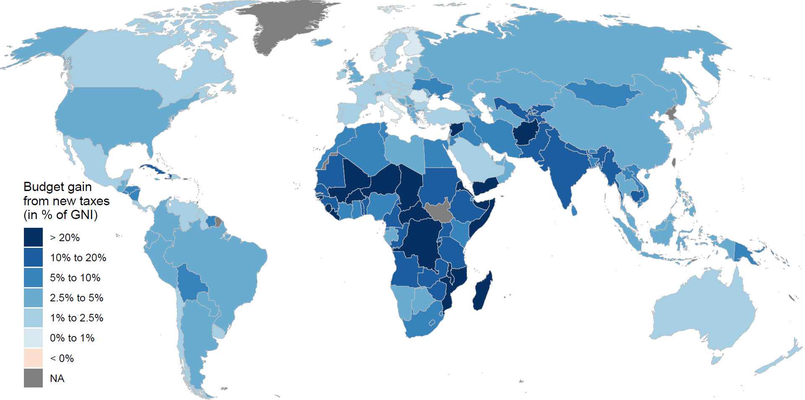

Figure 1: Gains for national budgets from new taxes and net transfers.  
Source: Fabre et al, *A shared vision toward global climate justice*.

**A pragmatic treaty in the interest of the greatest number**

The Union would be open to all countries. To encourage as many countries as possible to join, the treaty would include elements of flexibility and conditional cooperation. In particular, the participation required of a high-income country would be reduced to the extent that other high-income countries did not participate. Thus, if the European countries join the Union but the United States and Japan do not, Europe's contribution could be halved. Also, to facilitate the accession to the Union of fossil-dependent countries such as China, Iraq or South Africa, a country could make its participation in carbon pricing conditional on an exemption from the system of taxes and transfers (it would then be neither a beneficiary nor a contributor), provided this is accepted by the majority of other countries (weighted by their population). Finally, a country could make its participation conditional on the participation of one or more other countries, or on the GDP or emissions covered by the Union exceeding a threshold. For example, the European Union could choose to participate on condition that 60% of global emissions are covered, which would de facto make its participation conditional on that of China (which accounts for 30% of global emissions).

Various countries in the Global South could spearhead such a Union. Brazil is hosting the next COP, and intends to make it a major event. The African Union has already taken similar (albeit less precise) positions. Mexico is presided over by a climatologist, one of the main authors of the fifth IPCC report. India would be well advised to join such a Union, since it would receive large transfers from the rest of the world. China, with a per capita income equal to the world average, would be neither a contributor nor a beneficiary; it would have an interest in participating to ensure a low-carbon future in the long term, and outlets for its low-carbon equipment exports in the short term. In the absence of the United States, Europe would be the main contributor, and would enjoy a certain prestige. Moreover, recent academic surveys reveal that three quarters of Europeans support international climate and redistributive measures, and are ready to contribute financially to end climate change and extreme poverty.[3] It's hard to imagine certain countries, such as the United States, Russia and Saudi Arabia, joining the Sustainable Union in the short term. However, we can hope that social pressure will then be exerted on (and in) these recalcitrant countries, and eventually modify their political positioning.

**A solution not as impossible as you might think**

Many people believe that the reason such a treaty has not yet seen the light of day is that such an agreement is politically impossible. Yet the few academic surveys on the subject reveal strong public support for international climate policies, supranational governance and North-South solidarity. A survey of 125 countries shows that 69% of people are prepared to contribute 1% of their income to the fight against climate change.[4] Another shows that in each of the 17 countries surveyed (which include China, India, Russia, France, Egypt...), around 70% of the population support a global democratic government to deal with global issues (the USA is the country where this opinion is in the minority, with 45% support).[5] Meanwhile, a global tax on millionaires to fund low-income countries is supported by 8 out of 10 people in high-income countries (see Figure 2), and parties advocating global redistribution could win votes in elections.3 Admittedly, the political impossibility could come from governments rather than the population. By blocking any ambition in climate or tax agreements, the United States has played a decisive role. Trump's election should therefore be seen as an opportunity: it is now clear to everyone that it is an illusion to seek the cooperation of the United States, and that we must instead be resolute and united if we are not to lose ground in the confrontation that the President has initiated with the rest of the world, including with his allies.

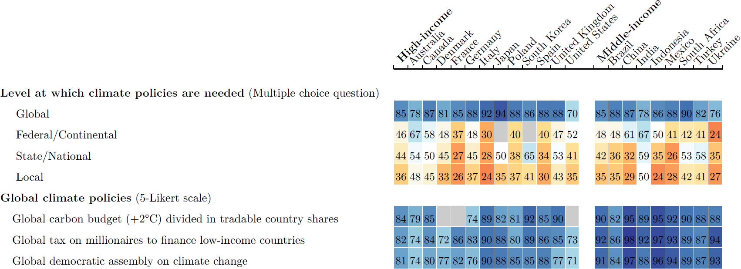

Figure 2. Support for global redistribution (% of responses *Somewhat* or *Strong support*, excluding *Indifferent*).   
Source: Fabre et al, *Majority Support for Global Redistributive and Climate Policies*, 2025.

Although they still need to be amended and negotiated, I believe that the principles and proposals that I put forward can pave the way for fruitful international agreements. I hope that these proposals can contribute to a positive political tipping point where a much larger and growing group of nations work together to solve humanity’s great challenges.

**Adrien Fabre**,

CNRS researcher at the International Center for Research on Environment and Development

1. Fabre, A., Arezki, R., Dasgupta, D., Hu, B., Sen, P., & van der Ploeg, R. (2024). A shared vision towards global climate justice.
2. Zucman, G. (2024). [A blueprint for a coordinated minimum effective taxation standard for ultra-high-net-worth individuals](https://www.taxobservatory.eu/publication/a-blueprint-for-a-coordinated-minimum-effective-taxation-standard-for-ultra-high-net-worth-individuals/).
3. Fabre, A., Douenne, T., & Mattauch, L. (2023). [International Attitudes Toward Global Policies](https://doi.org/10.2139/ssrn.4448523). FAERE Working Paper.
4. Andre, P., Boneva, T., Chopra, F., & Falk, A. (2024). [Globally representative evidence on the actual and perceived support for climate action](https://www.nature.com/articles/s41558-024-01925-3). Nature Climate Change.
5. Ghassim, F., & Pauli, M. (2024). [Who on Earth Wants a World Government, What Kind, and Why? An International Survey Experiment](https://doi.org/10.1093/isq/sqae105). International Studies Quarterly.