Public Acceptance of International Redistribution in High-Income Countries

Disclosure statement of Adrien Fabre

1. I received funding from the Agence nationale de la recherche for this research (ANR-24-CE03-7110).
2. There are no interested parties that have provided financial or in-kind support.
3. I serve pro bono as treasurer of the all-volunteer nonprofit Global redistribution advocates.
4. There are no potential conflicts of interest with author’s relatives.
5. No party has had the right to review the paper prior to circulation.
6. I have nothing else to disclose.

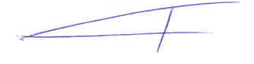
Paris, December 1st, 2025

Dr. Adrien Fabre

CNRS – CIRED
45 bis av. de la Belle Gabrielle
94130 Nogent-sur-Marne
France

