Biyi Chen

6205 internet computing

project 2

<http://ec2-54-69-58-81.us-west-2.compute.amazonaws.com/project2/homepage2.html>

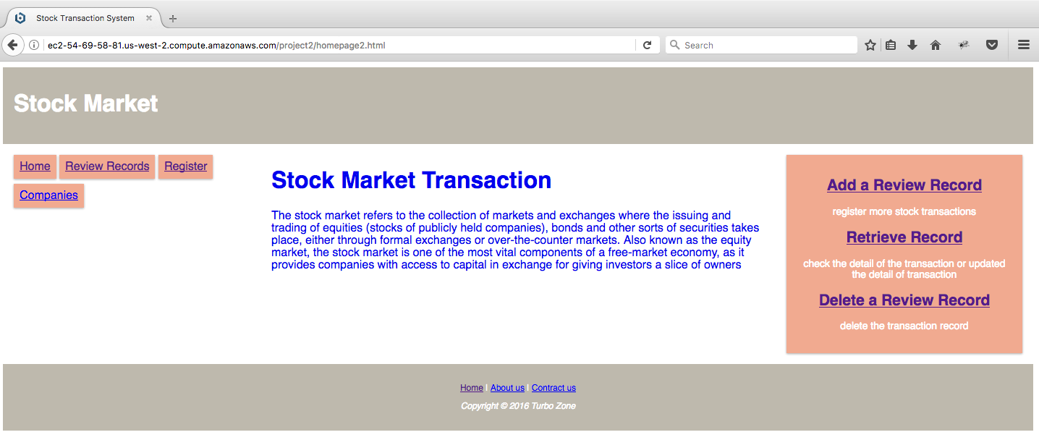

these are all functional nav bar. You can easily click one of them to go to the other page. And they are all responsive design.

<http://ec2-54-69-58-81.us-west-2.compute.amazonaws.com/project2/userinput.php>

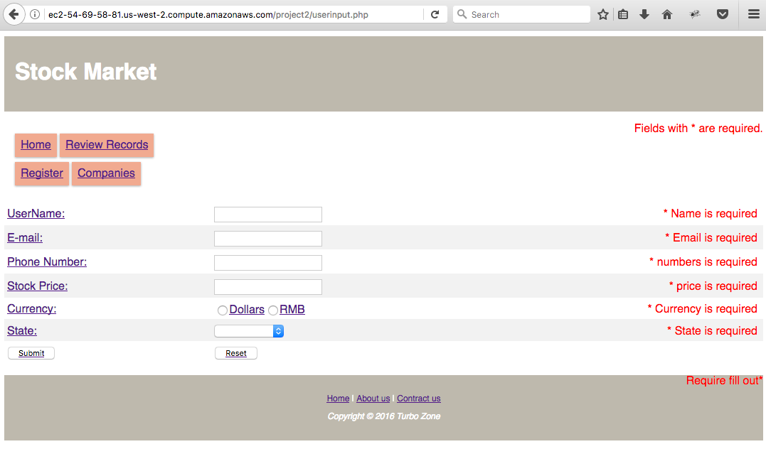

after you filled out all the information you will be redirected to the displaydata page, which is displaying all the data ordered by id on the record list as follow. The data is transferred to the database And retrieve the data by Json and Jquery code.

<http://ec2-54-69-58-81.us-west-2.compute.amazonaws.com/project2/displaydata.php>

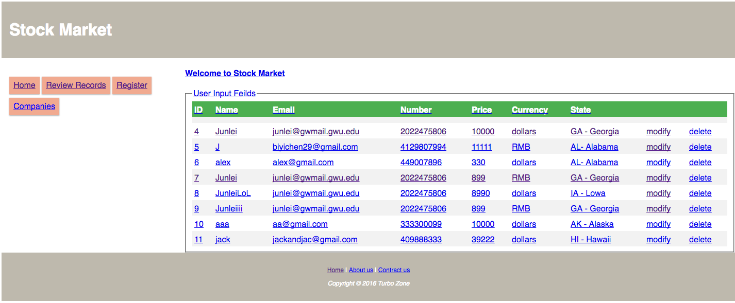

when you either click the record of “id, name, email, or number, or currency, or state” (all the clickable hyperlinks), or click the link as follow (simply just change the ?id=1,2,3,4…., whichever id that you might interest in to retrieve to look at the detail)you will be redirected to the record page as follow. If you click deleted, the record that you choose will be deleted.

<http://ec2-54-69-58-81.us-west-2.compute.amazonaws.com/project2/table.php?id=4>

