615 Final Report

Xiaohan Shi

2024-12-14

# Introduction

This report chooses Palau as the research object and firstly introduces its basic information, including geographic location, environmental characteristics, government description, economic situation and residents’ culture. Secondly, the data visualization shows the general characteristics and trends of Palau’s GDP, population, number of international tourists and weather data. This report then selects Fiji and analyzes it in comparison to Palau. Finally, this report summarizes Palau’s strengths, weaknesses, opportunities and threats through SWOT analysis.

# General Description

Palau is located in the Micronesia region of the Western Pacific Ocean. The total area of Palau is about 459 square kilometers (about 177 square miles), which makes it one of the smallest countries in the world. It is an archipelago of about 340 islands and reefs located in the northwestern part of the Philippine Sea. Palau’s largest island is Babeldaob, where the country’s capital, Engelmad, is located. The entire country covers an area of approximately 459 square kilometers, including several volcanic and coral reef islands, and the terrain is dominated by tropical islands and oceanic landscapes. Due to its unique location, Palau has a rich marine ecosystem and is known as one of the world’s last natural paradises.

# Key Facts of Palau

1. Government

Palau is a constitutional presidential republic with a bicameral legislature, the Olbiil Era Kelulau, and an independent judiciary. Its capital is Engelmade. Under the Compact of Free Association with the United States, Palau’s defense is the responsibility of the U.S. military. Currently, the country’s political system is non-partisan.

Outside of the national government structure, Palau is divided into 16 states, each with its own constitution and elected political subdivisions, which share a unified national judicial system. Of these 16 states, 10 are located on the country’s largest island, Babeldaob, while the remaining 6 are spread across other island groups.

1. Economy

Palau’s economy relies on tourism, subsistence agriculture, and fishing. Due to the islands’ rich marine life, barrier reefs, the key tours include scuba diving and snorkeling, and visit World War II wrecks. In April 2022, the country introduced Ol’au Palau, a responsible tourism initiative to safeguard its natural and cultural heritage. The government, supported significantly by U.S. financial aid, is the largest employer.

1. Nature Environment

For a tiny archipelago with only a 328.14 square km landmass, Palau has an intriguing biodiversity of its own (Home - Pristine, n.d.). Around 75% of Palau’s volcanic, coral atoll, and limestone islands are covered in native forests and mangroves. These forests, the most biodiverse in Micronesia, host over 1,400 plant species, including 194 endemic varieties such as 23 unique orchid species.

Palau also features the iconic Ngerukuid Islands Nature Reserve, or “70 Islands,” known for its maze-like channels and crystal-clear waters. Visitors often encounter sea creatures such as manta rays.

1. Culture

Matrilineal: The matrilineal traditions of Palauan culture deeply influence the social structure. Here, family lineage and inheritance are passed down through the female line, shaping unique patterns of social relationships and leadership.

Respect for Nature: Nature occupies a central place in Palauan culture. Traditional beliefs emphasize the harmonious coexistence of man and nature, a concept that is not only reflected in ancient practices, but is also compatible with modern concepts of environmental protection.

Oral Tradition: Oral traditions are an important way in which Palauan culture is preserved and transmitted. Through the telling of myths, legends and historical stories, Palauans maintain their cultural memory and transmit the values and identity of their communities.

Traditional Navigation: As a maritime people, Palauans are known for their excellent traditional navigation skills. They navigate the vast Pacific Ocean using the stars, winds, and nature to guide them, and this seafaring tradition, which is closely tied to the sea, is embedded in their cultural DNA.

1. Climate

Palau has a tropical rainforest climate with an average annual temperature of about 28°C. Rainfall is abundant throughout the year, with 3,800 millimeters per year. The average humidity is 82% and although rainfall is more frequent from June to October, sunshine is still abundant.

Geographically, Palau is on the edge of the typhoon belt. Tropical cyclones do often form in the vicinity each year, but major tropical cyclones are extremely rare. Only three systems, Mike, Bopha and Haiyan, have ever hit Palau as typhoons in the historical record (Wikipedia Contributors, 2024).

# Key Demographics

This report analyzes Palau’s economy, population, tourists, and weather-related data. GDP, population and visitors’ data are derived from R package WDI, from the World Bank’s World Development Indicators database. Weather-related data from Climate Statistics - PalauGov.pw.

Figure 1 illustrates the GDP of Palau from 2010-2023. The GDP increased year by year from 2010 to 2016, reaching the highest value of 298.3 million dollars in 2016. This was followed by fluctuations and an overall decline, with a significant decline beginning in 2019, likely due to a region-wide epidemic affecting Palau’s tourism industry. It picked up again after 2021, reaching $281.8 million in 2023.

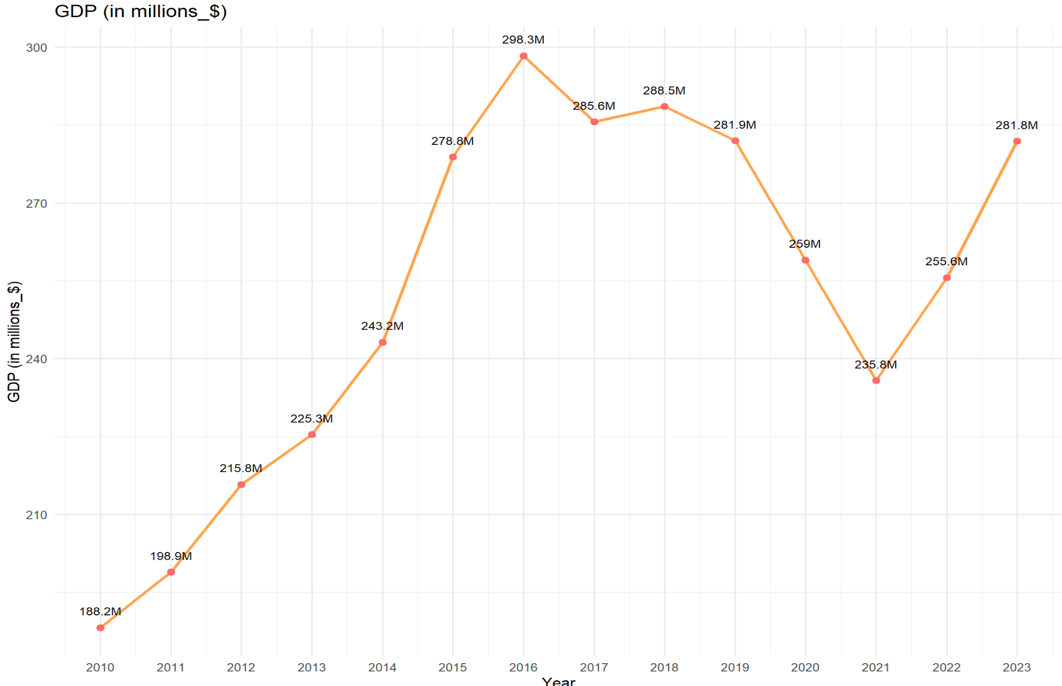

Figure 1: GDP of Palau from 2010-2023 (World Bank, 2024).

As figure 2 shows, Palau’s population decreased significantly from 2010 to 2013, reaching a minimum of 17,648 in 2013. Since then, it has slowly increased, but since 2019, there has been a slight decrease.

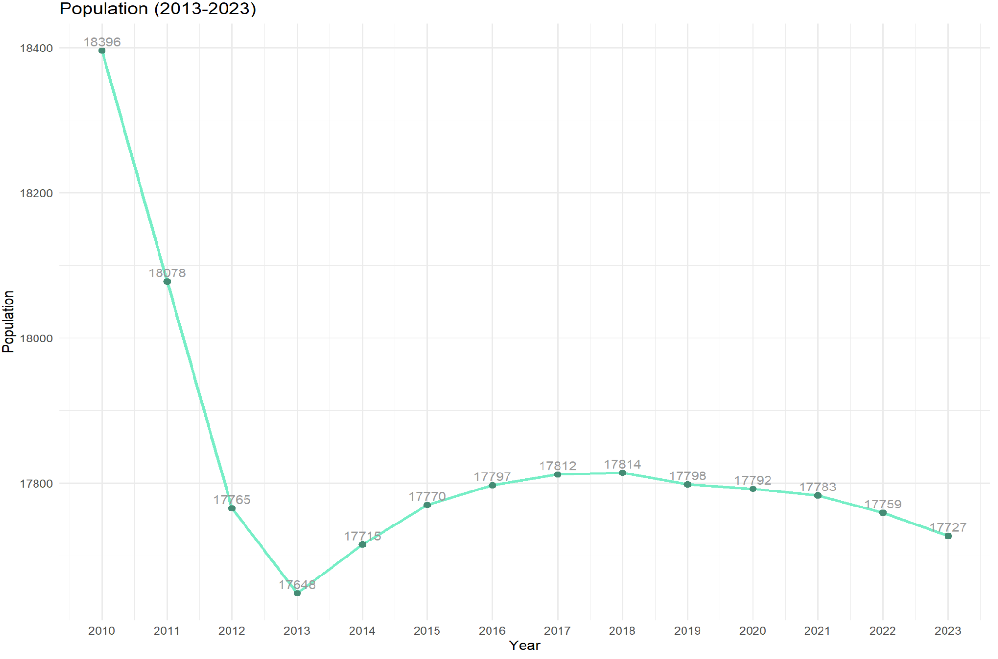

Figure 2: Population of Palau (World Bank, 2024).

As for the number of international tourists in figure 3, the overall trend from 2010 to 2015 was on the rise, reaching a peak of 162,000 people a year. It has decreased every year since then. The plunge in 2019-2020 due to the global epidemic is consistent with the downward trend in GDP.

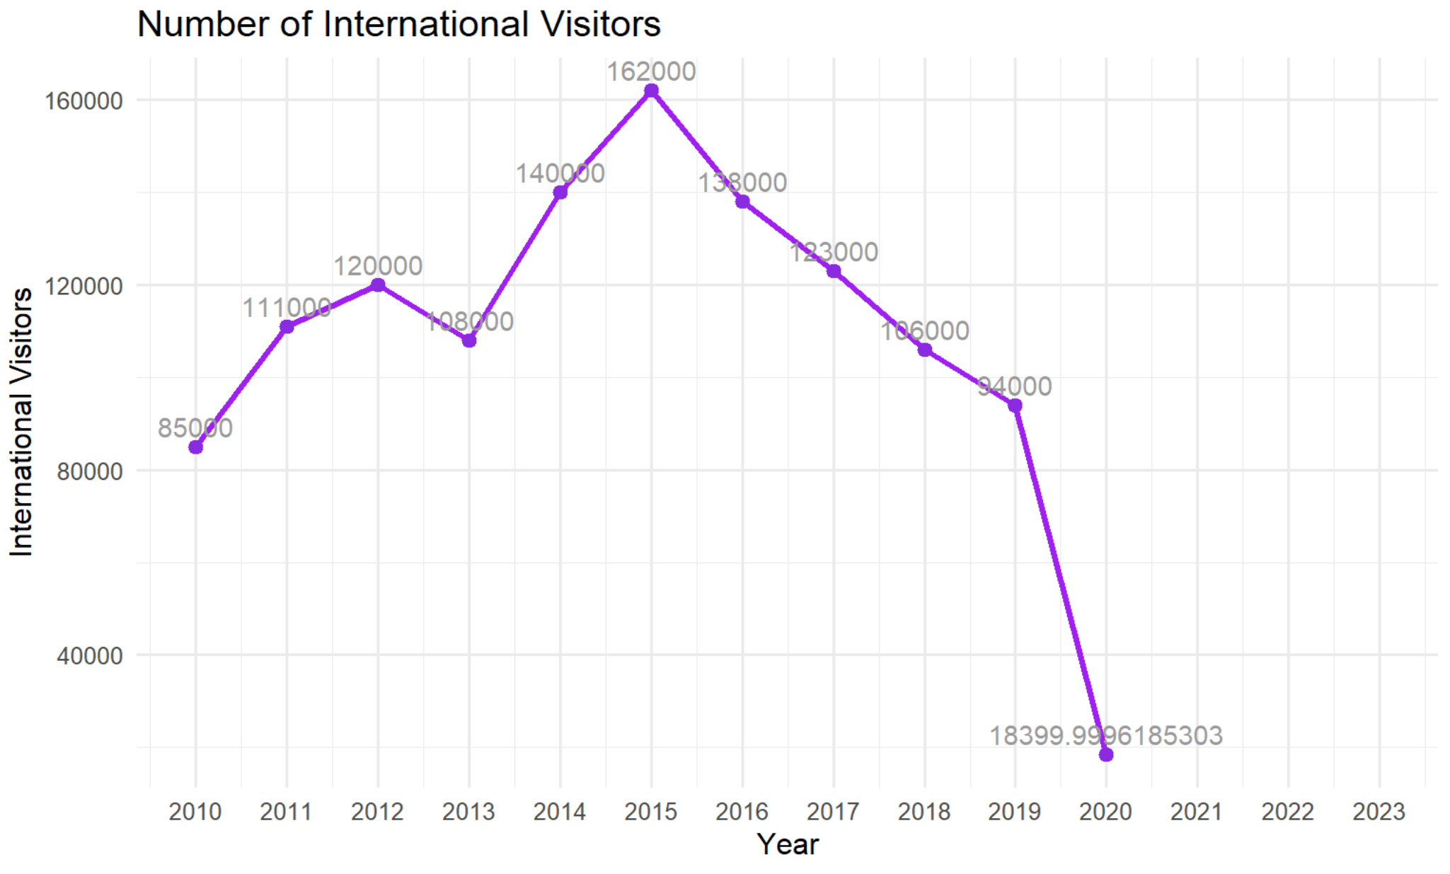

Figure 3: International visitors of Palau from 2010-2020 (World Bank, 2024).

For weather data, this report analyzes average annual rainfall and average annual temperature. Figure6 shows that the average annual rainfall in Palau from 2012 to 2021 is around 8 to 15inches. Figure 7 shows that the average annual temperature in Palau from 2012 to 2021 is relatively stable, around 80°F.

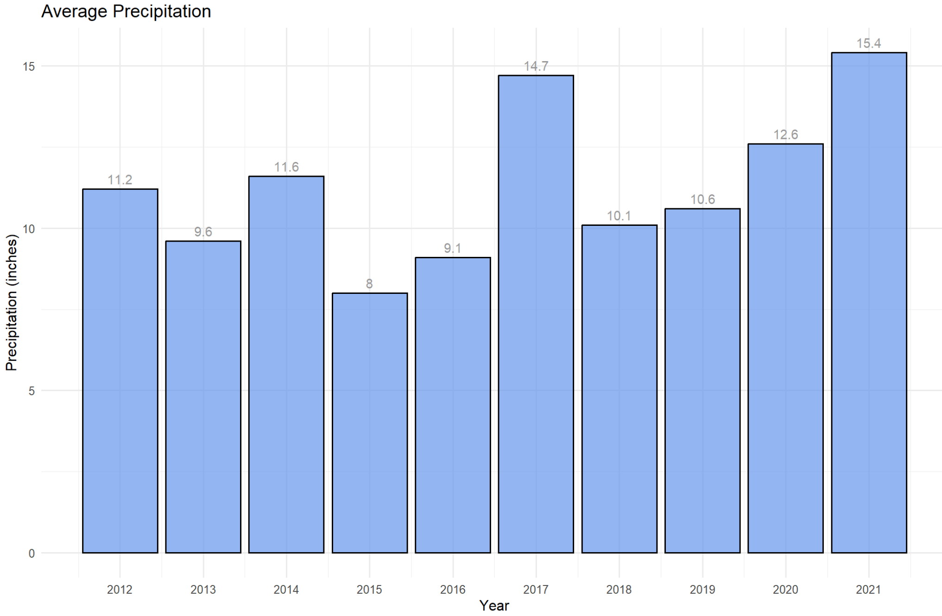

Figure 4: Average precipitation (inches).

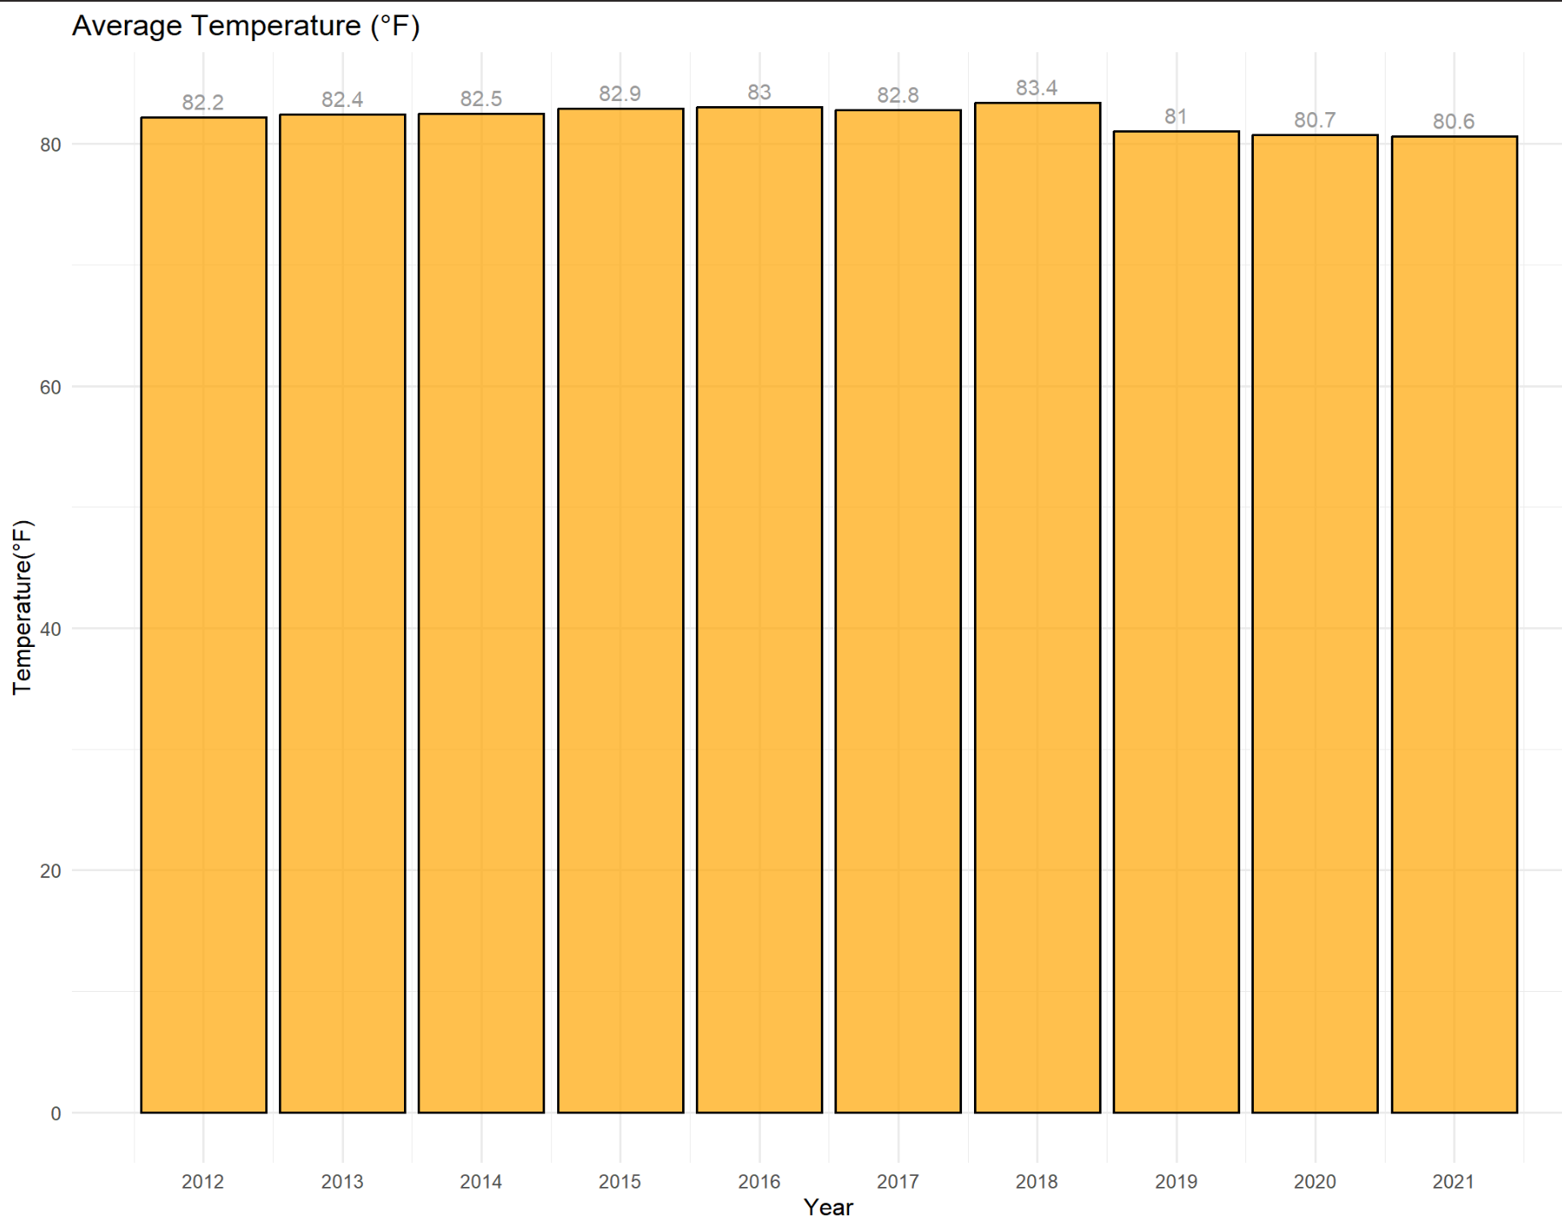

Figure 5: Average temperature of Palau.

# Comparative Analysis

Then this report selects Fiji as a comparison to analysis the difference between the two island. The reason why Fiji is selected for comparison is that its geographic proximity to Palau, similar reliance on tourism, and shared environmental and economic challenges. Additionally, both countries are known for their marine biodiversity.

**Introduction of Fiji**

Fiji is an island nation in the South Pacific, consisting of 332 islands, about 110 of which are regularly inhabited. It has a total area of approximately 18,274 square kilometers (7,055 square miles) and is located at approximately 16 degrees south latitude and 175 degrees east longitude. The two largest islands, Viti Levu and Vanua Levu, are the country’s main economic and population centers, respectively. Fiji is located in a geological region formed by volcanic rocks and coral reefs, and the terrain is characterized by rich tropical rainforests, mountains and spectacular coastlines. The country is located in the seismic belt of the South Pacific Ocean and is relatively volcanically and geologically active. Fiji has a tropical Marine climate, warm and humid all year round.

The GDP comparison shows the economic trends of Fiji and Palau over the years. As figure 6 and 7 show, Fiji’s economy is significantly larger than Palau’s due to its higher population and diversified economic sectors. Additionally, Fiji’s GDP also fluctuated significantly overall.

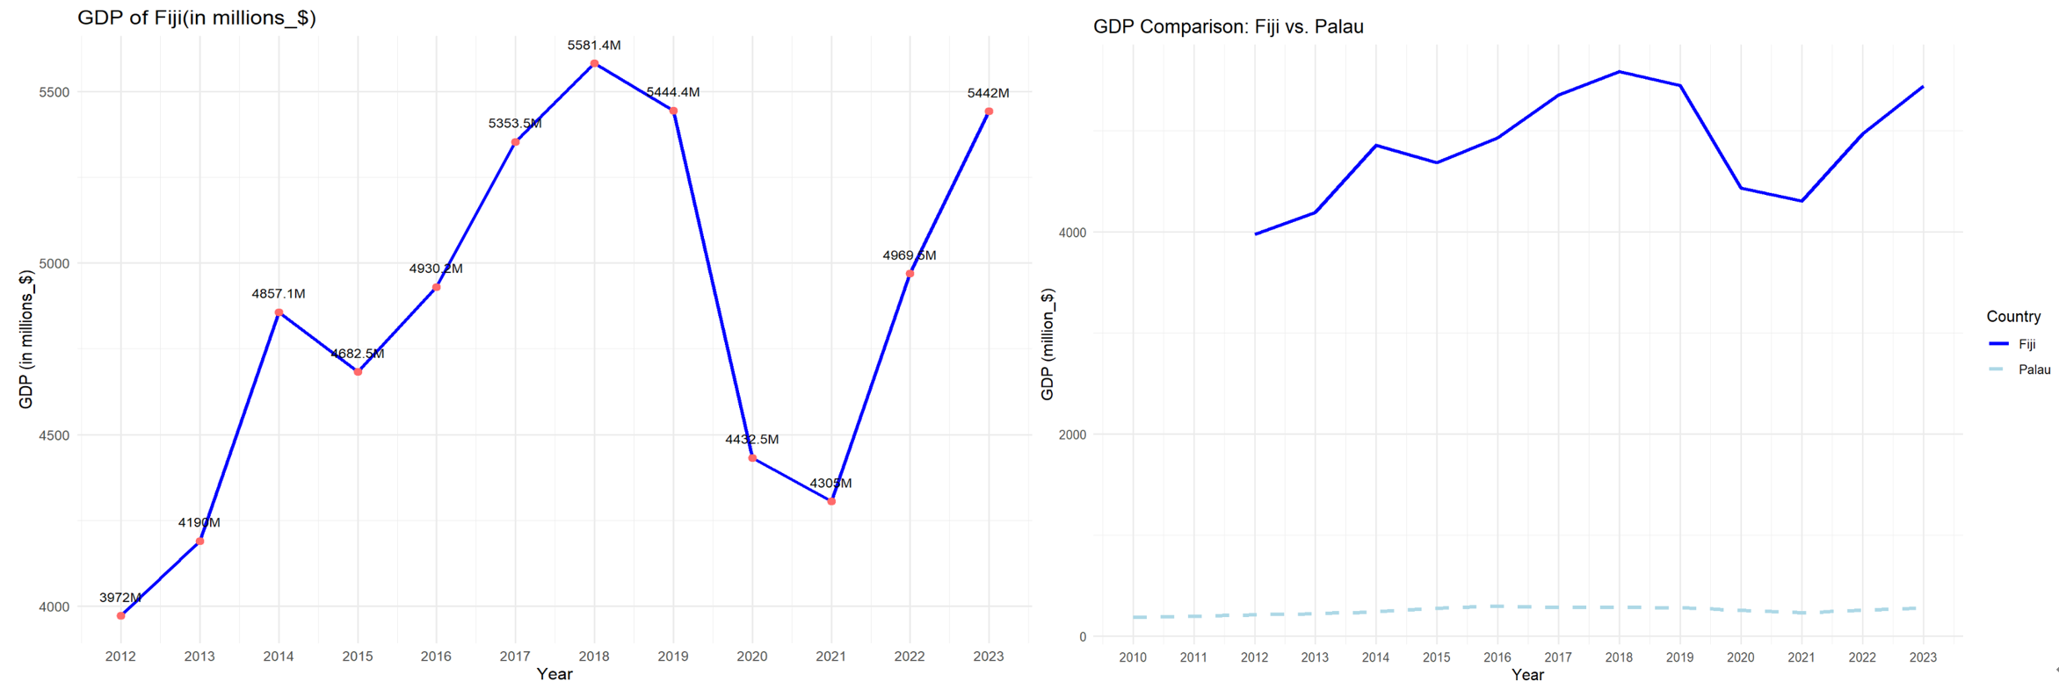

Figure 6&7: GDP of Fiji and Palau (World Bank, 2024).

Figure 8 and 9 are the line chart of population change in Fiji, showing a clear trend of population growth starting in 2021. The comparison on the right highlights that Fiji has a much larger population than Palau, reflecting its larger geographical area and resources. This also results in the huge gap of GDP between two islands.

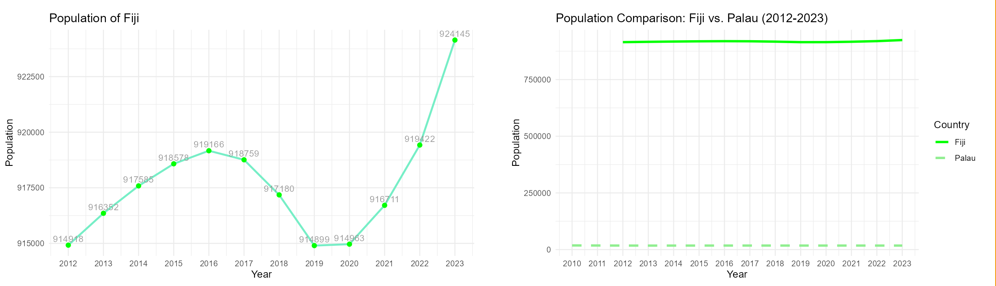

Figure 8&9: Population of Fiji and Palau (World Bank, 2024).

The figure 10 and 11 illustrate the trends in tourist arrivals to Fiji. The number of visitors has dropped significantly since 2019, presumably due to the global pandemic. The visitor trends on the right chart show the relative attractiveness of Fiji and Palau to international visitors. While both islands are heavily dependent on tourism, Fiji has a larger visitor base due to its size and infrastructure. However, as a result, the epidemic has also caused a greater loss of tourist numbers to Fiji.

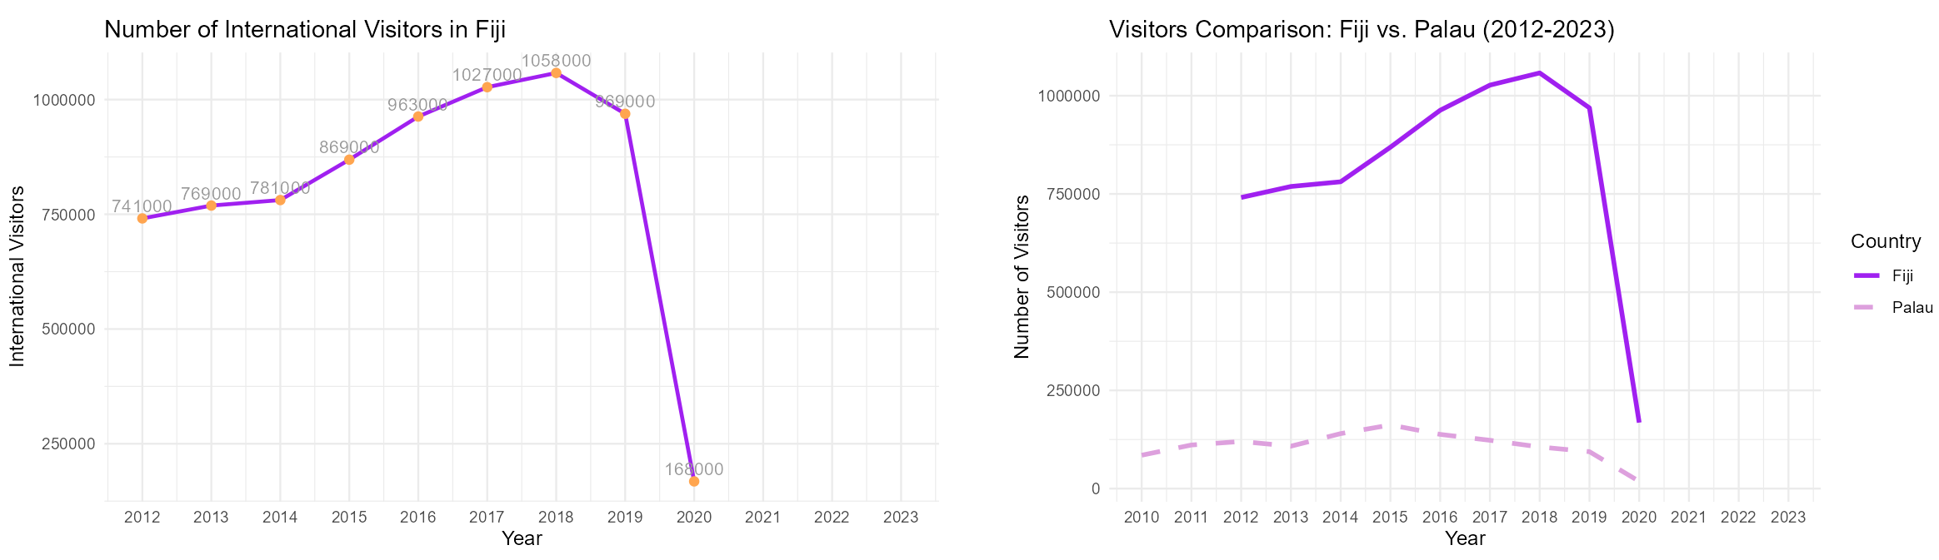

Figure 10&11: Visitors of Fiji and Palau (World Bank, 2024).

# SWOT Analysis of Palau

1. Strengths

Unique natural environment: Palau offers unrivalled pristine natural beauty, as well as world-class diving and snorkeling sites such as the German Channel and wreck sites.

Conservation pioneers: Palau has demonstrated leadership in environmental protection by pioneering Marine protected areas around the world, such as the Palau National Marine Sanctuary. In addition, the Ol’au Palau project was launched in 2022 to emphasize responsible tourism behavior and attract environmentally friendly tourists.

1. Weaknesses

Land and resource constraints: Palau is small in size, lacks exploitable resources, and receives fewer tourists than other popular islands such as Fiji.

Economy highly dependent on tourism: other industries such as agriculture and fishing are small, limiting the potential for economic diversification.

1. Opportunities

Special-interest tourism market: pristine natural environments and location can attract tourists who are ecologically friendly and want to be away from crowd.

Unique culture: Palau is rich in traditional culture, such as local handicrafts, traditional villages and legends, which can serve as an important resource for attracting tourists.

International cooperation and investment: working with international environmental organizations and national governments to promote Marine conservation and sustainable development. Seek outside investment to build infrastructure and tourism facilities.

1. Threats

Climate change: Palau has about 1,500 km of coastline, most of its population and infrastructure are located in coastal areas, so it is vulnerable to weather hazards caused by climate change. These include extreme high tides, coastal erosion, seal-level rise, increase in drought and storm activity, increase sea-surface temperature and coral bleaching (World Bank Climate Change Knowledge Portal, n.d.). In addition, because of its geographical isolation, these threats could easily pose a greater potential hazard to Palau.

Global economic fluctuations: As Palau is a highly tourism-dependent economy, a global economic downturn or crisis can directly affect visitor numbers and revenues. The impact of the global pandemic on Palau’s tourism and GDP in 2019-2021 is one example.

# References

About Palau - Office of the Special Prosecutor | Republic of Palau. (2019, June 3). Office of the Special Prosecutor | Republic of Palau. <https://www.palauosp.org/about-palau/>

Climate Statistics – PalauGov.pw. (n.d.). PalauGov.pw. <https://www.palaugov.pw/executive-branch/ministries/finance/budgetandplanning/climate-statistics/>

Home - Pristine. (n.d.). <https://pristineparadisepalau.com/>

Palau | Culture, History, & People. (2019). In Encyclopædia Britannica. <https://www.britannica.com/place/Palau>

Wikipedia Contributors. (2024, November 21). Palau. Wikipedia; Wikimedia Foundation. <https://en.wikipedia.org/wiki/Palau>

World Bank Climate Change Knowledge Portal. (n.d.). Climateknowledgeportal.worldbank.org. <https://climateknowledgeportal.worldbank.org/country/palau/vulnerability>

World Bank. (2024). World Development Indicators. R package WDI. Retrieved from <https://data.worldbank.org>