Patient’s Name : Mrs.Sakunthala Age/Sex : 32 Y/F
Ref.Consultant : Dr. Date : 10.3.12
Clinical History :

CT SCAN OF TEMPORAL BONES (PLAIN)

CT Temporal bone with HR sections and reformation studied reveals:
- Normally pneumatized mastoid air cells.
- Middle ear cavity normal.
- Ossicles normal.
- Cochlea and vestibule normal, semicircular canals normal.
- Descending facial nerve canal normal in size.
- Internal auditory canal normal in dimension.
- External auditory canal and tympanic membrane normal.
- CP angle cisterns normal.

IMPRESSION:

- CT Temporal bone Plain study within normal limits.

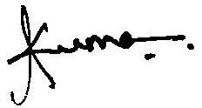

Dr.T.Kumar MD (Rad),
Radiologist.

